Welcome!

**Please scroll down to read introductory information**

*WordPub*

**BECE**

**BASIC DESIGN AND TECHNOLOGY**

# (Pre-Technical Skills)

**Past Questions & Answers**

## 2010

**Junior High School** **Years 1, 2 & 3**

**Compiled by:**



**© 2018 Word Publishers. All rights reserved**

**Unauthorized distribution and/or reproduction of this document prohibited.**

**CONTACT**

**Email:**

**info@wordpub.org**

**Telephone:**

**(+233) 030 295 1486,**

**(+233) 020 893 0787,**

**(+233) 057 860 0052, (+233) 024 850 6613.**

**Postal Address:**

**Word Publishers,**

**P.O. Box NT 583, Newtown – Accra, Ghana.**

**Location:**

**7 Tunemete Street, Dzorwulu-Accra, Ghana.**

**Website:**

[**bece.wordpub.org**](https://bece.wordpub.org/)

### ACKNOWLEDGEMENTS

* The **West African Examination Council** - for the BECE Pre-Technical Skills past questions used in this document.

* **Ernest Ato Bentil** and **Maxwell Mensah** – for your invaluable contribution to this work.

* **Ruth, Baaba and Fiifi Arthur** – for your relentless support

* **Teachers, parents and educational institutions** – for your continuous patronage and tireless efforts at ensuring quality education for the 21st century child

* Junior High School **students** – you are the ultimate reason for this work.

### DEDICATION

To the Lord **Jesus Christ**, our Saviour and soon-coming King

**April 2010**

### BASIC DESIGN AND TECHNOLOGY 1

**(Pre-Technical Skills 1)**

**Objective Test**

**40 minutes**

1. Stitches which are removed from an article after serving their purpose are known as
   1. joining stitches
   2. running stitches
   3. temporary stitches
   4. permanent stitches

1. What is the common nutrient found in liver and beans?
   1. Fats
   2. Vitamins
   3. Carbohydrates
   4. Proteins

1. The **most** popular method of preserving cassava is
   1. smoking
   2. freezing
   3. drying
   4. canning

1. The arrangement of shapes in a picture is known as
   1. composition
   2. drawing
   3. blending
   4. toning

1. The **most** suitable support for drawing is
   1. canvas
   2. paper
   3. rubber
   4. wall

*Figure 1 is a block. Use it to answer Questions 6 and 7.*

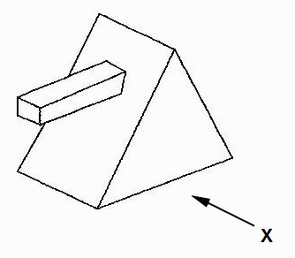

1. Which of the following represents the front elevation of the direction of arrow X?

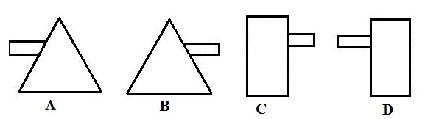

1. The plan is represented by

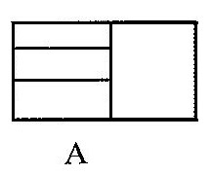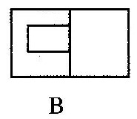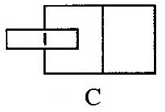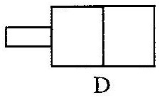

1. Graphic designers communicate information that can be
   1. seen and heard
   2. printed and read
   3. seen and read
   4. shown and felt

1. The artifact when completed should be able to hold a normal size candle. This specification is classified as
   1. function
   2. construction
   3. ergonomics
   4. aesthetics

1. In design, the process used to determine the strengths and weaknesses of an artifact is
   1. analyzing
   2. testing
   3. realization
   4. modification

1. The colour code for a live wire is
   1. blue
   2. red
   3. yellow
   4. green

1. Which of the following is **not** a basic home preventive maintenance of furniture?
   1. Strengthening joints
   2. Applying new finish
   3. Replacing damaged locks
   4. Replacing furniture

1. A method for making several identical copies of an artifact is
   1. shading
   2. drawing
   3. printing
   4. painting

1. A drawing of vegetation and buildings is
   1. landscape
   2. imaginative
   3. memory
   4. portraiture

1. An indirect risk to a sewing industry is
   1. low quality products
   2. misuse of profits
   3. inflation controls
   4. increasing capital

1. The snips is used for
   1. striking B. holding
   2. measuring
   3. cutting

1. Which of the following tools has a lever cap?
   1. Bench vice
   2. Hacksaw
   3. Outside calipers
   4. Jack plane

1. The term laying is used in
   1. block work B. wood work C. metal work

D. plastic work

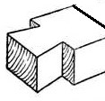

1. The sketch shown above is a
   1. tongue
   2. tenon
   3. mortice
   4. dovetail

1. Which of the following electronic components allows current to flow in only one direction?
   1. Inductor
   2. Diode
   3. Switch
   4. Capacitor

1. Which of the following applies to a two-point perspective drawing?
   1. Angle of projection is 30°
   2. Angle of projection is 60°
   3. Object is viewed from a corner
   4. Front view is drawn first

1. Which of the following is a physical property of metals?
   1. Weight
   2. Brittleness
   3. Ductility
   4. Malleability

1. The body of a spoke shave is made of
   1. cast iron
   2. mild steel
   3. copper D. lead

1. Which of the following materials is a ferrous metal?
   1. Lead B. Steel
   2. Copper
   3. Aluminium

1. The most appropriate surface finish for a garden chair is
   1. wax polish
   2. emulsion paint
   3. oil paint
   4. sanding sealer

1. One purpose of using a flux in soldering is to
   1. prevent formation of oxides
   2. wash surfaces of the work
   3. heat the soldering iron
   4. make the joint neat

1. A fuse wire breaks when there is
   1. high voltage
   2. excess current
   3. low voltage
   4. low current

1. Which of the following is the most appropriate instrument for drawing objects in oblique?
   1. 30° set square
   2. 45° set square
   3. Ruler
   4. A pair of dividers

1. In orthographic projection, the plan is projected onto the
   1. vertical plane
   2. horizontal plane
   3. side plane
   4. auxiliary plane

1. Which of the following is a thermoplastic material?
   1. Polyester resin
   2. Phenol formaldehyde
   3. Polyvinyl chloride
   4. Melamine formaldehyde

**April 2010**

### BASIC DESIGN AND TECHNOLOGY 1

**(Pre-Technical Skills 1)**

**Objective Test**

**ANSWERS**

1. C. temporary stitches
2. D. Proteins
3. C. drying
4. A. composition
5. B. paper
6. A.
7. A.
8. C. seen and read
9. A. function
10. B. testing
11. B. red
12. D. Replacing furniture
13. C. printing
14. A. landscape
15. C. inflation controls
16. D. cutting
17. D. Jack plane
18. A. block work
19. D. dovetail
20. B. Diode
21. D. Front view is drawn first
22. A. Weight
23. A. cast iron
24. B. Steel
25. C. oil paint
26. A. prevent formation of oxides
27. B. excess current
28. B. 45° set square
29. B. horizontal plane
30. C. Polyvinyl chloride

#### April 2010

**BASIC DESIGN AND TECHNOLOGY 2**

**(Pre-Technical Skills 2)**

**Essay**

**1 hour 15 minutes**

**SECTION A**

**(CORE SKILLS)**

**[20 marks]**

**Answer question 1 [COMPULSORY]**

1. (a) What is a *seam*?

* 1. Suggest the correct stitches for

* + 1. fringed edge of a tablecloth

* + 1. making of a baby’s petticoat

* 1. The figure below is a cube drawn in isometric

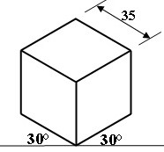

Sketch the cube in **two-point** perspective drawing

* 1. (i) What is *texture*?

(ii) List the **two** types of texture

* 1. Copy and complete the table below by providing the type of texture associated each object listed

|  |  |
| --- | --- |
| **OBJECT** | **TEXTURE** |
| Banana |  |
| Pineapple |  |
| Unwashed terrazzo |  |

**SECTION B**

**[50 marks]**

*Answer* **two** *questions* **only** *from this section All questions carry equal marks*

1. (a) State two methods suitable for joining sheet metals permanently

* 1. Sketch a lap joint used in sheet metalwork

* 1. List three items that can be manufactured from sheet metal

* 1. Figure 1 shows the front view of a clock. Use it to answer the questions that follow.

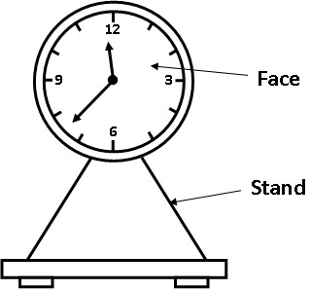

* + 1. State two properties of acrylic that makes it suitable for making the face of the clock.

* + 1. List two tools that can be used to mark-out the shape of the face of the clock.

1. Figure 2 shows the front elevation and plan of a square prism. Use it to answer questions 3(a)

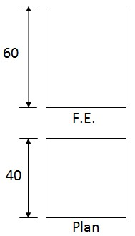

(a) Draw full size, the following:

* + 1. front elevation
    2. plan
    3. surface development

* 1. State one use of each of the following electronic components:
     1. capacitor
     2. inductor
     3. diode

* 1. Make a freehand pictorial sketch of a wooden mallet.

1. (a) Make a freehand sketch of a cross-cut saw

* 1. List three materials from which sandcrete blocks are manufactured

* 1. State one reason each for using the following in the workshop
     1. apron;
     2. gloves;
     3. helmet;
     4. goggles

#### April 2010

**BASIC DESIGN AND TECHNOLOGY 2**

**(Pre-Technical Skills 1)**

**Essay**

**ANSWERS**

1. **(a) What is a *seam*?**

A seam is a line of stitching, joining two or more pieces of fabric together permanently. **or**

a line where two pieces of fabric are sewn together in a garment or other article

**(b) Suggest the correct stitches for**

* + - * 1. **fringed edge of a tablecloth**

Neatening stitches, such as overcasting, blanket stitch and hemming stitch

* + - * 1. **making of a baby’s petticoat**

Decorative stitches, such as chain stitch, cross stitch, stem stitch and blanket stitch

* + 1. **The figure below is a cube drawn in isometric**



Sketch the cube in **two-point** perspective drawing

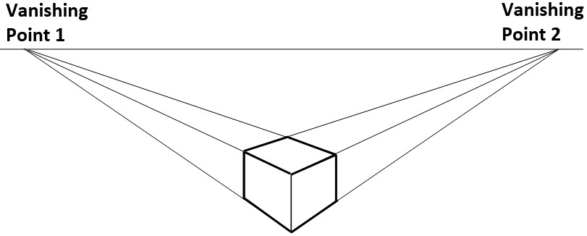

* + 1. **(i) What is *texture*?**

The feel or appearance of surface or substance Or

How rough or smooth a surface is or appears to be

**(ii) List the two types of texture**

Visual (virtual) texture

Tactile / Actual (tangible) texture

**(e) Copy and complete the table below by providing the type of texture associated each object listed**

|  |  |
| --- | --- |
| **OBJECT** | **TEXTURE** |
| Banana | Tactile / Smooth |
| Pineapple | Tactile / Rough |
| Unwashed terrazzo | Visual / rough |

**SECTION B**

**[50 marks]**

*Answer* **two** *questions* **only** *from this section All questions carry equal marks*

1. **(a) State two methods suitable for joining sheet metals permanently** Soldering

Welding

Riveting

Brazing

* 1. **Sketch a lap joint used in sheet metalwork**



* 1. **List three items that can be manufactured from sheet metal** 
     + - Roofing sheets
       - Barrels
       - Jewellery
       - Graters
       - Cooking utensils
       - Tins
       - Cans
       - funnels
       - buckets
       - machine parts
       - Water reservoir

**(d) Figure 1 shows the front view of a clock. Use it to answer the questions that follow.**



1. **State two properties of acrylic that makes it suitable for making the face of the clock.** 
   * Excellent optical clarity
   * Excellent resistance to sunlight • Rigid, with good impact strength • Flexible and shock resistant.
   * Easily cut, corrosion resistant and a good insulator.

1. **List two tools that can be used to mark-out the shape of the face of the clock.** • Centre punch
   * Felt-tip pen / marker pen
   * Try square
   * Pair of dividers
   * Pencil
   * Template

1. **Figure 2 shows the front elevation and plan of a square prism. Use it to answer questions 3(a)**



* 1. **Draw full size, the following:** 
     + 1. **front elevation**
       2. **plan**
       3. **surface development**

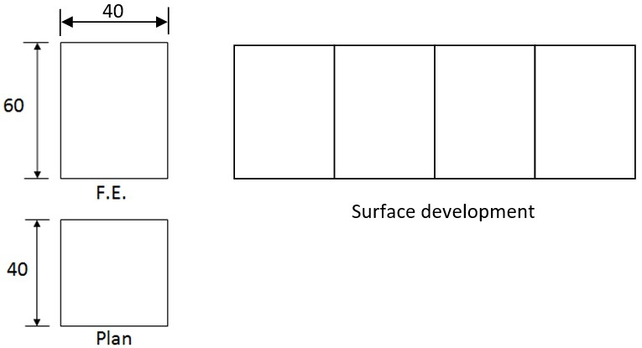

* 1. **State use one of each of the following electronic components:**

**(i) capacitor**

* + - * + Stores electrical current for future use
        + Used to operate the tuning dial of a radio
        + Used in loudspeakers to block DC and allow only AC to flow
        + Used to smooth out AC currents

**(ii) inductor**

* + - * + Used in electrical circuits to block AC while allowing DC to pass
        + Used to create a filter by blocking high frequency current and allowing only a certain frequency to pass through the circuit
        + Used as energy storage devices in transformers, motors and computers
        + Used in proximity sensors, such as those used in traffic lights

**(iii) diode**

* + - * + Used as rectifiers - to convert AC to DC by allowing electric current to flow in only one direction
        + Diodes are also used in/for the following:

signal limiters,

voltage regulators,

switches,

signal modulators,

signal mixers,

signal demodulators,

oscillators

* 1. **Make a freehand pictorial sketch of a wooden mallet.**

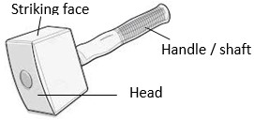

1. **(a) Make a freehand sketch of a cross-cut saw**

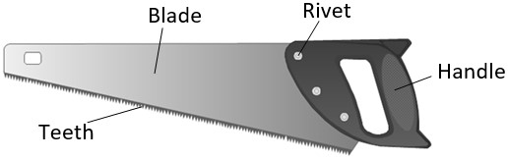

**(b) List three materials from which sandcrete blocks are manufactured**

* + - * + Sand,
        + Cement
        + Lime

**(c) State one reason each for using the following in the workshop (i) apron;**

To prevent clothes from becoming dirty / stained.

* + 1. **gloves;**

To protect the hands from injury and dirt.

* + 1. **helmet;**

To protect the head from injury

* + 1. **goggles**

To protect the eyes from injury / prevent particles from entering the eyes