**April 2011**

**INFORMATION AND COMMUNICATION TECHNOLO GY 1**

### OBJECTIVE TEST

45 Minutes

1. The **most** common means by which data are input into the computer is through the
   1. mouse
   2. keyboard
   3. microphone
   4. joystick

1. Computer devices such as mouse, trackpad and joystick are referred to as
   1. Output devices
   2. Pointing devices
   3. Standard devices
   4. Internal devices

1. The flat panel screen is also known as
   1. LCD
   2. VCD
   3. CRT
   4. OCR

1. Which of the following is a storage medium?
   1. Mouse
   2. Printer
   3. Keyboard
   4. Flash memory

1. The two components of the personal computer main memory are
   1. RAM and CU
   2. RAM and ROM
   3. ROM and CU
   4. ALU and CU

1. Which of the following devices has the largest storage capacity?
   1. Digital versatile disc
   2. Compact disc
   3. Floppy disk
   4. Hard disk

1. The process that starts an operating system when a computer system is turned on is referred to as
   1. loading
   2. start up
   3. booting
   4. shut down

1. Which of the following statements is not true?
   1. Remove all removable storage media or device from the system unit when switching on a computer.
   2. Shut down a computer system before removing the electric power supply
   3. Random access memory is part of main memory
   4. The application software must be loaded before an operating system can be loaded when a computer system is switched on.

1. GUI stands for
   1. Grand User Interface
   2. General User Interface
   3. Graphic User Interface
   4. Graphical User Interrupt

1. The software that manages the communication between the hardware and the application software of a computer system is called
   1. open office
   2. Microsoft office
   3. operating system
   4. internet

1. Windows organizes information on computers using a
   1. directory
   2. folder
   3. subdirectory
   4. disk

1. Which of the following are valid folder names
   1. Black/Stars
   2. Black **:** Stars
   3. Black_Stars
   4. Black Stars

* 1. I and II only B.

II and III only

* 1. III and IV only
  2. II and IV only

Use the following information to answer question 13

* 1. Processing
  2. Data
  3. Information

1. The sequence of the stages in the information processing cycle is
   1. I, II and III B. II, III and I
   2. II, I and III
   3. III, I and II

1. Which of the following is **not** a safety measure to consider in the ICT environment?
   1. Not overloading a socket
   2. Sitting in a correct posture behind the computer
   3. Allowing the battery of a laptop to run-down before charging D. Avoid plugging computers in damaged sockets

1. The legal right to control the production and selling of a book, play, film and software is known as A. production right
   1. copyright
   2. trade mark
   3. patent

1. Which of the following can bring enhanced learning experience to the classroom through the use of pictures, videos and sound? A. Software application B. Multimedia software
   1. Learning software
   2. Teaching and learning software

1. Which of the following is an effect of a loud ringing tone of a mobile phone?
   1. Wrist pain B. Neck pain
   2. Headache
   3. Hearing impairment

1. To which of the following activities is ICT useful?

I. Education II. Farming

III. Medicine

* 1. I and II only
  2. I and III only
  3. II and III only
  4. I, II and III

1. Which of the following keys are frequently used in our daily typing work on a computer system? I. Enter key II.

Space Bar

* 1. Print Screen
  2. Delete Key

* 1. I, II, III and IV
  2. I, II and III only
  3. I, II and IV only
  4. II, III and IV only

1. During typing lessons, computer users are supposed to use
   1. 5 fingers B. 6 fingers
   2. 8 fingers
   3. 10 fingers

1. The most appropriate finger required to type the letter F on a standard QWERTY computer keyboard

is the

* 1. left middle finger
  2. right middle finger
  3. left index finger
  4. right index finger

1. In the absence of a mouse, which of the following devices could be used to perform its functions?
   1. Scanner
   2. Webcam
   3. Keyboard
   4. Microphone

1. In typing a class assignment given by a Ghanaian Language teacher using the computer, which of the following application programs will be appropriate to use by the student?
   1. Spread sheet program
   2. Word processing program
   3. Database program
   4. Graphical program

1. A key on a keyboard of a computer has two symbols on it, top and down. Which of the following procedures will be appropriate to use to get the top key?
   1. Hold down the Shift key and press the identified key
   2. Hold down the Alt key and press the identified key
   3. Hold down the Ctrl key and press the identified key
   4. Hold down the Del key and press the identified key

1. To save a previously saved document under a new name, use the
   1. save command
   2. rename command
   3. resave command
   4. save as command

1. To bold a text in a word processing environment, first select the text, then use the shortcut keys
   1. Ctrl + B
   2. Shift + B
   3. Alt + B
   4. Insert + B

1. The symbols **B, I, U** are commonly used buttons found on the
   1. standard toolbar
   2. menu bar
   3. formatting toolbar
   4. drawing toolbar

1. Which of the following is not a tool on the drawing toolbar?
   1. Arc
   2. Oval
   3. Drop cap
   4. Lines

1. Which of the following is not a toolbar?
   1. Drawing toolbar
   2. Picture toolbar
   3. Word Art toolbar
   4. Word Wrap toolbar

1. Lines, block arrows and flowcharts are located on the
   1. drawing toolbar
   2. standard toolbar
   3. formatting toolbar
   4. menu bar

1. The default orientation for a word processing document is
   1. landscape
   2. portrait
   3. legal
   4. A4

1. To preview a document before printing is necessary because
   1. it displays the name of the document
   2. it displays how the document will look like after printing
   3. it displays copy and paste of the document
   4. it formats the document

1. A computer program that enables users to surf the internet is known as
   1. internet surfer
   2. internet browser
   3. web surfer
   4. web navigator

1. A teacher using the internet decided to send an electronic mail to Junior High School Students in Ghana. Which of the following will the teacher use to accomplish his/her mission?
   1. Website address
   2. Data file address
   3. E-mail address
   4. Modern address

1. In e-mail context, what does **bcc** stand for?
   1. Blank carbon copy
   2. Bulk carbon copy
   3. Blind carbon copy
   4. Backup carbon copy

1. The world wide network that makes electronic information available to users is also known as
   1. site
   2. web
   3. browser
   4. map

1. Transferring data from a remote computer to a local computer is referred to as
   1. downloading
   2. downlinking
   3. uploading
   4. uplinking

1. A tool for locating information on the internet is the
   1. universal engine B. database engine
   2. search engine
   3. deep web

1. A mathematical calculation in a spreadsheet is called
   1. label
   2. formula
   3. number
   4. value

1. Which of the following features in a browser enables users to fetch the latest copy of a web page?
   1. Refresh B.

Forward

* 1. Backward
  2. Stop

**April 2011**

**INFORMATION AND COMMUNICATION TECHNOLOGY 1**

## SOLUTIONS

### OBJECTIVE TEST

45 Minutes

1. B. keyboard
2. B. Pointing devices
3. A. LCD
4. D. Flash memory
5. B. RAM and ROM
6. D. Hard disk
7. C. booting

1. D. The application software must be loaded before an operating system can be loaded when a computer system is switched on
2. C. Graphic User Interface

1. C. operating system

1. A. directory

1. C. III and IV only

1. C. II, I and III

1. C. Allowing the battery of a laptop to run-down before charging

1. B. copyright

1. B. Multimedia software

1. D. Hearing impairment

1. D. I, II and III

1. C. I, II and IV only

1. D. 10 fingers

1. C. left index finger

**22.** C. Keyboard

**23.** B. Word processing program

**24.** A. Hold down the Shift key and press the identified key

**25.** D. save as command

**26.** A. Ctrl + B

**27.** C. formatting toolbar

**28.** C. Drop cap

**29.** D. Word Wrap toolbar

**30.** A. drawing toolbar

**31.** B. portrait

**32.** B. it displays how the document will look like after printing

**33.** B. internet browser

**34.** C. E-mail address

**35.** C. Blind carbon copy

**36.** B. web

**37.** A. downloading

**38.** C. search engine

**39.** B. formula

**40.** A. Refresh

**April 2011**

**INFORMATION AND COMMUNICATION TECHNOLOGY 2**

### ESSAY

**1 ¼ hours**

Answer all of Question 1

1. (a) Study the diagram below carefully and answer the questions that follow:

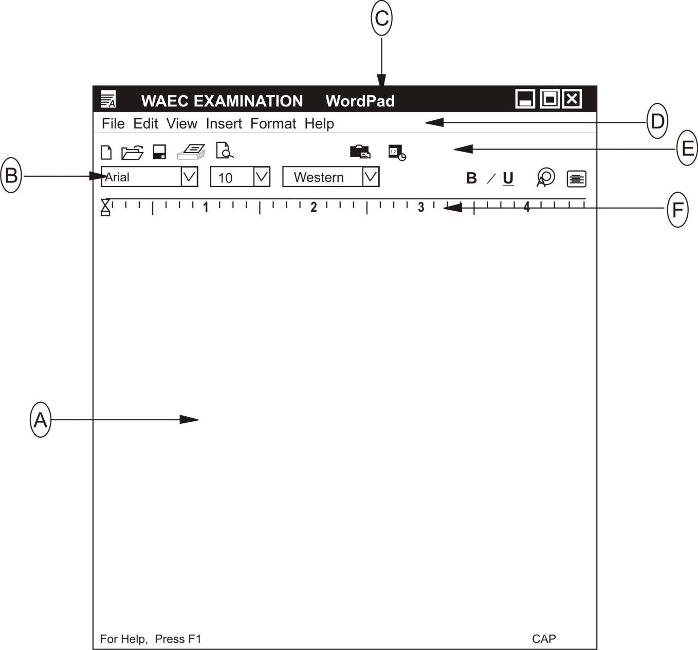

* 1. What is the name of the application program used to create the above file?

............................................................................................................[1 mark]

* 1. Give the file name of the application program above

...........................................................................................................[1 mark]

* 1. Name the parts labelled **A, B, C, D, E** and **F** in the diagram

* + - 1. .................................................................................................................
      2. .................................................................................................................
      3. .................................................................................................................
      4. .................................................................................................................
      5. .................................................................................................................
      6. .................................................................................................................

* 1. State the functions for B and C in (a) above.

B ...................................................................................................................

...............................................................................................................................

............................................................................................................................. ..

...............................................................................................................................

[2 marks]

C ...................................................................................................................

............................................................................................................................. ..

...............................................................................................................................

............................................................................................................................. ..

[2 marks]

(b) List the steps (*in the right order*) involved in switching on a personal computer system

...............................................................................................................................

............................................................................................................................. ..

............................................................................................................................... ............................................................................................................................. ..

...............................................................................................................................

............................................................................................................................. ..

.

[6 marks]

**(c) Identify the following ICT tools:**

(i)

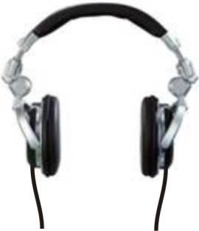 .................................................

(ii)

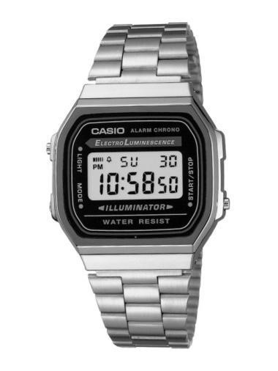 ..............................................

(iii)

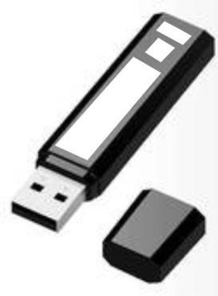 .............................................

[6 marks]

SECTION B

[36 marks]

Answer **three** questions **only** from this section

1. (a) What is:

(i) Input device:

............................................................................................................................. ...................

................................................................................................................................................

............................................................................................................................. ...................

............................................................................................................................. ..................

................................................................................................................................................

[3 marks]

(i) Output device:

............................................................................................................................................ ....

............................................................................................................................ ....................

............................................................................................................................. ...................

...............................................................................................................................................

............................................................................................................................. ...................

[3 marks]

(b) Classify the following into **either** input **or** output device in the table below:

* + - * 1. Microphone;
        2. Joystick;
        3. Webcam;
        4. Plotter;
        5. Scanner; (vi) Mouse.

INPUT DEVICE OUTPUT DEVICE

.................................................................. ........................................................................

.................................................................. ........................................................................

.................................................................. ........................................................................

.................................................................. ........................................................................

.................................................................. ........................................................................

................................................................... ........................................................................

................................................................... ........................................................................

.................................................................. ........................................................................

1. (a) Explain the term *desktop* as used in the personal computer environment

................................................................................................................................ .................... ............................................................................................................ ........................................

............................................................................................................................. .......................

....................................................................................................................................................

............................................................................................................................. .......................

[3 marks]

(b) List **three** areas of learning where information and communication technology tools can be integrated

............................................................................................................................. .......................

............................................................................................................................. .......................

....................................................................................................................................................

............................................................................................................................. .......................

....................................................................................................................................................

[3 marks]

(c) List **two** tools on the formatting toolbar of a word processing application

....................................................................................................................................................

............................................................................................................................. .......................

......................................................................................................................................... ...........

[2 marks]

(d) State **two** benefits associated with the use of information and communication tools in teaching and learning

............................................................................................................................. .......................

....................................................................................................................................................

............................................................................................................................. .......................

....................................................................................................................................................

............................................................................................................................. .......................

............................................................................................................................. ....................... ...................................................................................................... .............................................. ............................................................................................................................. .......................

[4 marks]

1. (a) (i) What is *internet*?

.................................................................................................................................. ..................

.............................................................................................................. ......................................

............................................................................................................................. .......................

.................................................................................................................................................... ............................................................................................................................. .......................

[3 marks]

(ii) List four uses of the internet

............................................................................................................................. .......................

....................................................................................................................................................

............................................................................................................................. .......................

.............................................................................................................................................. ......

.......................................................................................................................... ..........................

............................................................................................................................. .......................

....................................................................................................................................................

............................................................................................................................. .......................

....................................................................................................................................................

............................................................................................................................. .......................

[4 marks]

(b) (i) What is a *web browser*?

............................................................................................................................. .......................

....................................................................................................................................................

............................................................................................................................. .......................

............................................................................................................................. .......................

................................................................................................ ....................................................

[3 marks]

(ii) Give two examples of a *web browser*?

............................................................................................................................. .......................

............................................................................................................................. .......................

....................................................................................................................................................

............................................................................................................................. .......................

....................................................................................................................................................

[2 marks]

5. Explain the following terminologies:

1. Cell .........................................................................................................................................

............................................................................................................................. .......................

....................................................................................................................................................

............................................................................................................................. .......................

............................................................................................................................. .......................

* 1. marks]

1. Column: ............................................................................................................................

............................................................................................................................. .......................

....................................................................................................................................................

............................................................................................................................. .......................

............................................................................................................................... .....................

....................................................................................................................................................

* 1. marks]

1. Row ............................................................................................................................

....................................................................................................................................................

............................................................................................................................. .......................

.................................................................................................................................... ................

................................................................................................................ ....................................

* 1. marks]

1. Graph ............................................................................................................................. .........

....................................................................................................................................................

............................................................................................................................. .......................

................................................................................................................................ ....................

............................................................................................................ ........................................

* 1. marks]

**April 2011**

**INFORMATION AND COMMUNICATION TECHNOLOGY 2**

## SOLUTIONS

**ESSAY**

**1. (a) (i)** WordPad

* 1. WAEC EXAMINATION

* 1. A. Document Area or Text Area

* 1. Formatting Toolbar
  2. Title bar
  3. Menu bar

* 1. Standard toolbar
  2. Ruler

**(iv) Functions of B. (Formatting Toolbar) -** (i) To change the font style

* 1. To change the font size
  2. To change the font colour
  3. To bold font (or reverse it)
  4. To change font to italics (or reverse it)
  5. To underline font
  6. To insert bullets
  7. To align text to the right / left / centre

**Functions of C. (Title Bar)**

* 1. It shows / displays the title of the document
  2. It shows / displays the icon of the application program
  3. It shows / displays the name of the application program
  4. It shows / displays the minimize, maximize and close command buttons
  5. It can be used to resize the window
  6. It can be used to move / drag the window around

**(b) The steps (*in the right order*) involved in switching on a personal computer system**

(i) Check the power cables connected to the system unit and monitor (ii) Check the main socket connection.

(iii) Make sure there is no floppy disk in the floppy drive (iv) Press the power button on the system unit.

(v) Press the power button on the monitor

**(c) Identification of the following ICT tools:**

### (i)

 Headphone or earphone

### (ii)

 Digital watch

(iii)

 Pen drive or Flash memory/drive

1. **(i) Input device**

**A** device that allows the user to feed /put data into a computer **Or**:

A component or peripheral device used to enter information into a computer **Or**:

A hardware component that enables users to interact with a computer **Examples** are keyboard, mouse, joystick, scanner, etc

**(ii) An output device**

Any device that is capable of producing information from binary data that it receives from the CPU.

**Or**:

Any device capable of displaying information from a computer

**Examples** are printers, plotters, projectors, video displays, computer speakers, and synthesizers

**(b)**

|  |  |
| --- | --- |
| **INPUT DEVICE** | **OUTPUT DEVICE** |
| Microphone | Plotter |
| Joystick |  |
| Webcam |  |
| Scanner |  |
| Mouse |  |

1. **(a)** ***Desktop* as used in the personal computer environment**

The background image of a display screen, on which windows, icons, and other graphical items appear.

**Or**:

A display on a computer screen comprising background and icons representing equipment, programs, and files

The windows desktop is the environment where all your work on the computer takes place.

Some features of the desktop screen includes: Start button, Taskbar, Wall paper, Notification

area, Mouse pointer etc.

**(b)** **Areas of learning where information and communication technology tools can be** **integrated**

* + 1. Agriculture
    2. Medicine
    3. Geology
    4. Communications
    5. Education
    6. Business accounting
    7. Music

**(c) Tools on the formatting toolbar of a word processing application**

* + - Bold,
    - Italic,
    - Underline,
    - Font size list,
    - Font type list,
    - Alignment (Right, Centre, Left, Justify)

**(d) Benefits associated with the use of information and communication tools in teaching and learning**

* + 1. They enable us to perform complex calculations.
    2. Lectures can be conducted using LCD projectors to beam lecture notes onto large screens
    3. They enable us to share knowledge thus using mobile phones, radio and the internet. (iv) They enable us to access information using the internet or educational CDs like Microsoft Encarta

(v) They enable us to store large amounts of information on a portable medium, such flash memory, compact disk, digital versatile disc (DVD), etc

1. **(a)** **Internet**

The Internet is a worldwide system of interconnected computer networks.

**Or**

The internet is an international computer network made up of thousands of networks linked together.

**Or**:

A global (or giant) computer network linking smaller computer networks worldwide

**(b) Uses of the Internet**

(i) To search for information on various topics, such as new, weather, sports, etc (ii) To communicate with others through email, chatting services, phone calls, etc.

* + 1. Countries use it for internal relations.
    2. For business / commercial activities, such as online banking, job search, buying and selling, advertising etc
    3. For research / studies or surveys
    4. For educational purposes, such as long distance education (online programmes), project writing, etc
    5. For entertainment, such as watching movies, sports, etc.
    6. For social networking through websites such as faceboo, twitter, hi5, myspace, etc.
    7. It provides access to services such as such as online banking, job seeking, and purchasing tickets for your favorite movies etc.

**(c) (i) A web browser**

An application program used to browse the Internet or view web pages.

**(ii) Examples of web browser** (i) Netscape Navigator,

* 1. Opera, Safari,
  2. Internet Explorer,
  3. Mozilla Firefox,
  4. Slim,
  5. Google Chrome

1. **Explanation of the following terminologies:**

**(a) Cell**

* + - A rectangular box in a worksheet of a spreadsheet program, such as Excel
    - It is a box in which one can enter a single piece of data
    - It is the intersection of a row and column in a worksheet
    - It is identified by the letter of the column and the number of the row
    - The cell can hold 3 types of data – text, a number (or numeric value) or a formula

**(b) Column:**

* + - A vertical line of cells (boxes) in a worksheet of a spreadsheet program ▪ It is labelled with a letter
    - A column has the same width.

**(c) Row**

* + - A horizontal line of cells (boxes) in a worksheet of a spreadsheet program
    - It is labelled with a number
    - A row has the same height

**(d) Graph**

A chart and its associated sample data in a table called data

**Or**

* + - A visual representation of worksheet data

* + - Graphs / charts make it easier to understand the data in a worksheet
    - Some examples of graphs are
    - Pie graphs, bar graphs, line graphs, scatter graphs, column graphs, etc