**2011 Basic Design And Technology (Pre Technical Skills ) – Paper Two**

1. (a) State three characteristics of a good plain seam.

(b) State three causes of food spoilage.

(c) Complete the table below by filling in the blank spaces

|  |  |  |
| --- | --- | --- |
| **Colour** | **Association in Nature** | **Symbolism** |
| Example:  Red | Blood | Danger |
|  | Sky |  |
| White |  |  |
|  |  | Decay |
|  | Past history | Mourning |

(d) The headmaster of your school has asked you to design and construct a Kumasi Ventilated Improved Pit (KVIP) toilet for the school  
(i) List three building materials you will use for making the structure  
(ii) List four tools for constructing the walls.

2.(a) (i) Explain the term draw filing  
(ii) Sketch the triangular file  
(iii) Label any two parts on the sketch in (a)(ii) above

b. 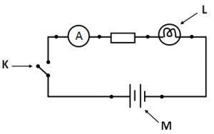

(i) Identify the items labeled K, L, M in the circuit diagram above.

(ii) List two examples of electrical conductors

(c) (i) State two precautions to be taken when cutting with a hacksaw

(ii) List three driving tools

3. Figure 1 is a pictorial drawing of a flagstand

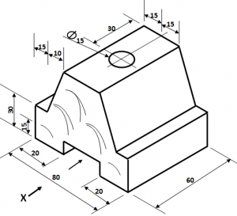

(a) Draw full size the following views in first angle projection

(i) front elevation in the direction of arrow X;  
(ii) plan

(b) List one specific tool for each of the following processes:  
(i) marking-out the tenon  
(ii) cutting the tenon

(c) State one finish for the flagstand

(d) (i) Sketch in pictorial drawing a brick hammer  
(ii) Label any two parts on the sketch in (d)(i)

4. (a) Explain the following terms:  
(i) pinning  
(ii) curing

(b) (i) Make a freehand sketch of an outside calipers  
(ii) State one use of the outside calipers

(c) State one use of the following measuring tools:  
(i) steel rule  
(ii) tape measure

(d) State two methods each for maintaining the tools stated in (c) above.

(e) Copy and complete the table below

|  |  |
| --- | --- |
| **Process** | **One tool used** |
| (i) Plumbing a wall |  |
| (ii) Checking corners of a wall |  |
| (iii) Measuring aggregates |  |
| (iv) Checking courses of a wall |  |
| (v)  Picking and spreading mortar |  |
| (vi) Mixing mortar |  |

# Paper Two – Answers

1. (a) State three characteristics of a good plain seam.  
Firm stitched and strong  
Well neatened  
Suitable for the fabric.

(b) State three causes of food spoilage.  
Enzyme action  
Moulds activity  
Yeasts activity  
Bacteria activity  
Insect infestation

(c) Complete the table below by filling in the blank spaces

|  |  |  |
| --- | --- | --- |
| **Colour** | **Association in Nature** | **Symbolism** |
| Example:  Red | Blood | Danger |
| Blue | Sky | Peace / Love / Harmony / |
| White | Cotton, Snow, Wool | Victory / Purity / Righteousness / Innocence |
| Brown | Earth / Mud | Decay |
| Black | Past history | Mourning |

(d) The headmaster of your school has asked you to design and construct a Kumasi Ventilated Improved Pit (KVIP) toilet for the school

(i) List three building materials you will use for making the structure  
• Sand,  
• stones,  
• iron rods,  
• wood,  
• cement,  
• roofing sheet,  
• nails

(ii) List four tools for constructing the walls.

? hand trowel  
? spirit level  
? float  
? gauge rod  
? straight edge  
? mortar board  
? line and pins  
? brick hammer / comb hammer  
? bolster and club hammer  
? builder’s square

2. (a) (i) Explain the term draw filing  
A technique used for producing smooth, square edges, especially on pieces of metal. The process works by moving any type of single cut file forwards and backwards along the length of the material’s edge

(ii) Sketch the triangular file

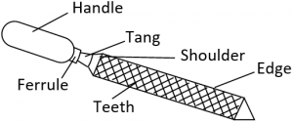

(iii) Label any two parts on the sketch in (a)(ii) above.  
• Handle  
• Tang  
• Shoulder  
• Ferrule  
• Edge  
• Teeth

b.(i) Identify the items labeled K, L, M in the circuit diagram above.  
K – Switch / Key  
L – Bulb  
M – Battery

(ii) List two examples of electrical conductors  
• Copper  
• Gold  
• Silver  
• Aluminium  
• Molybdenum  
• Zinc  
• Nickel  
• etc

(c) (i) State two precautions to be taken when cutting with a hacksaw  
• Tie / cover long or loose hair back to prevent entanglement  
• Remove all kinds of jewellery to prevent snagging.  
• Wear protective clothing to protect the skin  
• Wear protective gloves to protect the hands.  
• Use ear protectors such as plugs or mufflers to protect the ear.  
• Wear goggles / safety glasses to protect the eyes  
• Select correct blade for material being cut  
• When cutting, use steady strokes directed away from you.  
• Do not apply too much pressure on the blade to prevent breaking  
• Make sure the material to be cut is securely fastened

(ii) List three driving tools  
• Claw hammer  
• Screw driver  
• Nail Punch  
• Crow bar / pinch bar  
• Tower pincer

(a) Draw full size the following views in first angle projection

(i) front elevation in the direction of arrow X;

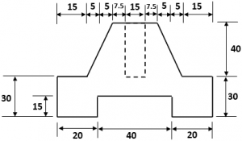

ii) plan

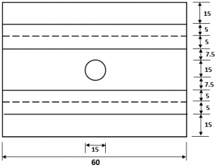

(b) List one specific tool for each of the following processes:  
(i) marking-out the tenon  
? Marking knife  
? Pencil  
? Try-square  
? Marking gauge  
? Rule / Tape measure

(ii) cutting the tenon  
? Try square  
? Marking gauge / mortise gauge  
? Pencil / Marking knife  
? Tenon Saw  
? Mallet  
? Bevel-edged chisel / firmer chisel

(c) State one finish for the flagstand  
? Varnish  
? Wax  
? Lacquer  
? Oil paint

(d) (i) Sketch in pictorial drawing a brick hammer

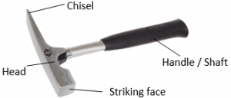

4. (a) Explain the following terms:  
(i) pinning  
Pinning refers to the clogging of the file teeth with pins, which are material shavings. These pins cause the file to lose its cutting ability and can scratch the workpiece.  
OR  
Pinning occurs when metal pieces, known as pins, get stuck within the teeth of the file. The pins then reduce the effectiveness of the file and also scratch the workpiece.

(ii) curing  
Curing of concrete is the provision of adequate moisture, temperature, and time to allow the concrete to achieve the desired properties for its intended use  
OR  
Curing is the process of maintaining satisfactory moisture content and temperature in freshly cast concrete for a definite period of time immediately following placement

(b) (i) Make a freehand sketch of an outside callipers

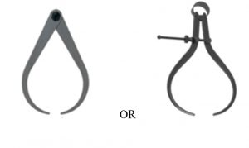

(ii) State one use of the outside callipers  
Outside callipers are used to measure thicknesses or outside diameters of objects.

(c) State one use of the following measuring tools:  
(i) steel rule  
• Marking out on a metal plate  
• Taking measurements

(ii) tape measure  
• Taking measurements  
• Setting out  
• marking out

(d) State two methods each for maintaining the tools stated in (c) above.  
(i) maintaining steel rule  
• Keep it clean and dry  
• Use it for its intended purpose only  
• Avoid bending it  
• Avoid scratching its surface

(ii) maintaining tape measure  
• After using, roll back into its case  
• Keep in a tool box  
• Keep it clean and dry  
• Use it for its intended purpose only

(e) Copy and complete the table below

|  |  |
| --- | --- |
| **Process** | **One tool used** |
| (i) Plumbing a wall | Plumb line  Spirit level |
| (ii) Checking corners of a wall | Builder’s square |
| (iii) Measuring aggregates | Gauge box |
| (iv) Checking courses of a wall | Gauge rod |
| (v)  Picking and spreading mortar | Trowel |
| (vi) Mixing mortar | Shovel  spade |

**2011 Basic Design And Technology (Pre Technical Skills ) – Paper One**

1. Which of the following is a neatening stitch?

A. overcasting  
B. feather  
C. chain  
D. stem

2. Green leafy vegetables and sea foods provide the body with

A. minerals  
B. proteins  
C. vitamins  
D. fats

3. Which of the following is a dry method of cooking?

A. boiling  
B. baking  
C. stewing  
D. steaming

4. The lightness or darkness in a drawing is the

A. hue  
B. shade  
C. tint  
D. tone

5. Any two primary colours mixed together in equal proportions produce a

A. complementary colour  
B. neutral colour  
C. secondary colour  
D. tint colour

6. Which of the following lines is used for showing visible outlines?

A. short dashes  
B. long chain  
C. thick continuous  
D. thin continuous

7. Figure 1 illustrates the principle of

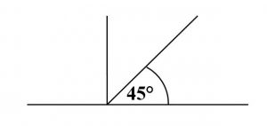

A. oblique axes  
B. perspective axes  
C. isometric axes  
D. orthographic axes

8. From the following options, select the designing media mixed with water

A. charcoal  
B. crayon  
C. chalk pastel  
D. poster colour

9. In design analysis, the size of the unit is considered under

A. cost  
B. ergonomics  
C. safety  
D. function

Figure 2 is a block. Use it answer questions 10 and 11

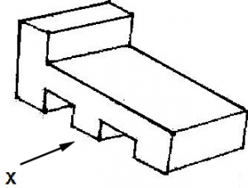

10. Which of the following represents the front elevation in the direction of arrow X?

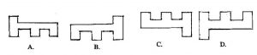

11. The plan is represented by

2011 bece past questions pretech q11

12. The two methods of drawing orthographic views are

A. first angle and second angle  
B. first angle and third angle  
C. second angle and third angle  
D. second angle and fourth angle

13. A vertical line is associated with

A. movement  
B. rest  
C. stability  
D. uncertainty

14. Which of the following situations is an indirect risk to a small business?

A. flood  
B. fire  
C. inflation  
D. theft

15. The factors to consider when setting up a sewing business includes

A. capital, location and personal needs  
B. capital, location and equipment  
C. raw materials, market and business risks  
D. raw materials, personal needs and demand

16. Which of the following is not a method of temporary termination of a wall?

A. toothing  
B. racking  
C. Indent  
D. bonding

17. Which of the following is not a mechanical property of metals?

A. brittleness  
B. ductility  
C. corrosion  
D. malleability

18. The head of a brick hammer is made of

A. high carbon steel  
B. mild steel  
C. cast iron  
D. medium carbon steel

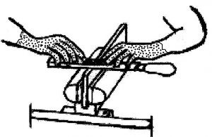

19. The operation shown in the sketch above is

A. cross filing  
B. draw filing  
C. smooth filing  
D. rough filing

20. The neutral wire has a colour code

A. black  
B. red  
C. yellow  
D. grey

21. Electrical appliances are usually plugged to the electricity mains through

A. switches  
B. lamp holders  
C. socket outlets  
D. ceiling rose

Use figure 3 to answer questions 22 and 23

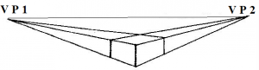

22. The parts VP1 and VP2 are called

A. viewing points  
B. vanishing points  
C. viewing planes  
D. vanishing planes

23. The object is drawn in

A. oblique  
B. isometric  
C. one point perspective  
D. two point perspective

24. Which of the following is not a fastener?

A. rivets  
B. screws  
C. soldering bits  
D. bolts and nuts

25. The plastic used for making an egg box is

A. acrylic  
B. polystyrene  
C. nylon  
D. polythene

26. Which of the following instruments are most suitable for dividing a circle into equal parts  
I. set square  
II. protractor  
III. a pair of compasses

A. I and II only  
B. I and III only  
C. II and III only  
D. I, II and III

27. Polyvinyl acetate is a type of a/an

A. aggregate  
B. adhesive  
C. abrasive  
D. finish

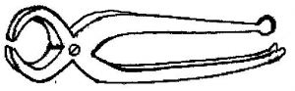

28. The tool shown above is a

A. crowbar  
B. pincers  
C. screw driver  
D. claw hammer

29. To avoid vertical straight joint in a wall, introduce a

A. bat  
B. block  
C. batten  
D. brick

30. The lines drawn below are  
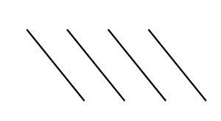

A. tangential  
B. horizontal  
C. vertical  
D. inclined

**Paper One – Answers**

1. A. overcasting
2. A. minerals
3. B. baking
4. D. tone
5. C. secondary colour
6. C. thick continuous
7. A. oblique axes
8. D. poster colour
9. B. ergonomics
10. A.
11. A.
12. B. first angle and third angle
13. C. stability
14. C. inflation
15. B. capital, location and equipment
16. D. bonding
17. C. corrosion
18. D. medium carbon steel
19. B. draw filing
20. A. black
21. C. socket outlets
22. B. vanishing points
23. D. two point perspective
24. C. soldering bits
25. B. polystyrene
26. C. II and III only
27. B. adhesive
28. B. pincers
29. A. bat
30. D. inclined