**2012 BECE Mathematics (Maths) Past Questions Paper One**

1. If P = {2, 3, 5, 7}and Q = {2, 4, 6, 8}, find P∩Q
2. {2}
3. {3}
4. {4}
5. {5}
6. Which of the following numbers is an integer?

A.

B.

C. 0.5

D. 1

1. Find the Lowest Common Multiple (LCM) of 22× 3 × 52 and 23 × 32 × 5

A. 22 × 3 × 5

B. 22 × 33 × 52

C. 23 × 3 × 5

D. 23 × 32 × 52

1. How many diagonals are in a rectangle?

A. 1

B. 2

C. 3

D. 4

1. Simplify – 4 (3 – 5) + 10 – 3 (7 + 4) + 30

A. - 1

B. 15

C. 56

D. 65

1. An iron rod 15 m long is divided into 12 equal parts. How long is each part?

A. 0.80 m

B. 1.25 m

C. 1.50 m

D. 3.00 m

1. Convert 42 to a base two numeral.

A. 1001010two

B. 1010010two

C. 1010100two

D. 101010two

1. Simplify

A. 57

B. 58

C. 59

D. 513

1. A tank contains 400 litres of water. If 100 litres is used, what percentage is left?

A. 25%

B. 30%

C. 40%

D. 75%



***NOT DRAWN TO SCALE***

4 cm

3 cm

**A**

**B**

**C**

Triangle ABC is a right-angled triangle. Find the length of AC.

A. 1 cm

B. 5 cm

C. 7 cm

D. 12 cm

1. Arrange the following fractions in descending order of magnitude:

A.

B.

C.

D.

1. Find the image of 3 under the mapping, *x* → 10 – 2*x*

A. 4

B. 5

C. 8

D. 16

1. Simplify

A.

B.

C.

D.

1. If 2*x* = 5(*x* – 2) + 7, find the value of *x*

A. –

B. –1

C. 1

D.

The table below shows the day and night temperatures of a town during a week.

*Use it to answer Questions* **15** *and* **16**

|  |  |  |
| --- | --- | --- |
| Week day | Temperatures (°C) | |
| Day | Night |
| Monday  Tuesday  Wednesday  Thursday  Friday  Saturday  Sunday | 33  29  32  34  32  30  30 | 24  25  23  26  24  24  25 |

1. Find, correct to **one** decimal place, the average day temperature for the week

A. 24.4 °C

B. 30.2 °C

C. 31.4 °C

D. 32.2 °C

1. On which day was the change in temperature the **least**?

A. Monday

B. Saturday

C. Sunday

D. Tuesday

1. A box contains 30 identical balls of which 16 are white and the rest yellow. If a girl picks a ball at random from the box, what is the probability that it is a yellow ball?

A.

B.

C.

D.

1. Find the truth set of (x + 3) ≤ 2x – 1

A. {x: x ≤ –3}

B. {x: x ≤ –1}

C. {x: x ≥ 1}

D. {x: x ≥ 3}

1. The perimeter of the figure below is 71 cm. Find the diameter of the semi-circular portion.

[Take = π]

24 cm

25 cm

***NOT DRAWN TO SCALE***

A. 1.0 cm

B. 3.5 cm

C. 7.0 cm

D. 14.0 cm

1. Simplify

A.

B.

C.

D.

1. Kojo is 20% heavier than Afua. If Kojo weighs 6 kg, what is Afua’s weight?

A. 4.8 kg

B. 5.0 kg

C. 6.0 kg

D. 7.2 kg

1. Find the volume of a cylinder of height 3 cm and radius 2 cm.

A. 6π cm3

B. 12π cm3

C. 18π cm3

D. 24π cm3

1. Given the points S(5, -2) and T(3, 2), calculate the gradient of the line ST.

A. - 2

B. -

C.

D. 2

1. Kofi invested GH¢ 150,000 at 2.5% per annum simple interest. How long will it take this amount to yield an interest of GH¢11,250.00?

A. 2 years

B. 3 years

C. 4 years

D. 5 years

1. Express 3.75 as a mixed fraction.

A.

B.

C.

D.

1. A map is drawn to the scale 1:100,000. What distance in kilometres is represented by 5 cm on the map?

A. 0.5 km

B. 5.0 km

C. 50.0 km

D. 500.0 km

1. Given that **r** = and **s** = , find **r** – 2**s**

A.

B.

C.

D.

1. Esi went to the market and bought 500 g of meat, 850 g of fish and 900 g of eggs. What is the total weight of the items she bought in kilograms?

A. 2.20 kg

B. 2.25 kg

C. 2.35 kg

D. 22.50 kg

1. A watch gains minutes per hour. What is the total time gained from 12 noon to 12 midnight in a day?

A. 9 minutes

B. 15 minutes

C. 18 minutes

D. 36 minutes

1. A printing machine prints 600 books in 3 hours. How many books will the machine print in 5 hours?

A. 360 books

B. 1000 books

C. 1800 books

D. 3000 books

1. The bearing of Atoru from Busase is 275°. What is the bearing of Busase from Atoru?

A. 180°

B. 175°

C. 095°

D. 075°

1. In a class of 24 pupils, 10 study French only and 8 study English only. If each pupil studies at least one of the two subjects, how many study English?

A. 12

B. 14

C. 16

D. 18

1. Convert 84 to a base five numeral.

A. 4130five

B. 3014five

C. 314five

D. 114five

1. In the diagrams below, triangle A1B1C1 is an enlargement of triangle ABC. Determine the scale factor.

***NOT DRAWN TO SCALE***

3 cm

4 cm

**C**

**B**

**A**

6 cm

8 cm

**A1**

**B1**

**C1**

A. 0.50

B. 0.75

C. 2.00

D. 4.00

1. Find the least number that must be added to 308 to make it divisible by 19.

A. 4

B. 7

C. 15

D. 18

1. In a school of 940 pupils, the number of girls exceeds the number of boys by 150. How many girls are there in the school?

A. 620

B. 545

C. 470

D. 395

1. Which of the following fractions is equivalent to ?

A.

B.

C.

D.

In the diagram below, line PQ is parallel to RS and UV is a line drawn through PQ and RS.

*Use the diagram to answer Questions* **38** *and* **39***.*

*a*

*b*

*c*

35°

**S**

**Q**

**V**

**U**

**R**

**P**

***NOT DRAWN TO SCALE***

1. Find angle *a.*

A. 35°

B. 55°

C. 135°

D. 145°

1. Angle ***b*** and angle ***c*** are

A. alternate angles

B. vertically opposite angles

C. corresponding angles

D. interior opposite angles

1. Expand ­­ – *x*(3 – 2*x*)

A. –2*x*2 – 3*x*

B. 2*x*2 – 3*x*

C. –2*x*2 + 3*x*

D. 2*x*2 + 3*x*

## OBJECTIVE TEST

SOLUTIONS

1. A. {2}
2. D. 1
3. D. 23 × 32 × 52
4. B. 2
5. B. 15
6. B. 1.25 m
7. D. 101010two
8. C. 59
9. D. 75%
10. B. 5 cm
11. B.
12. A. 4
13. D.
14. C. 1
15. C. 31.4 °C
16. D. Tuesday
17. B.
18. C. {x: x ≥ 1}
19. D. 14.0 cm
20. C.
21. B. 5.0 kg
22. B. 12π cm3
23. A. - 2
24. B. 3 years
25. D.
26. B. 5.0 km
27. B.
28. B. 2.25 kg
29. C. 18 minutes
30. B. 1000 books
31. C. 095°
32. B. 14
33. C. 314five
34. C. 2.00
35. C. 15
36. B. 545
37. B.
38. D. 145°
39. C. corresponding angles
40. B. 2*x*2 – 3*x*

**2012 BECE Mathematics (Maths) Past Questions Paper Two**

1. **(a)** Evaluate , leaving the answer in standard form.

**(b)** An amount of GH¢4,200.00 was shared between Aba and Kwame. If Aba had of the amount,

**(i)** how much did Kwame receive?

**(ii)** what percentage of Aba’s share did Kwame receive?

**(c)** Find the value of x in the diagram below.

4*x* – 30

2*x* + 30

*x* + 10

1. **(a)** A car consumes a gallon of petrol for every 30 km drive. The driver of the car set out on a journey of 420 km with 10 gallons of petrol in the fuel tank.

**(i)** How many more gallons of petrol will be needed to complete the journey?

**(ii)** Find the cost of the petrol used for the journey of 420 km if a gallon of petrol costs GH¢5.50

**(b)** The average number of spectators at a football competition for the first five days was 3,144. The attendance on the sixth day was 3,990. Find the

**(i)** The total attendance on the first five days

**(i)** The average attendance for the 6 days

**(c)** The area enclosed by a square garden is 121 m2. What is the distance around the garden?

1. **(a)** The table below shows the number of students who scored more than 80% in the listed subjects

|  |  |
| --- | --- |
| Subject | Number of students |
| Biology  Physics  Chemistry  French  Geography  History | 26  30  32  38  24  30 |

**(i)** Draw a pie chart for the distribution

**(ii)** What is the probability that a student chosen at random from the distribution offers Chemistry?

**(b)** A woman bought 210 oranges for GH¢7.50. She sold all of them at 3 for 15 Gp. Find the

**(i)** total selling price of the oranges

**(ii)** percentage profit

1. The marks scored by some students in a Mathematics test are as follows:

3 3 5 6 3 4 7 8 3 4

5 4 7 4 3 7 4 6 4 8

4 5 6 3 8 4 5 6 4 5

1. Construct a frequency distribution table for the scores.

**(b)** Using the table, find for the distribution, the

**(i)** mode;

**(ii)** mean, correct to one decimal place

**(iii)** median

1. **(a)** **(i)** Find the least Common Multiple (L.C.M.) of 9, 18 and 16.

**(ii)** Arrange in **ascending** order of magnitude

**(b)** Using a ruler and a pair of compasses only,

**(i)** construct a triangle *PQR* with length *PQ* = 10 cm, angles *QPR* = 45° and *PQR* = 60°.

**(ii)** Construct the perpendicular bisectors of *PR* and *RQ* to meet at *T*.

**(iii)** Measure the length of *TP*.

1. **(a)** **(i)** Using a scale of 2 cm to 1 unit on both axes, draw two perpendicular axes O*x* and O*y* on a graph sheet.

**(ii)** Mark on the same graph sheet, the *x*-axis from -5 to 5 and *y*-axis from -6 to 6.

**(iii)** Plot the points *P*(4, 2), *Q*(2, 5) and *R*(2, 2). Join the points *P*, *Q*, *R* to form a triangle *PQR*

**(iv)** Using the *x*-axis as a mirror line, draw the image *P*1*Q*1*R*1 of the triangle *PQR* such that *P*→*P*1, *Q*→*Q*1, *R*→*R*1

**(v)** Write down the coordinates of *P*1, *Q*1 and *R*1.

**(vi)** Translate triangle *PQR* by the vector such that *P*→*P*2, *Q*→*Q*2, *R*→*R*2

**(vii)** Label the vertices of triangle *P*2*Q*2*R*2

SOLUTIONS

1. **(a)**

**Method 1 (Converting to common fractions)**

NB:

Eg,

= (0.035 × 1.02) ÷ 0.00015

= 

= 

= 

= 

= 238 = 2.38 × 102

**1. (a)**

**Method 2 (Converting to whole numbers)**

Multiplying both numerator and denominator by 100000

(to convert to whole numbers)

NB

Multiplying by 100,000 shifts the decimal point 5 places to the right (in both numerator and denominator)



= 

= 

= 238

= 2.38 × 102

**1. (b) (i) Method 1**

**Aba’s share =**  of the amount,

NB:

7 divides (‘goes into’) 4,200 to give 600

**=** 

**=** 5 × GHc 600

= GHc 3,000

Therefore **Kwame’s** share = GHc 4,200 – GHc 3,000

= **GHc 1,200**

1. **Method 2**

**Kwame’s fraction =** 

Therefore **Kwame’s** share **=** 

**=** 2 × GHc 600

= **GHc 1,200**

1. Percentage of Aba’s share that Kwame received

= 

**=** 

**= 40%**

NB:

One complete revolution (circle) = 360°

**1.(c)** (4x – 30°) + (2x + 30°) + (x +10°) = 360°

4x + 2x + x – 30° + 30° + 10° = 360°

7x + 10° = 360°

7x = 360° - 10°

7x = 350°

 **=** 

**x = 50°**

1. **(a) (i) Let g = no. of gallons needed for the entire journey**

**Approach 1** (Equivalent Fractions)

|  |  |  |
| --- | --- | --- |
|  | **Distance (km)** | **Petrol (Gallon)** |
|  | 30 | 1 |
| The entire journey | 420 | g |

From the table above, 

Cross multiplying, we have 

⇒ 

⇒ 

Amount needed for the entire journey = 14 gallons

He already has 10 gallons; therefore he needs **4 gallons more**

**2. (a) (i)**

**Approach 2**  (The rule: If more, less divides …)

If 30 km → 1

Then 420 km → ? (more)

If more, less (i.e., 30) divides; ∴ we have

 = 14

Amount needed for the entire journey = 14 gallons

He already has 10 gallons, therefore he needs **4 gallons more**

**2. (a) (i)**

**Approach 3**  (Equivalent ratios)

30 : 1 = 420 : g

⇒ 

⇒ 30 x g = 420 x 1

⇒ 

⇒ 

Amount needed for the entire journey = 14 gallons

He already has 10 gallons, therefore he needs **4 gallons more**

**2. (a) (ii) Let THE COST OF PETROL USED FOR THE JOURNEY = c**

**Approach 1** (Common Logic)

If 1 gallon → GHc 5.50

Then 14 gallons → 14 × GHc 5.50 = **GHc 77.00**

**Approach 2** (Equivalent Fractions)

|  |  |  |
| --- | --- | --- |
|  | **Petrol (gallons)** | **Cost (GHc)** |
|  | 1 | 5.50 |
| The entire journey | 14 | c |

From the table above, 

Cross multiplying, we have 

⇒ 

Cost of petrol needed for the journey = **GHc 77.00**

**2. (b) (i)**  **Total attendance on first five days** = 5 × average attendance

= 5 × 3144

= **15720 spectators**

**(ii)** Average attendance for the 6 days = = 

**=** 

**= 3285 spectators**

**2. (c)**

121 m2

Area of the square = 121m2

L × L = 121m2

L2 = 121m2

L = 

L = 11 m

121 m2

11m

11m

11m

11m

The distance around the garden (perimeter) = 4 × 11 m

= **44 m**

1. **(a) (i)**

|  |  |  |
| --- | --- | --- |
| **Subject** | **No. of students** | **Angle of sector** |
| Biology | 26 |  |
| Physics | 30 |  |
| Chemistry | 32 |  |
| French | 38 |  |
| Geography | 24 |  |
| History | 30 |  |
| **TOTAL** | **180** | **360°** |

Pie chart showing the number of students who scored more than 80% in the listed subjects

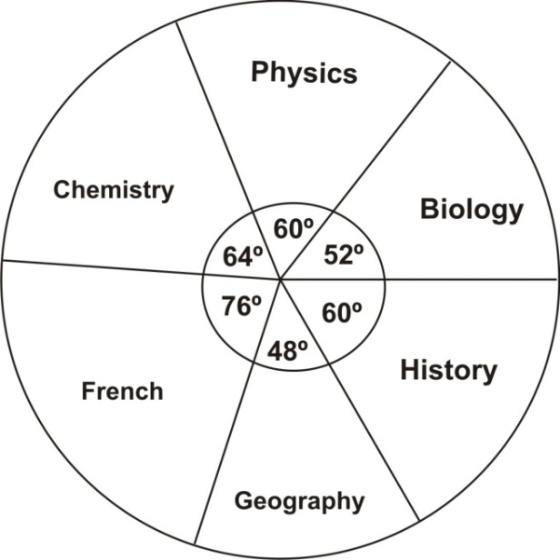

**3 (a) (ii) Probability =** 

**=** 

**=** 

**Approach 2 (using angle of sector)**

**Probability =** 

**=** 

**=** 

**3 (b) (i)**

**Approach 1** (Unitary Approach – the value of one item)

If 3 oranges sell for 15 Gp,

then 1 orange sells for 

hence, 210 oranges would sell for 210 × 5 Gp

= 1050 Gp = GHc 10.50

**Approach 2** (Equivalent Fractions)

|  |  |
| --- | --- |
| **No. of oranges** | **SP (in Gp)** |
| 3 | 15 |
| 210 | y |

From the table above, 

Cross multiplying, we have 

⇒ 

⇒ 

⇒ y = 1050 Gp

= GHc 10.50

**Approach 3**  (The rule: If more, less divides …)

If 3 → 15 Gp

Then 210 → ? (more)

If more, less (i.e., 4) divides; ∴ we have

 ⇒ 

= 1050 Gp = GHc 10.50

**Approach 4**  (Equivalent ratios)

3 : 15 = 210 : y

⇒ 

= 1050 Gp = GHc 10.50

**3. (b) (ii)** Profit = Total SP – Total CP

= GHc 10.50 – GHc 7.50

= GHc 3.00

**Percentage Profit =** 

**=** 

**=** 

**= 40%**

1. **(a) Frequency distribution table**

|  |  |  |
| --- | --- | --- |
| **Mark (x)** | **Tally** | **Frequency (f)** |
| 3 | ~~∕∕∕∕~~ ∕ | 6 |
| 4 | ~~∕∕∕∕~~ ∕∕∕∕ | 9 |
| 5 | ~~∕∕∕∕~~ | 5 |
| 6 | ∕∕∕∕ | 4 |
| 7 | ∕∕∕ | 3 |
| 8 | ∕∕∕ | 3 |

**4. (b) (i) Mode = The mark with the highest frequency = 4**

**(ii) Mean**

|  |  |  |  |
| --- | --- | --- | --- |
| **Mark (x)** | **Tally** | **Frequency (f)** | **fx** |
| 3 | ~~∕∕∕∕~~ ∕ | 6 | 18 |
| 4 | ~~∕∕∕∕~~ ∕∕∕∕ | 9 | 36 |
| 5 | ~~∕∕∕∕~~ | 5 | 25 |
| 6 | ∕∕∕∕ | 4 | 24 |
| 7 | ∕∕∕ | 3 | 21 |
| 8 | ∕∕∕ | 3 | 24 |
|  |  | Σ*f* = 30 | Σ*fx* = 148 |

The mean mark =  =  Mean = 4.9 (correct to 1 d.p.)

**4.(b) (iii) Median**

**Approach1**

Listing all the given marks in ascending order, we have

3,3,3,3,3,3, 4,4,4,4,4,4,4,4, **4, 5**, 5,5,55, 6,6,6,6, 7,7,7, 8,8,8

The middle marks are 4 and 5

∴ The median =  =  = 4.5 or 4

**Approach 2**

The median

= the mark at the ½(Σf+1)th position

⇒ the ½ (30+1)th position

= ½ (31) = 15½th position

The mark at the 15½th position

= the average of the marks at the 15th and 16th positions

=  =  = 4.5 or 4

1. **(a) (i) LCM of 9, 18 and 16**

**Approach 1 (Successive division by prime factors)**

|  |  |  |  |
| --- | --- | --- | --- |
| **2** | **9** | **18** | **16**  NB  2 cannot ‘go into’ 9 without a remainder, therefore, 9 is repeated.  2 ‘into’ 18 = 9,  2 ‘into’ 16 = 8  The process is repeated till we obtain 1 for all.  NB  2 cannot divide (‘go into’) 9 without a remainder, therefore, 9 is repeated.  2 ‘into’ 18 = 9,  2 ‘into’ 16 = 8  The process is repeated till we obtain 1 for all. |
| **2** | 9 | 9 | 8 |
| **2** | 9 | 9 | 4 |
| **2** | 9 | 9 | 2 |
| **3** | 9 | 9 | 1 |
| **3** | 3 | 3 | 1 |
|  | 1 | 1 | 1 |

**The LCM = 2 × 2 × 2 × 2 × 3 × 3**

**= 16 × 9 = 144**

**(a) (i) Approach 2 (Listing multiples)**

9 = {9, 18, 27, 36, 45, 54, 63, 72, 81, 90, 99, 108, 117, 126, 135, **144**, …}

18 = {18, 36, 54, 72, 90, 108, 126, **144**, …}

16 = {16, 32, 48, 64, 80, 96, 112, 128, **144**, …}

Hence the Least Common Multiple **(LCM) = 144**

**5. (a) (ii)**  in ascending order of magnitude

**=** 

**=** 

**=** 

Therefore in ascending order, we have

**5. (b) (i), (ii)**

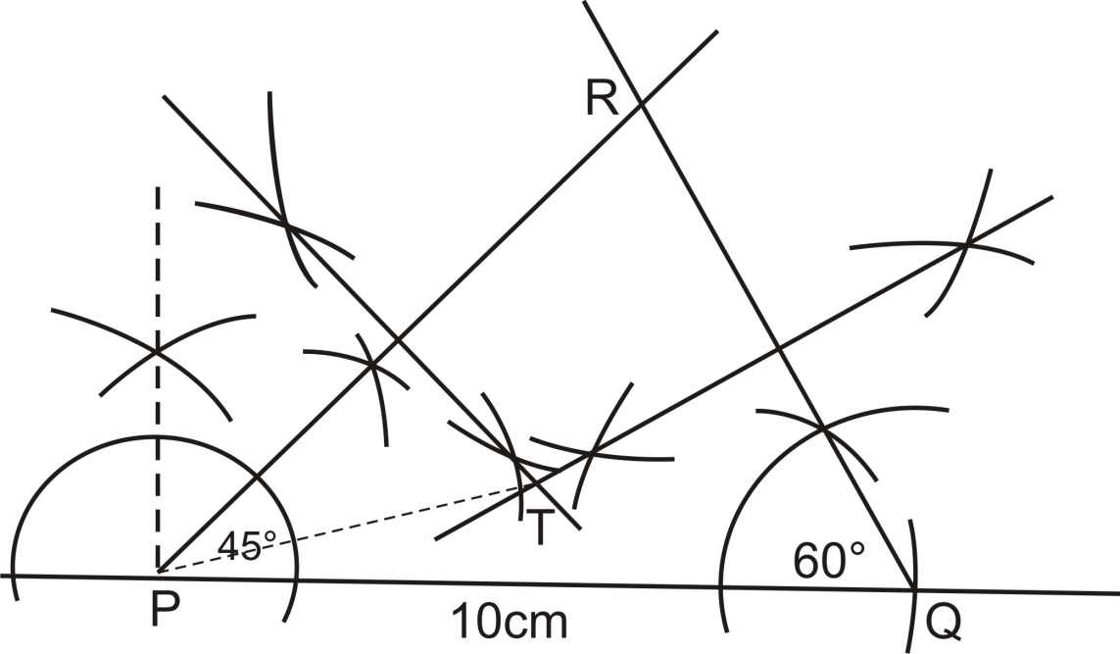

The length of TP = 5.2 cm (approx.)

1. **(a)**

**Approach 1** (By Inspection / Construction)

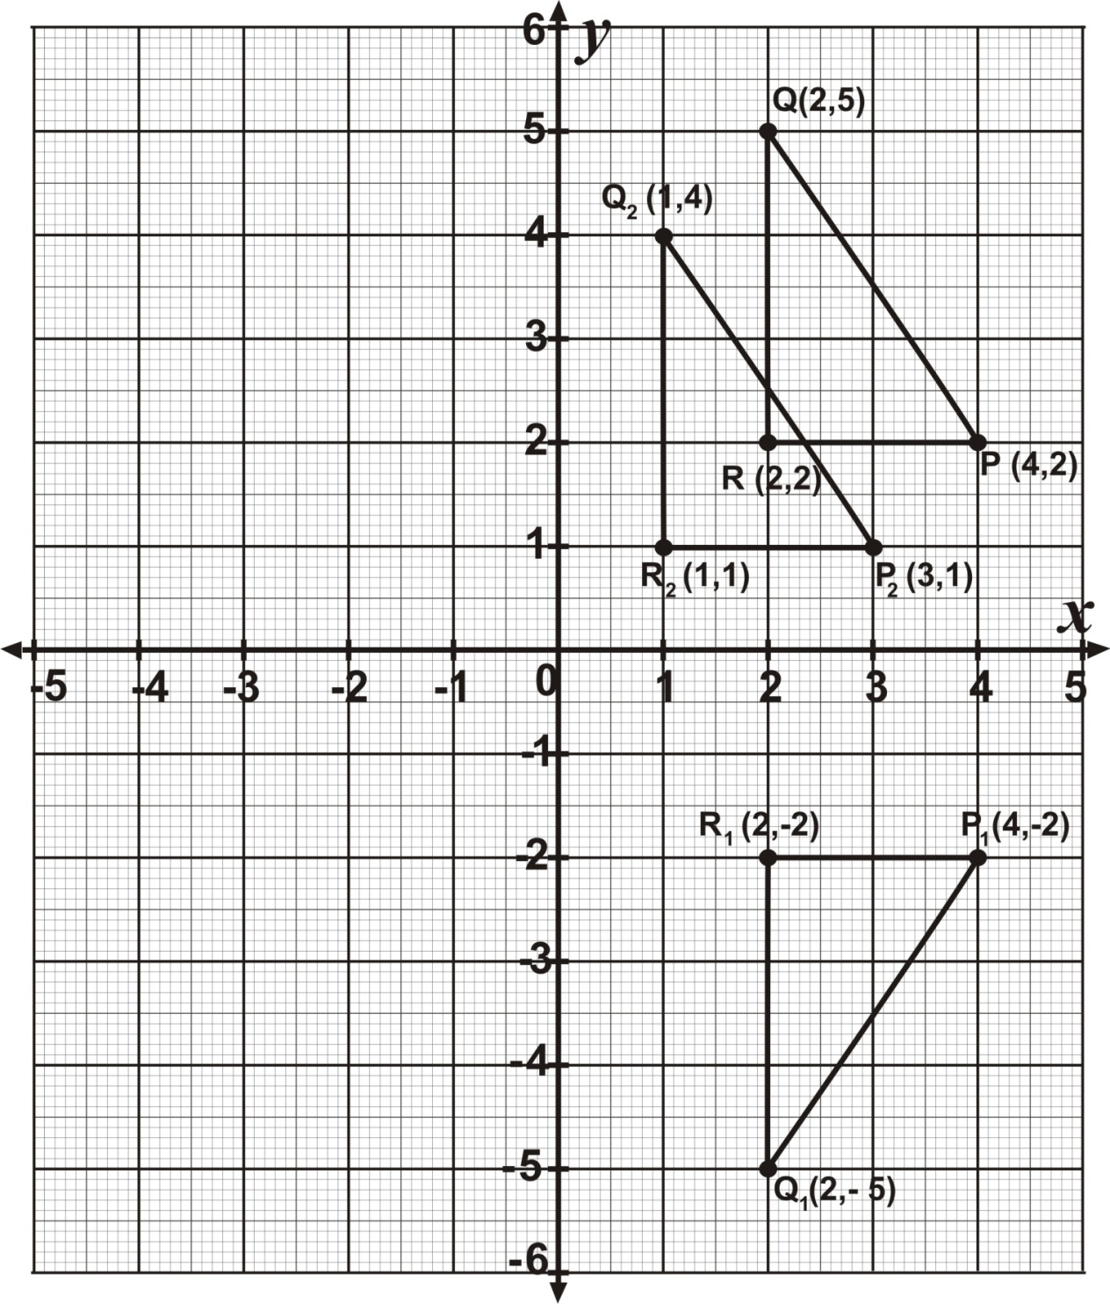

**Approach 2** (The rule / formula)

**(a) (iv)** Reflecting (*x*, *y*) in the x-axis



⇒ 

⇒ 

⇒ 

∴ Plot and join P1(4, -2), Q1(2, -5) and C1(2, -2) as the image of triangle PQR under a reflection in the x- axis

(*as shown in the diagram above*)

**(a) (vi) Translating PQR by vector**

Translating (*x, y*) by vector 









∴ Plot and join P2(3, 1), Q2(1, 4) and R2(1, 1) as the image of triangle PQR under a translation by vector 