**2012 Basic Design And Technology (Pre Technical Skills ) – Paper Two**

1. (a) Ama ate fried fish, kenkey and fresh pepper sauce

Copy and complete in a table what Ama ate into the functional groups of food.

|  |  |
| --- | --- |
| **Food item** | **Functional group** |
| (i)     Fried fish |  |
| (ii)    Kenkey |  |
| (iii)   Fresh pepper sauce |  |

(b) The diagram below is the drawing of a mango

(i) Enlarge the diagram



(ii) Shade your drawing in  
(b) (i) in three tones

(iii) List two other methods of shading apart from the one used in (b) (ii)

(c) (i) State two reasons why investigations are carried out in the design process.

(ii) List three electrical appliances used in the home

2. The figure shows the pictorial view of a wooden block made from odum  
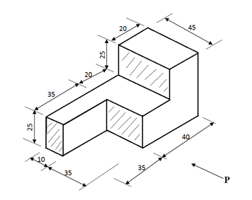

(a) (i) Draw full size the front elevation in the direction of arrow P

(ii) List two finishes that can be applied on the wooden block

(b) State one use each of the following in soft soldering:

(i) flux;  
(ii) soldering bit

(c) Make a freehand sketch of a pair of snips

(d) The table below shows tools, their uses and ways of caring for them.

Copy and complete the table

|  |  |
| --- | --- |
| **Food item** | **Functional group** |
| (i)     Fried fish |  |
| (ii)    Kenkey |  |
| (iii)   Fresh pepper sauce |  |

3.  
(a) Explain each of the following terms as used in concrete :  
(i) fine aggregates  
(ii) coarse aggregates

(b) List three methods of pictorial drawing

(c) (i) Make a freehand sketch of a pick-axe  
(ii) Label any two parts on the tool sketched in (c)(i) above

(d) List two items made of cast iron.

(e) Draw the symbol for each of the following electronic components  
(i) resistor  
(ii) capacitor  
(iii) a switch

(f) The figure below shows a pictorial view of a coal-pot made from a metal plate  
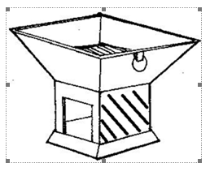

Arrange the following steps in a sequential order for making the coal-pot.

(i) File pieces to the required sizes;  
(ii) Mark-out the parts of the coal-pot  
(iii) Assemble the parts;  
(iv) Measure the metal pieces to the required dimensions;  
(v) Cut out pieces.

4. (a) (i) State the difference between plumbing and leveling in walling  
(ii) List two tools used for plumbing and leveling in walling

(b) List two examples each of a conductor and an insulator

(c) State one purpose each for the following  
(i) curing a brick;  
(ii) applying a piece of chalk on the face of a file.

(d) (i) Make a freehand sketch of the soldering iron used in sheet metal work.  
(ii) Label any two parts on the tool sketched in (d) (i)

(e) The table below shows two materials to be glued together

Copy and complete the table

|  |  |
| --- | --- |
| **Prepared Materials** | **Types of adhesive** |
| (i) Odum to odum |  |
| (ii) Formica to wawa |  |
| (iii) Veneer to odum |  |

**Paper Two – Answers**

1. (a) Ama ate fried fish, kenkey and fresh pepper sauce

Copy and complete in a table what Ama ate into the functional groups of food.

|  |  |
| --- | --- |
| **Food item** | **Functional group** |
| (i)     Fried fish | Body building food |
| (ii)    Kenkey | Energy giving food |
| (iii)   Fresh pepper sauce | Protective food |

(b)i The diagram below is the drawing of a mango



(ii) Shade your drawing in (b) (i) in three tones

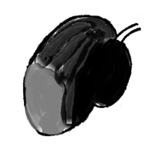

(iii) List two other methods of shading apart from the one used in (b) (ii)

Hatching (shading with lines)  
Cross hatching (shading with crossed lines)  
Stippling (shading with dots)  
Smudging (shading by smearing with finger)

(c) (i) State two reasons why investigations are carried out in the design process.  
? To properly identify and specify the problem  
? To decide on best solutions to the problem  
? To decide on the most suitable materials and tools needed to solve the problem  
? To decide on the right form/shape and size of the article

(ii) List three electrical appliances used in the home  
? Pressing iron  
? Radio set  
? Television set  
? Electric cooker  
? Refrigerator  
? Electric kettle  
? Blender  
? Microwave oven

2. The figure shows the pictorial view of a wooden block made from odum



(i) Draw full size the front elevation in the direction of arrow P

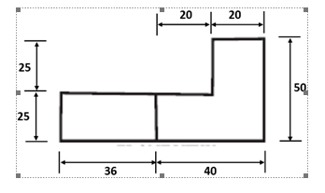

(ii) List two finishes that can be applied on the wooden block  
• Varnish  
• Wax  
• Lacquer  
• Oil paint

(b) State one use each of the following in soft soldering:

(i) flux;  
• It prevents oxidation (the formation of fresh oxides) by forming a protective layer on the solder.  
• It cleans the surface of the base metal during heating.  
• It eliminates impurities appearing on metal surface.  
• It breakdowns the surface tension of molten solder which helps the easy flow.

(ii) soldering bit  
• It gives the necessary heat to melt the solder

(c) Make a freehand sketch of a pair of snips  
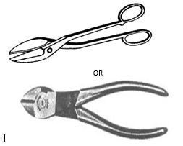

(d) The table below shows tools, their uses and ways of caring for them.

Copy and complete the table

|  |  |  |
| --- | --- | --- |
| **Tool** | **One use each** | **One way of caring for the tool** |
| (i)   Builders square | ·    Used to check if the corners of walls, etc, are accurate right angles (90°) | ·       Clean and keep it dry  ·       Use it for the right job  ·       Keep in a tool box |
| (ii)  Hand file | ·    Used to file shoulders of metal  ·    Used to file corners of metal | ·       Clean after use  ·       Use it for the right job  ·       Keep the teeth sharp  ·       Keep it in a tool box  ·       Oil the metal part |
| (iii) Rip saw | ·    Used for cutting a piece of wood into two | ·       Sharpening  ·       Shaping  ·       Setting  ·       Topping / Jointing  ·       Oiling the blade  ·       Cleaning  ·       Racking the saw |
| (iv) Gauge rod | ·    Used to check if the course height is accurate | ·       Clean and keep it dry  ·       Use it for the right job  ·       Keep in a tool box |

3. (a) Explain each of the following terms as used in concrete :  
(i) fine aggregates

Sand which has been washed and sieved to remove particles greater than 5mm in diameter and is to be used for mortar.  
OR  
Sieved sand, of diameter less than 5 mm, to be used for mixing mortar.

(ii) coarse aggregates  
The mixture of sand, stones, gravel and other particles whose diameters are greater then 5 mm and used for mixing mortar

(b) List three methods of pictorial drawing  
? Oblique drawing  
? Isometric drawing  
? Perspective drawing

(c) (i) Make a freehand sketch of a pick-axe  
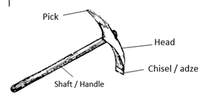

(ii) Label any two parts on the tool sketched in (c)(i) above

• Shaft / handle  
• Head  
• Pick  
• Chisel / adze

(d) List two items made of cast iron.

(e) Draw the symbol for each of the following electronic components

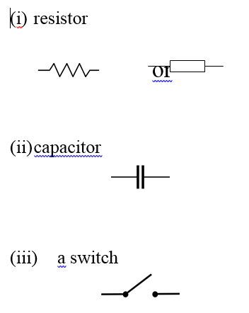

(f) The figure below shows a pictorial view of a coal-pot made from a metal plate



Arrange the following steps in a sequential order for making the coal-pot.  
(i) File pieces to the required sizes;  
(ii) Mark-out the parts of the coal-pot  
(iii) Assemble the parts;  
(iv) Measure the metal pieces to the required dimensions;  
(v) Cut out pieces.

(i) Measure the metal pieces to the required dimensions;  
(ii) Mark-out the parts of the coal-pot  
(iii) Cut out pieces  
(iv) File pieces to the required sizes;  
(v) Assemble the parts;

4. (a) (i) State the difference between plumbing and levelling in walling  
Plumbing refers to checking the vertical uprightness of the wall, whilst  
Levelling refers to checking the horizontal levelness of the wall.

(ii) List two tools used for plumbing and leveling in walling  
Plimb line and Spirit level / bubble level

(b) List two examples each of a conductor and an insulator

|  |  |
| --- | --- |
| CONDUCTOR | INSULATOR |
| Copper  Gold  Silver  Aluminium  Molybdenum  Zinc  Nickel  etc | wood  clay  plastics  fabric  paper  rubber  glass  etc |

(c) State one purpose each for the following  
(i) curing a brick;  
to make it stronger  
to reduce cracking  
to reduce shrinking  
to make it bond better

(ii) applying a piece of chalk on the face of a file.  
to prevent metal chips from clogging the teeth of the file  
to prevent pinning  
to make its teeth easier to clean

(d) (i) Make a freehand sketch of the soldering iron used in sheet metal work.  
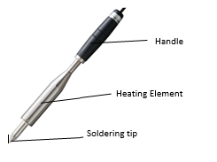

(ii) Label any two parts on the tool sketched in (d) (i)  
• Handle  
• Heating element  
• Soldering Tip / copper tip

(e) The table below shows two materials to be glued together

Copy and complete the table

|  |  |
| --- | --- |
| **Prepared Materials** | **Types of adhesive** |
| (i) Odum to odum | White glue / Polyvinyl acetate (PVA) |
| (ii) Formica to wawa | Contact adhesive / impact adhesive |
| (iii) Veneer to odum | Contact adhesive / impact adhesive |

**2012 Basic Design And Technology (Pre Technical Skills ) – Paper One**

1. Which of the sets are temporary stitches?

A. Basting and tracking  
B. Hemming and basting  
C. Tracking and hemming  
D. Tracking and running

2. The main vitamin Ama gets when she eats oranges is

A. vitamin C  
B. vitamin D  
C. vitamin E  
D. vitamin K

3. Crockery is a collection of

A. forks and spoons  
B. glasses and spoons  
C. plates and forks  
D. plates and glasses

4. The arrangement of the shapes in a picture is known as:

A. blending  
B. composition  
C. drawing  
D. toning

5. Which of the following colours produces a feeling of coolness?

A. blue  
B. orange  
C. violet  
D. white

6. The aspect of analysis which considers the appearance of an artefact is known as

A. aesthetics  
B. construction  
C. ergonomics  
D. function

7. In designing, possible solutions are generated by the use of

I. observation  
II. drawing  
III. sketches

Which of the following options are correct?  
A. I and II only  
B. II and III only  
C. I and III only  
D. I, II and III

8. Drawing of an object starts with

A. colour  
B. line  
C. shape  
D. texture

9. Which of the following colours is used to represent an earth wire?

A. blue  
B. brown  
C. red  
D. yellow

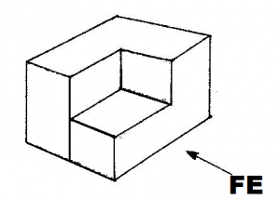  
10. Which of the following views represent the plan?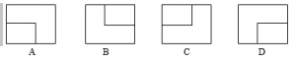

11. The left-end view is represented by  
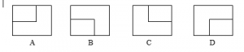

12. Weakness on a joint of furniture may be due to

A. excessive glueing  
B. hammering hard  
C. missing nail  
D. over polishing

13. Which of the following options suggest a dot in nature?

A. a cube of sugar  
B. a grain of sand  
C. footpath lane  
D. Veins of a leaf

14. The B range of pencils are the

A. finest  
B. hardest  
C. smoothest  
D. softest

15. Mounting an exhibition enables the dressmaker to

I. show her handiwork  
II. attract customers  
III. increase her income  
IV. show her generosity

A. I, II and III only  
B. I, II and IV only  
C. II and IV only  
D. III and IV only

16. Brass is made of

A. copper and tin  
B. copper and zinc  
C. lead and tin  
D. lead and zinc

17. Which of the following tools is used for checking alignment of a wall?

A. building square  
B. folding rule  
C. gauge  
D. straight edge

18. The symbol below indicates a/an  
PT Q18 2012

 A. diode  
B. capacitor  
C. inductor  
D. resistor

19. Iron filings are removed from the teeth of a file by using

A. chalk  
B. scriber  
C. file card  
D. flat chisel

20. Mould boxes are oiled before use to

A. increase the size of the brick  
B. prevent brick sticking to the box  
C. smoothen the surface of the brick  
D. give the brick a shiny surface

B. prevent brick sticking to the box

21. The type of line drawn across the rectangle below is  
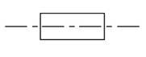

 A. centre line  
B. hidden detail  
C. construction line  
D. dimensional line

22. Which of the following is an abrasive?

A. oil paint  
B. emery cloth  
C. wax polish  
D. contact glue

23. Metals which contain iron and carbon are called

A. non-ferrous alloy  
B. non-ferrous metals  
C. ferrous metals  
D. fibre glass

24. The tool used for marking out the final circular shape below is a  
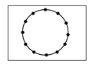

A. scriber  
B. pair of dividers  
C. dot punch  
D. centre punch

25. Glass paper is used on wood to

A. fill the pores  
B. produce a smooth surface  
C. form beautiful grains  
D. reduce the thickness

26. Which of the following is not a safety measure when using electrical appliances?

A. Read all warning and instructions on the appliance before use  
B. Do not touch electrical appliance with wet hands  
C. Do not plug in too many appliances on a socket at a time  
D. Leave all appliances on after use.

27. Which of the following is the correct order of applying a finish to a block wall?

I. Plastering  
II. Painting  
III. Scraping

A. I, II, III  
B. I, III, II  
C. II, I, III  
D. III, II, I

Use the figure below to answer questions 28 to 30  
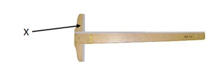

28. The figure is a

A. rule  
B. tee square  
C. try square  
D. set square

29. The part labeled X is called

A. blade  
B. lead  
C. set  
D. stock

30. The tool shown in the figure is used to

A. draw horizontal lines  
B. draw vertical lines  
C. set variable angles  
D. measure horizontal lines

**Paper One – Answers**

1. A. Basting and tracking
2. A. vitamin C
3. D. plates and glasses
4. B. composition
5. A. blue
6. A. aesthetics
7. B. II and III only
8. B. line
9. D. yellow
10. A.
11. C.
12. C. missing nail
13. B. a grain of sand
14. D. softest
15. A. I, II and III only
16. B. copper and zinc
17. D. straight edge
18. A. diode
19. C. file card
21. A. centre line
22. B. emery cloth
23. C. ferrous metals
24. D. centre punch
25. B. produce a smooth surface
26. D. Leave all appliances on after use.
27. B. I, III, II
28. B. tee square
29. D. stock
30. A. draw horizontal lines