**June 2013**

**INFORMATION AND COMMUNICATION TECHNOLOGY 1**

## OBJECTIVE TEST

45 Minutes

1. The flat panel screen is also known as
   1. CRT
   2. LCD
   3. OCR
   4. VCD

1. The device that the computer uses to keep data is
   1. input device
   2. output device
   3. processing device
   4. storage device

1. The first key on the computer keyboard is
   1. Caps Lock
   2. Delete
   3. Enter
   4. Esc

1. In which of the following are the storage devices arranged on the basis of lowest to the highest capacity?
   1. CD, DVD, Floppy Disk and Hard Disk B. Floppy Disk, Hard Disk, DVD and CD C. Floppy Disk, CD, DVD and Hard Disk D. Floppy Disk, DVD, CD and Hard Disk

1. A pen drive
   1. inputs information
   2. puts out information
   3. retrieves information
   4. stores information

1. The main storage medium within the system unit of the computer is the
   1. CD-ROM
   2. FDD
   3. HDD
   4. USB

1. To boot a computer is the same as to
   1. shut down the computer
   2. restart the computer
   3. start the computer
   4. stop the computer

1. On which bar is the system clock located?
   1. Menu bar
   2. Scrollbar
   3. Task bar
   4. Toolbar

1. The command button used to exit windows application is the
   1. close button
   2. maximize button
   3. minimize button
   4. restore button

1. An example of an operating system is
   1. CALC
   2. DISK
   3. DOS
   4. WORD

1. To copy a file means to
   1. cut the file from the desktop
   2. delete the file into recycle bin
   3. make a duplicate of the file
   4. remove the file from a folder

1. Programs that perform specific task for users are refered to as
   1. application software
   2. computer software C. operating software

D. system software

1. A group of files are stored in a
   1. folder
   2. graphic
   3. text
   4. word

1. The operation whereby the computer manipulates data to produce information is known as
   1. capturing
   2. processing
   3. recording
   4. retrieving

1. Which of the following components emits radiation?
   1. Hard disk
   2. Keyboard
   3. Mobile phone
   4. Speaker

1. The legal right that does not allow people to copy intellectual property without the permission of the original owner is called
   1. copyright
   2. freeware
   3. piracy
   4. privacy

1. Software that presents lessons in a movie-like manner is referred to as
   1. multiplicity
   2. multimedia
   3. multipurpose
   4. multitasking

1. The symbos B, I, U are commonly used buttons found on the
   1. drawing toolbar
   2. formatting toolbar
   3. menu toolbar
   4. standard toolbar

1. Right-clicking a mouse on an open window
   1. creates a new document
   2. opens a file menu
   3. opens a new window
   4. opens a context menu if available

1. Which of the following computer keyboard keys is used to delete characters from left to right on-screen?
   1. Alternate
   2. Backspace
   3. Delete
   4. shift

1. Which of the following computer keys allows the user to type upper case letters?
   1. Alternate key
   2. Control key
   3. Caps Lock key
   4. Num Lock key

1. Which of the following keys is used for multiple selection of texts that are **not** continuous?
   1. Alt
   2. Ctrl
   3. Del
   4. Shift

1. When a user clicks within a selected text by holding down the left mouse button, and then transfers the cursor to a different location within the same document, the text will be
   1. cut
   2. moved
   3. copied
   4. deleted

1. Which of the following menu titles contains the bullets and numbering command?
   1. Edit menu
   2. File menu
   3. Format menu
   4. Insert menu

1. In order to apply bold formatting to a section of existing text, the user must first
   1. click on the formatting button
   2. click the shortcut mouse button
   3. save the document
   4. select the section to be formatted

1. The save command is found under which of the following menu buttons?
   1. Edit
   2. File
   3. Insert
   4. Tools

1. Which of the following command buttons is found on the standard toolbar?
   1. Bold
   2. Bullets
   3. Redo
   4. Undo

1. When a text automatically moves to the next line at the end of a margin in a word processing program, it is referred to as
   1. text wrap
   2. word wrap
   3. text movement
   4. word movement

1. Which of the following is a tool on the drawing toolbar?
   1. Arrows
   2. Change Case
   3. Drop Cap
   4. Text Direction

1. A rectangle can be drawn in word processing application using the
   1. Arrow
   2. Circle
   3. Oval
   4. Square

1. The device which is used to produce hard copies from personal computers in schools is
   1. photocopier
   2. monitor
   3. printer
   4. scanner

1. A computer program that enables users to surf the internet is known as
   1. internet explorer
   2. navigator
   3. web browser
   4. internet surfer

1. Word processing is used mainly by
   1. accountants
   2. artists
   3. engineers
   4. secretaries

1. Which of the following devices will enable users to get access to the internet connection?
   1. keyboard
   2. Modem
   3. Projector
   4. Scanner

1. Transferring data from a remote computer to local computer is referred to as
   1. download
   2. linkdown
   3. upload
   4. linkup

1. Specialized programs that assist users to locate information on the internet are called
   1. agents
   2. internet browsers
   3. search engines
   4. web

1. Which of the following refers to unsolicited e-mails in the form of advertising and chain letters?
   1. Flaming
   2. Inbox
   3. Spam
   4. Trash

1. The software responsible for the management of the basic operations of the computer is the
   1. application program
   2. device drivers
   3. operating system
   4. utility program

1. On which of the following toolbars is the print preview button located?
   1. Drawing
   2. Formatting
   3. Header and Footer
   4. Standard

1. The intersection of the 8th row and the 7th column in a spreadsheet application will have the cell reference
   1. 8G B. G8 C. 7H

D. H7

**June 2013**

**Information and Communication Technology 1**

## SOLUTIONS

### OBJECTIVE TEST

45 Minutes

1. B. LCD
2. D. storage device
3. D. Esc
4. C. Floppy Disk, CD, DVD and Hard Disk
5. D. stores information
6. C. HDD
7. C. start the computer
8. C. Task bar
9. A. close button
10. C. DOS
11. C. make a duplicate of the file
12. A. application software
13. A. folder
14. B. processing
15. C. Mobile phone
16. A. copyright
17. B. multimedia
18. B. formatting toolbar
19. B. opens a file menu
20. C. Delete
21. C. Caps Lock key
22. B. Ctrl
23. B. moved
24. C. Format menu
25. D. select the section to be formatted
26. B. File
27. C. Redo (or D. Undo)
28. B. word wrap
29. A. Arrows
30. D. Square
31. C. printer
32. C. web browser
33. D. secretaries
34. B. Modem
35. A. download
36. C. search engines
37. C. Spam
38. C. operating system
39. D. Standard
40. B. G8

#### June 2013

**INFORMATION AND COMMUNICATION TECHNOLOGY 2**

**ESSAY 1 ¼ hours**

**SECTION A [24 marks]**

##### Answer Question 1 (Compulsory)

**1.** (a) ABC Supermarket has acquired an application to generate cash receipts for goods purchased by its customers as shown in the diagram below.

The amount for each item is obtained by multiplying the unit price and quantity of goods purchased. The subtotal is a summation of the amounts obtained for all purchased items. The tax payable is computed at the rate of 10% of the subtotal.

The total amount to be paid is the summation of the subtotal and the tax payable on purchased items.

Using the diagram below, answer the questions that follow

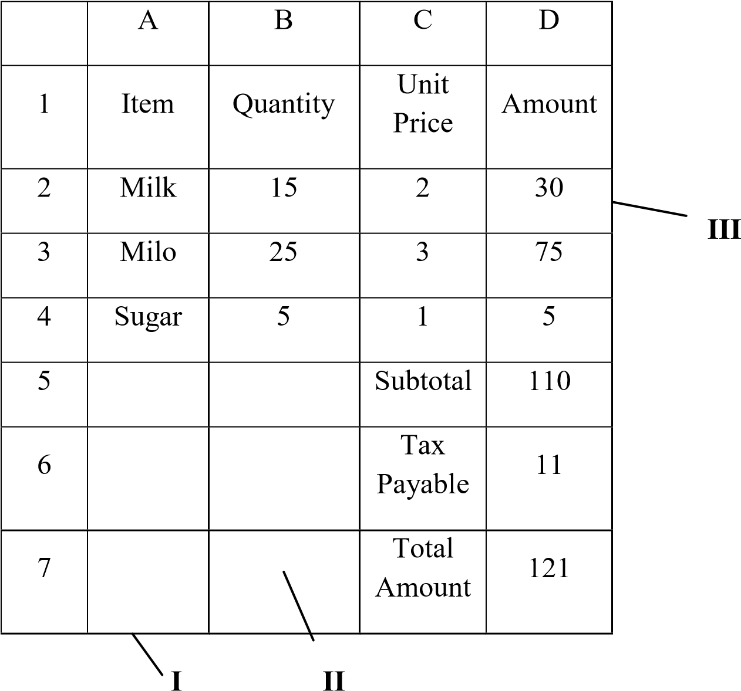

(i) Name the application program used in creating the above.

…………………………………………………………………………………….

[2 marks]

(ii) Identify the parts labelled I, II and III.

………………………………………………………………………………………………

………………………………………………………………………………………………

………………………………………………………………………

[3 marks]

(iii) Provide the formula used in calculating the following cells.

D2 ………………………………………………………………………………….

D5…………………………………………………………………………………..

D6…………………………………………………………………………………..

[6 marks]

1. Use the diagram below to answer questions (i), (ii) and (iii)

**E**

**B**

**F1**

**F2**

**F3**

**F4**

**F12**

**ESC**

**A**

**C**

**D**

* 1. Identify the diagram above.

…………………………………………………………………………………

[2 marks]

* 1. Name the parts labelled **A**, **B**, **C**, **D** and **E**

…………………………………………………………………………………

…………………………………………………………………………………

…………………………………………………………………………………

…………………………………………………………………………………

…………………………………………………………………………………

[5 marks]

* 1. State one function each of the parts labelled **B** and **C** in the diagram in (b) above.

…………………………………………………………………………………

…………………………………………………………………………………

…………………………………………………………………………………

…………………………………………………………………………………

[4 marks]

1. State **one** function of the diagram identified in (b) (i)

…………………………………………………………………………………

…………………………………………………………………………………

…………………………………………………………………………………

[2 marks]

##### SECTION B [36 marks]

*Answer* **three** *Questions* **only** *from this section*

1. (a) State two:

(i) positive uses of the internet;

…………………………………………………………………………………

…………………………………………………………………………………

…………………………………………………………………………………

…………………………………………………………………………………

[4 marks]

(ii) negative uses of the internet.

…………………………………………………………………………………

…………………………………………………………………………………

…………………………………………………………………………………

[4 marks]

* 1. List four storage media

…………………………………………………………………………………

…………………………………………………………………………………

…………………………………………………………………………………

…………………………………………………………………………………

[4 marks]

1. (a) Explain communication as used in the computer industry

…………………………………………………………………………………

…………………………………………………………………………………

…………………………………………………………………………………

[3 marks]

* 1. Video conferencing refers to:

…………………………………………………………………………………

…………………………………………………………………………………

…………………………………………………………………………………

…………………………………………………………………………………

[3 marks]

* 1. List two devices associated with video conferencing.

…………………………………………………………………………………

…………………………………………………………………………………

[2 marks]

* 1. State four media for sending and receiving information …………………………………………………………………………………

…………………………………………………………………………………

…………………………………………………………………………………

[4 marks]

1. (a) In word processing application, when is it appropriate to use:

(i) copy-and-paste;

…………………………………………………………………………………

…………………………………………………………………………………

…………………………………………………………………………………

…………………………………………………………………………………

[3 marks]

(ii) cut-and-paste;

…………………………………………………………………………………

…………………………………………………………………………………

…………………………………………………………………………………

…………………………………………………………………………………

[3 marks]

* 1. (i) What is a font?

…………………………………………………………………………………

…………………………………………………………………………………

…………………………………………………………………………………

…………………………………………………………………………………

[3 marks]

(ii) List three font styles

…………………………………………………………………………………

…………………………………………………………………………………

[3 marks]

1. (a) What is:

(i) motherboard

…………………………………………………………………………………

…………………………………………………………………………………

…………………………………………………………………………………

…………………………………………………………………………………

[3 marks]

(ii) ergonomics

…………………………………………………………………………………

…………………………………………………………………………………

…………………………………………………………………………………

…………………………………………………………………………………

[3 marks]

(iii) menu bar

…………………………………………………………………………………

…………………………………………………………………………………

…………………………………………………………………………………

…………………………………………………………………………………

[3 marks]

* 1. What is copyright used for?

…………………………………………………………………………………

…………………………………………………………………………………

…………………………………………………………………………………

…………………………………………………………………………………

[3 marks]

#### June 2013

**INFORMATION AND COMMUNICATION TECHNOLOGY 2**

|  |  |  |  |  |  |
| --- | --- | --- | --- | --- | --- |
|  |  |  | **SOLUTIONS**  **ESSAY** | |  |
| **1.** | **(a)** | **(i)** | **Application program used** Spreadsheet application or Microsoft Excel or Lotus 1-2-3 |  |  |
|  |  | **(ii)** | **Parts**  I - Column |  |  |
|  |  |  | II - Cell |  |  |
|  |  |  | III - Row |  |  |
|  |  | **(iii)** | **Formulae used in the cells**  D2 =B2*C2 |  |  |
|  |  |  | D5 =SUM(D2:D4) or | =D2+D3+D4 |  |
|  |  |  | D6 =10%*D5 or | =0.1*D5 or | =D5/10 |
|  | **(b)** | **(i)** | **The diagram**  A computer keyboard |  |  |
|  |  | **(ii)** | **Parts** |  |  |
|  |  |  | A - SHIFT Key |  |  |
|  |  |  | B - Space bar |  |  |
|  |  |  | C. - Arrow keys or movement keys | |  |
|  |  |  | D - Enter key or Return key | |  |
|  |  |  | E - Function keys | |  |
|  |  | **(iii)** | **PART FUNCTION** | |  |
| 1. - To create a horizontal space in a text 2. - To control the cursor or move the cursor in a different   direction | | |

##### or

To scroll through documents

**(c) Function of diagram in b (i)**

To input data and/or commands into a computer

Or

To enter data characters (numbers, letters and/or symbols) and commands into a computer

1. **(a) (i) positive uses of the internet** 
   * + **Education** – through distance learning, e-books, e-learning centres, etc
     + **Entertainment** – through music, sports, movies, and games
     + **Information** - Easy dissemination of and access to information – through search engines, blogs, news websites, etc
     + **Communication** – through emails, chats, social networks, etc
     + **Trading** (buying and selling) - through credit or debit cards, money transfer services, etc
     + **Payment of bills** - through credit or debit cards, money transfer services, etc
     + **Advertising** of products and services.

**(ii) negative uses of the internet**

* + - **Stealing / Theft** – through hacking, impersonation, deception or other means.
    - **Creation of malicious software** (malware), such as viruses, worms or Trojan horses, to damage or disrupt a computer system
    - **Copyright infringement** - Violating the rights of others by unauthorized use or copying of their creative works.
    - **Hacking / Cracking** - Tapping into confidential data in the computer systems of others without permission for various reasons.
    - **Pornography** – publishing or viewing pornographic pictures or movies.
    - **Infringement of privacy** – Accessing other people’s private information without their permission.

* 1. **Storage media** 
     + Hard disc drive
     + External hard drive
     + DVD
     + CD
     + Flash drive (pen drive)
     + Memory card
     + Magnetic tape
     + Zip drive
     + Floppy disk

1. **(a) Communication as used in the computer industry**

Transfer or exchange of information between or among two or more persons via a media, such as the mobile phone or a communication network

Or

Sending and/ or receiving information through a given media, such telephone or the internet.

* 1. **Video conferencing**

Holding a meeting through video and audio signals

Or

A meeting in which the participants are in different places but are connected by video and audio links Or

Using video and audio signals to link participants at different and remote locations Or

Live video and audio communication between three or more locations

* 1. **Devices associated with video conferencing**

INPUT DEVICES

* + - Video camera
    - Webcam
    - microphones
    - CD/ DVD player
    - Cassette player

OUTPUT DEVICES

* + - Computer monitor
    - television
    - projector
    - loudspeakers
    - headphones

DATA PROCESSING

* + - Computer DATA TRANSFER
    - A Network, such as the internet

* 1. **Media for sending and receiving information** 
     + Mobile phones
     + Landline telephones
     + Radio
     + Television
     + Internet
     + Local Area Network (LAN)
     + Newspapers
     + Magazines

1. **(a) When it is appropriate to use in word processing,** 
   * 1. **copy-and-paste**

When data that has already been inputted has to be duplicated (copied) in another part of the same document or in another document

* + 1. **cut-and-paste**

When data that has already been inputted has to be moved/ transferred to another part of the same document or to another document.

* 1. **(i) A font**

A set of letters, numbers and symbols that share a unified design Or

A complete set of type or printed or screen characters of the same design

**(ii) Font styles**

* + - * Times New Roman
      * Arial
      * Tahoma
      * Cambria
      * Calibri

##### ▪ *Brush Script*

▪ Verdana

###### ▪ Monotype Corsiva

* **Britannic Bold**
* Broadway
* Georgia
* Castellar
* Lucida Calligraphy
* Algerian

**5. (a) (i) Motherboard**

The main circuit board of a computer

Or

The circuit board in a minicomputer or microcomputer through which all signals are directed Or

A printed circuit board containing the principal components of a microcomputer or other device, with connectors into which other circuit boards can be slotted

* 1. **Ergonomics**

The design of workplace or equipment for comfort, efficiency, safety and productivity

Or

Factors or qualities in the design of workplace or equipment that contribute to comfort, efficiency, safety and productivity

* 1. **Menu bar**

A horizontal bar usually displayed at the top of a computer screen or window, listing available menus for an application

Or

A horizontal strip at the top of a window that shows the menus available in a program

**(b) What copyright is used for**

* + to promote the progress of science, technology and the arts
  + to encourage the creation of new and improved intellectual works
  + to prevent the unlawful / unauthorized use and/or duplication of creative works ▪ to protect the interests of the authors/creators of intellectual property