2013 BECE Mathematics (Maths) Past Questions – Paper One
Share:


1. If A = {5, 10, 15, 20, 25, 125}and B = {5, 10, 15, 20, 25, 625}, list the elements of A⋃B
A. {5, 25}
B. {10, 20, 125, 625}
C. {5, 15, 25, 125, 625}
D. {5, 10, 15, 20, 25, 125, 625}
2. Express 1.25 as a percentage
A. 25%
B. 75%
C. 125%
D. 175%
3. Arrange the following in ascending order of magnitude: 0.301, 0.3, 0.33, 0.03
A. 0.03, 0.3, 0.301, 0.33
B. 0.03, 0.301, 0.3, 0.33
C. 0.33, 0.3, 0.301, 0.03
D. 0.33, 0.301, 0.3, 0.03
4. Evaluate 53 – (–7) + (–15)
A. 31
B. 45
C. 61
D. 75
5. Given that A = {a, e, i, o, u} and B = {r, s, t}. How many elements are in A∩B?
A. 0
B. 1
C. 2
D. 3
6. Convert to a base ten numeral.
A. 194
B. 280
C. 284
D. 300
7. Simplify
A. 1/12
B. 1/6
C. 1/4
D. 1/3
8. A car uses 150 litres of petrol in 45 minutes. How many litres of petrol will it use in 1 hour?
A. 375 litres
B. 230 litres
C. 225 litres
D. 200 litres
9. Simplify
10 Find the rule of the mapping
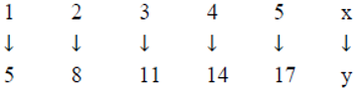
A. x+2
B. x+4
C. 2x+3
D. 3x+2
11. Given that – 1 = 2 – m, find m
A. – 3
B. – 1
C. 1
D. 3
12. The perimeter of a rectangle is 48 cm. If the length is 14 cm, find its width.
A. 24 cm
B. 20 cm
C. 10 cm
D. 3.4 cm
13. Make d the subject of the relation n=2d+3
14 Calculate the gradient of the straight line joining the points A(3, 5) and B(–2, 3)
A 5/2
B 2/5
C -2/5
D -5/2
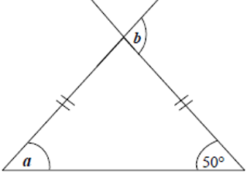
Use the diagram below to answer Questions 15 and 16
15. Find the angle marked a
A. 70°
B. 50°
C. 40°
D. 30°
16. Find the angle marked b
A. 150°
B. 140°
C. 110°
D. 100°
17. If S = {1, 2, 3, 4, 5, 6, 7, 8, 9, 10}, find the probability that a number selected at random from S is odd.
A 3/8
B 1/4
C 1/2
D 5/8
18. Find the vector which translates the point (4, –5) to (3, –2)
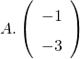
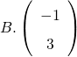
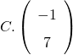
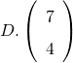
19 Factorize completely the expression 2xy-6y+7x-21
A (x-3)(2y+7)
B (x+3)(2y-7)
C (y+3)(2x-7)
D. (y+3)(2x-7)
20. The area of a circle is 154 cm2. Find the diameter. [Take π = 22/7]
A 7 cm
B 14 cm
C 21 cm
D 49 cm
21. Maame Esi rides her bicycle to school and back everyday. If the distance from her home to the school is 2345 m, how many kilometers does she cover everyday?
A. 4.98 km
B. 4.69 km
C. 3.96 km
D. 3.68 km
22. The length of a rectangular fence is 25 m. The ratio of the length to the width is 5:3. Find the width of the rectangular fence.
A. 9 m
B. 13 m
C. 15 m
D. 16 m
23. Evaluate if a = 30 and b = 1.
24. How many 15Gp Christmas cards can be bought with GH¢18.00?
A. 120
B. 150
C. 180
D. 270
25 If 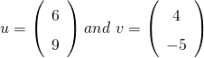, find u+v
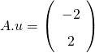
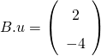
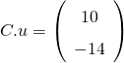
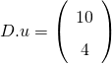
26. If 4956 × 25 = 123,900, evaluate 495.6 × 2.5 leaving the answer in standard form.
27 Which of the following expressions is illustrated on the number line?
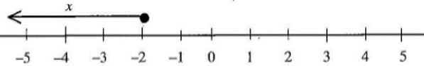
28. If 180 oranges were shared among Kwame and Ama in the ratio 7:5, respectively, how many oranges did Ama receive?
A. 45
B. 60
C. 75
D. 90
29. Calculate the simple interest on GH¢ 450.00 for 2 years at 12% per annum.
A. GH¢ 191.00
B. GH¢ 108.00
C. GH¢ 54.00
D. GH¢ 27.00
30. If 15% of the length of a rope is 75 cm, find half of the length of the rope.
A. 500 cm
B. 250 cm
C. 150 cm
D. 100 cm
31. In an office, 2/3 of the telephone bill is paid by Tom, by 1/5 by Azuma and the remaining by Tina. What fraction is paid by Tina?
A 2/15
B 1/4
C 1/3
D 7/15
32.
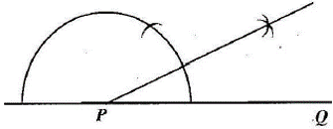
Which of the following best describes the construction?
A. Constructing a perpendicular at P
B. Constructing the bisector of line PQ
C. Constructing an angle of 30° at P
D. Constructing an angle of 45° at P
33. Express 0.055 as a common fraction
A 11/40
B 5/18
C 1/40
D 11/200
The table below shows the distribution of workers in some trades
Trade | Shoe making | Mining | Road transport | Agriculture | Manufacturing goods
Number of workers | 300,000 | 25,000 | 160,000 | 225,000 | 165,000

Use this information to answer Questions 34 and 35
34. Which trade employed the most number of workers?
A. Agriculture
B. Manufacturing goods
C. Shoe making
D. Road transport
35. How many people are employed under all the trades?
A. 325,000
B. 485,000
C. 650,000
D. 875,000
36. Aba bought a carton of fish at GH¢ 80.00 and sold it at a profit of GH¢ 13.60. Find the selling price.
A. GH¢ 66.40
B. GH¢ 93.60
C. GH¢ 103.60
D. GH¢ 144.00
37.
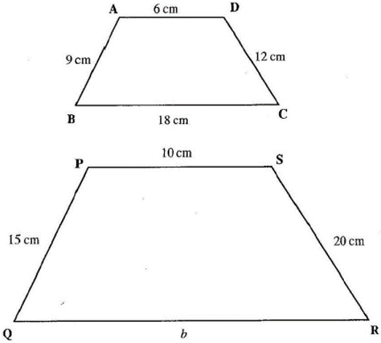
If the two figures ABCD and PQRS are similar, find the value of b.
A. 60 cm
B. 40 cm
C. 33 cm
D. 30 cm
38. A man shared an amount of money between his two children, Esi and Ato in the ratio 2:3 respectively. If Ato received GH¢ 45.00, what was the total amount shared?
A. GH¢ 18.00
B. GH¢ 27.50
C. GH¢ 75.00
D. GH¢ 112.50
39. How many edges has a cuboid?
A. 16
B. 12
C. 8
D. 4
40. Two sets whose intersection is an empty set are
A. disjoint sets
B. equivalent sets
C. finite sets
D. empty sets

Objective Answers
1 D. {5, 10, 15, 20, 25, 125, 625}
2 C. 125%
3. A. 0.03, 0.3, 0.301, 0.33
4 B. 45
6 5 A. 0
7 C. 284
8 A. 1/12
9 D. 200 litres
10 A (4a^2 x)/3by
11 D 3x+2
12 D. 3
13 C. 10 cm
14 C.
15 B 2/5
16 B. 50°
17 C 1/2
18. B

19 A (x-3)(2y+7)
20 B 14 cm
21 B. 4.69 km
22 C. 15 m
23 B -1/3
24 A. 120
25 D
26
27 A x≤-2
28 C. 75
29 B. GH¢ 108.00
30 B. 250 cm
31 A 2/15
32 C. Constructing an angle of 30° at P
33 D 11/200
34 C. Shoe making
35 D. 875,000
36 B. GH¢ 93.60
37 D. 30 cm
38 C. GH¢ 75.00
39 B. 12
40 A. disjoint sets

2013 BECE Mathematics (Maths) Past Questions – Paper Two
1.(a) Fifty students in a class took an examination in French and Mathematics. If 14 of them passed French only, 23 passed in both French and Mathematics and 5 of them failed in both subjects, find
(i) the number of students who passed in French
(ii) the probability of selecting a student who passed in Mathematics
(b) Solve the inequality
2. (a) Convert to a base two numeral
(b) A man had three GH¢ 50.00, seven GH¢ 20.00 and five GH¢ 10.00 notes in his pocket. If he bought a bicycle for GH¢ 150.00 and two mobile phones at GH¢ 80.00 each, how many GH¢ 20.00 and GH¢ 10.00 notes did he have left?
3. (a) Using a ruler and a pair of compasses only,
(i) construct a triangle XYZ with length |XY| = 7cm, length YZ = 5cm and angle XYZ = 45°
(ii) Measure and write down the length of XZ
(b) Given that the circumference of a circle is 44 cm, find
(i) the radius of the circle
(ii) the area of the circle [Take π = 22/7]
4. The table shows the distribution of marks of students in a class test
Mark | 1 | 2 | 3 | 4 | 5 | 6
Frequency | 5 | 6 | 5 | 3 | 4 | 2
(a) Using a graph sheet, draw a bar chart for the distribution.
(b) Calculate the mean mark of the distribution correct to the nearest whole number.
5. (a) Simplify

(b) Copy and complete the magic square so that the sum of numbers in each row or column or diagonal is 18
 | 4
7 | 8

(c) Find the sum of all the factors of 24.
(d) Given that m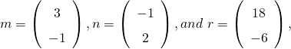 , find m + n + r
6. (a) Copy and complete the table for the relation y=2x+5
X | –3 | –2 | –1 | 0 | 1 | 2 | 3 | 4
y | –1 | 1 |  | 5 |  |  |  | 13
(b) (i) Using a scale of 2 cm to 2 units on both axes, draw two perpendicular axes OX and OY on a graph sheet.
(ii) Mark the x-axis from –6 to 10 and y-axis from –6 to 14.
(iii) Using the table, plot all the points of the relation y=2x+5 on the graph.
(iv) Draw a straight line through the points.
(c) Use the graph to find
(i) y when x = 1.6
(ii) x when y = 10

Paper 2 Answers
(a) Venn Diagram
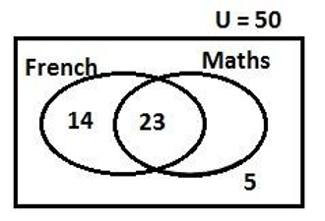
(a) (i) Number of students who passed in French (F)
= F only + Both F and M
= 14 + 23
= 37
(a) (ii) Probability of selecting a student who passed in Maths.
Approach 1
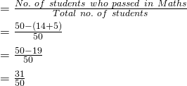
(a) (ii) Probability of selecting a student who passed in Maths.
Approach 2
Let m = number of students who passed in Maths only
Then 14 + 23 + m + 5 = 50
⇒ 14 + 23 + 5 + m = 50
⇒ 42 + m = 50
⇒ m = 50 – 42
m = 8
Therefore, the number of students who passed in Maths
= 23 + 8 = 31
(b) Solving
Approach 1
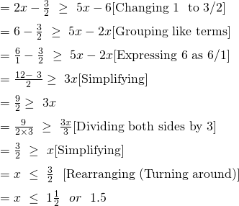
(b) Approach 2
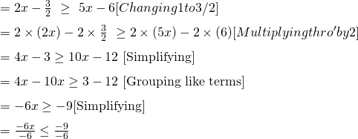
2. (a) Converting to base ten
= (4×25) + (4×5) + (4×1)
= 100 + 20 + 4
= 124
Now, converting 124 to a base 2 numeral
=
2 | 124 | Remainder
 | 62 | 0
 | 31 | 0
 | 15 | 1
 | 7 | 1
 | 3 | 1
 | 1 | 1
 | 0 | 1

=
(b) Amount in man’s pocket
= 3 × (GH¢ 50) + 7 × (GH¢ 20) + 5 × (GH¢ 10)
= GH¢ 150 + GH¢ 140 + GH¢ 50
= GH¢ 340
Purchases = 1 bicycle + 2 mobile phones
= GHC 150 + 2 × GHC 80
= GHC 150 + GHC 160
= GHC 310
Amount left = GHC 340 – GHC 310
= GHC 30
He had one GHC 20.00 and one GHC 10.00 left
3 (a) (i)
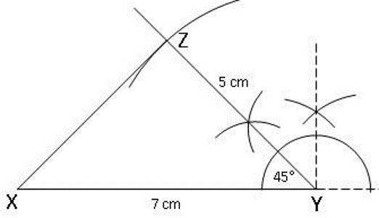
(ii) |XZ| = 5cm (or 5.1cm or 4.9cm)
(b) (i) C = 44cm, π = 22/7, r = ?
Approach 1
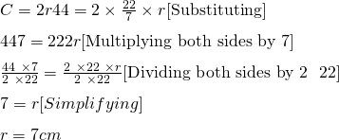
(b) (i) C = 44cm, π = 22/7, r = ?
Approach 2
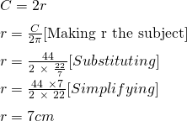
(ii) π = 22/7, r = 7, Area = ?

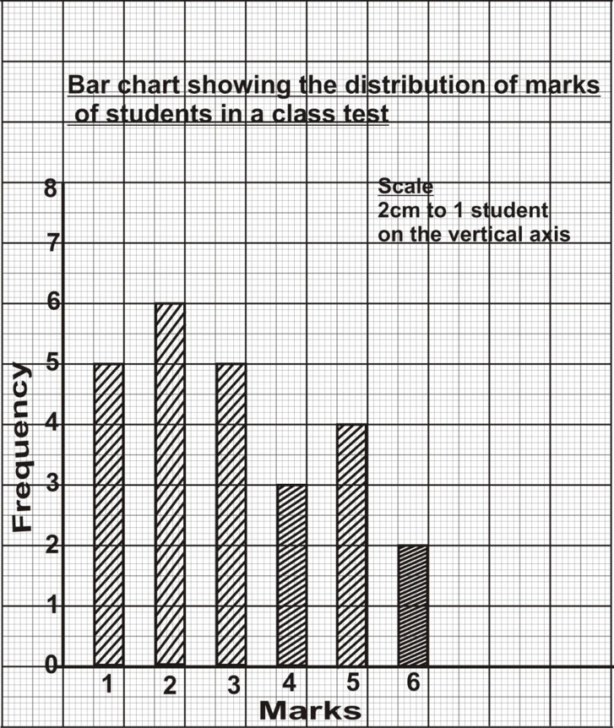
4 (a) Bar chart

(b) Finding the mean (Approach 1)
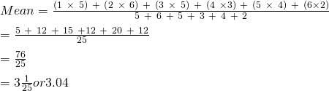
(b) Finding the mean (Approach 2)
Mark  (x) | Frequency  (f) | fx
1 | 5 | 5
2 | 6 | 12
3 | 5 | 15
4 | 3 | 12
5 | 4 | 20
6 | 2 | 12
 | ∑f = 25 | ∑ f x = 76
5 (a)
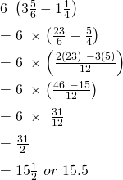
(b) Magic square with magic number 18
9 | 4 | 5
2 | 6 | 10
7 | 8 | 3

(c) Factors of 24 = {1, 2, 3, 4, 6, 8, 12, 24}
Sum of factors = 1 + 2 + 3 + 4 + 6 + 8 + 12 + 24
= 60
(d) m + n + r

6 (a) Relation: y=2x-5
When
x = – 1, y = 2(–1) + 5 ⇒ –2 + 5 = 3
x = 1, y = 2(1) + 5 ⇒ 2 + 5 = 7
x = 2, y = 2(2) + 5 ⇒ 4 + 5 = 9
x = 3, y = 2(3) + 5 ⇒ 6 + 5 = 11
Table of values
x | –3 | –2 | –1 | 0 | 1 | 2 | 3 | 4
y | –1 | 1 | 3 | 5 | 7 | 9 | 11 | 13

(b) Graph of the relation y=2x-5

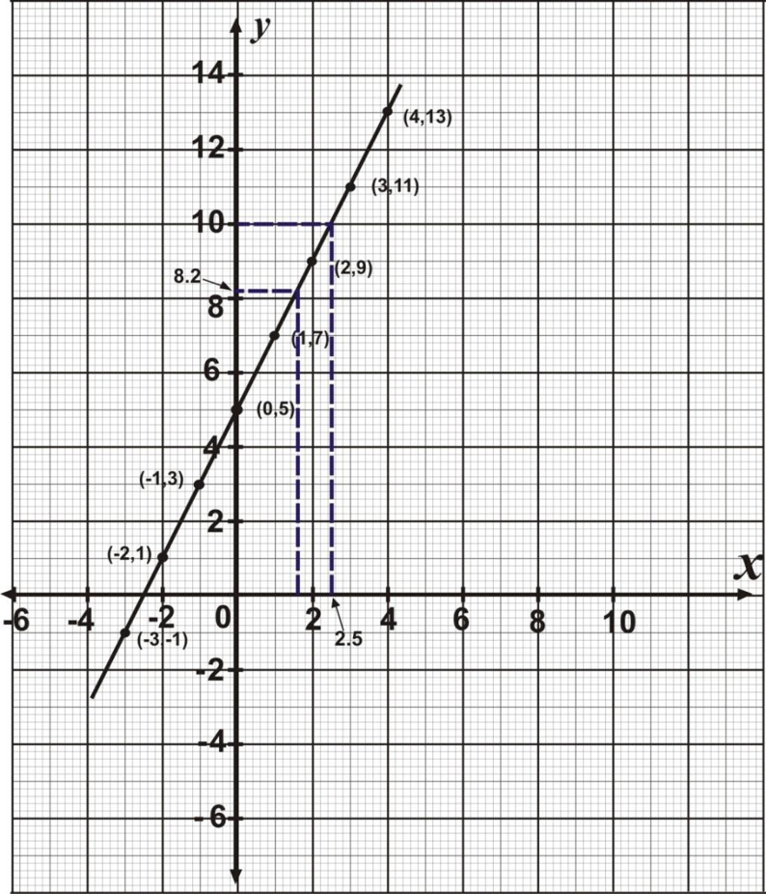
(c) (i) When x = 1.6, y = 8.2
(ii) When y = 10, x = 2 ½ or 2.5

