**2013 Basic Design And Technology (Pre Technical Skills ) – Paper Two**

1. (a) State two functions of protein in the body

(b) List two ways by which patching can be done

(c) (i) Explain a design brief  
(ii) List three methods of carrying out design investigations.  
(iii) State two factors to consider when selecting the best solution from the generated possible solutions in designing.

(d) (i) What is the colour spectrum?  
(ii) List the three primary colours  
(iii) Explain secondary colours

2. Figure 1 shows two views of a solid to be produced with sheet metal

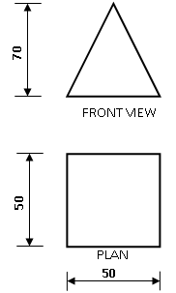

(a) Draw full size the following:  
(i) front view  
(ii) plan  
(iii) surface development

(b) State the name of the solid in figure 1

(c) (i) make a freehand pictorial sketch of a marking gauge  
(ii) Label any two parts of the tool you have sketched in (c)(i) above

3a) Using symbols, draw an electrical circuit diagram to show the following  
(i) two bulbs in parallel  
(ii) a switch  
(iii) a cell

(b) State one function of a light emitting diode (LED) in an electrical circuit.

(c) (i) Make a freehand sketch of a dot punch.

(ii) Indicate the point angle on the tool you sketched in (c)(i) above

(d) Copy and complete the table below

|  |  |
| --- | --- |
| ITEM | ONE SUITABLE MATERIAL FOR MAKING IT |
| Traditional oven |  |
| Kitchen stool |  |
| Bristle of tooth brush |  |
| Garden rake |  |

(e) State one reason each for carrying out the following processes  
(i) leveling a wall  
(ii) applying flux when soldering

4. (a) Explain the following  
(i) ratio 1:4 for mortar mixture;  
(ii) non-ferrous alloys

(b) (i) Make a freehand pictorial sketch of a flat screwdriver  
(ii) Label two parts of the tool you sketched in (b)(i) above  
(iii) State one main use of the tool you sketched in (b)(i) above.

(c) (i) Add three more courses to the wall in Figure 2  
(ii) Show a toothing end on the wall  
(iii) List two tools for laying the wall  
(iii) State one reason for intruding a half-bat in the wall.

**Paper Two – Answers**

1. (a) State two functions of protein in the body  
It promotes growth and development.  
It repairs worn out tissues in the body.  
It provides energy in the absence of carbohydrates  
It supports production of hormones and enzymes

(b) List two ways by which patching can be done  
By hand  
By machine

(c) (i) Explain a design brief  
A short statement that expresses the solution to a problem  
Or  
A statement of what the designer intends to design and make

(ii) List three methods of carrying out design investigations.  
By observing carefully  
By visiting  
By experimenting  
By reading relevant literature  
By interviewing  
By surfing the internet

(iii) State two factors to consider when selecting the best solution from the generated possible solutions in designing.  
Its function / effectiveness  
Its physical appearance (Aesthetics)  
Its cost of designing and making  
Its safety and suitability  
Its durability

(d) (i) What is the colour spectrum?  
The distribution of colours produced when white light is dispersed by a prism

(ii) List the three primary colours?  
The primary colours for  
(α) pigment: red, yellow and blue  
(β) light (additive): red, green and blue  
(γ) light (subtractive): magenta, cyan and yellow

(iii) Explain secondary colours  
A colour resulting from the mixing of two primary colours in equal proportions

For pigment, the secondary colours are  
Violet = (red + blue),  
green = (yello + blue) and  
orange = (red + yellow)

For light (additive), the secondary colours are  
Yellow = (green + red)  
Cyan = (green + blue)  
Magenta = (red + blue)

For light (subtractive), the secondary colours are:  
Red = (yellow + magenta)  
Green = (yellow + cyan)  
Blue = (magenta + cyan)

2. Figure 1 shows two views of a solid to be produced with sheet metal

(a) Draw full size the following:  
(i) front view  
(ii) plan  
(iii) surface development

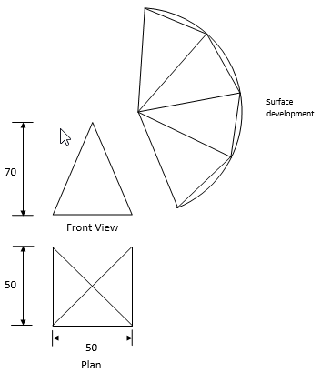

(b) State the name of the solid in figure 1  
Square pyramid

(c) (i) make a freehand pictorial sketch of a marking gauge

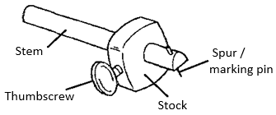

(ii) Label any two parts of the tool you have sketched in (c)(i) above  
♣ Thumbscrew  
♣ Stem  
♣ Spur / marking pin  
♣ Stock

3. (a) Using symbols, draw an electrical circuit diagram to show the following  
(i) two bulbs in parallel  
(ii) a switch  
(iii) a cell

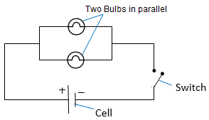

(b) State one function of a light emitting diode (LED) in an electrical circuit.  
♣ Used to indicate the presence of electric current in the electrical circuit.  
♣ It allows electric current to flow through in only one direction.

(c) (i) Make a freehand sketch of a dot punch.

2013 Bece pretech dot punch

(ii) Indicate the point angle on the tool you sketched in (c)(i) above  
60°

(d) Copy and complete the table below

|  |  |
| --- | --- |
| ITEM | ONE SUITABLE MATERIAL FOR MAKING IT |
| Traditional oven | Clay |
| Kitchen stool | Odum, wawa |
| Bristle of tooth brush | Nylon |
| Garden rake | Iron, cast iron, steel |

(e) State one reason each for carrying out the following processes  
(i) leveling a wall  
To ensure that the wall is perfectly horizontal  
OR  
To check the horizontal straightness of the wall.

(ii) applying flux when soldering  
• To prevent oxidation (the formation of fresh oxides) by forming a protective layer on the solder.  
• To clean the surface of the base metal during heating.  
• To eliminate impurities appearing on metal surface.  
• To breakdown the surface tension of molten solder which helps the easy flow.

4. (a) Explain the following  
(i) ratio 1:4 for mortar mixture;  
One part of cement to be mixed with four parts of sand.

(ii) non-ferrous alloys  
Non ferrous alloys are alloys that do not contain iron  
OR  
Non ferrous alloys are uniform mixtures of metals that do not contain iron

(b) (i) Make a freehand pictorial sketch of a flat screwdriver

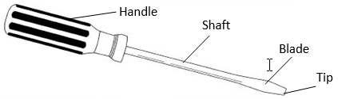

(ii) Label two parts of the tool you sketched in (b)(i) above  
• Handle  
• Shaft  
• Blade  
• Tip

(iii) State one main use of the tool you sketched in (b)(i) above.  
It is used to drive in / tighten and drive out / loosen screws into/out of work peices

(c) (i) Add three more courses to the wall in Figure 2  
(ii) Show a toothing end on the wall  
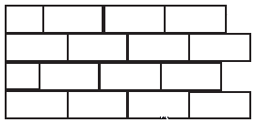

(iii) List two tools for laying the wall  
♣ hand trowel  
♣ spirit level  
♣ float  
♣ gauge rod  
♣ straight edge  
♣ mortar board  
♣ line and pins  
♣ brick hammer / comb hammer  
♣ bolster and club hammer  
♣ builder’s square

(iii) State one reason for intruding a half-bat in the wall.  
To avoid continuous vertical joints

**2013 Basic Design And Technology (Pre Technical Skills ) – Paper One**

1. Which of the stitches can be used to hold down a hem decoratively?

A. Basting  
B. Hemming  
C. Herringbone  
D. Overcasting

2. The advantage of buying food in bulk is that it

A. becomes abundant  
B. becomes cheaper  
C. is easier to choose  
D. is easier to store

3. A balanced meal must contain

A. food from each food group  
B. little fat and oil only  
C. protective foods only  
D. protein foods only

4. Drawing and painting are grouped under

A. landscape  
B. still life  
C. three-dimensional work  
D. two-dimensional work

5. Identify the drawing tool from the following items

A. Crayon  
B. Paper  
C. Palette  
D. Ruler

The figure below is a wooden block. Use it to answer Questions 6 and 7.  
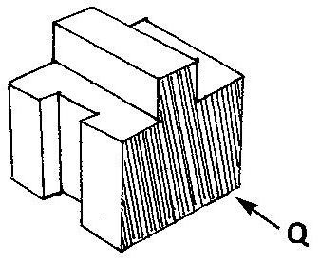

6. Which of the following represents the front view in the direction of arrow Q?

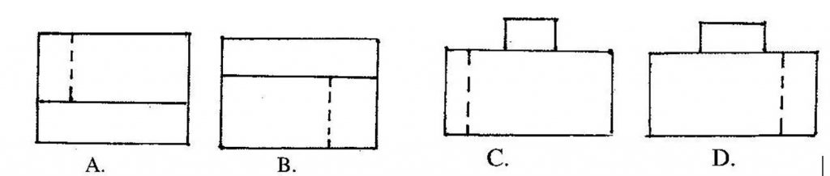

7. The plan is represented by

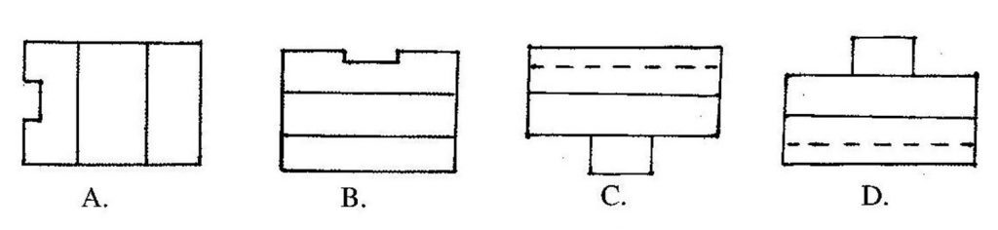

8. A sole proprietor

A. shares profit with friends  
B. shares profit with a partner  
C. takes decisions alone  
D. takes decision with his staff

9. The statement describing the problem in designing is referred to as

A. design brief  
B. design process  
C. situation  
D. investigation

10. Which of the following is not a type of joint for fixing parts of furniture ?

A. Movable joints  
B. Unmovable joints  
C. Temporary joints  
D. Permanent joints

11. In oblique drawing one side of the object is inclined at an angle of

A. 30°  
B. 45°  
C. 60°  
D. 90°

12. In a circuit diagram, current flows from

A. neutral to negative  
B. neutral to positive  
C. positive to negative  
D. negative to positive

13. Select a neutral colour from the options below

A. blue  
B. orange  
C. red  
D. white

14. The first step in designing is

A. choosing the right materials  
B. colouring the sketches  
C. identifying the problem  
D. making sketch models

15. A dressmaker may also be skillful in

I. embroidery making  
II. furnishing homes beautifully  
III. making beautiful paintings  
IV. selecting materials for upholstery

A. I, II and III only  
B. I, II and IV only  
C. I, III and IV  
D. II, III and IV only

16. Turpentine is mixed with

A. emulsion paint  
B. lacquer  
C. oil paint  
D. thinner

17. The elevation projected onto the side vertical plane is the

A. front  
B. plan  
C. end  
D. back

18. Which of the following is not a fastener?

A. bolts and nuts  
B. soldering bits  
C. screws  
D. rivets

19. Files are cleaned by using the

A. file card  
B. hacksaw blade  
C. scriber  
D. chisel

20. Which of the following components stores electrical charge?

A. diode  
B. switch  
C. resistor  
D. capacitor

21. The type of material used to strengthen joints in woodwork is known as

A. adhesives  
B. abrasives  
C. sanding sealer  
D. wax polish

22. Which of the following types of line is used to indicate the size of a drawing?

A. Hidden line  
B. Centre line  
C. Construction line  
D. Dimension line

23. Sandcrete bricks are made from

A. cement and clay  
B. cement and sand  
C. cement and laterite  
D. cement and lime

24. Which of the following is used to protect the head from injury?

A. apron  
B. gloves  
C. goggles  
D. helmet

25. The funnel is an example of surface development of a

A. cone  
B. cylinder  
C. square prism  
D. square pyramid

26. Which of the following tools are used for boring wood?

A. brace and bit  
B. mortice chisel and mallet  
C. hammer and cold chisel  
D. hammer and centre punch

27. The first step to be taken when checking a socket outlet for a fault is to

A. open the socket outlet  
B. switch off power at the main switch  
C. test the socket outlet  
D. remove the main fuse

28. The soft solder is an alloy of

A. copper and lead  
B. copper and tin  
C. lead and tin  
D. lead and aluminium

29. Which of the following is a cutting tool?

A. scrubbing plane  
B. bench vice  
C. rawhide mallet  
D. soldering iron

30. A face side mark on planed wood indicates that the surface

A. is smooth  
B. is rough  
C. has been tested for flatness  
D. has been tested for squareness

**Paper One – Answers**

1. C. Herringbone
2. B. becomes cheaper
3. A. food from each food group
4. D. two-dimensional work
5. A. Crayon
6. C.
7. C.
8. C. takes decisions alone
9. C. situation
10. C. Temporary joints
11. B. 45°
12. C. positive to negative
13. D. white
14. C. identifying the problem
15. B. I, II and IV only
16. B. soldering bits
17. B. soldering bits
18. B. soldering bits
19. D. capacitor
20. D. capacitor
21. A. adhesives
22. D. Dimension line
23. B. cement and sand
24. D. helmet
25. A. cone
26. A. brace and bit
27. B. switch off power at the main switch
28. C. lead and tin
29. A. scrubbing plane
30. C. has been tested for flatness