**2013 Integrated Science Past Questions – Paper One**

1. The S.I unit of temperature is

A. candela  
B. degree Celsius  
C. joule  
D. kelvin

2. Air is an example of

A. gas in gas mixture  
B. liquid in liquid mixture  
C. solid in liquid mixture  
D. solid in solid mixture

3. Which of the following activities are involved in the rearing of tilapia?

I. Feeding of fish  
II. Pond stocking  
III. Pest control

A. I and II only  
B. I and III only  
C. II and III only  
D. I, II and III

4. The part of the flower that contains nectar is called

A. anther  
B. petal  
C. ovary  
D. sepal

5. Which of the following methods protects pure iron from rusting by coating with zinc?

A. Alloying  
B. Galvanizing  
C. Greasing  
D. Painting

6. Leaching of nutrients from the soil leads to soil

A. acidity  
B. alkalinity  
C. erosion  
D. porosity

7. The hereditary material that is passed on from parents to offspring is known as

A. gene  
B. sperm  
C. red blood cell  
D. white blood cell

8. The solar system is made up of the

A. earth, moon and stars  
B. sun, comets and meteors  
C. sun, earth and moon  
D. sun, planets and other heavenly bodies

9. The type of management system which allows farm animals to roam about freely is known as

A. extensive system  
B. intensive system  
C. semi-extensive system  
D. semi-intensive system

10. External respiration in living organisms is also known as

A. aerobic respiration  
B. anaerobic respiration  
C. gaseous respiration  
D. tissue respiration

11. A rigid bar which is capable of turning about a fixed point is a / an

A. inclined plane  
B. lever  
C. screw  
D. wheel and axle

12. A positively charged ion is called

A. anion  
B. cation  
C. neutron  
D. proton

13. One way of ensuring that organisms are not endangered is to

A. allow them to be hunted  
B. allow their predators to outnumber them  
C. protect their habitats  
D. pollute their habitats

14. A good thermometric liquid must

A. be colourless  
B. boil at 100°C and freeze at 0°C  
C. cling to the walls of the glass  
D. expand evenly and regularly

15. Which of the following metals will produce a gas when placed in lime juice?

A. Copper  
B. Lead  
C. Magnesium  
D. Silver

16. The physical property of a soil which is determined by the feel method is soil

A. structure  
B. temperature  
C. texture  
D. water

17. The reason why gaps are left in the joints of railway lines is to allow for

A. cooling  
B. contraction  
C. expansion  
D. maintenance

18. Which of the following effects are caused by rusting?

I. Loss of strength  
II. Loss of structure  
III. Loss of electrical conductivity

A. I and II only  
B. I and III only  
C. II and III only  
D. I, II and III only

19. Leguminous crops may often be cultivated to add

A. carbon to the soil  
B. nitrogen to the soil  
C. protein to the soil  
D. potassium to the soil

20. A place where an organism can live and interbreed successfully is called

A. community  
B. ecosystem  
C. environment  
D. habitat

21. Which of the following methods of treating water makes it soft?

A. Addition of alum  
B. Addition of sodium carbonate  
C. Chlorination  
D. Filtration

22. Dehusking and shelling are both activities carried out in the processing of

A. cowpea  
B. groundnut  
C. maize  
D. sorghum

23. Typhoid fever is transmitted through

A. contact with contaminated skin wounds  
B. eating contaminated food  
C. eating uncooked food  
D. drinking treated water

24. One advantage of friction is that it

A. enables cutting tools to be sharpened  
B. increases the efficiency of machines  
C. produces a lot of heat in machines  
D. wears off the soles of shoes

25. Sickle is a farm tool used for

A. harvesting rice  
B. trimming hedges  
C. transplanting seedlings  
D. watering crops

26. One characteristic of the image formed in a pin-hole camera is that the image is

A. diminished  
B. magnified  
C. upright  
D. virtual

27. Transplanting of seedlings is usually done in the evening because

A. darkness promotes rapid growth  
B. pest attack is minimal  
C. transpiration is minimal  
D. seedlings require less nutrients

28. Which of the following statements about molecules is/ are correct? Molecules

I. are chemically combined group of atoms  
II. are physically combined group of atoms  
III. can exist on their own

A. I only  
B. II only  
C. I and III only  
D. I, II and III

29. Fruits which are dispersed by wind are likely to be

A. dry  
B. hairy  
C. juicy  
D. sticky

30. Which of the following materials allows electric current to pass through easily?

A. Aluminium  
B. Carbon  
C. Glass  
D. Water

31. Water contains two elements, hydrogen and oxygen, in the ratio of

A. 1:2  
B. 1:3  
C. 2:1  
D. 3:1

32. In the digestive system of ruminants, vitamins are synthesized in the

A. abomasum  
B. omasum  
C. reticulum  
D. rumen

33. The best way of protecting oneself from high blood pressure is to

A. consume alcoholic drinks  
B. eat high carbohydrate diets  
C. engage in smoking  
D. exercise regularly

34. The property of metals which makes them to be easily drawn into thin wires is known as

A. conductivity  
B. ductility  
C. malleability  
D. resistivity

35. An atom of an element is represented as . How many neutrons are in the nucleus of the atom?

A. 13  
B. 14  
C. 27  
D. 40

36. Viable seeds are ones that

A. are able to germinate under suitable conditions  
B. are eaten by animals after planting  
C. contain a lot of oil  
D. have hard seed coat

37. Which of the following processes can occur at all temperatures?

A. Boiling  
B. Evaporation  
C. Melting  
D. Sublimation

38. Which of the following human activities maintains the carbon cycle?

A. Bush burning  
B. Felling of trees  
C. Release of fumes from factories  
D. Replanting of trees felled as timber

39. The farming system which involves the growing of one type of crop on the same piece of land every season is known as

A. mixed cropping  
B. mixed farming  
C. monocropping  
D. monoculture

40. The presence of chlorophyll in green plants is a necessary condition for photosynthesis because it

A. absorbs oxygen  
B. absorbs solar energy  
C. produces carbon dioxide  
D. produces water vapour

June2013

INTEGRATEDSCIENCE1

SOLUTIONS

OBJECTIVE TEST

1. D. Kelvin

2. A.gas in gas mixture

3. D.I,II and III

4. B. petal

5. B. Galvanizing

6. A. acidity

7. A. gene

8. D. sun, planets and other heavenly bodies

9. A. extensive system

10. C. gaseous respiration

11. B. lever

12. B.cation

13. C.protect their habitats

14. D. expand evenly and regularly

15. C. Magnesium

16. C. texture

17. C. expansion

18. D. I,II and III only

19. B. nitrogen to the soil

20. D. habitat

21. B. Addition of sodium carbonate

22. B. groundnut

23. B. eating contaminated food

24. A. enables cutting tools to be sharpened

25. A. harvesting rice

26. A. diminished

27. C. transpiration is minimal

28. C. I and III only

29. B. hairy

30. A. Aluminium

31. C. 2:1

32. D. rumen

33. D. exercise regularly

34. B. ductility

35. B. 14

36. A. are able to germinate under suitable conditions

37. B.Evaporation

38.D. Replanting of trees felled as timber

39. C. mono cropping

40. B. absorbs solar energy

**2013 Integrated Science Past Questions – Paper Two**

1. (a) The diagrams below are illustrations of an experiment to demonstrate a biological principle  
Study the diagrams carefully and answer the questions that follow

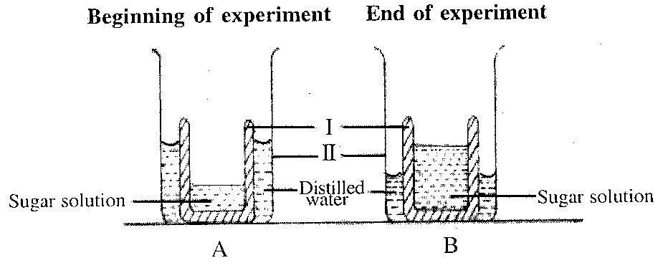

(i) Name the parts labelled I and II  
(ii) State two difference between the set-ups A and B  
(iii) What is the role played by the part labelled I in the experiment?  
(iv) Name the biological principle being demonstrated in this experiment  
(v) State one way in which plants benefit from the principle named in (iv)  
(vi) State one way in which animals benefit from the principle named in (iv)

(b) In an experiment to investigate the reactivity of zinc, a piece of the metal was dropped into a test tube containing dilute hydrochloric acid. The experimental set-up is illustrated below.

Study the set-up carefully and answer the questions that follow.

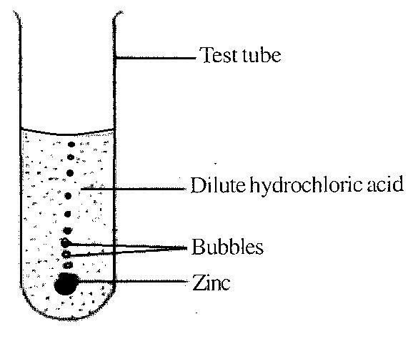

(i) Write a balanced chemical equation for the reaction that occurred in the experiment.  
(ii) Name the gas evolved.  
(iii) List two metals which can react in a similar way as the zinc  
(iv) List two metals which cannot react in a similar way as the zinc.  
(v) Name two glass apparatus which could have been used instead of the test tube.

(c) The diagram below is an illustration of a thermos flask  
Study the diagram carefully and answer the questions that follow

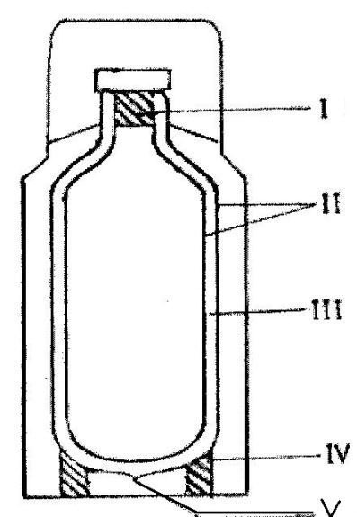

(i) Name the parts labelled I, II, III, IV and V  
(ii) How does the device minimize heat loss or gain through  
(α) conduction ? (β) convection ? (ʎ) radiation ?  
(iii) State one use of the thermos flask

(d) The diagrams below illustrate an experimental set-up on a physical property of soil using three soil types, X, Y and Z  
Study the set-up carefully and answer the questions that follow:

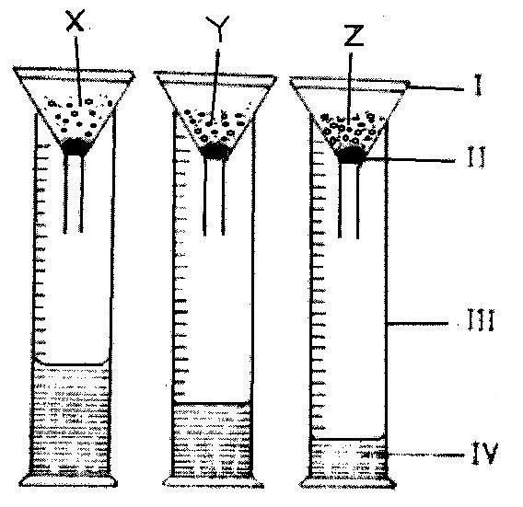

(i) Name the parts of the set-up labelled I, II, III and IV  
(ii) Which of the three soil types has the  
(α) highest water holding capacity?  
(β) least water holding capacity?  
(iii) Name each of the three soil types X, Y and Z  
(iv) Suggest a suitable title for the experiment

2. (b) State four hereditary features in humans

(c) State the energy transformation that takes place in each of the following activities:  
(i) dry cell in use;  
(ii) solar panel in use;  
(iii) electric stove in use;  
(iv) hammering of a piece of metal  
[4 marks]  
(d) State two ways each in which each of the following cultural practices is important in vegetable production:  
(i) staking  
(ii) pruning

3. (a) (i) What is indiscriminate sex?  
(ii) Give two reasons why teenagers indulge in indiscriminate sex.  
[4 marks]  
(b) Name two sources each of  
(i) natural light  
(ii) artificial light  
[4 marks]  
(c) State three ways in which soil texture is important in crop production.

(d) Write down the systematic name of each of the following chemical compounds:  
(i) FeS  
(ii) CO  
(iii) Cu2O  
(iv) NaOH

4. (a) (i) What do the symbols L, N and E represent in an electric plug?  
(ii) What is the function of the fuse box in household electrical wiring?

(b) Mention four classes of insect pest based on their feeding habits [4 marks]

(c) Classify the first four elements of the periodic table as metals and non-metals  
[4 marks]  
(d) Name the three types of blood vessels in humans

5. (a) (i) State the difference between organic fertilizer and inorganic fertilizer  
(ii) State two effects of inorganic fertilizer on the environment  
[4 marks]  
(b) Classify the following substances as acids or bases.  
(i) unripe lemon juice;  
(ii) wood ash;  
(iii) liquid in a car battery;  
(iv) bicarbonate of soda  
[4 marks]

(c) (i) What is a fruit?  
(ii) State two differences between a fruit and a seed.  
[4 marks]

(d) State the effect of heat on each of the following substances:  
(i) plastics  
(ii) alcohol  
(iii) metal rod

6. (a) Classify the following chemical substances based on their uses under the headings as shown in  
the table below:  
Milk of magnesia, alcohol, paracetamol, sodium hydroxide, N.P.K.

|  |  |  |
| --- | --- | --- |
| **Agriculture** | **Industry** | **Medicine** |
|  |  |  |

(b) State one use each of the following instruments used in the study of the weather:  
(i) rain gauge;  
(ii) hygrometer;  
(iii) anemometer.

(c) (i) Name two types of transistors.  
(ii) Draw and label the circuit symbols of the transistors named in (i)

(d) State three reasons why vegetable farming is important.

**INTEGRATEDSCIENCE 2**

SOLUTIONS

**Essay**

**1. (a) (i) PART NAME**

**I** - A hollowyamorpotato orpawpaw cup orsemi-permeablecontainer

**II** - A beaker ortrough

**(ii) Differences betweenset-ups A andB**

|  |  |
| --- | --- |
| **Set-upA** | **Set-upB** |
| Thesugar solution is concentrated | Thesugar solution is dilute |
| Thelevel of thedistilledwateris  high | Thelevel of thedistilledwaterislow |
| The amountof sugar solution is  smaller | The amountof sugar solution is  greater |

**(iii) Roleplayed by part I**

It serves asasemi-permeable membrane – to allow the movement ofwatermolecules from thewater into thesugar solution.

**(iv) Biological principle demonstrated**

Osmosis

**(v) Howplants benefit fromthe named principle (osmosis)**

• Absorption ofwaterbythe roots of plants

• Transportationofwaterfrom the roots to the otherparts of theplant

• Movement of water fromoneplant cellto theother

**(vi) Howanimals benefit fromosmosis**

• Movement of water into thecytoplasm of someorganisms suchas amoeba

• Re-absorption of waterin the kidneytubules of mammals

**(b) (i) Balancedequationfor the reaction**

Zn + 2HCl ⟶ ZnCl2 + H2

**(ii) Thegasevolved**

Hydrogengas or H2(gas)

**(iii) Metals that can react in a similarway asthe zinc**

Lithium, Magnesium, Potassium, Sodium, Calcium, Aluminium, Iron

**(iv) Metals that cannotreact in a similarway as the zinc**

Copper, silver,gold, mercury, platinum

**(v) Glassapparatus that could havebeen used.**

Beaker,conical flask, measuring cylinder, flat bottomed flask,gas jar

**(c) (i) Parts**

**I** - Cork or plastic/rubber stopper

**II** - Silvered or shinysurfaced double wall

**III** - Vacuum or emptyspace

**IV** - Cork support or plastic/rubber support

**V** - Vacuum seal

**(ii) Howthedeviceminimizes heatlossorgainthrough**

**(**�**) conduction**

Minimized bythe cork orplastic/rubber stopperand Cork support or

plastic/rubber support

**(**�**) convection**

Minimized bythevacuum

**(**�**) radiation**

Minimized bythe silvered or shinysurfaced doublewall

**(iii) Useofthe thermos flask**

• Maintains the temperatureof its contents forarelativelylongtime, ie, itkeeps its hot contents hot and its cold contents cold

• It preventsheat loss or heatgain of its contents for alongperiod.

**(d) (i) PARTS**

**I** - funnel

**II** - cotton wool

**III** - measuringcylinder

**IV** - water

**(ii) (**�**)** Highest waterholdingcapacity - **Z (**�**)** Least water holding capacity - **X**

**(iii) SOILTYPES**

**X** - Sandy **Y** - Loamy **Z** - Clayey

**(iv) Suitable title for experiment**

• Experiment to comparethe water-holding capacities ofsandy, loamyandclayeysoils

• Experiment to demonstrate thedrainage abilities ofsandy, loamyand clayeysoils.

**2. (a) Particles which make upmatter**

• Protons, Neutrons and Electrons

**(b) Hereditary features inhumans**

• Shapeof nose

• Sizeof ear

• Height

• Colour ofskin

• Mass

• Colour oreyes

• Temperament

• Intelligence

**(c) Energy transformationsinthefollowing activities: (i) dry cellin use;**

Chemical energy⟶electrical energy

**(ii) solar panel inuse;**

Solar/Light energy⟶ electrical energy

**(iii) electric stovein use;**

Electrical energy⟶ heatenergy+light energy

**(iv) hammering ofa pieceofmetal**

Kinetic energy⟶soundenergy+light energy

**(d) Importanceofthefollowing cultural practicesinvegetableproduction:**

**(i) staking**

• Gives the plants the abilitytogrowwithoutbendingor breaking

• Prevents fruits fromgettingrotten(as theylieon theground)

• Enables the plant toget sufficient sunlight neededforhealthygrowth

• Creates spacein-betweenplants for easier movement ofthe farmer.

**(ii) pruning**

• Increases the qualityandquantityof cropyield

• Helps to check the spread of pest and diseases

• Enables the plant toget sufficient sunlight neededforhealthygrowth

• Enhances healthiergrowth ofthe plant

• Improves ventilation forthe plant

|  |  |  |  |
| --- | --- | --- | --- |
| **3.** | **(a)** | **(i)** | **I*ndiscriminate sex*** |
|  |  |  | Havingsexual intercoursewith multiple (two ormore) partners and usuallywithout protection (useofcondom) |
|  |  | **(ii)** | **Reasons why teenagers indulge inindiscriminatesex.** |

• Curiosity

• Peer pressure

• Poverty

• Illiteracyor ignoranceofconsequences

• Lack of sufficient recreational avenues

• Broken homes

• Irresponsible parenting

• Low self esteem

• Fallen moral standardsofsociety.

• Lack of self-control

**(b) Sources of**

**(i) natural light**

• Sun

• Stars

• Lightning

• Volcanic eruption

• Firefly

• Glow worm

• Anglerfish

• lanternfish

**(ii) artificial light**

• Moon

• Electric bulb

• Torch

• Matches

• Vehicleheadlamps

• Light-emittingdiodes(LEDs)

• Light-emitting electrochemical cells (LECs)

**(c) Ways inwhichsoil textureis important incrop production.**

• It affects soilfertility

• It affects its water-holdingcapacity

• It affects its nutrient retention

• It affects its plant-holdingcapacity

• It affects the abilityof thesoil to resist erosion.

• It affects soiltemperature

**(d) Systematic namethe following chemical compounds:**

(i) FeS - Iron (II)sulphide

(ii) CO - Carbon(II)oxide **or**Carbonmonoxide (preferredIUPAC name)

(iii) Cu2O - Copper (I) oxide

(iv) NaOH- Sodiumhydroxide

**4. (a) (i) What thesymbols L, NandE represent in anelectricplug**

**L** - livepin

**N** - neutral pin

**E** - earth pin

**(ii) Thefunction ofthefusebox in householdelectrical wiring**

• The fuse boxhouses andcontrols theincoming electrical service and distribution to circuits within thehouse.

• It providesprotection againstpower fluctuation through theuse offuses

**(b) Four classes ofinsect pestbased ontheir feeding habits**

• Piercing&suckinginsects (eg,aphids, mosquitoes)

|  |  |  |
| --- | --- | --- |
| • | Chewinginsects | (eg,grasshoppers, beetles, weevils) |
| • | Siphoninginsects | (eg, moths, butterflies) |
| • | Sponginginsects | (eg, housefly) |

**(c) Classification of the first four elements of the periodic table**

|  |  |
| --- | --- |
| METALS | NON-METALS |
| Lithium | Hydrogen |
| Beryllium | Helium |

**(d) The three types ofbloodvessels in humans**

• Capillaries

• Veins

• Arteries

**5. (a) (i) Differencebetween*organic fertilizer*and*inorganic fertilizer***

|  |  |
| --- | --- |
| ORGANIC FERTILIZER | INORGANICFERTILIZER |
| Madefrom animal or plant  matter (natural sources) | Made from chemicals  (artificial sources) |

**(ii) Effects of*inorganic fertilizer*onthe environment**

• Damageand destructionofplant andanimal life,when used in excess

• Contamination of waterbodies when rain washeschemicals into them.

• Contributes to the formation of acid rain, when fossilfuels areburnt during their production

• Contributes to thegreenhouse effect, , when fossil fuels areburnt duringtheir production

• Nitrogen-containingfertilizers can cause soil acidification

**(b) Classificationofthefollowing substances as*acids* or*bases*.**

|  |  |
| --- | --- |
| ACIDS | BASES |
| Unripe lemon juice | Wood ash |
| Liquid in a car battery | bicarbonate of soda |

**(c) (i) A *fruit*?**

A matureovarycontainingseed

**(ii) Differences betweena*fruit*anda *seed*.**

|  |  |
| --- | --- |
| FRUIT | SEED |
| A matureovary | A matureovule |
| Contains aseed | Contains an embryo |
| Pericarp is formed  from thewallof the ripened ovary | Theseedcoat(testa)  is formed from integuments of ovule. |
| Cannot germinate  under anycondition | Can germinate under  the right conditions. |

**(d) The effect of heatoneachofthefollowing substances:**

|  |  |  |  |
| --- | --- | --- | --- |
| (i) | plastics | - Causes melting |  |
| (ii) | alcohol | - Causes boiling | orfasterevaporation |
| (iii) | metal rod | - Causes expansion |  |

**6. (a) Classificationof:**

***Milk of magnesia, alcohol, paracetamol, sodium hydroxide, N.P.K.***

|  |  |  |
| --- | --- | --- |
| **Agriculture** | **Industry** | **Medicine** |
| N.P.K | Alcohol  Sodiumhydroxide | Milk of magnesia  Paracetamol |

**(b) Oneuse eachofthefollowinginstruments**

|  |  |  |
| --- | --- | --- |
| (i) | rain gauge | - To measuretheamountof rainfall |
| (ii) | hygrometer | - To measuretheatmospherichumidity |
| (iii) | anemometer. | - To measurethe speed ofwind. |

**(c) (i) Types oftransistors.**

• PNPtransistor

• NPN transistor

**(ii)** Circuitsymbol of**PNP**transistor

Collector

Base

Emitter

**(ii)** Circuitsymbol of **NPN** transistor

Collector

Base

Emitter

**(d) Reasons why vegetable farming is important.**

• Source of employment –Income generation or wealth creation

• Foreign exchange earner for the nation, when exported.

• Provision of nutrition for man-Vegetables are very rich in essential vitamins, mineral salts and proteins.

• Certain vegetables help to conserve soil fertility

• Provides raw material for the food processing industry

• Certain vegetables are used in the pharmaceutical industry

• Vegetable take a shorter time to mature, hence it provides greater returns per given time and space.