Welcome!

Please scroll down to read introductory information

WordPub
BECE
BASIC DESIGN AND TECHNOLOGY
(Home Economics)

Past Questions & Answers

2014

Junior High School
Years 1, 2 & 3

Compiled by:


© 2018 Word Publishers. All rights reserved

Unauthorized distribution and/or reproduction of this document prohibited.

CONTACT

Email:
info@wordpub.org

Telephone:
(+233) 030 295 1486,
(+233) 020 893 0787,
(+233) 057 860 0052,
(+233) 024 850 6613.

Postal Address:
Word Publishers,
P.O. Box NT 583,
Newtown – Accra,
Ghana.

Location:
7 Tunemete Street,
Dzorwulu-Accra,
Ghana.

Website:
bece.wordpub.org

ACKNOWLEDGEMENTS

- The West African Examination Council - for the BECE BDT (Home Economics) past questions used in this document.

- Ernest Bentil and Dorothy Mensah – for your invaluable contribution to this work.

- Mr Eric Arthur – for your expert counsel and assistance

- Ruth, Baaba and Fiifi Arthur – for your relentless support

- Teachers, parents and educational institutions – for your continuous patronage and tireless efforts at ensuring quality education for the 21st century child

- Junior High School students – you are the ultimate reason for this work.

DEDICATION
To the Lord Jesus Christ, our Saviour and soon-coming King

June 2014

BASIC DESIGN AND TECHNOLOGY 1

(Home Economics 1)

Objective Test

40 minutes

- To hold a lining onto a fabric temporarily, one can use
  - basting
  - even tacking
  - tailor’s tacks
  - thread marking

- Which of the following stitches can be used to neaten raw edges of a set-in-sleeve?
  - Feather
  - Fishbone
  - Herringbone
  - Loop

- The goiter on Evelyn’s neck is caused by lack of
  - calcium
  - iodine
  - protein
  - vitamin

- Man-made elements represented in art include
  - branches
  - rivers
  - stones
  - walls

- The visitors’ book signed at exhibitions helps the exhibitor to know the
  - dignitaries who attended
  - number of works in high demand
  - observations made about the work
  - people who came

Use the sketch below to answer questions 6 and 7
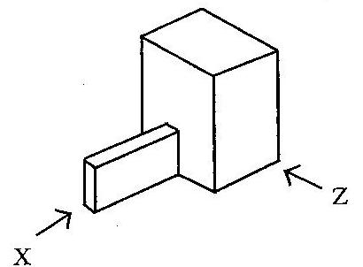

- Which of the following represents the front view in the direction of arrow Z?

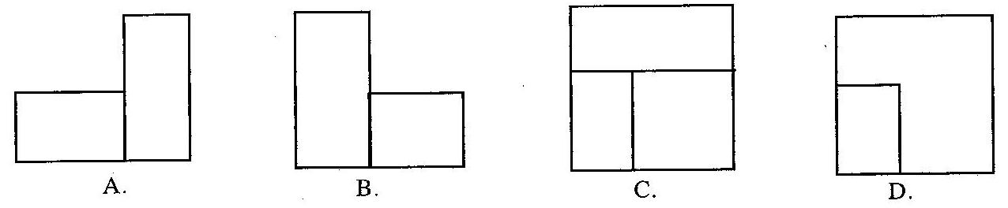

- Which of the following represents the left end elevation in the direction of arrow X?

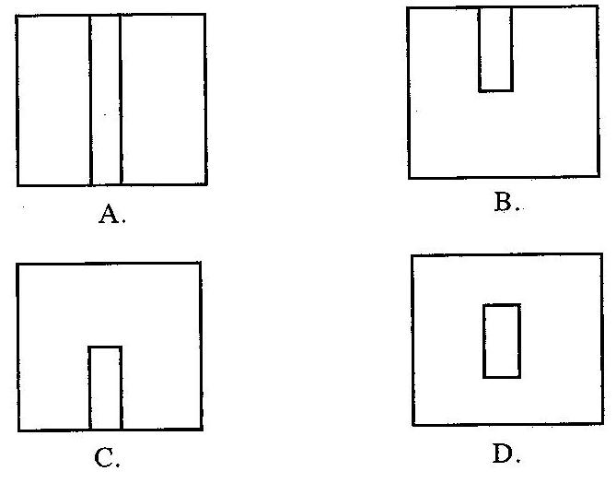

- A place where art works are sold is
  - an archive
  - a gallery
  - a museum
  - a studio

- In design, the conditions that the final solution must satisfy is termed
  - investigation
  - specification
  - development
  - analysis

- Which of the following instruments is most suitable for drawing horizontal lines?
  - Tee-square
  - Protractor
  - Compass
  - Set-square

Figure 2 shows a design process. Use it to answer questions 11 and 12

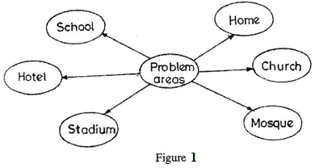

- Figure 1 shows the method of
  - specifying solutions
  - stating specification
  - evaluating artifact
  - identifying needs

- Which of the following design process stages follows the method shown in figure 1?
  - Writing specifications
  - Writing situation
  - Analyzing a situation
  - Sketching possible solutions

- Shading with lines is described as
  - cross hatching
  - hatching
  - stippling
  - tonal value

- Which of the following colours produces a feeling of warmth?
  - Blue
  - Green
  - Violet
  - White

- Which of the following factors can cause a sewing business to collapse?
  - Advertising
  - Insurance
  - Low sales
  - Skilled labour

- Which of the following tools is used for drawing lines when drafting patterns?
  - A pair of dividers
  - A protractor
  - Metre rule
  - Tape measure

- It is better to use cotton fabrics for making specimen because it is
  - beautiful
  - dirt resistant
  - durable
  - easy to handle

- All vegetable fibres leave ………………….. when burnt.
  - ashes
  - charcoal
  - hard ball
  - soft ball

- The most suitable fabric for making a bed sheet is
  - cotton
  - nylon
  - rayon
  - silk

- One can make an embroidered table runner if he or she learns
  - designing
  - drawing
  - sewing
  - weaving

- Which of the following measurement is needed when making a boy’s pair of shorts?
  - Back length
  - Chest
  - Crotch
  - Width

- The commonest collar on babies’ garment is
  - Chinese
  - Peterpan
  - Shawl
  - Shirt

- Which of the following are portions of control equipment?
- Measuring cups
- Weighing scales
- Polythene bags
- Empty tins

  - I, II and III only
  - I, II and IV only
  - I, III and IV only
  - II, III and IV only

- Choice of equipment and tools is based on
  - how difficult to clean and maintain
  - lack of space for storage
  - life span of equipment
  - unavailability of spare parts

- Moist heat causes ………………… to the human skin.
  - bruises
  - burns
  - cuts
  - scalds

- Food preservation is the treatment given to foods to enable them stay fresh for
  - a long time
  - some days
  - three days
  - three weeks

- The method of cooking in which heat travels directly to the food is
  - baking
  - boiling
  - grilling
  - stewing

- The method of cooking which is fast but expensive to use is
  - boiling
  - frying
  - grilling
  - roasting

- Which of the following are reasons for cooking food? To
- help food digest faster
- make the food edible
- make the food soft
- make the food last longer

  - I, II and III only
  - I, II and IV only
  - I, II and IV only
  - II, III and IV only

- The most important factor to consider when planning meals is the
  - appearance of the food
  - family budget
  - food available
  - service of the food

June 2014

BASIC DESIGN AND TECHNOLOGY 1

(Home Economics 1)

Objective Test
ANSWERS
- B. even tacking
- C. Herringbone
- B. iodine
- D. walls
- C. observations made about the work
- A.
- C.
- B. gallery
- B. specification
- A. Tee-square
- D. identifying needs
- D. Sketching possible solutions
- B. hatching
- C. Violet
- C. Low sales
- C. Metre rule
- C. durable
- A. ashes
- A. cotton
- D. weaving
- C. Crotch
- B. Peterpan
- B. I, II and IV only
- C. life span of equipment
- D. scalds
- A. a long time
- C. grilling
- B. frying
- A. I, II and III only
- B. family budget

June 2014

BASIC DESIGN AND TECHNOLOGY 2

(Home Economics 2)

Essay

1 hour
SECTION A
(CORE SKILLS)
[20 marks]
Answer question 1 [COMPULSORY]

- (a) State the main method for cooking the following foods:

- rice ……………………………………………………………………………

- cake ………………………………………..…………………………………

(b) State four suitable methods for preserving fish.
……………………………………………………………………………………………………………………………………………………………………………………………………
……………………………………………………………………………………………………………………………………………………………………………………………………

(c) (i) List the type of pencil most suitable for the following operations:

OPERATION | PENCIL USED
Lettering
Drawing outlines
Shading

(ii) List four methods of recording data for solving design problems.
……………………………………………………………………………………………………………………………………………………………………………………………………
……………………………………………………………………………………………………………………………………………………………………………………………………

(d) (i) State three benefits of packaging.
……………………………………………………………………………………………………………………………………………………………………………………………………
……………………………………………………………………………………………………………………………………………………………………………………………………

(ii) List two important information on a good package
……………………………………………………………………………………………………………………………………………………………………………………………………
(e) Draw a line to illustrate each of the following:
(i) movement
(ii) texture.

MOVEMENT | TEXTURE

SECTION B
[50 marks]
Answer two questions only from this section
All questions carry equal marks

- The sketch below shows the style of a blouse Afua decides to make for sale.

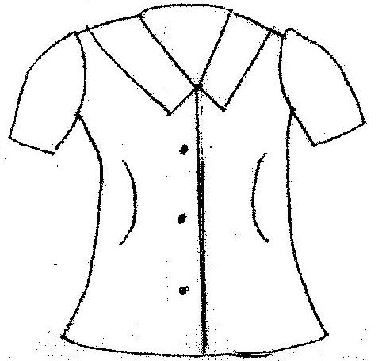
(a) State five processes that will be used in making up the blouse.

…………………………………………………………………………………………
…………………………………………………………………………………………
…………………………………………………………………………………………
…………………………………………………………………………………………
…………………………………………………………………………………………

(b) State five cotton fabrics that can be used in making the blouse

…………………………………………………………………………………………
…………………………………………………………………………………………
…………………………………………………………………………………………
…………………………………………………………………………………………

(c) The cost of making one blouse is GHC 2.50. Work out the cost of fifteen blouses.
…………………………………………………………………………………………
…………………………………………………………………………………………
…………………………………………………………………………………………
…………………………………………………………………………………………
…………………………………………………………………………………………

(d) If Afua sells one blouse at GHC 3.75. Work out the total profit for the fifteen blouses
…………………………………………………………………………………………
…………………………………………………………………………………………
…………………………………………………………………………………………
…………………………………………………………………………………………
…………………………………………………………………………………………

- (a) What is boiling as a method of cooking?

…………………………………………………………………………………………
…………………………………………………………………………………………
…………………………………………………………………………………………

(b) State two advantages of boiling as a method of cooking
…………………………………………………………………………………………
…………………………………………………………………………………………
…………………………………………………………………………………………
…………………………………………………………………………………………

(c) State two disadvantages of boiling as a method of cooking
…………………………………………………………………………………………
…………………………………………………………………………………………
…………………………………………………………………………………………
…………………………………………………………………………………………

(d) List ten food items that can be cooked using the boiling method
…………………………………………………………………………………………
…………………………………………………………………………………………
…………………………………………………………………………………………
…………………………………………………………………………………………
…………………………………………………………………………………………
(e) List two examples each of food items which can be prepared with the following methods of cooking
METHOD OF COOKING | EXAMPLES
Stewing
Frying
Poaching
Steaming

(f) Plan a two course lunch menu for an adolescent using meat for the main dish and provide a suitable dessert
…………………………………………………………………………………………
…………………………………………………………………………………………
…………………………………………………………………………………………
…………………………………………………………………………………………
…………………………………………………………………………………………
…………………………………………………………………………………………
…………………………………………………………………………………………

- (a) The passage below describes the threading of the sewing machine. Fill in the blank spaces with the appropriate words selected from the list below

balance wheel, spool pin, needle, tension disc, thread, reel, take-up-lever, second, first thread guide

Place the …………………….. of thread on the …………………………… Turn the ……………………………… so that the needle is at the highest point. Pass the thread through the …………………………… at the top of the machine. Draw the thread through the …………………………. to the …………………………….. Pass the thread through the ………………………… thread guide and finally through the eye of the ………………….

(b) Mention the main types of sewing equipment
…………………………………………………………………………………………
…………………………………………………………………………………………
…………………………………………………………………………………………

(c) Give two examples of each type of sewing equipment mentioned in 4 (b) above
…………………………………………………………………………………………
…………………………………………………………………………………………
…………………………………………………………………………………………

(d) What is microwave cooking?
…………………………………………………………………………………………
…………………………………………………………………………………………
…………………………………………………………………………………………

(e) List four food items which can be cooked in a microwave
…………………………………………………………………………………………
…………………………………………………………………………………………
…………………………………………………………………………………………
…………………………………………………………………………………………

(f) State one reason for using microwave to cook
…………………………………………………………………………………………
…………………………………………………………………………………………

(g) State two advantages of microwave cooking
…………………………………………………………………………………………
…………………………………………………………………………………………
…………………………………………………………………………………………
…………………………………………………………………………………………

(h) State two disadvantages of microwave cooking
…………………………………………………………………………………………
…………………………………………………………………………………………
…………………………………………………………………………………………
…………………………………………………………………………………………

June 2014

BASIC DESIGN AND TECHNOLOGY 2

(Home Economics 2)

Essay
ANSWERS

- (a) State the main method for cooking the following foods:

- rice - boiling
- cake - baking

(b) State four suitable methods for preserving fish.

- Drying
- Smoking
- Freezing
- Salting
- Frying
- Canning

(c) (i) List the type of pencil most suitable for the following operations:

OPERATION | PENCIL USED
Lettering | HB
Drawing outlines | H, 2H
Shading | 2B or BB , 3B, 4B, 5B, 6B

(ii) List four methods of recording data for solving design problems.
- Taking notes / Using computer
- Taking photographs
- Video recording
- Audio recording
- Drawing / sketching
- Drawing graphs
- Making charts

(d) (i) State three benefits of packaging.

- It adds value to the product
- It protects the product from contamination
- It protects the consumer from hazards
- Attracts consumers
- Makes handling easier / makes it portable
- Promotes easy identification.

(ii) List two important information on a good package
- Information about content / manufacturer
- Date of production
- Expiry date
- Instructions for usage

(e) Draw a line to illustrate each of the following:
(i) movement

Any line apart from horizontal or vertical lines, eg
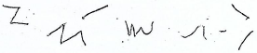

(ii) texture.
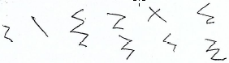

SECTION B
[50 marks]
Answer two questions only from this section
All questions carry equal marks

- The sketch below shows the style of a blouse Afua decides to make for sale.

(a) State five processes that will be used in making up the blouse.
Arrangement of fullness
Collar making
Openings
Seam making
Fastening
Neatening

(b) State five cotton fabrics that can be used in making the blouse
Denim.
Sateen.
Calico.
Poplin.
Muslin
Flannel

(c) The cost of making one blouse is GHC 2.50. Work out the cost of fifteen blouses.
Cost for one blouse = GHC 2.50
Hence, cost for fifteen blouses = 15 x GHC 2.50
= GHC 37.50

(d) If Afua sells one blouse at GHC 3.75. Work out the total profit for the fifteen blouses
Profit = Selling price – Cost price
Profit for 1 blouse = GHC 3.75 – GHC 2.50
= GHC 1.25
Hence, profit for 15 blouses = 15 x 1.25
= GHC 18.75

2ND METHOD

If selling price for 1 blouse = GHC 3.75
Then, selling price for 15 blouses = 15 x GHC 3.75
= GHC 56.25
Hence, Profit for 15 blouses = Selling price – Cost price
= GHC 56.25 – GHC 37.50
= GHC 18.75

- (a) What is boiling as a method of cooking?

Boiling is a method of cooking food in boiling water in a saucepan with a fitting lid at a temperature of 100 degrees Celsius

(b) State two advantages of boiling as a method of cooking
Boiled foods are easily digestible.
It is economical

(c) State two disadvantages of boiling as a method of cooking
Boiled foods are usually not attractive unless garnished.
Boiled foods go bad quickly, if not preserved well.

(d) List ten food items that can be cooked using the boiling method
…Rice, banku, plantain, yam, cocoyam, cassava, potato, fish, meat, egg, maize, cowpea

(e) List two examples each of food items which can be prepared with the following methods of cooking
METHOD OF COOKING | EXAMPLES
Stewing | Meat, carrots, cucumber, tomatoes
Frying | Fish and meat, yam, plantain
Poaching | Eggs and fish,
Steaming | Kenkey and fish, carrots, cucumber

(f) Plan a two course lunch menu for an adolescent using meat for the main dish and provide a suitable dessert
Main meal (1st course): Brown beef stew and boiled rice.
Dessert (2nd course) : Pineapple upside down

ALTERNATIVE
Main meal (1st course): Mutton palmnut soup and fufu (pounded cassava and plantain)
Dessert (2nd course) : Sliced oranges

ALTERNATIVE
Main meal (1st course): okro stew with goat meat and banku
Dessert (2nd course) : mango juice

- (a) The passage below describes the threading of the sewing machine. Fill in the blank spaces with the appropriate words selected from the list below

balance wheel, spool pin, needle, tension disc, thread, reel, take-up-lever, second, first thread guide

Place the …reel…. of thread on the …spool pin…. Turn the …balance wheel….. so that the needle is at the highest point. Pass the thread through the …first thread guide…. at the top of the machine. Draw the thread through the …tension disc…….. to the …take-up-lever…. Pass the thread through the …second…..thread guide and finally through the eye of the …needle..

(b) Mention the main types of sewing equipment
Large sewing equipment
Small sewing equipment

(c) Give two examples of each type of sewing equipment mentioned in 4 (b) above
Large equipment examples: ironing board and sewing machine.
Small equipment examples: tape measure, scissors, thread and needle

(d) What is microwave cooking?
Is a method of cooking and reheating food by means of electromagnetic waves in a micro
wave oven powered by electricity.

(e) List four food items which can be cooked in a microwave
Potatoes, Carrot, Meat, Fish, Oats, rice, beans, maize

(f) State one reason for using microwave to cook
It cooks food fast,
It is easy / convenient to use.

(g) State two advantages of microwave cooking
If properly set, it needs less attention
Food nutrients are conserved.

(h) State two disadvantages of microwave cooking
The oven is expensive.
Food can be dried when not covered properly.
It cannot be used where there is no electricity

