Welcome!

Please scroll down to read introductory information

WordPub
BECE
Information and Communication Technology

Past Questions & Answers

2014

Junior High School
Years 1, 2 & 3

Compiled by:


© 2018 Word Publishers. All rights reserved

Unauthorized distribution and/or reproduction of this document prohibited.

CONTACT

Email:
info@wordpub.org

Telephone:
(+233) 030 295 1486,
(+233) 020 893 0787,
(+233) 057 860 0052,
(+233) 024 850 6613.

Postal Address:
Word Publishers,
P.O. Box NT 583,
Newtown – Accra,
Ghana.

Location:
7 Tunemete Street,
Dzorwulu-Accra,
Ghana.

Website:
bece.wordpub.org

ACKNOWLEDGEMENTS

- The West African Examination Council - for the BECE Information and Communication Technology past questions used in this document.

- Ernest Ato Bentil – for your invaluable contribution to this work.

- Ruth, Baaba and Fiifi Arthur – for your relentless support

- Teachers, parents and educational institutions – for your continuous patronage and tireless efforts at ensuring quality education for the 21st century child

- Junior High School students – you are the ultimate reason for this work.

DEDICATION
To the Lord Jesus Christ, our Saviour and soon-coming King

June 2014

INFORMATION AND COMMUNICATION TECHNOLOGY 1

OBJECTIVE TEST

45 minutes

- The part of the computer which displays information to the user in soft copy format is the
  - Monitor
  - Printer
  - Processor
  - Scanner

- The sharpness of an image on a monitor screen is determined by the number of
  - Inches
  - Pits
  - Pixels
  - Units

- Which of the following can be used as an input device and at the same time as an output device?
  - Microphone
  - Modem
  - Printer
  - Speaker

- The device that uses the magnetic method to store data is
A. compact disk
B. digital versatile disk
C. hard disk
D. optical disk

- Which of the following devices has the largest storage capacity?
  - Compact disk
  - Digital versatile disk
  - Flash memory
  - Hard disk

- By default, the drive letter assigned to the hard disk drive is
  - A:
  - B:
  - C:
  - D:

- Which of the following devices must be turned on first when booting a computer?
  - Monitor
  - Printer
  - Scanner
  - System Unit

- The program that is loaded into the main memory when a computer is booted is
  - Utility program
  - Operating system
  - Communication software
  - Word processing software

- To copy a file means to
  - Cut the file
  - Delete the file
  - Remove the file
  - Make a duplicate of the file

- A group of files are stored in a
  - Folder
  - Graphic
  - Text
  - Word

- The area of the taskbar that displays small icons of some programs such as the system clock is
  - Programs area
  - Scroll bar
  - Start menu
  - System tray

- Which of the following is a problem to computer users as a result of radiation from the monitor?
  - Cardiovascular
  - Dizziness
  - Eye irritation
  - Loss of grip strength

- Dragging a folder from one drive to a window on another drive is equivalent to a
  - Cut operation
  - Copy operation
  - Delete operation
  - Move operation

- Which of the following safety precaution(s) is/are advisable to practice?
I. Do not answer or receive calls when charging mobile phones
II. Do not overload sockets
III. Plugging ICT tools in damaged sockets can be allowed sometimes.

  - I and II only
  - I and III only
  - II and III only
  - I, II and III

- A computer program that can copy itself and infect the computer without the permission or knowledge of the user is
  - Virus
  - Anti-virus
  - Window
  - Word processor

- The software that assists students in learning and can also be used to take online examinations is
  - Classroom software
  - Education software
  - Entertaining software
  - Graphic software

- ICT tools can be used in all the following areas except
  - Sharing ideas
  - Starting cabinetry
  - Accessing information
  - Retrieving information

- The act of clicking on an object and dragging it to a different location is referred to as
  - Drop-and-drag
  - Drag-and-drop
  - Drop-and-move
  - Drag-and-paste

- When pursuing typing lessons, computer users are expected to use
  - 5 fingers
  - 6 fingers
  - 8 fingers
  - 10 fingers

- Which of the following keys is not a function key on the computer keyboard?
  - F1
  - F2
  - F9
  - F13

- The computer keyboard combination that would move the cursor insertion point to the beginning of the current document is
  - Ctrl + B
  - Ctrl + H
  - Ctrl + Home
  - Ctrl + PgUp

- Which of the following commands is used to resave an edited file with the same file name?
  - Copy
  - Save
  - Save As
  - Send

- Computerized text editing is also referred to as
  - Database application
  - Desktop application
  - Spreadsheet application
  - Word processing application

- In order to apply bold formatting to a section of existing text, the user must first
  - Save the document
  - Click the start button
  - Click on the formatting button
  - Select the section to be formatted

- Text that is justified is
  - Adjusted to meet one margin
  - Adjusted to meet both margins
  - Grammatically correct
  - Only visible in print preview

- Which of the following keys are used to underline a text in word processing?
  - Ctrl + B
  - Ctrl + H
  - Ctrl + I
  - Ctrl + U

- When a text automatically moves to the next line at the end of a margin in a word processing program, it is referred to as
  - Text wrap
  - Word wrap
  - Hard return
  - Text movement

- The default orientation for a word processing document is
  - A4
  - Landscape
  - Letter
  - Portrait

- To print a document after previewing, use the
  - Edit command button
  - Open command button
  - Print command button
  - Save command button

- On an email interface, which of the following areas is mandatory to complete and send a message?
  - Sender body
  - Sender name
  - Message header / subject
  - Message recipient email address

- Which of the following domain name extensions is used by educational institutions?
  - .com
  - .edu
  - .net
  - .org

- Which of the following is a web browser?
  - Firewall
  - Opera
  - Windows
  - Yahoo

- Which feature in a browser enables users to fetch the latest copy of a web page?
  - Backward
  - Forward
  - Refresh
  - Stop

- Transmitting data from a local computer to a remote computer is referred to as
  - Downlinking
  - Downloading
  - Uplinking
  - Uploading

- The http:// in a website address refers to
  - Domain name
  - Directory name
  - File name
  - Protocol

- The command button that opens a dialog box for users to create an email message is
  - Back button
  - Compose button
  - Create button
  - Refresh button

- A spreadsheet cell name is referenced by a
  - Letter
  - Number
  - Letter and a number
  - Number and a letter

- Mathematical calculations in a spreadsheet are called
  - Formulas
  - Labels
  - Numbers
  - Values

- Which of the following does a user need to bypass before accessing an email?
  - Username and computer name
  - Username and email name
  - Username and password
  - Username and yahoo

- To apply a formula or function in a spreadsheet program, the symbol used is
  - = or *
  - = or +
  - = or /
  - = or –

June 2014

INFORMATION AND COMMUNICATION TECHNOLOGY 1
ANSWERS
OBJECTIVE TEST
- A. monitor
- C. pixels
- B. Modem
- C. hard disk
- D. hard disk
- C. C
- D. system unit
- B. operating system
- D. make a duplicate of the file
- A. folder
- D. system tray
- C. eye irritation
- B. copy operation
- A. I and II only
- A. virus
- B. education software
- B. starting cabinetry
- B. drag-and-drop
- D. 10 finger
- D. F13
- C. Ctrl + Home
- B. Save
- D. word processing application
- D. select the section to be formatted
- B. adjusted to meet both margins
- D. Ctrl + U
- B. word wrap
- D. portrait
- C. print command button
- D. Message recipient email address
- B. .edu
- B. Opera
- C. Refresh
- D. uploading
- D. protocol
- B. compose button
- C. letter and a number
- A. formulas
- C. Username and password
- D. = or –

June 2014

INFORMATION AND COMMUNICATION TECHNOLOGY 2
PAPER 2
ESSAY 1 ¼ hours
[60 marks]

SECTION A
[24 marks]
Answer Question 1 [Compulsory]
1. (a)
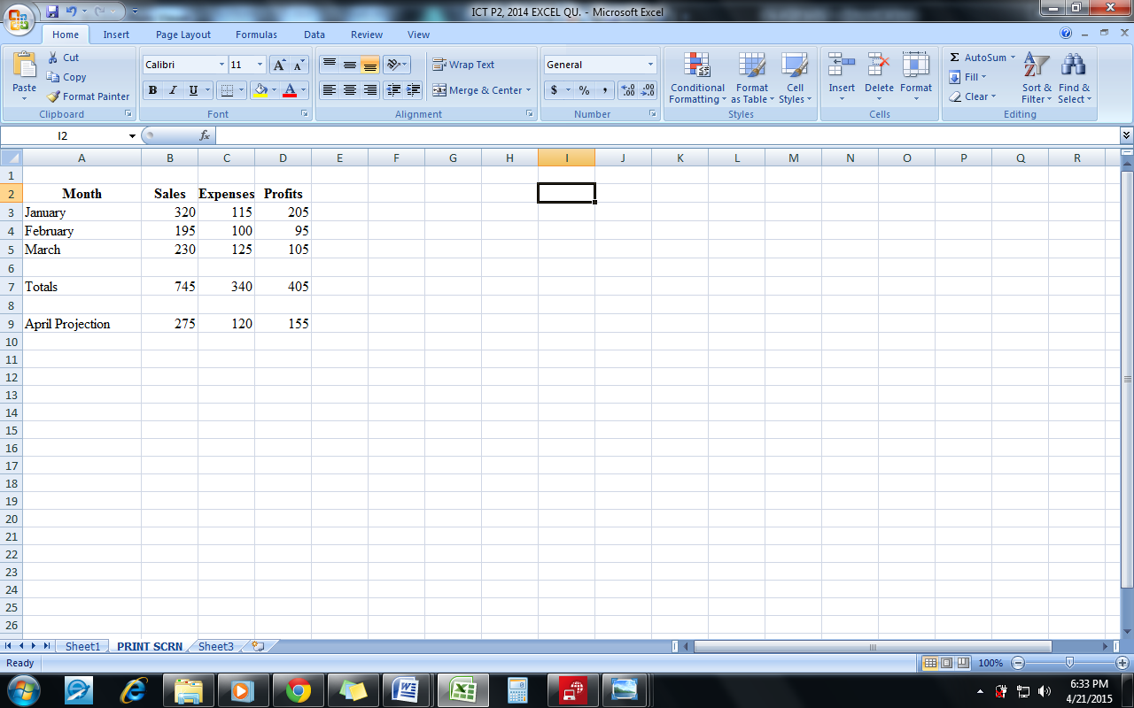
A

B

C

Use the diagram above to answer questions (i) to (iv)
(i) Name the application program used for the above figure [2 marks]
.........................................................................................................................................

(ii) Write the formula/ function used to calculate the profit for cell D7 [2 marks]
.........................................................................................................................................
.........................................................................................................................................

(iii) Write the formula/function used to calculate the total expenses for cell C7.[2 marks]
.........................................................................................................................................
.........................................................................................................................................

(iv) Name the parts labelled A, B and C [3 marks]
A ...........................................................................................................................
B ...........................................................................................................................
C ...........................................................................................................................

(b) Complete the table below
Windows button | Name of Windows button | Function of Windows button

[12 marks]
(c) In a word processing application, what is the command button print preview used for?
[3 marks]
.......................................................................................................................................................
.......................................................................................................................................................
.......................................................................................................................................................

SECTION B
[36 marks]
Answer three questions only from this section

2. (a) State the data types for the following characters as used in a spreadsheet application:
(i) 13.65 ...................................................................................................... [2 marks]
(ii) 24.04’ ...................................................................................................... [2 marks]
(iii) =SUM(A5:G5) .........................................................................................[2 marks]
(iv) =A4 + C8 – G25 .........................................................................................[2 marks]
(v) +233244971100 ..........................................................................................[2 marks]

(b) Formatting a disk refers to ....................................................................................................
...................................................................................................................................................... ......................................................................................................................................................
......................................................................................................................................................
[2 marks]
3. List
(a) two toggle keys on a standard computer keyboard [2 marks]
......................................................................................................................................................
......................................................................................................................................................

(b) three features of a web browser [3 marks]
......................................................................................................................................................
......................................................................................................................................................
......................................................................................................................................................

(c) two components of the central processing unit. [2 marks]
......................................................................................................................................................
......................................................................................................................................................

(d) two operating system software [2 marks]
......................................................................................................................................................
......................................................................................................................................................

(e) three health hazards associated with prolonged use of computers and ICT tools [3 marks]
......................................................................................................................................................
......................................................................................................................................................
......................................................................................................................................................

4. (a) Give two examples of a typing software. [2 marks]
......................................................................................................................................................
......................................................................................................................................................

(b) Certain books are published both in hard copies and soft copies (e-books). Give two reasons for using
(i) hard copies formats; [4 marks]
..........................................................................................................................................
..........................................................................................................................................
..........................................................................................................................................
..........................................................................................................................................
(ii) soft copies formats [4 marks]
..........................................................................................................................................
..........................................................................................................................................
..........................................................................................................................................
..........................................................................................................................................
(c) Arrange the storage devices, compact disc, hard disk and pen drive in descending order of
(i) access speed; [1 mark]
..........................................................................................................................................
..........................................................................................................................................
(ii) storage capacity. [1 mark]
..........................................................................................................................................
..........................................................................................................................................

5. State the purpose of the following commands on an email application such as yahoo or gmail:
(a) My account; [3 marks]
......................................................................................................................................................
......................................................................................................................................................
......................................................................................................................................................
......................................................................................................................................................
(b) Compose; [3 marks]
......................................................................................................................................................
......................................................................................................................................................
......................................................................................................................................................
......................................................................................................................................................

(c) Attach; [3 marks]
......................................................................................................................................................
......................................................................................................................................................
......................................................................................................................................................
......................................................................................................................................................

(d) Sign up; [3 marks]
......................................................................................................................................................
......................................................................................................................................................
......................................................................................................................................................
......................................................................................................................................................

END OF ESSAY
June 2014
INFORMATION AND COMMUNICATION TECHNOLOGY 2
ANSWERS
ESSAY

1. (a) (i) The application program used for the above figure
Microsoft Excel
(ii) The formula / function used to calculate the profit for cell D7
=B7–C7 or =D3+D4+D5 or =SUM(D3:D5)
(iii) The formula / function used to calculate the total expenses for cell C7
=C3+C4+C5 or =SUM(C3:C5)
(iv) Names of the parts
A - Name box
B - Formula bar
C - worksheet/ worksheet window

(b)
Windows button | Name of Windows button | Function of Windows button
 | Close | - Ends an application OR  - Shuts down an open/ active file or program OR  - Deactivates and stores an open/ active file or program
 | Minimize | - Drops window onto the taskbar OR  - Reduces the size of the window to the taskbar
 | Maximize | - Enlarges a window to occupy the entire screen OR  - Increases the size of a window to occupy the entire screen
 | Restore down | - Returns the size of a window to a previous custom size.

(c) What print preview is used for
It shows exactly what a printed copy of the document will look like.
OR
It shows exactly what will be printed if the print command is given.

2 (a) Data types for the following as used in a spreadsheet application
(i) 13.65 Value
(ii) 24.04’ Label
(iii) =Sum(A5:G5) Function
(iv) =A4+C8–G25 Formula
(v) +233244971100 Value

(b) Formatting a disk refers to
Organizing a disk / storage device in such a way that data can be stored on it
Formatting a disk would delete all data which was previously stored on it.

3. (a) Toggle keys on a standard computer keyboard
CAPS LOCK, NUM LOCK, SCROLL LOCK
(b) Features of a web browser
- Navigation buttons (forward and back butttons)
- Address bar
- Search bar
- Stop button
- Refresh/ Reload button
- Print button
(c) Components of the central processing unit
- The Arithmetic and Logic Unit (ALU), which performs all calculations.
- The Control Unit (CU), which controls the flow of data around the computer.
- *Modern central processing units may also have a Memory component, which is used to stores data
(d) Operating system software (examples of)
- Linux,
- Windows (95/ 98/ ME/ 2000/ XP/ Vista/ 7/ 8)
- Macintosh System (Mac OS)
- Micro-soft Disk Operating System (MS-DOS)
- OS/2 Warp,
- Unix,
- Android
- etc

(e) Health hazards associated with prolonged use of computers and ICT tools
    - Eye problems [radiation from computer monitor, television, other such devices]
    - Back ache, [Sitting behind a computer or other ICT tool for long periods]
    - Neck ache [Sitting behind a computer or other ICT tool for long periods]
    - Wrist pain [Using a keyboard or a mouse for long periods]
    - Ear problems / Hearing impairment [High sound volume from speakers / headset/ headphones]
    - *Cancer [radiation from mobile phones / devices]

4 (a) Examples of typing software
    - Mavis Beacon Teaches Typing
    - Life typing tutor
    - Touch typist typing tutor
    - Mac typing software
    - TypingMaster pro
    - Rapid Typing
    - Letter Chase Typing Tutor
    - TypeSmart typing tutor

(b) Reasons for books in
(i) hard copies formats
- Can be used without an electronic device
- Actual notes can be written and highlights made on its pages for easy reference.
- Can be accessed and used without electricity
- Can be used in areas where there is no electricity
- Information can be shared without using an electronic device
- Could be more portable than some computers

(ii) soft copies formats
      - Searching for a particular information is easier and faster – using the search feature
      - Sharing information across long distances is faster and easier - using the internet or intranet or removable storage media such as pendrives, compact discs, etc
      - Saves space - Several e-books can be loaded onto a computer or other portable device
      - Cheaper - due to its electronic format it costs less than equivalent books in hard copy formats
      - Versatile – It is possible to change the font size, convert to audio, etc to suit the preference of the user.
      - Can be read even in the dark without light
      - Maintains its state, no matter how old – does not get old or dirty or torn, etc

(c) Arranging Compact disc, hard disk and pen drive in descending order of
(i) access speed
Hard disk, pendrive, compact disc
(ii) storage capacity
Hard disk, pendrive, compact disc

5. Purpose of the following commands on email applications such as yahoo or gmail
(a) My account
To keep a private record of all mails/ messages sent, received and drafted
(b) compose
To create a new message/ document / mail to be sent
(c) Attach
To add/ fix an already existing document on a storage media to a current message to be sent
(d) sign up
To register for the first time on an email application OR
To create a new email account

