Welcome!

Please scroll down to read introductory information

WordPub
BECE
BASIC DESIGN AND TECHNOLOGY
(Pre-Technical Skills)

Past Questions & Answers

2014

Junior High School
Years 1, 2 & 3

Compiled by:


© 2018 Word Publishers. All rights reserved

Unauthorized distribution and/or reproduction of this document prohibited.

CONTACT

Email:
info@wordpub.org

Telephone:
(+233) 030 295 1486,
(+233) 020 893 0787,
(+233) 057 860 0052,
(+233) 024 850 6613.

Postal Address:
Word Publishers,
P.O. Box NT 583,
Newtown – Accra,
Ghana.

Location:
7 Tunemete Street,
Dzorwulu-Accra,
Ghana.

Website:
bece.wordpub.org

ACKNOWLEDGEMENTS

- The West African Examination Council - for the BECE Pre-Technical Skills past questions used in this document.

- Ernest Ato Bentil and Maxwell Mensah – for your invaluable contribution to this work.

- Ruth, Baaba and Fiifi Arthur – for your relentless support

- Teachers, parents and educational institutions – for your continuous patronage and tireless efforts at ensuring quality education for the 21st century child

- Junior High School students – you are the ultimate reason for this work.

DEDICATION
To the Lord Jesus Christ, our Saviour and soon-coming King

June 2014

BASIC DESIGN AND TECHNOLOGY 1

(Pre-Technical Skills 1)

Objective Test

40 minutes

- To hold a lining onto a fabric temporarily, one can use
  - basting
  - even tacking
  - tailor’s tacks
  - thread marking

- Which of the following stitches can be used to neaten raw edges of a set-in-sleeve?
  - Feather
  - Fishbone
  - Herringbone
  - Loop

- The goiter on Evelyn’s neck is caused by lack of
  - calcium
  - iodine
  - protein
  - vitamin

- Man-made elements represented in art include
  - branches
  - rivers
  - stones
  - walls

- The visitors’ book signed at exhibitions helps the exhibitions helps the exhibitor to know the
  - dignitaries who attended
  - number of works in high demand
  - observations made about the work
  - people who came

Use the sketch below to answer questions 6 and 7
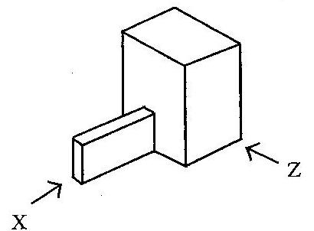

- Which of the following represents the front view in the direction of arrow Z?

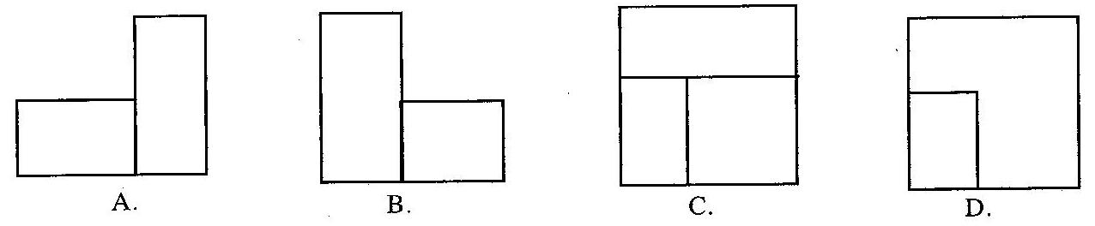

- Which of the following represents the left end elevation in the direction of arrow X?

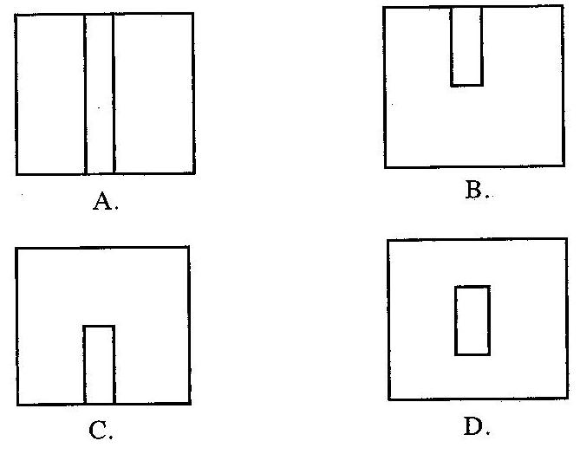

- A place where art works are sold is
  - an archive
  - a gallery
  - a museum
  - a studio

- In design, the conditions that the final solution must satisfy is termed
  - investigation
  - specification
  - development
  - analysis

- Which of the following instruments is most suitable for drawing horizontal lines?
  - Tee-square
  - Protractor
  - Compass
  - Set-square

Figure 2 shows a design process. Use it to answer questions 11 and 12

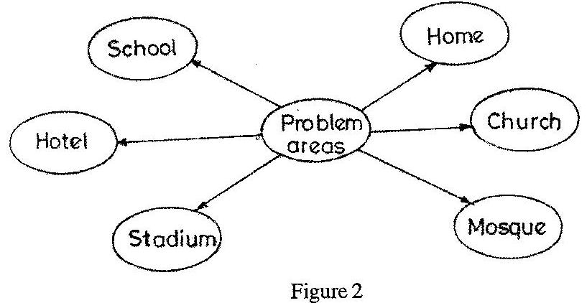

- Figure 2 shows the method of
  - specifying solutions
  - stating specification
  - evaluating artifact
  - identifying needs

- Which of the following design process stages follows the method shown in figure 2?
  - Writing specifications
  - Writing situation
  - Analyzing a situation
  - Sketching possible solutions

- Shading with lines is described as
  - cross hatching
  - hatching
  - stippling
  - tonal value

- Which of the following colours produces a feeling of warmth?
  - Blue
  - Green
  - Violet
  - White

- Which of the following factors can cause a sewing business to collapse?
  - Advertising
  - Insurance
  - Low sales
  - Skilled labour

- In mixing mortar, the ratio 1:5 represents
  - one part sand to five parts cement
  - one part water to five parts cement
  - one part cement to five parts sand
  - one part cement to five parts gravel

- Aggregates used for concrete mixture should be
  - well graded
  - round in size
  - square in size
  - medium graded

- Which of the following represents a centre line?

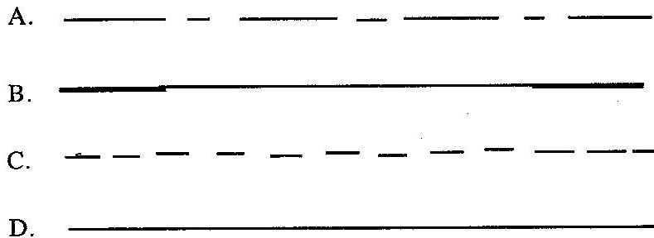

- Which of the following is a safety workshop practice?
  - Wearing strong boots
  - Wearing loose clothing
  - Leaving tools on bench
  - Using mushroom head chisel

- Polyvinyl acetate is also called
  - animal glue
  - white glue
  - resin glue
  - contact glue

- Making a round hole in a piece of metal is termed
  - boring
  - chipping
  - drilling
  - chamfering

- Which of the following is not a property of aluminium?
  - Light in weight
  - It corrodes
  - Absorbs heat readily
  - It is a good conductor of electricity

- In furniture works, joints which have to be disconnected at certain times can be described as
  - permanent joints
  - immovable joints
  - movable joints
  - temporary joints

Use the symbol below to answer questions 24 and 25

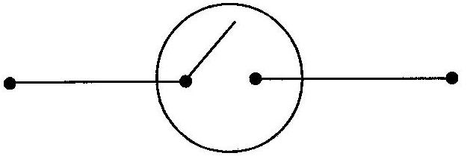

- The symbol shows
  - an inductor
  - a diode
  - a switch
  - a capacitor

- The component is used for
  - storing electrical energy
  - opening and closing a circuit
  - opposing the flow of electric current.
  - allowing current to flow in one direction

- In applying finishes, the emulsion paint is mixed with
  - oil
  - water
  - thinner
  - turpentine

- The most appropriate tool for enlarging holes in metals is the
  - flat file
  - hand file
  - square file
  - round file

Use the sketch below to answer questions 28 to 30

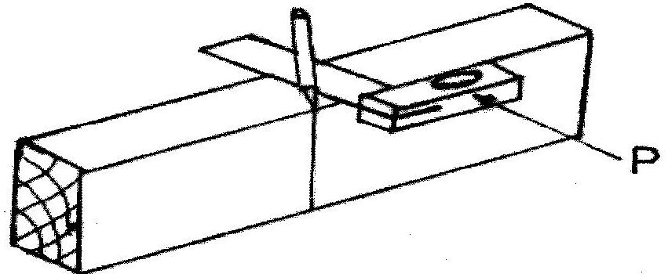

- The process represented in the sketch is
  - marking out
  - measuring
  - cutting
  - drilling

- The tool marked P is a
  - marking gauge
  - builder’s square
  - try-square
  - mortise gauge

- The material being worked on is
  - polyvinyl chloride
  - mahogany
  - sandcrete block
  - mild steel.

END OF PAPER

June 2014

BASIC DESIGN AND TECHNOLOGY 1

(Pre-Technical Skills 1)

Objective Test
ANSWERS
- B. even tacking
- C. Herringbone
- B. iodine
- D. walls
- C. observations made about the work
- A.
- C.
- B. gallery
- B. specification
- A. Tee-square
- D. identifying needs
- B. Writing situation
- B. hatching
- C. Violet
- C. Low sales
- C. one part cement to five parts sand
- A. well graded
- A.
- A. Wearing strong boots
- B. white glue
- C. drilling
- B. It corrodes
- C. movable joints
- C. a switch
- B. opening and closing a circuit
- B. water
- D. round file
- A. marking out
- C. try-square
- B. mahogany

June 2014

BASIC DESIGN AND TECHNOLOGY 2

(Pre-Technical Skills 2)

Essay

1 hour 15 minutes

SECTION A
(CORE SKILLS)
[20 marks]
Answer question 1 [COMPULSORY]

- (a) State the main method for cooking the following foods:

- rice
- cake

(b) State four suitable methods for preserving fish.

(c) (i) List the type of pencil most suitable for the following operations:

OPERATION | PENCIL USED
Lettering
Drawing outlines
Shading

(ii) List four methods of recording data for solving design problems.

(d) (i) State three benefits of packaging.
(ii) List two important information on a good package

(e) Draw a line to illustrate each of the following:
(i) movement
(ii) texture.

SECTION B
[50 marks]
Answer two questions only from this section
All questions carry equal marks

- Figure 1 shows a wooden object to be prepared in the workshop.

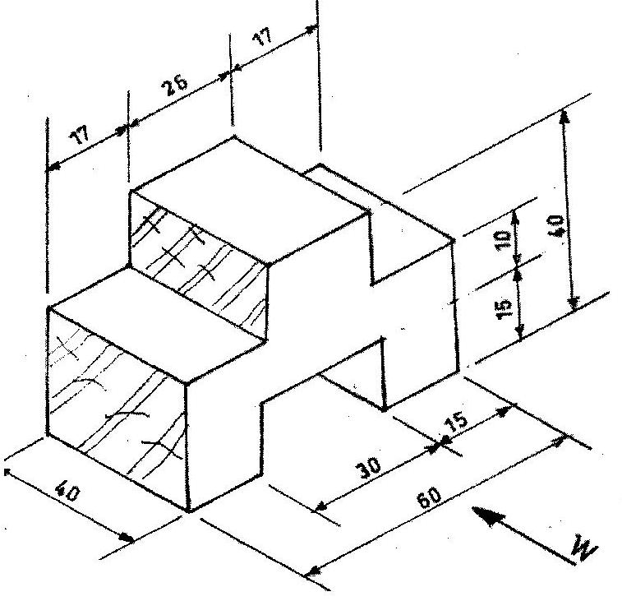

- Draw full size the front view in the direction of arrow W.

- List two tools used for:

- marking-out the shape of the object
- cutting the waste wood.

- State two ways of caring for and maintaining the jack plane.
- State the difference between ferrous metals and non-ferrous metals.
- Make a freehand sketch of the builder’s square.

- (a) State one reason why personal safety should be observed in the workshop.

(b) List two specific tools for carrying out each of the following operations:
(i) setting-out a wall;
(ii) moulding bricks;
- cutting a tenon from a piece of wood;
- soldering sheet metals.

(c) (i) Make a freehand pictorial sketch of a rasp file
(ii) Label any two parts of the tool sketched in (c)(i) above.
- State one use of the rasp file.

(d) (i) State the main difference between a brick and a block.
(ii) List the two main materials for making sandcrete blocks.

- (a) List one protective clothing each for the following:
- foot;
- head;
- eyes,

(b) (i) Make a freehand pictorial sketch of the firmer chisel.
(ii) Label any two parts of the tool sketched in 4 (b) (i)

(c) State one reason each for carrying out the following operations:
(i) cross-filing
(ii) curing a sandcrete block;
(iii) setting out a wall.

(d) Copy and complete the table below

ALLOY | COMPOSITION | ONE USE EACH
Soft solder
Brass
Bronze

June 2014

BASIC DESIGN AND TECHNOLOGY 2

(Pre-Technical Skills 2)

Objective Test
ANSWERS

SECTION A
(CORE SKILLS)

- (a) State the main method for cooking the following foods:
- rice - boiling
- cake - baking

(b) State four suitable methods for preserving fish.
- Drying
- Smoking
- Freezing
- Salting
- Frying
- Canning

(c) (i) List the type of pencil most suitable for the following operations:

OPERATION | PENCIL USED
Lettering | HB
Drawing outlines | H, 2H
Shading | 2B or BB , 3B, 4B, 5B, 6B

(ii) List four methods of recording data for solving design problems.
- Taking notes / Using computer
- Taking photographs
- Video recording
- Audio recording
- Drawing / sketching
- Drawing graphs
- Making charts

(d) (i) State three benefits of packaging.
- It adds value to the product
- It protects the product from contamination
- It protects the consumer from hazards
- Attracts consumers
- Makes handling easier / makes it portable
- Promotes easy identification.

(ii) List two important information on a good package
- Information about content / manufacturer
- Date of production
- Expiry date
- Instructions for usage

(e) Draw a line to illustrate each of the following:
(i) movement

Any line apart from horizontal or vertical lines, eg
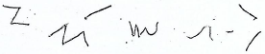

(ii) texture.
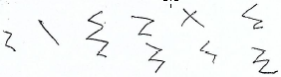

SECTION B
[50 marks]
Answer two questions only from this section
All questions carry equal marks

- Figure 1 shows a wooden object to be prepared in the workshop.

- Draw full size the front view in the direction of arrow W.

Accurately drawing 6 horizontal lines and 6 vertical lines neatly

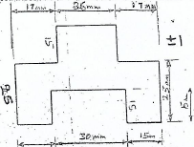

- List two tools used for:

- marking-out the shape of the object
- Marking knife
- Pencil
- Try-square
- Marking gauge
- Rule / Tape measure
- Straight edge

- cutting the waste wood.
- Mortise chisel or firmer chisel
- Mallet
- Tenon saw / other back saws (except rip saw)

- State two ways of caring for and maintaining the jack plane.
- Cleaning the tool after use
- Oiling the metal parts
- Keeping the tool in the rack or tool box
- Sharpening the tool before use

- State the difference between ferrous metals and non-ferrous metals.

- Ferrous metals are metals that contain iron while non-ferrous metals do not contain iron.
- Ferrous metals can rust while non-ferrous metals do not rust.

- Make a freehand sketch of the builder’s square.
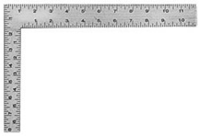

- (a) State one reason why personal safety should be observed in the workshop.
- To avoid injury
- To prevent accident

(b) List two specific tools for carrying out each of the following operations:
(i) setting-out a wall;
- Line and pins
- Straight edge
- Builder’s square
- Profile Boards
- Spirit Level
- Tape measure / surveyor’s tape
- Pegs
- Piece of chalk

(ii) moulding bricks;
- Mould box
- Head pan / gauge box / wheel barrow
- Shovel / spade
- Tamping rod
- Pick Axe

- cutting a tenon from a piece of wood;
- Try square
- Marking gauge / mortise gauge
- Pencil / Marking knife
- Tenon Saw
- Mallet
- Bevel-edged chisel / firmer chisel

- soldering sheet metals.
- Soldering iron / bit
- Coal pot / stove / blow lamp
- File / emery cloth
- Shears / pair of snips
- Mallet
- Folding bar

(c) (i) Make a freehand pictorial sketch of a rasp file
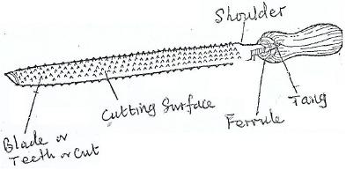

(ii) Label any two parts of the tool sketched in (c)(i) above.
- Blade / teeth / cut
- Tang
- Ferrule
- Handle
- Shoulder

- State one use of the rasp file.
- For smoothening edges and shapes
- For shaping a circular piece of wood

(d) (i) State the main difference between a brick and a block.
- The size: A block is bigger than a brick
- The weight: A block is heavier than a brick
- The material: A block is made of concrete whilst brick is made of clay

(ii) List the two main materials for making sandcrete blocks.
- Sand
- Cement

- (a) List one protective clothing each for the following:
- foot; safety boots / safety shoes / Protective shoes

- head; Helmet

- eyes, Goggles / eye shield / spectacles

(b) (i) Make a freehand pictorial sketch of the firmer chisel.
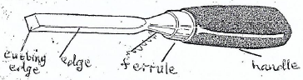

(ii) Label any two parts of the tool sketched in 4 (b) (i)
- Cutting edge
- Edge
- Ferrule
- Handle

(c) State one reason each for carrying out the following operations:
(i) cross-filing
- For removing waste metal
- For removing unwanted metal
- For removing excess metal

(ii) curing a sandcrete block;
- To help the block to attain its maximum strength
- To prevent rapid drying
- To reduce shrinkage
- To make it dense
- To prevent / reduce cracks
- To make it durable

(iii) setting out a wall.
- For straightness
- For squaring
- For accuracy

(d) Copy and complete the table below

ALLOY | COMPOSITION | ONE USE EACH
Soft solder | Lead + tin or antimony | - For joining sheet metal  - For soldering sheet metal, wires cables and pipe
Brass | Copper + zinc | - Door locks  - Door handles  - Musical instruments  - Hinges  - Ornaments  - Taps  - Bolts and nuts  - Bells
Bronze | Copper + tin | - Statues  - Trophies  - Shields  - Church bells

