Welcome!

Please scroll down to read introductory information

WordPub
BECE
Integrated Science

Past Questions and Answers

2014

Junior High School
Years 1, 2 & 3

Compiled by:


© 2018 Word Publishers. All rights reserved

Unauthorized distribution and/or reproduction of this document prohibited.

CONTACT

Email:
info@wordpub.org

Telephone:
(+233) 030 295 1486,
(+233) 020 893 0787,
(+233) 057 860 0052,
(+233) 024 850 6613.

Postal Address:
Word Publishers,
P.O. Box NT 583,
Newtown – Accra,
Ghana.

Location:
7 Tunemete Street,
Dzorwulu-Accra,
Ghana.

Website:
bece.wordpub.org

ACKNOWLEDGEMENTS

- The West African Examination Council - for the BECE Integrated Science past questions used in this document.

- Ernest Ato Bentil and Francisco Ameyedowo – for your invaluable contribution to this work.

- Mr Eric Arthur – for your expert counsel and assistance

- Ruth, Baaba and Fiifi Arthur – for your relentless support

- Teachers, parents and educational institutions – for your continuous patronage and tireless efforts at ensuring quality education for the 21st century child

- Junior High School students – you are the ultimate reason for this work.

DEDICATION
To the Lord Jesus Christ, our Saviour and soon-coming King

JUNE 2014

INTEGRATED SCIENCE 1

OBJECTIVE TEST

45 minutes

- Which of the following types of teeth is used by mammals to tear food material?
  - Canines
  - Incisors
  - Molars
  - Premolars

- The eclipse formed when the moon comes between the sun and the earth is known as
  - annular eclipse
  - lunar eclipse
  - solar eclipse
  - total eclipse

- The element with the chemical symbol S is
  - silicon
  - silver
  - sodium
  - sulphur

- The term leaching in soils refers to
  - accumulation of organic matter
  - decomposition of plant material.
  - fixation of nitrogen
  - removal of soil nutrients by water.

- Which of the following statements about a plant cell is correct? It
  - does not have a nucleus
  - contains large vacuoles
  - is surrounded by the cell membrane only
  - does not have a definite shape

- An example of a derived quantity is
  - length
  - mass
  - temperature
  - volume

- Solid non-metals normally break into pieces when hammered because they are
  - brittle
  - ductile
  - lustrous
  - malleable

- Young rabbits are called
  - bunnies
  - cubs
  - fingerlings
  - kids

- Producers in an ecosystem are plants that
  - attract insects
  - feed on other plants
  - feed on dead materials
  - manufacture their own food.

- The form of energy produced from the nucleus of an atom is termed
  - chemical energy
  - mechanical energy
  - nuclear energy
  - thermal energy

- Which of the following elements is a semi-metal?
  - Carbon
  - Nitrogen
  - Silicon
  - Sodium

- A system of farming that leads to continuous destruction of virgin forest is
  - mixed farming
  - mixed cropping
  - pastoral farming
  - shifting farming

- The by-products of respiration are
  - carbon dioxide and heat
  - carbon dioxide and water
  - oxygen and heat
  - oxygen and water.

- Which of the following statements about a force are correct? It
- is measured in newtons
- is measured in newton-metre
- can start a motion
- can change the direction of a moving body.

  - I and II only
  - I and III only
  - I, III and IV only
  - I, II, III and IV

- Which of the following substances is a solid-gas mixture?
  - Lather
  - Bronze
  - Steel
  - Smoke

- Weeds on a school farm could be controlled by
  - handpicking
  - mowing
  - ploughing
  - tilling

- An example of a non-living tissue used in osmosis experiment is
  - cellophane
  - filter paper
  - potato
  - polythene

- Kerosene is poured on the surface of a pond in order to
  - make it unsafe for human consumption
  - make it safe for animal consumption
  - increase the surface tension
  - break the surface tension

- Which of the following processes is used to separate insoluble solids from liquids?
  - Crystallization
  - Evaporation
  - Filtration
  - Sublimation

- The process of removing unproductive poultry birds from a flock is referred to as
  - candling
  - culling
  - dehorning
  - drenching

- Which of the following pairs of diseases can be spread easily when food is exposed to houseflies?
  - Dysentery and malaria
  - Malaria and tuberculosis
  - Dysentery and cholera
  - Cholera and tuberculosis

- The pressure in fluids
  - acts differently in all directions
  - acts upwards at any point
  - decreases with depth
  - increases with depth

- Which of the following processes involve a change in the state of matter from liquid to solid?
  - Beans
  - Bread
  - Cabbage
  - Egg

- Which of the following food items contains the highest amount of dietary fibre?
  - Beans
  - Bread
  - Cabbage
  - Egg

- An example of a disease vector is
  - earthworm
  - liver fluke
  - tapeworm
  - tick

- Which of the following devices is made of semiconductor?
  - Capacitor
  - Inductor
  - Resistor
  - Transistor

- Which of the following statements about the properties of water are correct? It
- is colourless and tasteless
- is neutral to litmus paper
- turns red litmus paper blue
- is a universal solvent

  - I and II only
  - I and III only
  - I, II and IV only
  - I, III and IV only

- The study of the soil profile of an area helps the farmer to
  - control weed growth
  - determine the soil temperature
  - determine the types of crop to grow.
  - know the pesticides to use.

- When a green leaf is placed in a test tube containing ethanol and heated over a water bath the leaf
  - becomes soft
  - changes colour to brown
  - changes colour to blue-black
  - is decolourized.

- Which of the following sources of energy is / are renewable?
- Solar
- Crude oil
- Wind

  - I only
  - I and II only
  - I and III only
  - I, II and III

- Which of the following substances is a compound?
  - Hydrogen
  - Nitrogen
  - Oxygen
  - Water

- A disease-causing organism that is most difficult to control in crop production is
  - bacterium
  - fungus
  - nematode
  - virus

- Which of the following organisms is/ are multicellular?
- Amoeba
- Paramecium
- Onion

  - I only
  - III only
  - I and III only
  - II and III only

- In electronic circuits, LEDs are used to indicate the absence or presence of
  - emitter and collector
  - electric current
  - p-n junction
  - voltage source.

- Steel is an alloy of iron and
  - aluminium
  - carbon
  - silicon
  - gold

- Soil aeration could be improved through
  - mulching
  - irrigation
  - soil drainage
  - fertilizer application

- Which of the following pairs of structures are part of the respiratory system of humans?
  - Fallopian tube and alveoli
  - Pharynx and oesophagus
  - Trachea and alveoli
  - Trachea and duodenum

- Which of the following effects is not a result of illegal connection of electricity? It can
  - lead to fire outbreak
  - lead to frequent power cut-off
  - increase the flow of current in the supply chain.
  - cause damage to electrical appliance

- Which of the following statements about the scientific method is / are correct? It provides
- logical procedure for arriving at knowledge.
- knowledge that can be verified
- knowledge that can never be changed

  - I only
  - I and II only
  - I and III only
  - II and III only

- An entrepreneur’s decision as to what to produce is a/ an
  - co-ordinating function
  - organizing function
  - planning function
  - supervising function.

END OF PAPER

JUNE 2014

INTEGRATED SCIENCE 1

OBJECTIVE TEST
SOLUTIONS

- A. canines
- C. solar eclipse
- D. sulphur
- D. removal of soil nutrients by water
- B. contains large vacuoles
- D. volume
- A. brittle
- A. bunnies
- D. manufacture their own food
- C. nuclear energy
- C. silicon
- D. shifting farming
- B. carbon dioxide and water
- C. I, III and IV only
- D. smoke
- A. handpicking
- A. cellophane
- D. break the surface tension
- C. filtration
- B. culling
- C. Dysentery and cholera
- D. increases with depth
- B. freezing
- A. Beans
- D. tick
- D. Transistor
- C. I, II and IV only
- C. determine the types of crop to grow
- D. decolourized
- C. I and III only
- D. water
- A. Bacterium
- B. III only
- B. electric current
- B. carbon
- D. fertilizer application
- C. trachea and alveoli
- C. increase the flow of current in the supply chain
- B. I and II only
- C. planning function

JUNE 2014

INTEGRATED SCIENCE 2

ESSAY

1 ¼ hours

PART I
[40 marks]
Answer all of Question 1

- (a) The diagrams below represent the stages in the life cycle of a mosquito

Study the diagrams carefully and answer the questions that follow

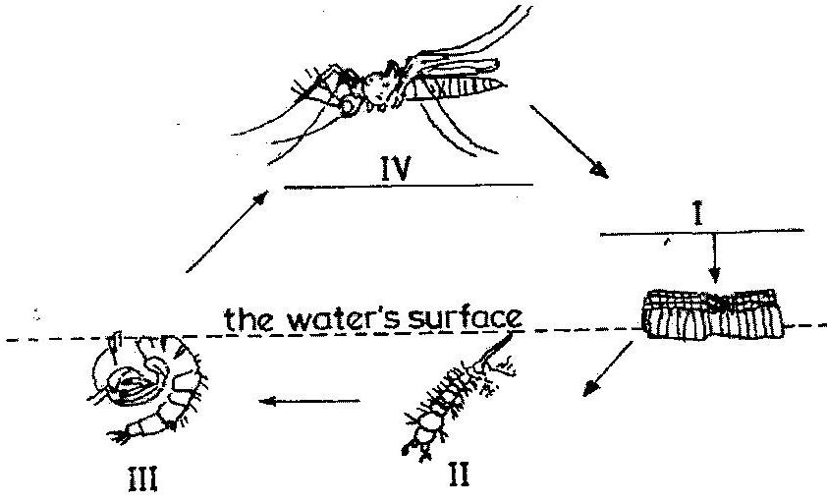

- Name each of the stages labeled I, II, III and IV
- State how stage II obtains oxygen
- State two methods of controlling each of the stages labeled III and IV

(b) The diagrams below are different laboratory set-ups used in the separation of mixtures.
Study the diagrams carefully and answer the questions that follow

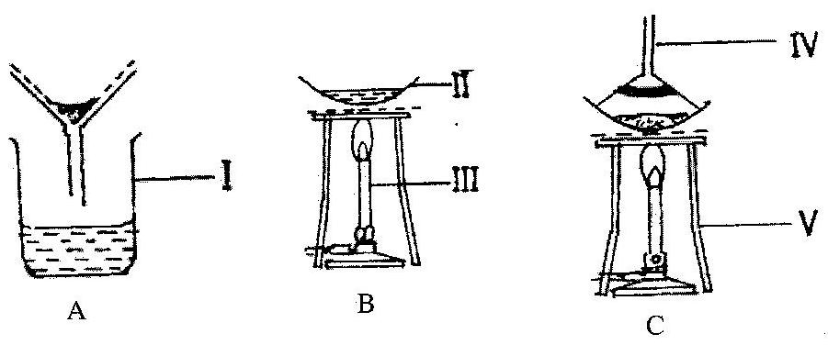

- Name each of the parts labeled I, II, III, IV and V.
- Name the separation method represented by each diagram.
- Which of the set-ups is used to obtain clear water from muddy water?
- Which of the set-ups is used to obtain salt from salt solution?

(c) The diagrams below show some instruments used in the laboratory.
Study the diagrams carefully and answer the questions that follow

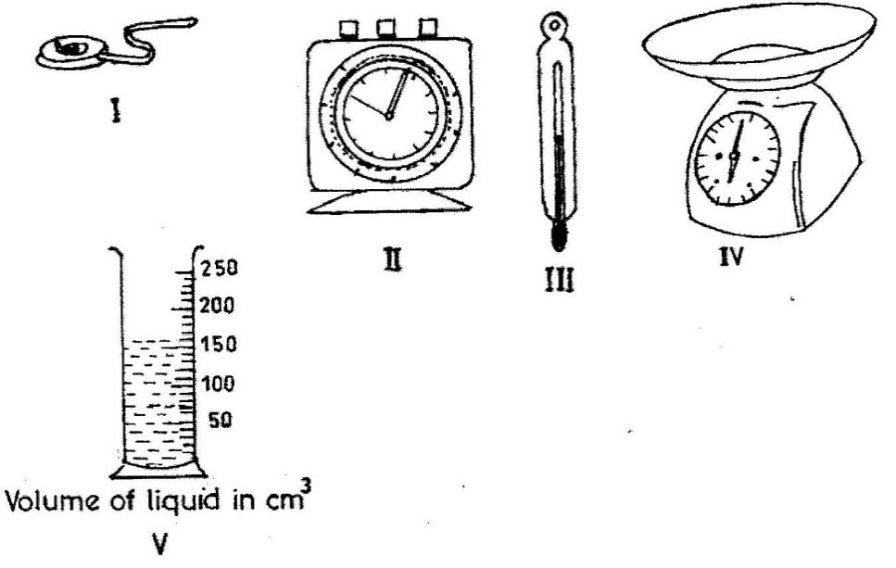

- Identify each of the instruments labeled I, II, III, IV and V
- State one use of each of the instruments labeled I, II, III and IV
- Read and record the volume of the liquid in the instrument labeled V

(d) The diagram below shows the digestive system of a class of farm animals.
Study the diagrams carefully and answer the questions that follow
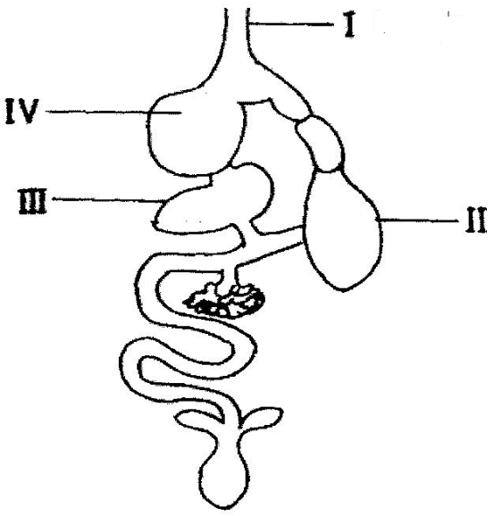

- Name each of the parts labeled I, II, III and IV
- State one function each of the parts labeled II and IV
- Name two farm animals that possess this type of digestive system.
- Mention two diseases which affect this class of farm animals.
[10 marks]

PART II
[60 marks]
Answer four questions only from this part.

- (a) (i) Name the two elements that combine to form water.
(ii) Write a balanced chemical equation to show how the water is formed from the named elements

(b) State two ways of maintaining a balance in an ecosystem.

(c) (i) What is a fertile soil?
(ii) State two factors that cause loss of soil fertility.

(d) Classify the following items as magnetic or non-magnetic substance:
wood, steel blade, rubber and glass jar.

- (a) (i) What is germination of seed?
(ii) State two conditions necessary for the germination of seed.

(b) State four methods used in identifying farm animals

(c) Explain why it is easier to cut a piece of yam with a sharp knife than with a blunt knife

(d) State three differences between a metal and a non-metal.

- (a) (i) What is debeaking?
(ii) Give two reasons why debeaking in poultry birds is important.

(b) (i) A steel needle carefully placed on the surface of water floats. What type of force made the steel needle to float?
(ii) Name three substances that could be added to the water to make the steel needle to sink.

(c) (i) Explain why gold is preferred to iron in the making of jewelleries.
(ii) State one way of preventing rusting.

(d) (i) State two elements of climate
(ii) Name the equipment used to measure each of the elements stated in (i) above.

- (a) (i) What is refraction of light?
(ii) Sketch a diagram to show the path of a light ray when it travels from air to glass.

(b) Explain why it is difficult to separate iron and sulphur mixture after strong heating.

(c) (i) Give two example of digestive enzymes produced in humans.
(ii) For each of the enzymes given in (i), name the part of the human body where the enzyme is produced.

(d) List four methods of applying fertilizers to crops.

- (a) Consider the substance listed below:
carbon dioxide, gold, bronze, iron, oxygen and ink

From the list, select the substance that:
- supports burning
- is used as jewellery;
- is used for making statues

(b) (i) Name two diseases associated with the circulatory system of humans.
(ii) State one way of preventing each of the diseases named in (i)

(c) Give two examples of each of:
(i) major plant nutrients;
(ii) minor plant nutrients.

(d) (i) State two properties of a good thermometric liquid.
(ii) Give two examples of a good thermometric liquid.

END OF ESSAY TEST

JUNE 2014

INTEGRATED SCIENCE 2

ESSAY

SOLUTIONS

- (a)
- Name of each stage
  - Egg
  - Larva
  - Pupa
  - Adult / Imago

- How stage II obtains oxygen
The larva comes to the surface of the water body to obtain oxygen from the air through a structure called the siphon.

- Methods of controlling each of the stages labeled III and IV

Controlling stage III
- Adding oil to cover the water surface
- Introduction of fish into the water body
- Spraying the water body with pesticides
- Adding kerosene to cover the water surface

Controlling stage IV
- The use of lethal ovitraps
- The use of mosquito spray / insecticide
- The use of mosquito coil
- Clearing mosquito breeding grounds such as choked gutters, stagnant pools of water, etc

(b)
- Name of the part labeled
- Beaker
- Evaporating disc
- Candle
- Inverted funnel
- Tripod stand

- Name the separation method represented by each diagram.
- Filtration
- Evaporation
- sublimation

- The set-up used to obtain clear water from muddy water
Set up A

- The set-up used to obtain salt from salt solution?
Set-up B

(c)
- Identification of the instruments labeled I, II, III, IV and V
- Tape measure
- stop clock
- Thermometer
- Weighing scale/ Top pan balance
- Measuring cylinder

- State one use of each of the instruments labeled I, II, III and IV
- to measure length of materials
- to measure time
- to measure temperature
- to measure the mass of materials
- to measure the volumes of liquid substances

- Read and record the volume of the liquid in the instrument labeled V
Volume of liquid = 160 cm³

(d)
- Name each of the parts labeled I, II, III and IV
- Gullet
- Gizzard
- Liver
- Crop

- State one function each of the parts labeled II and IV

- used to grind food
- used to store food temporarily

- Name two farm animals that possess this type of digestive system.

Turkey, fowl, duck, ostrich, geese, guinea fowl.

- Mention two diseases which affect this class of farm animals.
Coccidiosis, fowl typhoid, fowl pox, newcastle disease, pneumonia.

PART II
[60 marks]

- (a) (i) Name the two elements that combine to form water.

Hydrogen and oxygen

(ii) Write a balanced chemical equation to show how the water is formed from the named elements
H₂ + ½ O₂ H₂O OR
2H₂ + O₂ 2H₂O

(b) State two ways of maintaining a balance in an ecosystem.
- Stopping indiscriminate felling of tress
- By enforcing environmental protection laws; United Nation resolutions on release of poisonous gases should be adhered to.
- Activities of mining industries should be strictly monitored.
- Poaching of animals for their parts should be stopped

(c) (i) What is a fertile soil?

Soil that has the ability to supply the required nutrients needed for plant growth

(ii) State two factors that cause loss of soil fertility.
- Soil erosion,
- leaching,
- excessive irrigation,
- over cropping,
- surface compacting.

(d) Classify the following items as magnetic or non-magnetic substance:
wood, steel blade, rubber and glass jar.

Magnetic substance - steel blade
Non-magnetic substance - wood, rubber and glass jar.

- (a) (i) What is germination of seed?
The process by which a viable seed grows/develops into a seedling.

(ii) State two conditions necessary for the germination of seed.
- Presence of air
- Presence of water
- Viable seed
- Optimum temperature

(b) State four methods used in identifying farm animals
Tagging, tattooing, branding, tonging, ear notching

(c) Explain why it is easier to cut a piece of yam with a sharp knife than with a blunt knife
The cutting edge of a sharp knife has very small surface area so requires smaller force to yield the pressure needed to cut the yam - making cutting easy, but the cutting edge of a blunt knife has a relatively larger surface area so it needs a larger force to yield the pressure needed to cut the yam.

(d) State three differences between a metal and a non-metal.

Metals | Non-metals
Have high melting point | Have low melting point
Are lustrous | Are not lustrous
Are malleable | Are not malleable
Have high density | Have low density
Are ductile | Are brittle
Are good conductors of heat and electric current | Are poor conductors of heat and electric current

- (a) (i) What is debeaking?
The process by which about half the beak of a bird is removed
or
The process of removing the upper part of the beak of a bird

(ii) Give two reasons why debeaking in poultry birds is important.
- To prevent wasting of food
- To prevent egg eating
- To prevent vent pecking
- To prevent injuring other birds

(b) (i) A steel needle carefully placed on the surface of water floats. What type of force made the steel needle to float?
Surface tension

(ii) Name three substances that could be added to the water to make the steel needle to sink.
Oil, detergent, grease, kerosene, soap

(c) (i) Explain why gold is preferred to iron in the making of jewelleries.
It does not react with substances like water and oxygen.
It does not rust
It is very malleable

(ii) State one way of preventing rusting.
- Applying oil to the surface of the metal
- Galvanizing the metal
- Keeping the metal inside a desiccator
- Alloying the metal

(d) (i) State two elements of climate
Temperature,
rainfall,
relative humidity,
light intensity,
wind speed,
wind direction,
atmospheric pressure

(ii) Name the equipment used to measure each of the elements stated in (i) above.
ELEMENT EQUIPMENT
Temperature Thermometer
rainfall, rain gauge
relative humidity, hygrometer
light intensity, photometer
wind speed, wind vane
wind direction, anemometer
atmospheric pressure barometer

- (a) (i) What is refraction of light?
The bending of light rays as it travels from an optically less dense medium to an optically more dense medium

(ii) Sketch a diagram to show the path of a light ray when it travels from air to glass.
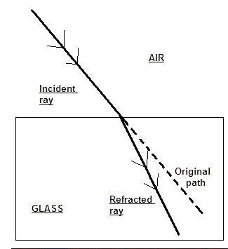

(b) Explain why it is difficult to separate iron and sulphur mixture after strong heating.
This is because after strong heating, the iron and sulphur react to form iron (II) sulphide which cannot be separated by physical means

(c) (i) Give two example of digestive enzymes produced in humans.
Salivary amylase,
pepsin,
renin,
lipase,
trypsin,
pancreatic amylase,
maltase

(ii) For each of the enzymes given in (i), name the part of the human body where the enzyme is produced.
ENZYME PART WHERE ENZYME IS PRODUCED
Salivary amylase Mouth
pepsin, stomach
rennin stomach
lipase pancreas
trypsin pancreas
pancreatic amylase pancreas
maltase small intestine

(d) List four methods of applying fertilizers to crops.
Drilling, broadcasting, side dressing , top dressing, ringing,

- (a) Consider the substance listed below:
carbon dioxide, gold, bronze, iron, oxygen and ink

From the list, select the substance that:
- supports burning - oxygen
- is used as jewellery; - gold
- is used for making statues - bronze

(b) (i) Name two diseases associated with the circulatory system of humans.
Arteriosclerosis, coronary thrombosis, heart cancer, leukimea, high blood pressure, piles, varicose vein

(ii) State one way of preventing each of the diseases named in (i)
Arteriosclerosis-
- regular exercising of the body
- avoid smoking
- low fat intake

Piles-
- intake a lot of water
- eat a lot of vegetables and fruits

High blood pressure-
- regular exercising of the body
- low salt intake
- low fat intake
Varicose vein- surgical removal of vein

(c) Give two examples of each of:
(i) major plant nutrients;
Nitrogen, phosphorus, sulphur, potassium, calcium, magnesium.

(ii) minor plant nutrients.
Chlorine, iron, fluoride, manganese, molybdenum

(d) (i) State two properties of a good thermometric liquid.
- Remains a liquid within a wide temperature range
- It must not wet class
- Expands uniformly with a rise in temperature
- It must not vaporize easily

(ii) Give two examples of a good thermometric liquid.
Mercury and alcohol

END OF ESSAY TEST

