2015 BECE Mathematics (Maths) Past Questions Paper One

- List the members of the set Q = {prime factors of 30}
  - {2, 3, 5}
  - {2, 6, 10}
  - {3, 5, 15}
  - {3, 6, 15}

- Given that set P = {m, n, o, p}, find the number of subsets of P.
  - 4
  - 8
  - 10
  - 16

- If M = {multiples of 4 between 10 and 25} and N = {even numbers between 11 and 23}, find M ∪ N
  - {12, 16, 20}
  - {14, 18, 22}
  - {12, 14, 16, 18, 22}
  - {12, 14, 16, 18, 20, 22, 24}

- What is the place value of 7 in 24.376 ?
  - Unit
  - Ten
  - Tenth
  - Hundredth

- Find the Highest Common Factor of 24, 42 and 72
  - 4
  - 6
  - 7
  - 12

- Express 120₅ as a number in base 10
  - 25
  - 27
  - 32
  - 35

- If p × q × r = 1197, and p = 19, q = 3, find r
  - 21
  - 49
  - 57
  - 61

- How many integers are within the interval – 5 < x < 7 ?
  - 10
  - 11
  - 12
  - 13

- Divide 1.612 by 0.4
  - 4.3
  - 4.03
  - 0.403
  - 0.43

- Arrange the following fractions in ascending order: $\frac{5}{8}, \frac{11}{20}, \frac{7}{10}$
  - $\frac{5}{8}, \frac{11}{20}, \frac{7}{10}$
  - $\frac{7}{10}, \frac{5}{8}, \frac{11}{20}$
  - $\frac{11}{20}, \frac{5}{8}, \frac{7}{10}$
  - $\frac{5}{8}, \frac{7}{10}, \frac{11}{20}$

- Abena spent $\frac{1}{5}$ of her money on sweets, $\frac{4}{7}$ on provisions and the rest on gari. What fraction of her money did she spend on gari?
  - $\frac{27}{35}$
  - $\frac{13}{35}$
  - $\frac{8}{35}$
  - $\frac{5}{35}$

- If 5 boys took 14 days to cultivate a piece of land, how long will it take 7 boys working at the same rate to cultivate the land ?
  - 14 days
  - 12 days
  - 10 days
  - 8 days

- A man invested GHC 800.00 in a bank at a simple interest rate of 5% per annum. Find his total amount in the bank at the end of one year.
  - GHC 840.00
  - GHC 860.00
  - GHC 900.00
  - GHC 960.00

- John sold a car for GHC 60,000.00 and made a profit of 20%. What is the cost price of the car?
  - GHC 48,000.00
  - GHC 50,000.00
  - GHC 72,000.00
  - GHC132,000.00

- What is the value of x if 10^{x} = 1000?
  - 1
  - 2
  - 3
  - 4

- Express 625.13 in standard form
  - 6.2513 × 10⁻²
  - 6.2513 × 10⁻⁴
  - 6.2513 × 10²
  - 6.2513 × 10⁴

- Find the median of the numbers 17, 12, 15, 16, 8, 18, 13 and 14
  - 8
  - 12
  - 14.5
  - 15.5

- The ages in years of 10 children at a party are 2, 3, 3, 3, 4, 4, 5, 5, 5 and 6. If a child is chosen at random, what is the probability that he / she is not less than 5 years old ?
  - $\frac{2}{3}$
  - $\frac{2}{5}$
  - $\frac{3}{10}$
  - $\frac{1}{2}$

- Expand (2x + y) (2x - y)
  - 2x² – y²
  - 4x² – y²
  - 2x² + 4xy – y²
  - 4x² + 4xy – y²

- Find the value of n, if 25.003 = (2 × 10) + (5 × 1) + (3 × n)
  - 0.001
  - 0.011
  - 0.01
  - 0.1

- Evaluate (3m)² – 3m², when m = 2.
  - 12
  - 18
  - 20
  - 24

- A wrist watch is priced GHC 2,000.00. A shopkeeper allows a discount of 2% on the cost price. Find the discount on 20 of such wrist watches.
  - GHC 500.00
  - GHC 600.00
  - GHC 800.00
  - GHC 1,000.00

- Find the value of m, if 4(m + 4) = – 8.
  - – 6
  - – 2
  - 2
  - 6

- Find the rule for the following mapping
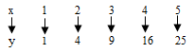
  - y→x+2
  - y→2x
  - y→x²
  - y→2x+2

- How many vertices has a cuboid?
  - 6
  - 7
  - 8
  - 14

- The circumference of a circle is 440 m. Find the area of the circle. [Take π = $\frac{22}{7}$]
  - 14,400 m²
  - 15,400 m²
  - 16,400 m²
  - 18,000 m²

- What name is given to a triangle which has all its sides equal?
  - Isosceles triangle
  - Scalene triangle
  - Equilateral triangle
  - Right-angle triangle

- At eight o’clock, which of the following is the angle between the hour and the minute hands of the clock?
  - 150°
  - 120°
  - 90°
  - 60°

- A rectangular field 50 m wide and y m long requires 260 m of fencing. Find y.
  - 15 m
  - 40 m
  - 80 m
  - 105 m

- Which of the following best describes the statement: ‘The locus of a point which moves so that its distance from two fixed points are always equal’?
  - Bisector of an angle
  - Perpendicular bisector
  - Circle
  - Two parallel lines

- The point K (1, 5) is rotated through 90° anti-clockwise about the origin. Find the coordinates of the image of K.
  - (5, -1)
  - (-5, 1)
  - (-1, 5)
  - (1, -5)

- Kwame is facing west. Through how many degrees should he turn anti-clockwise to face north?
  - 90°
  - 180°
  - 270°
  - 360°

- Given that vectors u = $\left(\begin{aligned}-3 \\ 5\end{aligned}\right)$ and v = $\left(\begin{aligned} 2 \\ -3\end{aligned}\right)$, find 2v – u
  - $\left(\begin{aligned} 1 \\ -1\end{aligned}\right)$
  - $\left(\begin{aligned}-1 \\ 1\end{aligned}\right)$
  - $\left(\begin{aligned}-7 \\ -11\end{aligned}\right)$
  - $\left(\begin{aligned} 7 \\ -11\end{aligned}\right)$

What is the name of the figure above?
  - Cuboid
  - Kite
  - Triangle
  - Pyramid
13 | 12 | 17
E | F | 10
11 | 16 | G

Use the magic square above to answer questions 35 to 37

- Find the value of F
  - 14
  - 15
  - 18
  - 23

- Find the value of E.
  - 14
  - 15
  - 18
  - 23

- Evaluate E + G
  - 29
  - 30
  - 33
  - 38

- The hypotenuse and a side of a right-angled triangle are 13 cm and 5 cm respectively. Find the length of the third side.
  - 8 cm
  - 9 cm
  - 12 cm
  - 17 cm

- Find the missing number in the sequence below:
11, 16, 22, 29, __, 46, 56
  - 30
  - 36
  - 37
  - 39

- A hall which is 20 m long is represented on a diagram as 10 cm long. What is the scale of the diagram?
  - 1:200
  - 1:250
  - 1:400
  - 1:500

Objective Test
SOLUTIONS

- A. {2, 3, 5}
- D. 16
- D. {12, 14, 16, 18, 20, 22, 24}
- D. Hundredth
- B. 6
- D. 35
- A. 21
- B. 11
- B. 4.03
- C. $11/20, 5/8, 7/10$
- C. $8/35$
- C. 10 days
- A. GHC 840.00
- B. GHC 50,000.00
- C. 3
- C. 6.2513 × 10²
- C. 14.5
- B. $\frac{2}{5}$
- B. 4x² – y²
- A. 0.001
- D. 24
- C. GHC 800.00
- A. – 6
- C. y→x²
- C. 8
- B. 15,400 m²
- C. Equilateral triangle
- B. 120°
- C. 80 m
- B. Perpendicular bisector
- B. (-5, 1)
- C. 270°
- D. $\left(\begin{aligned} 7 \\ -11\end{aligned}\right)$
- D. Pyramid
- A. 14
- C. 18
- C. 33
- C. 12
- C. 37
- A. 1:200

2015 BECE Mathematics (Maths) Past Questions Paper Two
- (a) Find the difference between the product of 2.5 and 7.5 and the sum of 2.75 and 9.55.
- Solve $\frac{3x+2}{3}-\frac{3-x}{8}=\frac{1}{6}$
- A container is 24 m long, 9 m wide and 8 m high. How many books can it hold if each book is 20 cm long, 16 cm wide and 6 cm thick.

- (a) In a test consisting of 90 questions, Ama answered 75% of the first 40 questions correctly. If she had to get a score of 80% in the test,
    - how many questions did she answer correctly out of the first 40 questions?
    - how many questions should she answer correctly out of the 90 questions ?
    - what percentage of the remaining 50 questions should she answer correctly in order to get the 80%?

  - Three interior angles of a pentagon are 100°, 120° and 108°. Find the size of each of the remaining two interior angles, if one of them is three times the other.

- (a) Given that vectors p = $\left(\begin{aligned}2 \\ 2\end{aligned}\right)$ and q = $\left(\begin{aligned}x \\ y\end{aligned}\right)$, find :
(i) q if q – p = $\left(\begin{aligned}12 \\ 9\end{aligned}\right)$;
(ii) the magnitude of the vector q - p
50°
30°
7x-25°
A
B
C
D
NOT DRAWN TO SCALE
(b)

In the diagram |AB| = |AC|, angle ADC = 30° and angle ACD = 7x – 25°. Find
- the value of x;
- angle DAC;
- angle BAD.

- (a) The Value Added Tax (VAT) paid by a man on a deep freezer was GHC 90.00. If VAT was charged at 15%,
    - what was the price of the deep freezer?
    - How much did the man pay including VAT?
(b) The average of the numbers 5, 7, 2, 6, x, (x+1), 7 and 4 is 5. Find the value of x.
(c) Simplify: $\frac{mn+mp+nq+pq}{n+p}$

- (a) A cylinder which has a height of 90 cm and diameter 14 cm is closed at both ends.
Find:
    - its total surface area;
    - the volume of the cylinder
[Take π = 22/7]
(b) (i) Using a ruler and a pair of compasses only, construct triangle PQR such that
|PQ| = 8cm, angle PQR = 120° and |QR| = 6 cm.
(ii) Measure:
(α) |PR|;
(β) angle QPR

- The table shows the distribution of grades of candidates in an examination.
Grade | 1 | 2 | 3 | 4 | 5 | 6
Frequency | 2 | 3 | 6 | 5 | 4 | 10

(a) Using a graph sheet, draw a bar chart for the distribution
(b) If all candidates who obtained grades above grade 3 were awarded credit, find the probability that a candidate selected at random obtained credit.
(c) Calculate, correct to the nearest whole number, the mean grade of the candidates.

END OF ESSAY TEST

MATHEMATICS 2

ESSAY

SOLUTIONS

- (a) Product of 2.5 and 7.5
= 2.5 × 7.5
= $\frac{25}{10}×\frac{75}{10}$
= $\frac{1875}{100}$
= 18.75

Sum of 2.75 and 9.55
=
2.75
+ 9.55
12.30

Difference between 18.75 and 12.30
=
18.75
– 12.30
6.45

(b) Solving $\frac{3x+2}{3}-\frac{3-x}{8}=\frac{1}{6}$
⇒ $24\left(\frac{3x+2}{3}\right)-24\left(\frac{3-x}{8}\right)=24\left(\frac{1}{6}\right)$
⇒ $8\left(3x+2\right)-3\left(3-x\right)=4\left(1\right)$
⇒ 24x + 16 – 9 + 3x = 4
⇒ 24x + 3x = 4 – 16 + 9
⇒ 27x = – 3
⇒ $\frac{27x}{27} = \frac{-3}{27}$
⇒ x =$-\frac{1}{9}$

(c) Volume of container = length × width × height
= 24m × 9m × 8m
= 2400cm × 900cm × 800cm
= 1728000000 cm³

Volume of each book = 20 cm × 16 cm × 6 cm
= 320 cm² × 6 cm
= 1920 cm³

No. of books the container can hold = $\frac{Volume of container}{Volume of each book}$
= $\frac{1728000000 {cm}^{3}}{1920 {cm}^{3}}$
= 900,000 books

- (a) (i) No.of questions Ama answered correctly out of first 40 questions
= 75% of first 40 questions
= $\frac{75}{100}×40$
= $\frac{75×4}{10}$
= 30 questions

(ii) To score 80% in the test, then she needs to answer

= 80% × 90 questions
= $\frac{80}{100}×90$
= 8 × 9
= 72 questions correctly

(iii) No. of questions she must answer correctly in the remaining 50 questions
= 72 – 30 questions
= 42 questions

Percentage of 42 out of 50 questions

= $\frac{42}{50}×100\%$
= 42 × 2%
= 84%

(b) Sum of interior angles of a pentagon (5-sided polygon)
= (n – 2) × 180° , where n = no.of sides
= (5 – 2) × 180° [n = 5 sides]
= 3 × 180°
= 540°

Let size of smaller missing angle = x
then, size of bigger missing angle = 3x

Now, if sum of interior angles = 540°,
⇒ 100° + 120° + 108° + x + 3x = 540°
⇒ 328° + 4x = 540°
⇒ 4x = 540° – 328°
⇒ 4x = 212°
⇒ x = $\frac{212}{4}$
⇒ x = 53°

Hence, the other missing angle = 3x
= 3 × 53°
= 159°
The sizes of the two remaining interior angles = 53° and 159°

- (a) (i) If q – p = $\left(\begin{aligned}12 \\ 9\end{aligned}\right)$
Then, $\left(\begin{aligned}x \\ y\end{aligned}\right)- \left(\begin{aligned}2 \\ 2\end{aligned}\right)= \left(\begin{aligned}12 \\ 9\end{aligned}\right)$
⇒ $\left(\begin{aligned}x \\ y\end{aligned}\right)= \left(\begin{aligned}12 \\ 9\end{aligned}\right)+\left(\begin{aligned}2 \\ 2\end{aligned}\right)$
⇒ $\left(\begin{aligned}x \\ y\end{aligned}\right)= \left(\begin{aligned}12+2 \\ 9+2\end{aligned}\right)$
⇒ $\left(\begin{aligned}x \\ y\end{aligned}\right)= \left(\begin{aligned}14 \\ 11\end{aligned}\right)$
⇒ q = $\left(\begin{aligned}14 \\ 11\end{aligned}\right)$

(ii) Magnitude of vector q – p
= magnitude of $\left(\begin{aligned}12 \\ 9\end{aligned}\right)$
= $\sqrt{{12}^{2}+9^{2}}$
= $\sqrt{144+81}$
= $\sqrt{225}$
= 15 units

(b) (i) Since |AB| = |AC|
⇒ angle ABC = angle ACB [Base angles of isosceles triangle equal]
Let angle ABC = angle ACB = y

Then, y + y + 50° = 180° [interior angles of a triangle =180°]
⇒ 2y = 180° – 50°
⇒ 2y = 130°
⇒ y = $\frac{130}{2}$
⇒ y = 65°

Now, 65° + (7x – 25°) = 180° [angles at a point on a straight line=180°]
⇒ 7x + 65° – 25° = 180°
⇒ 7x + 40 = 180°
⇒ 7x = 180° – 40°
⇒ 7x = 140°
⇒ x = $\frac{140°}{7}$
⇒ x = 20°

(ii) Angle DAC + 7x – 25° + 30° = 180° [interior angles of a triangle =180°]
Let angle DAC = a
⇒ a + 7x – 25° + 30° = 180°
⇒ a + 7(20°) – 25° + 30° = 180°
⇒ a + 140° – 25° + 30° = 180°
⇒ a + 115° + 30° = 180°
⇒ a + 145° = 180°
⇒ a = 180° – 145°
⇒ a = 35°
⇒ angle DAC = 35°

(iii) angle BAD = angle BAC + angle DAC
= 50° + 35°
= 85°

- (a) (i) If (VAT) 15% → GH¢ 90.00
Then (Original price) 100% → ? (more)

If more, less (15%) divides, hence

= $\frac{100\%}{15\%}×GHc 90$
= 100 × GHc 6
= GHc 600
Original price = GHc 600.00

(ii) Total amount paid = Original price + VAT
= GHc 600.00 + GHc 90.00
= GHc 690.00

(b) If the average of 8 no.s: 5, 7, 2, 6, x, (x+1), 7 and 4 = 5, then

⇒ $\frac{5+7+2+6+x+x+1+7+4}{8} = 5$
⇒ $\frac{32+2x}{8} = 5$
⇒ $8\left(\frac{32+2x}{8}\right) = 8 (5)$
⇒ 32 + 2x = 40
⇒ 2x = 40 – 32
⇒ 2x = 8
⇒ x = 8/2
⇒ x = 4

(c) Simplification of $\frac{mn+mp+nq+pq}{n+p}$
= $\frac{m(n+p)+q(n+p)}{n+p}$
= $\frac{\left(n+p\right)(m+q)}{n+p}$
= $\frac{\left(n+p\right)(m+q)}{n+p}$
= m + q

- (a) (i) h = 90cm, d = 14 cm,
⇒ r = 14cm÷2
r = 7cm
Total Surface Area of closed cylinder
= 2πr² + 2πrh , where r = radius, h = height
= $\left(2×\frac{22}{7}×7×7\right)+ \left(2×\frac{22}{7}×7×90\right)$
= (2 × 22 × 7) + (2 × 22 × 90)
= 308 + 3960
= 4268 cm²

(ii) Volume of cylinder
= π r² h , where r = radius, h = height
= $\frac{22}{7}×7×7×90$
= 22 × 7 × 90
= 154 × 90
= 13860 cm³

(b) (i)
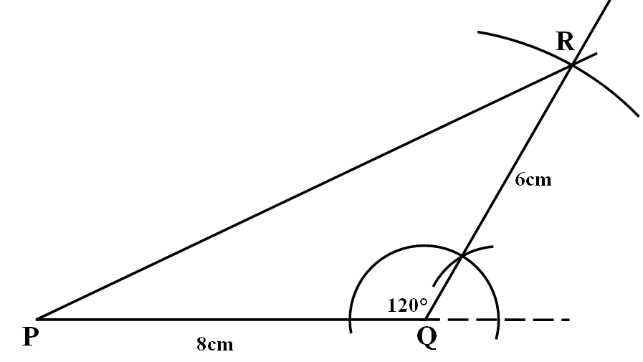

(ii) Measure:
(α) |PR| = 12.1 cm (± 0.1cm)

(β) angle QPR = 25° (± 1°)

- (a) Bar chart for the frequency distribution table below
Grade | 1 | 2 | 3 | 4 | 5 | 6
Frequency | 2 | 3 | 6 | 5 | 4 | 10

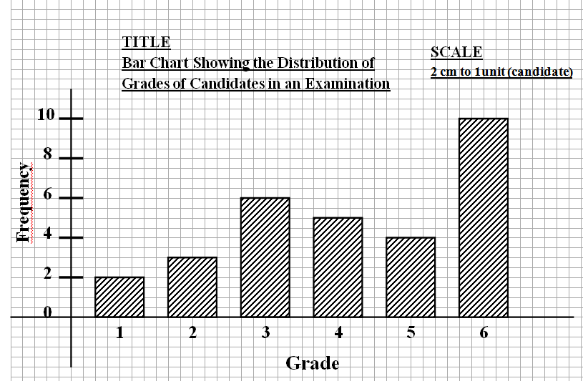

(b) Number of candidates who obtained credit (grades above grade 3 for the distribution)
= Frequencies of Grade 1 and Grade 2
= 2 + 3
= 5

Total number of candidates = 2 + 3 + 6 + 5 + 4 + 10
= 30

Probability of selecting a candidate who obtained credit

= $\frac{No.of candidates who obtained credit}{Total no.of candidates}$
= $\frac{5}{30} = \frac{1}{6}$

(c) Mean grade = $\frac{Sum of all grades}{Total no. of candidates}$
= $\frac{\left(1×2\right)+\left(2×3\right)+\left(3×6\right)+\left(4×5\right)+\left(5×4\right)+(6×10)}{2+3+6+5+4+10}$
= $\frac{2 +6+18+20+20+60}{2+3+6+5+4+10}$
= $\frac{126}{30}$ = $\frac{42}{10}$ = $4\frac{2}{10}$
= $4\frac{1}{5}$ or 4.2
≈ 4 (to nearest whole number)

