**2015 BECE Mathematics (Maths) Past Questions Paper One**

1. List the members of the set Q = {prime factors of 30}
   1. {2, 3, 5}
   2. {2, 6, 10}
   3. {3, 5, 15}
   4. {3, 6, 15}
2. Given that set P = {m, n, o, p}, find the number of subsets of P.
   1. 4
   2. 8
   3. 10
   4. 16
3. If M = {multiples of 4 between 10 and 25} and N = {even numbers between 11 and 23}, find M ∪ N
   1. {12, 16, 20}
   2. {14, 18, 22}
   3. {12, 14, 16, 18, 22}
   4. {12, 14, 16, 18, 20, 22, 24}
4. What is the place value of 7 in 24.376 ?
   1. Unit
   2. Ten
   3. Tenth
   4. Hundredth
5. Find the Highest Common Factor of 24, 42 and 72
   1. 4
   2. 6
   3. 7
   4. 12
6. Express 1205 as a number in base 10
   1. 25
   2. 27
   3. 32
   4. 35
7. If p × q × r = 1197, and p = 19, q = 3, find r
   1. 21
   2. 49
   3. 57
   4. 61
8. How many integers are within the interval – 5 < *x* < 7 ?
   1. 10
   2. 11
   3. 12
   4. 13
9. Divide 1.612 by 0.4
   1. 4.3
   2. 4.03
   3. 0.403
   4. 0.43
10. Arrange the following fractions in ascending order:

1. Abena spent of her money on sweets, on provisions and the rest on gari. What fraction of her money did she spend on gari?
2. If 5 boys took 14 days to cultivate a piece of land, how long will it take 7 boys working at the same rate to cultivate the land ?
   1. 14 days
   2. 12 days
   3. 10 days
   4. 8 days
3. A man invested GHC 800.00 in a bank at a simple interest rate of 5% per annum. Find his total amount in the bank at the end of one year.
   1. GHC 840.00
   2. GHC 860.00
   3. GHC 900.00
   4. GHC 960.00
4. John sold a car for GHC 60,000.00 and made a profit of 20%. What is the cost price of the car?
   1. GHC 48,000.00
   2. GHC 50,000.00
   3. GHC 72,000.00
   4. GHC132,000.00
5. What is the value of *x* if 10*x* = 1000?
   1. 1
   2. 2
   3. 3
   4. 4
6. Express 625.13 in standard form
   1. 6.2513 × 10-2
   2. 6.2513 × 10-4
   3. 6.2513 × 102
   4. 6.2513 × 104
7. Find the median of the numbers 17, 12, 15, 16, 8, 18, 13 and 14
   1. 8
   2. 12
   3. 14.5
   4. 15.5
8. The ages in years of 10 children at a party are 2, 3, 3, 3, 4, 4, 5, 5, 5 and 6. If a child is chosen at random, what is the probability that he / she is **not** less than 5 years old ?
9. Expand (2x + y) (2x - y)
   1. 2x2 – y2
   2. 4x2 – y2
   3. 2x2 + 4xy – y2
   4. 4x2 + 4xy – y2
10. Find the value of n, if 25.003 = (2 × 10) + (5 × 1) + (3 × n)
    1. 0.001
    2. 0.011
    3. 0.01
    4. 0.1
11. Evaluate (3m)2 – 3m2, when m = 2.
    1. 12
    2. 18
    3. 20
    4. 24
12. A wrist watch is priced GHC 2,000.00. A shopkeeper allows a discount of 2% on the cost price. Find the discount on 20 of such wrist watches.
    1. GHC 500.00
    2. GHC 600.00
    3. GHC 800.00
    4. GHC 1,000.00
13. Find the value of m, if 4(m + 4) = – 8.
    1. – 6
    2. – 2
    3. 2
    4. 6
14. Find the rule for the following mapping



* 1. y→x+2
  2. y→2x
  3. y→x2
  4. y→2x+2

1. How many vertices has a cuboid?
   1. 6
   2. 7
   3. 8
   4. 14
2. The circumference of a circle is 440 m. Find the area of the circle. [Take π = ]
   1. 14,400 m2
   2. 15,400 m2
   3. 16,400 m2
   4. 18,000 m2
3. What name is given to a triangle which has all its sides equal?
   1. Isosceles triangle
   2. Scalene triangle
   3. Equilateral triangle
   4. Right-angle triangle
4. At eight o’clock, which of the following is the angle between the hour and the minute hands of the clock?
   1. 150°
   2. 120°
   3. 90°
   4. 60°
5. A rectangular field 50 m wide and y m long requires 260 m of fencing. Find y.
   1. 15 m
   2. 40 m
   3. 80 m
   4. 105 m
6. Which of the following best describes the statement: ‘*The locus of a point which moves so that its distance from two fixed points are always equal*’?
   1. Bisector of an angle
   2. Perpendicular bisector
   3. Circle
   4. Two parallel lines
7. The point K (1, 5) is rotated through 90° anti-clockwise about the origin. Find the coordinates of the image of K.
   1. (5, -1)
   2. (-5, 1)
   3. (-1, 5)
   4. (1, -5)
8. Kwame is facing west. Through how many degrees should he turn anti-clockwise to face north?
   1. 90°
   2. 180°
   3. 270°
   4. 360°
9. Given that vectors **u** = and **v** = , find 2**v** – **u**

What is the name of the figure above?

* 1. Cuboid
  2. Kite
  3. Triangle
  4. Pyramid

|  |  |  |
| --- | --- | --- |
| 13 | 12 | 17 |
| E | F | 10 |
| 11 | 16 | G |

Use the magic square above to answer questions **35** to **37**

1. Find the value of F
   1. 14
   2. 15
   3. 18
   4. 23
2. Find the value of E.
   1. 14
   2. 15
   3. 18
   4. 23
3. Evaluate E + G
   1. 29
   2. 30
   3. 33
   4. 38

1. The hypotenuse and a side of a right-angled triangle are 13 cm and 5 cm respectively. Find the length of the third side.
   1. 8 cm
   2. 9 cm
   3. 12 cm
   4. 17 cm
2. Find the missing number in the sequence below:

11, 16, 22, 29, __, 46, 56

* 1. 30
  2. 36
  3. 37
  4. 39

1. A hall which is 20 m long is represented on a diagram as 10 cm long. What is the scale of the diagram?
   1. 1:200
   2. 1:250
   3. 1:400
   4. 1:500

## Objective Test

SOLUTIONS

1. A. {2, 3, 5}
2. D. 16
3. D. {12, 14, 16, 18, 20, 22, 24}
4. D. Hundredth
5. B. 6
6. D. 35
7. A. 21
8. B. 11
9. B. 4.03
10. C.
11. C.
12. C. 10 days
13. A. GHC 840.00
14. B. GHC 50,000.00
15. C. 3
16. C. 6.2513 × 102
17. C. 14.5
18. B.
19. B. 4x2 – y2
20. A. 0.001
21. D. 24
22. C. GHC 800.00
23. A. – 6
24. C. y→x2
25. C. 8
26. B. 15,400 m2
27. C. Equilateral triangle
28. B. 120°
29. C. 80 m
30. B. Perpendicular bisector
31. B. (-5, 1)
32. C. 270°
33. D.
34. D. Pyramid
35. A. 14
36. C. 18
37. C. 33
38. C. 12
39. C. 37
40. A. 1:200

**2015 BECE Mathematics (Maths) Past Questions Paper Two**

1. (a) Find the difference between the product of 2.5 and 7.5 and the sum of 2.75 and 9.55.
2. Solve
3. A container is 24 m long, 9 m wide and 8 m high. How many books can it hold if each book is 20 cm long, 16 cm wide and 6 cm thick.
4. (a) In a test consisting of 90 questions, Ama answered 75% of the first 40 questions correctly. If she had to get a score of 80% in the test,
   * 1. how many questions did she answer correctly out of the first 40 questions?
     2. how many questions should she answer correctly out of the 90 questions ?
     3. what percentage of the remaining 50 questions should she answer correctly in order to get the 80%?
   1. Three interior angles of a pentagon are 100°, 120° and 108°. Find the size of each of the remaining two interior angles, if one of them is three times the other.
5. (a) Given that vectors **p** = and **q** = , find :

(i) **q** if **q** – **p** = ;

(ii) the magnitude of the vector **q** - **p**

**50°**

**30°**

**7x-25°**

**A**

**B**

**C**

**D**

**NOT DRAWN TO SCALE**

(b)

In the diagram |AB| = |AC|, angle ADC = 30° and angle ACD = 7x – 25°. Find

1. the value of x;
2. angle DAC;
3. angle BAD.
4. (a) The Value Added Tax (VAT) paid by a man on a deep freezer was GHC 90.00. If VAT was charged at 15%,
   * 1. what was the price of the deep freezer?
     2. How much did the man pay including VAT?

(b) The average of the numbers 5, 7, 2, 6, x, (x+1), 7 and 4 is 5. Find the value of x.

(c) Simplify:

1. (a) A cylinder which has a height of 90 cm and diameter 14 cm is closed at both ends.

Find:

* + 1. its total surface area;
    2. the volume of the cylinder

[Take π = 22/7]

(b) (i) Using a ruler and a pair of compasses only, construct triangle PQR such that

|PQ| = 8cm, angle PQR = 120° and |QR| = 6 cm.

(ii) Measure:

(α) |PR|;

(β) angle QPR

1. The table shows the distribution of grades of candidates in an examination.

|  |  |  |  |  |  |  |
| --- | --- | --- | --- | --- | --- | --- |
| Grade | 1 | 2 | 3 | 4 | 5 | 6 |
| Frequency | 2 | 3 | 6 | 5 | 4 | 10 |

(a) Using a graph sheet, draw a bar chart for the distribution

(b) If all candidates who obtained grades above grade 3 were awarded credit, find the probability that a candidate selected at random obtained credit.

(c) Calculate, correct to the nearest whole number, the mean grade of the candidates.

***END OF ESSAY TEST***

## MATHEMATICS 2

## ESSAY

## SOLUTIONS

1. **(a)** Product of 2.5 and 7.5

= 2.5 × 7.5

=

=

= 18.75

Sum of 2.75 and 9.55

=

2.75

+ 9.55

12.30

**Difference** between 18.75 and 12.30

=

18**.**75

– 12**.**30

**6.45**

**(b) Solving**

⇒

⇒

⇒ 24*x* + 16 – 9 + 3*x* = 4

⇒ 24*x* + 3*x* = 4 – 16 + 9

⇒ 27*x* = – 3

⇒

⇒ ***x* =**

**(c)** Volume of container = length × width × height

= 24m × 9m × 8m

= 2400cm × 900cm × 800cm

= 1728000000 cm3

Volume of each book = 20 cm × 16 cm × 6 cm

= 320 cm2 × 6 cm

= 1920 cm3

**No. of books the container can hold** =

=

= **900,000 books**

1. **(a) (i) No.of questions Ama answered correctly out of first 40 questions**

= 75% of first 40 questions

=

=

= 30 questions

**(ii)** To score 80% in the test, then she needs to answer

= 80% × 90 questions

=

= 8 × 9

= 72 questions correctly

**(iii)** No. of questions she must answer correctly in the remaining 50 questions

= 72 – 30 questions

= 42 questions

**Percentage of 42 out of 50 questions**

=

= 42 × 2%

= 84%

**(b)** **Sum of interior angles of a pentagon (5-sided polygon)**

= (n – 2) × 180° , where n = no.of sides

= (5 – 2) × 180° [n = 5 sides]

= 3 × 180°

= 540°

Let size of smaller missing angle = *x*

then, size of bigger missing angle = 3*x*

Now, if sum of interior angles = 540°,

⇒ 100° + 120° + 108° + *x* + 3*x* = 540°

⇒ 328° + 4*x* = 540°

⇒ 4*x* = 540° – 328°

⇒ 4*x* = 212°

⇒ *x* =

⇒ *x* = 53°

Hence, the other missing angle = 3*x*

= 3 × 53°

= 159°

The sizes of the two remaining interior angles = 53° and 159°

1. **(a) (i)** If **q** – **p** =

Then,

⇒

⇒

⇒

⇒ **q =**

**(ii)** Magnitude of vector **q** – **p**

= magnitude of

=

=

=

= 15 units

**(b) (i)** Since |AB| = |AC|

⇒ angle ABC = angle ACB [Base angles of isosceles triangle equal]

Let angle ABC = angle ACB = y

Then, y + y + 50° = 180° [interior angles of a triangle =180°]

⇒ 2y = 180° – 50°

⇒ 2y = 130°

⇒ y =

⇒ y = 65°

Now, 65° + (7x – 25°) = 180° [angles at a point on a straight line=180°]

⇒ 7x + 65° – 25° = 180°

⇒ 7x + 40 = 180°

⇒ 7x = 180° – 40°

⇒ 7x = 140°

⇒ x =

⇒ x = 20°

**(ii) Angle DAC** + 7x – 25° + 30° = 180° [interior angles of a triangle =180°]

Let angle DAC = a

⇒ a + 7x – 25° + 30° = 180°

⇒ a + 7(20°) – 25° + 30° = 180°

⇒ a + 140° – 25° + 30° = 180°

⇒ a + 115° + 30° = 180°

⇒ a + 145° = 180°

⇒ a = 180° – 145°

⇒ a = 35°

⇒ **angle DAC** = 35°

**(iii) angle BAD** = angle BAC + angle DAC

= 50° + 35°

= 85°

1. **(a) (i)** If (VAT) 15% → GH¢ 90.00

Then (Original price) 100% → ? (more)

If more, less (15%) divides, hence

=

= 100 × GHc 6

= GHc 600

**Original price** = GHc 600.00

**(ii)** **Total amount paid** = Original price + VAT

= GHc 600.00 + GHc 90.00

= GHc 690.00

**(b)** If the average of 8 no.s: 5, 7, 2, 6, x, (x+1), 7 and 4 = 5, then

⇒

⇒

⇒

⇒ 32 + 2x = 40

⇒ 2x = 40 – 32

⇒ 2x = 8

⇒ x = 8/2

⇒ x = 4

**(c)** **Simplification of**

=

=

=

= m + q

1. **(a) (i)** h = 90cm, d = 14 cm,

⇒ r = 14cm÷2

r = 7cm

**Total Surface Area of closed cylinder**

= 2πr2 + 2πrh , where r = radius, h = height

=

= (2 × 22 × 7) + (2 × 22 × 90)

= 308 + 3960

= 4268 cm2

**(ii) Volume of cylinder**

= π r2 h , where r = radius, h = height

=

= 22 × 7 × 90

= 154 × 90

= 13860 cm3

**(b) (i)**

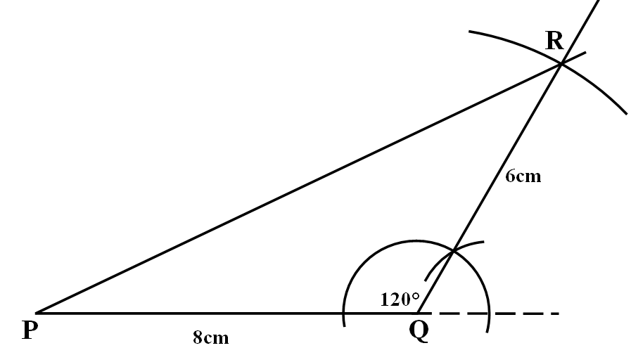

**(ii)** Measure:

(α) |PR| = 12**.**1 cm (± 0**.**1cm)

(β) angle QPR = 25° (± 1°)

1. **(a) Bar chart for the frequency distribution table below**

|  |  |  |  |  |  |  |
| --- | --- | --- | --- | --- | --- | --- |
| Grade | 1 | 2 | 3 | 4 | 5 | 6 |
| Frequency | 2 | 3 | 6 | 5 | 4 | 10 |

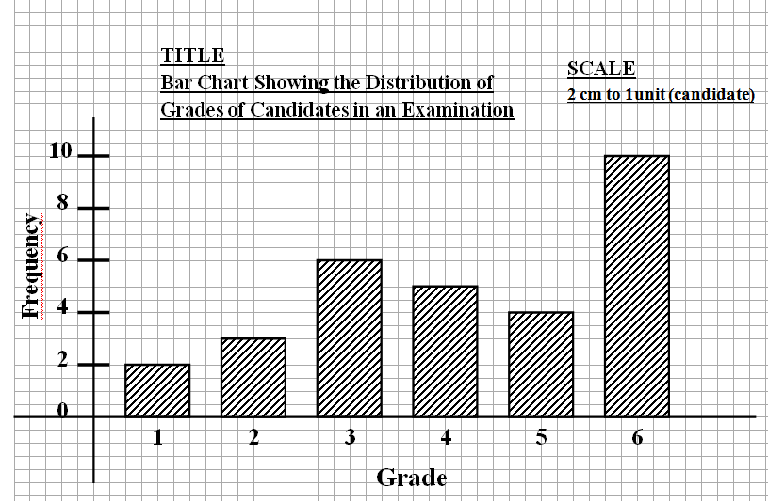

**(b)** **Number of candidates who obtained credit** (grades above grade 3 for the distribution)

= Frequencies of Grade 1 and Grade 2

= 2 + 3

= 5

**Total number of candidates** = 2 + 3 + 6 + 5 + 4 + 10

= 30

**Probability of selecting a candidate who obtained credit**

=

=

**(c)** **Mean grade** =

=

=

= = =

= or 4.2

≈ 4 (to nearest whole number)