2015 Basic Design And Technology (Pre Technical Skills ) – Paper Two

1(a) State one reason why a dressmaker would use a double stitch for fastening on a stitch instead of a knot.
(b) List two suitable each methods of preserving the following food items:
(i) plantain
(ii) mango
(c) (i) Copy and complete the table below by providing one suitable instrument for carrying out each of the operations listed:
OPERATION | ONE SUITABLE INSTRUMENT
Drawing a horizontal line
Drawing a circle
Measuring an angle
(ii) Sketch the following geometrical solids:
(α) cylinder
(β) cone
(d) (i) What is an exhibition?
(ii) Give two reasons why artworks are exhibited
(iii) List two types of exhibition
(iv) State one major difference between the two types of exhibition in (d)(iii) above.
2. (a) Figure 1 shows the isometric view of a wooden stand.
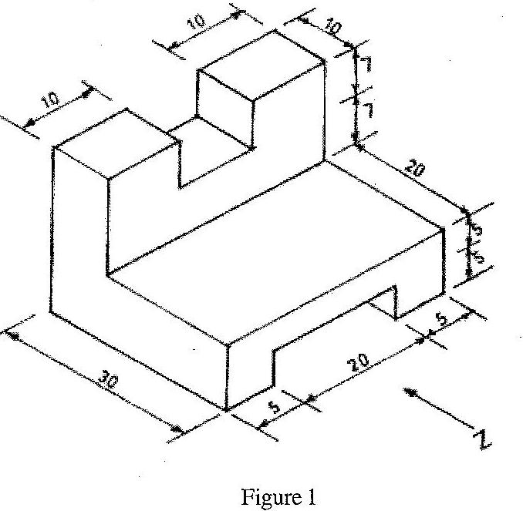
(i) Draw full size the front view in the direction of arrow Z
(ii) State the most suitable abrasive that can be applied on the work.
(b) State one method of preventing pinning in files
(c) (i) Make a freehand pictorial sketch of the wooden float.
(ii) Label any two parts of the tool sketched in (c)(i)
(iii) State one use of the wooden float
(d) (i) State one way of preventing accidents in the workshop
(ii) State two qualities of a good mortar
(iii) Explain the ration 1:6 in a mortar mix
3. (a) (i) Make a freehand pictorial sketch of a flat chisel
(ii) State one use of the flat chisel
(iii) State one method of maintaining the flat chisel
(b) Figure 2 shows the sketch of a type of sheet metal joint
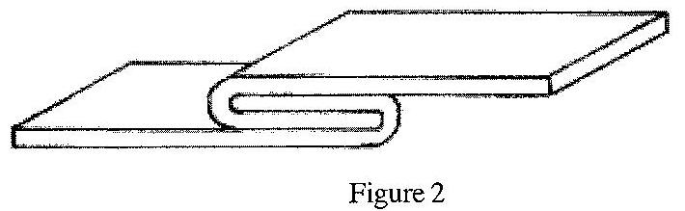
(i) State the name of the joint
(ii) List one tool for cutting the sheet metal
(iii) State one article that can be made with the joint
(c) Copy and complete the table below
 | Name of tool | State one part of the tool | One use of the tool
(i) | Hacksaw
(ii) | Soldering iron
(iii) | Mortise chisel
(d) State one reason each for the following operations
(i) glasspapering a piece of work made from wood;
(ii) mixing turpentine with oil paint
4. (a) (i) Make a freehand pictorial sketch of a marking knife
(ii) State one use of the marking knife
(iii) State one method of maintaining the marking knife.
(b) Copy and complete the table below
 | Name of material | One property each | One use each
(i) | Wawa
(ii) | Polyvinyl Chloride (PVC)
(iii) | Clay
(c) Figure 3 shows a sketch of a sandcrete block
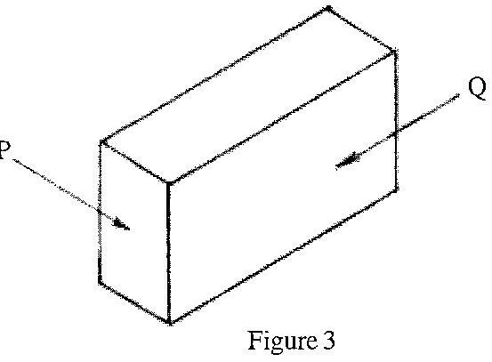
(i) State the parts labelled P and Q
(ii) List two materials used for making the block
(iii) Re-arrange the following procedures for moulding the block in their correct order:
1. tamp and use a wooden batten to strip off the excess mortar
2. batch sand and cement and mix thoroughly
3. remove and dry blocks
4. fill the mould box with mortar
5. add water and mix mortar;
6. assemble the mould box and clean the internal surface
Paper Two – Answers
1. (a) State one reason why a dressmaker would use a double stitch for fastening on a stitch instead of a knot.
♣ knots may come off from fabric
♣ knots may tear fine fabrics
♣ knots may cause tiny lumps in seams or hems when the fabric is pressed
♣ Double stitches are firmer / stronger so that it does not come off easily
(b) List two suitable each methods of preserving the following food items:
(i) plantain – Drying, freezing
(ii) mango – Bottling, jam making, canning, drying chutney, freezing
(c) (i) Copy and complete the table below by providing one suitable instrument for carrying out each of the operations listed:
OPERATION | ONE SUITABLE INSTRUMENT
Drawing a horizontal line | Tee square (or T-square)
Drawing a circle | Pair of compasses
Measuring an angle | Protractor
(ii) Sketch the following geometrical solids:
(α) cylinder (β) cone
(d) (i) What is an exhibition?
Public display of goods and services
(ii) Give two reasons why artworks are exhibited
Promote product or service
Advertise product or service
Sell product or service
Demonstrate product or service
Provide knowledge and skills about product or service
(iii) List two types of exhibition
♣ General
♣ Specialized
(iv) State one major difference between the two types of exhibition in (d)(iii) above.
♣ General exhibition deals with all kinds of products while
♣ Specialized deals with a particular product
2. (a) Figure 1 shows the isometric view of a wooden stand.
(i) Draw full size the front view in the direction of arrow Z
Drawing 7 horizontal lines and 6 vertical lines neatly
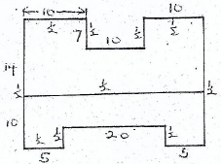
(ii) State the most suitable abrasive that can be applied on the work.
Glass paper
Sandpaper
(b) State one method of preventing pinning in files
Rubbing chalk on the file
(c) (i) Make a freehand pictorial sketch of the wooden float.
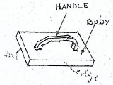
(ii) Label any two parts of the tool sketched in (c)(i)
(iii) State one use of the wooden float
♣ For rendering
♣ For plastering
♣ For filling mortar joints
♣ For holding mortar
♣ For screeding
♣ For dressing
♣ For spreading
(d) (i) State one way of preventing accidents in the workshop
♣ Wear protective clothing
♣ Avoid horse play
♣ Use right tool for the right job
♣ Avoid spilling oil on the floor
(ii) State two qualities of a good mortar
♣ workable
♣ free from impurities
♣ plastic / flexible
♣ uniform colour
♣ correct quantity of binding agents
♣ set within stipulated time
(iii) Explain the ration 1:6 in a mortar mix
It means one part of cement to six parts of sand.
or
Six parts of sand to one part of cement
3. (a) (i) Make a freehand pictorial sketch of a flat chisel
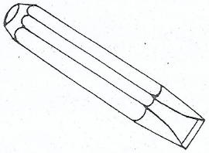
(ii) State one use of the flat chisel
♣ For cutting sheet metals
♣ For general purpose chiselling (metalwork / blockwork / woodwork)
(iii) State one method of maintaining the flat chisel
♣ Grind all burrs / mushroom heads
♣ Keep the cutting edge sharp
♣ Use it for the right job
♣ Keep it in a tool box or rack
♣ Clean with rag
(b) Figure 2 shows the sketch of a type of sheet metal joint
(i) State the name of the joint
Grooved lap joint
(ii) List one tool for cutting the sheet metal
♣ Shears / snips
♣ Flat chisel
♣ Sheet saw
♣ Junior hacksaw
(iii) State one article that can be made with the joint
♣ Milo tin
♣ Bucket
♣ Milk tin
♣ Metal trunk
♣ Dustbin
♣ Any food can
♣ Funnel
(c) Copy and complete the table below
 | Name of tool | State one part of the tool | One use of the tool
(i) | Hacksaw | (i) Blade  (ii) Frame  (iii) Handle  (iv) | (i) For cutting metals  (ii) For cutting objects
(ii) | Soldering iron | (i) Handle  (ii) Bit / head  (iii) Stem / shank | For soldering
(iii) | Mortise chisel | (i) Handle  (ii) Cutting edge  (iii) Blade  (iv) Ferrule  (v) Tang  (vi) Washer | For cutting deep holes in Wood / mortising  For chopping out waste in wood
For chopping out waste in wood
(d) State one reason each for the following operations
(i) glasspapering a piece of work made from wood;
♣ To make it smooth
♣ To obtain good finish
♣ To make it attractive
(ii) mixing turpentine with oil paint
♣ To obtain uniform mixture
♣ To enable it flow easily under the brush
♣ For thinning oil paint / To dilute the paint
4. (a) (i) Make a freehand pictorial sketch of a marking knife
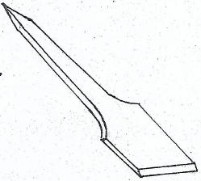
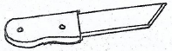
(ii) State one use of the marking knife
♣ It is used to mark lines on wood
♣ It is used to cut veneer
(iii) State one method of maintaining the marking knife.
♣ keep the cutting edge sharp
♣ clean after use
♣ keep it in a tool box
♣ oil the metal part
(b) Copy and complete the table below
 | Name of material | One property each | One use each
(i) | Wawa | (i) Light in weight  (ii) It has straight grains  (iii) Easy to work with  (iv) Less durable  (v) White to pale yellow / cream in colour | (i) For making construction works  (ii) For making Kitchen  (iii) For making plywood (core)
(ii) | Polyvinyl Chloride (PVC) | (i) It is soft / flexible  (ii) Easy to cut | (i) Making garden hose  (ii) Electrical insulators  (iii) Making suitcase  (iv) Bowls
(iii) | Clay | (i) Smooth  (ii) Sticky | (i) Traditional oven  (ii) Traditional building (atakpame)  (iii) Pottery work
(c) Figure 3 shows a sketch of a sandcrete block
(i) State the parts labelled P and Q
P – header / header face
Q – stretcher / stretcher face
(ii) List two materials used for making the block
♣ sand
♣ cement
♣ water
(iii) Re-arrange the following procedures for moulding the block in their correct order:
1. tamp and use a wooden batten to strip off the excess mortar
2. batch sand and cement and mix thoroughly
3. remove and dry blocks
4. fill the mould box with mortar
5. add water and mix mortar;
6. assemble the mould box and clean the internal surface
1. batch sand and cement and mix thoroughly
2. add water and mix mortar
3. assemble the mould box and clean the internal surface
4. fill the mould box with mortar
5. tamp and use a wooden batten to strip off the excess mortar
6. remove and dry blocks
OR
1. – 2
2. – 5
3. – 6
4. – 4
5. – 1
6. – 3

