**BECE Past Questions & Answers – 2015 (Science)**

JUNE 2015  
INTEGRATED SCIENCE 1  
OBJECTIVE TEST  
45 minutes

1.     Brass is an alloy of  
A.    iron and carbon  
B.    zinc and copper  
C.    iron and copper  
D.    copper and tin

2.     An example of inorganic fertilizer is  
A.    ammonium nitrate  
B.    cow dung  
C.    farmyard manure  
D.    poultry dropping

3.     The component of the human blood which transports oxygen to all parts of the body is  
A.    plasma  
B.    platelets  
C.    red blood cells  
D.    white blood cells

4.     The importance of the fuse in an electrical circuit is to  
A.    regulate the voltage  
B.    prevent damage to electrical appliances  
C.    alter the flow of current in the circuit  
D.    minimize the use of current

5.     Which of the following step(s) is/are required in the scientific method?  
I.    Formulation of hypothesis  
II.    Identification of the problem  
III.    Experimentation

A.    I only  
B.    II only  
C.    II and III only  
D.    I, II and III

6.     Which of the following food items produces amino acids as end product of digestion?  
A.    Cabbage  
B.    Fish  
C.    Margarine  
D.    Rice

7.     The process of increasing the strength of a signal using a transistor is known as  
A.    amplification  
B.    biasing  
C.    doping  
D.    switching

8.     The physical arrangement of soil particles into aggregates is termed  
A.    soil porosity  
B.    soil profile  
C.    soil structure  
D.    soil texture

9.     The solvent which is most effective in washing bitumen from the hand is  
A.    acid  
B.    alcohol  
C.    kerosene  
D.    water

10.     A piece of stone could be classified as an opaque material because it  
A.    absorbs all the light incident on it  
B.    does not absorb light incident on it  
C.    allows all the light incident on it to pass through it  
D.    does not allow light incident on it to pass through it

11.     Fish swims in water with little resistance because it possesses  
A.    gills  
B.    scales  
C.    caudal fins  
D.    streamlined body

12.     Which of the following conditions promote(s) rusting of iron?  
I.    Air  
II.    Moisture  
III.    Oil

A.    I only  
B.    II only  
C.    I and II only  
D.    II and III only

13.     The change in the volume of water when a piece of stone is dropped into it is equal to the  
A.    density of the stone  
B.    mass of the stone  
C.    volume of the stone  
D.    weight of the stone

14.     The second stage in the life cycle of a mosquito is the  
A.    egg  
B.    imago  
C.    larva  
D.    pupa

15.     Which of the following objects could be attracted by a magnet?  
A.    Copper chain  
B.    Gold chain  
C.    Steel blade  
D.    Aluminium spoon

16.     The knowledge of soil texture is important because it  
A.    influences plant population  
B.    determines the planting distance  
C.    determines the type of crop to be grown  
D.    influences the method of pest control

17.     How many atoms are present in CaCl2?  
A.    2  
B.    3  
C.    4  
D.    5

18.     The transfer of heat from the bottom to the top of a beaker containing water is by  
A.    absorption  
B.    conduction  
C.    convection  
D.    radiation

19.     An example of a chemical compound is  
A.    aluminium  
B.    ammonia  
C.    oxygen  
D.    phosphorus

20.     The type of the human teeth used for biting food substances is  
A.    canines  
B.    incisors  
C.    molars  
D.    premolars

21.     Which of the following heavenly bodies is a star?  
A.    Jupiter  
B.    Moon  
C.    Sun  
D.    Venus

22.     Which of the following organisms is an endoparasite?  
A.    Fleas  
B.    Louse  
C.    Tapeworm  
D.    Tick

23.     The part of the plant where pollination occurs is the  
A.    flowers  
B.    leaves  
C.    roots  
D.    stems

24.     Which of the following substances is capable of neutralizing an acid?  
A.    Vinegar  
B.    Water  
C.    Sodium chloride  
D.    Sodium hydroxide

25.     Droplet infection is the method by which  
A.    diseases are transmitted from animals to plants  
B.    infected animals are processed  
C.    human beings protect themselves from diseases  
D.    diseases are spread through the air

26.     An example of a derived quantity is  
A.    length  
B.    mass  
C.    time  
D.    velocity

27.     A structure in the human reproductive system which stores sperms temporarily is the  
A.    epididymis  
B.    penis  
C.    scrotum  
D.    vulva

28.     Which of the following statements about diffusion is/are correct?  
I.    It involves the movement of water molecules only  
II.    It occurs in both gases and liquids  
III.    It involves a semi-permeable membrane

A.    I only  
B.    II only  
C.    I and II only  
D.    I, II and III

29.     A farming system which requires at least three years programme is  
A.    mixed cropping  
B.    crop rotation  
C.    organic farming  
D.    mixed farming

30.     The component of a living cell responsible for respiration is  
A.    chloroplast  
B.    mitochondria  
C.    nucleus  
D.    vacuole

31.     Which of the following statements about a second class lever is correct? The  
A.    pivot is between the load and the effort  
B.    pivot and the load are at the same position  
C.    load is between the effort and the pivot  
D.    effort is  between the load and the pivot

32.     One advantage of soft water over hard water is that soft water  
A.    has a pleasant taste  
B.    can prevent heart diseases  
C.    does not waste soap  
D.    forms scales in kettles

33.     The gas produced when glucose is oxidized during aerobic respiration is  
A.    hydrogen  
B.    nitrogen  
C.    oxygen  
D.    carbon dioxide

34.     The systematic name for N2O is  
A.    nitrogen (I) oxide  
B.    nitrogen (II) oxide  
C.    nitrogen (III) oxide  
D.    nitrogen (IV) oxide

35.     A husbandry practice which involves the removal of unwanted plant parts is known as  
A.    mulching  
B.    pruning  
C.    thinning  
D.    pricking out

36.     The number of p-n junctions in a transistor is  
A.    1  
B.    2  
C.    3  
D.    4

37.     Fruits dispersed by wind  
A.    have hairs  
B.    are sticky  
C.    are succulent  
D.    have hooks

38.     Substances that burn living tissues when they come into contact with these tissues are considered  
A.    corrosive  
B.    flammable  
C.    irritant  
D.    toxic

39.     The function of the platelets in the circulatory system of humans is to  
A.    transport oxygen  
B.    transport carbon dioxide  
C.    clot the blood  
D.    defend the body

40.     Energy is the  
A.    force to move an object  
B.    weight to do work  
C.    ability to do work  
D.    power to carry an object

JUNE 2015  
INTEGRATED SCIENCE 1  
OBJECTIVE TEST  
SOLUTIONS

1.     B.    zinc and copper  
2.     A.    ammonium nitrate  
3.     C.    red blood cells  
4.     B.    prevent damage to electrical appliances  
5.     D.    I, II and III  
6.     B.    Fish  
7.     A.    amplification  
8.     B.    soil structure  
9.     C.    kerosene  
10.     D.    does not allow light incident on it to pass through it  
11.     D.    streamlined body  
12.     C.    I and II only  
13.     C.    volume of the stone  
14.     C.    larva  
15.     C.    Steel blade  
16.     C.    determines the type of crop to be grown  
17.     B.    3  
18.     C.    convection  
19.     B.    ammonia  
20.     B.    incisors  
21.     C.    Sun  
22.     C.    Tapeworm  
23.     A.    flowers  
24.     D.    Sodium hydroxide  
25.     D.    diseases are spread through the air  
26.     D.    velocity  
27.     A.    epididymis  
28.     B.    II only  
29.     B.    crop rotation  
30.     B.    mitochondria  
31.     C.    load is between the effort and the pivot  
32.     C.    does not waste soap  
33.     D.    carbon dioxide  
34.     D.    nitrogen (I) oxide  
35.     B.    pruning  
36.     B.    2  
37.     A.    have hairs  
38.     A.    corrosive  
39.     C.    clot the blood  
40.     C.    ability to do work

## JUNE 2015      (FIRST SITTING)

## INTEGRATED SCIENCE 2

## ESSAY

## 1 ¼ hours

**This paper is in two parts: I and II. Answer Question 1 in part I and any other four questions in part II**

**PART I**

**[40 marks]**

Answer **all** of Question **1**

1. (a) The diagrams below are illustrations of three different organisms harmful to farm animals

          Study the diagrams carefully and answer the questions that follow

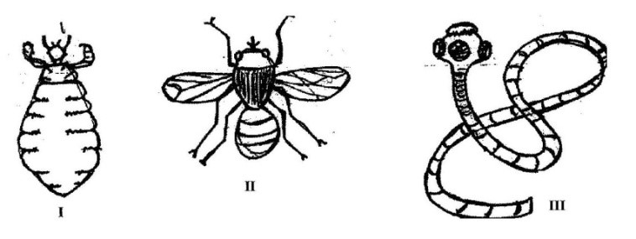

* Identify **each** of the organisms labelled **I, II** and **III** [3 marks]
* Which of the organisms is/are:

(α)   parasite(s)

(β)   pest(s)                                                                                                              [3 marks]

* State **one** effect **each** of the following organism on farm animals

(α)   **I**;

(β)   **II**;

(γ)    **III**.                                                                                                                   [3 marks]

* State **three** methods of controlling the organism labelled **III** [3 marks]

(b)     The diagram below illustrates a burning candle placed in front of a plane mirror MM**′** and an image of the candle formed in the mirror.

          Study the diagram carefully and answer the questions that follow

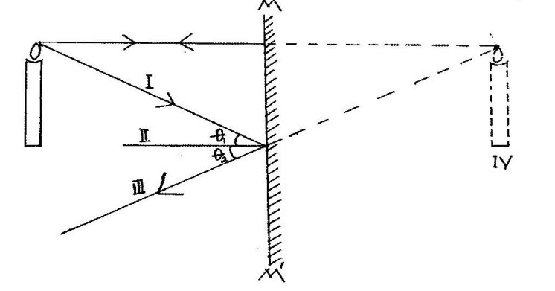

* Name the parts labelled **I, II, III** and **IV** [4 marks]
* State the relationship between angles θ1 and θ2 [1 mark]
* Give **three** characteristics of **IV** in the diagram [3 marks]
* Explain why **IV** is represented in broken lines [2 marks]

(c)     In an experiment to investigate the reactivity of sodium, a piece of sodium metal was dropped in a beaker containing water. The experimental set-up is as illustrated below.

          Study the set-up carefully and answer the questions that follow

* State what would happen if a glowing splint was held at the mouth of the beaker [2 marks]
* Name the gas evolved [1 mark]
* Write a balanced chemical equation for the reaction that occurred [3 marks]
* Name **two** other metals that can react in a similar ways as the sodium [2 marks]

(d)     An experiment to investigate the conditions for germination of viable bean seeds was carried out. The diagrams below are illustrations of the different conditions in which the seeds were kept. The beakers labelled **A, B** and **C** containing the seeds were kept at room temperature.

Study the diagrams carefully and answer the questions that follow

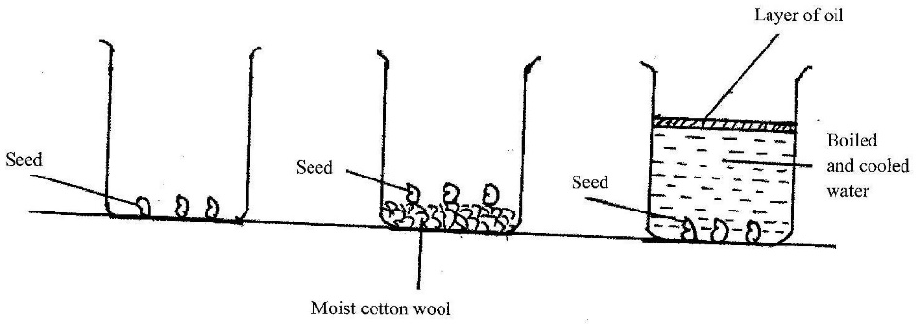

* State what would happen to the seeds in **each** of the beakers labelled **A, B** and **C** when the experiment was observed after five days. [3 marks]
* Give reasons for **each** of your answers in (i) [4 marks]
* Why was oil spread on the surface of the water in the beaker labelled **C**? [2 marks]

**PART II**

**[60 marks]**

Answer **four** questions **only** from this section

1. (a)    (i)      What is weather?

(ii)     State **two** differences between weather and season                                               [4 marks]

(b)     State the composition of **each** of the following alloys;

(i)      steel;

(ii)     stainless steel                                                                                                          [3 marks]

(c)     List **four** benefits of vegetables to humans                                                                     [4 marks]

(d)     The diagram below is an illustration of life-cycle of a flowering plant.

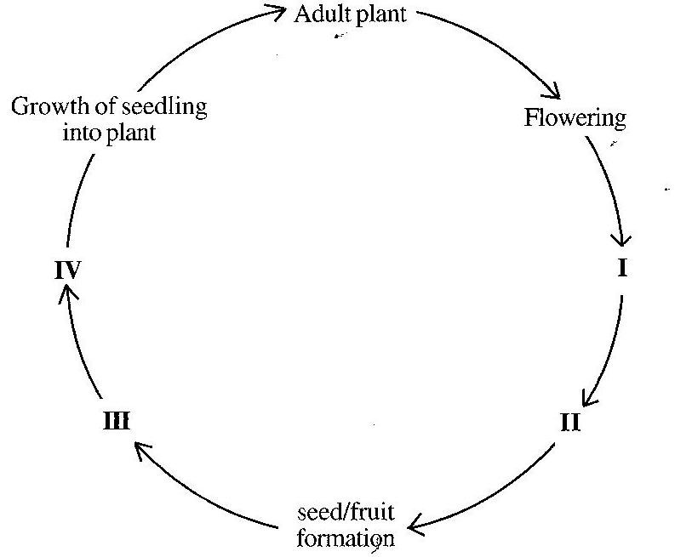

Name **each** of the stages labelled **I, II, III** and **IV**                                                         [4 marks]

1. (a) Explain how
   * lithium atom becomes **positively** charged
   * oxygen atom becomes **negatively** charged [2 marks]

(b)     (i)      What is potential energy?

(ii)     A coconut of mass 2 kg is on a tree 5 m tall. Determine the potential energy of the coconut at this height           [Take **g** = 10 ms–2] [5 marks]

(c)     State **four** causes of teenage pregnancy                                                      [4 marks]

(c)     State **four** uses of soil in agriculture.                                                                       [4 marks]

1. (a)    Give **four** health benefits of water to humans                                                     [4 marks]

(b)     (i)      State **two** ways in which crop rotation is important in crop production

(ii)     Distinguish between mixed cropping and mixed farming                          [4 marks]

(c)     (i)      What is a fuse?

(ii)     Name the colour code of the wire on which a fuse is placed in a three-pin plug[3 marks]

(d)     (i)      In a tabular form, state **three** differences between osmosis and diffusion

(ii)     State **one** way in which osmosis is similar to diffusion                                         [4 marks]

1. (a) (i)      What is a balanced ration in animal nutrition?

(ii)     State **two** benefits of balanced ration to poultry                                                    [4 marks]

(b)   List **four** hazards that may be encountered in teaching and learning of science [4 marks]

(c)   Name the parts of the circulatory system of humans                                      [3 marks]

(d)  (i)      What is a simple machine?

(ii)     State **two** methods of overcoming friction in everyday activities              [4 marks]

1. (a)    (i)      What is a magnetic field?

(ii)     To which class of mixture does **each** of the following belong?

(α)   Smoke

(β)   Air

(γ)    Bronze                                                                                                          [5 marks]

(b)     (i)      What is plaque in human dentition?

(ii)     State the function of chlorophyll in photosynthesis                                               [3 marks]

(c)     Identify the scientific principle underlying the operation of **each** of the following industries

* kenkey production
* salt smoking
* fish smoking
* biogas production [4 marks]

(d)     (i)      What is plant parasite?

(ii)     Give **one** example of a plant parasite                                                                     [3 marks]

## UNE 2015     (FIRST SITTING)

## INTEGRATED SCIENCE 2

## ESSAY

SOLUTIONS

**PART I**

**[40 marks]**

1. (a)

* Identify **each** of the organisms labelled **I, II** and **III**             [3 marks]

1. –              Louse
2. –            Tsetse fly

* –         Tapeworm

* Which of the organisms is/are:

(α)     parasite(s)

Louse and tapeworm

(β)     pest(s)                                                                                                  [3 marks]

tsetsefly

* State **one** effect **each** of the following organism on farm animals

(α)     **I**:       Sucks blood of animals, resulting in anaemia

(β)     **II**:      Infects animals with sleeping sickness, which can lead to death

(γ)     **III**.    feeds on the digested food nutrients in the body of animal, which affects the immune system and leads to weakness and ill-health          [3 marks]

* State **three** methods of controlling the organism labelled **III** [3 marks]
* Deworming,
* regualar checks by veterinary personnel
* Proper disposal of sewage
* clean grazing on low risk pasture

(b)

* Name the parts labelled **I, II, III** and **IV** [4 marks]

1. –              Incident ray
2. –            Normal

* –         Reflected ray

1. –         Image

* State the relationship between angles θ1 and θ2 [1 mark]

Angles θ1 and θ2 are equal

* Give **three** characteristics of **IV** in the diagram [3 marks]
* it is erect (upright)
* it is virtual
* It has the same size as the object
* Its distance to the mirror equals the distance of the object from the mirror
* It is formed behind the mirror

* Explain why **IV** is represented in broken lines [2 marks]

IV is represented in broken lines because it is a virtual (not a real) image (cannot be captured  on a screen)

(c)     (i)    State what would happen if a glowing splint was held at the mouth of the beaker [2 marks]

The glowing splint would be ignited (become aflame / catch fire)

* Name the gas evolved [1 mark]

Hydrogen

* Write a balanced chemical equation for the reaction that occurred [3 marks]

2 Na  +  2 H2O          →         2 NaOH  +  H2

* Name **two** other metals that can react in a similar ways as the sodium [2 marks]

Lithium, Potassium

(d)

* State what would happen to the seeds in **each** of the beakers labelled **A, B** and **C** when the experiment was observed after five days.                                                                                                           [3 marks]

Beaker A       –           Seeds do not germinate

Beaker B       –           Seeds germinate

Beaker C       –           Seeds do not germinate

* Give reasons for **each** of your answers in (i) [4 marks]
* Seeds in beaker A do not germinate because there is no water / moisture present
* Seeds in beaker B germinate because all the conditions necessary for germination, namely, moisture, air, optimum temperature and viable seed are present.
* Seeds in beaker C do not germinate because there is no air present (due to layer of oil on water surface)

* Why was oil spread on the surface of the water in the beaker labelled **C**?[2 marks]

To prevent air (atmospheric oxygen) from getting dissolved in the water and reaching the seeds

**PART II**

**[60 marks]**

Answer **four** questions **only** from this section

1. (a)    (i)    What is weather?

The atmospheric condition of a place at a particular time.

or

The state of the atmosphere at a particular place and time

or

The condition of the atmosphere of a place over a short period of time

(ii)   State **two** differences between weather and season                                       [4 marks]

|  |  |
| --- | --- |
| WEATHER | SEASON |
| Atmospheric condition of a place over a short period of time | The average atmospheric condition of a place over a longer period of time within a year |
| Changes relatively quickly (lasts for a short time, usually about a day) | Changes relatively slowly (lasts for a longer time, usually 3 or more months) |
| It is less predictable | It is more predictable |

(b)     State the composition of **each** of the following alloys;

(i)    steel;

iron and carbon

(ii)   stainless steel                                                                                                  [3 marks]

iron, carbon and chromium

(c)     List **four** benefits of vegetables to humans                                                            [4 marks]

Provide mineral salts, which supports metabolic activities for proper functioning of the body

Provide vitamins for protection against diseases

Provide dietary fibre for easy bowel movement

Provide antioxidants, which fights stress and strengthen immune system

Makes our food tastier / more enjoyable

(d)     Name **each** of the stages labelled **I, II, III** and **IV**                                    [4 marks]

1. –          Pollination
2. –        Fertilization

* –     Dispersion / dispersal

1. –    Germination
2. (a) Explain how
   * lithium atom becomes **positively** charged

Lithium has 1 electron in its outermost shell, making it unstable. In order to become stable, it loses the electron on its outermost shell. As a result, the atom becomes positively charged, since there is now 1 more positive charge (proton) than negative charge (electron)

* oxygen atom becomes **negatively** charged [2 marks]

Oxygen has 6 electrons in its outermost shell, making it unstable. In order to become stable, it gains 2 more electrons on its outermost shell to make it completely filled. As a result, the negative charges (electrons) become 2 more than the positive charges (protons), making the atom negatively charged.

(b)     (i)    What is potential energy?

The energy possessed by a body as a result of its position or state.

(ii)     A coconut of mass 2 kg is on a tree 5 m tall. Determine the potential energy of the coconut at this height                                    [Take **g** = 10 ms–2] [5 marks]

Potential energy        =          mass(m) × height(h) × acceleration due to gravity(g)

=          2 kg × 5 m × 10ms-2

=                       100kgm2s-2

=                       100 J

(c)     State **four** causes of teenage pregnancy                                                                 [4 marks]

* Indiscriminate / Casual sex
* Irresponsible parenting
* Lack of sex education in schools
* Illiteracy
* Negative peer pressure
* Lack of contraceptive use / rejection of family planning methods
* Wrong application of birth control measures
* Unemployment
* Poverty
* Streetism

(d)     State **four** uses of soil in agriculture.                                                                     [4 marks]

* It serves as a support to agricultural crops
* It serves as a habitat (home) for several micro-organisms, which are important for plant growth.
* It holds water for the use of agricultural crops and animals.
* It contains mineral salts which are used by crops for healthy growth.
* It supports grass and other plants, which farm animals feed on for their sustenance
* It helps maintain suitable temperature for the development of plant roots and micro-organisms.

1. (a)    Give **four** health benefits of water to humans                                                        [4 marks]

* It helps with easy bowel movement (Prevents constipation)
* It helps with the metabolic activities of the body
* It can relieve stress
* It can relieve headaches
* It promotes healthy and radiant skin
* It helps to maintain optimum blood pressure
* It helps to maintain suitable body temperature.
* It supports the proper functioning of the cells/ tissues/ organs of the body.

(b)     (i)    State **two** ways in which crop rotation is important in crop production

* It helps in maintaining soil fertility
* The legumes included in crop rotation fix atmospheric nitrogen in the soil,
* The growing of cover crops helps check soil erosion
* The system of rotation helps check pests and diseases
* There is a reduced risk of losing yield, in case of pest or disease attack.

(ii)   Distinguish between mixed cropping and mixed farming                              [4 marks]

Mixed cropping – Different types of crops are grown on the same piece of land

Mixed farming – Crops are grown and farm animals are reared at different sections of the same piece of land.

(c)     (i)    What is a fuse?

An electrical safety device containing a piece of a metal that melts if the current running through it exceeds a particular level, thereby breaking the circuit

**or**

a safety device consisting of a strip of wire that melts and breaks an electric circuit if the current exceeds a safe level

(ii)   Name the colour code of the wire on which a fuse is placed in a three-pin plug

Red/ brown                                                                                                     [3 marks]

(d)     (i)    In a tabular form, state **three** differences between osmosis and diffusion

|  |  |
| --- | --- |
| OSMOSIS | DIFFUSION |
| It involves the movement of only solvent or water molecules | It involves movement of solute molecules /particles |
| Semi-permeable membrane present | No semi-permeable membrane |
| Applies in only liquids (solvent molecules) | Applies in solids, liquids and gases |
| Movement of solvent molecules from lower to higher concentration | Movement of solute particles from a higher concentration to a lower concentration |

(ii)   State **one** way in which osmosis is similar to diffusion                                 [4 marks]

* They both involve the movement of molecules
* The particles / molecules move to cause equality in the concentrations of the regions
* presence of a concentration gradient

1. (a) (i)    What is a balanced ration in animal nutrition?

The feed allowed for a given animal during a 24-hour period which contains all the essential nutrients to the animal in the right proportion and amount .

(ii)   State **two** benefits of balanced ration to poultry                                             [4 marks]

It ensures healthy and strong birds

It increase the quality of the eggs produced

It increases the quantity of eggs produced

It increases the rate of growth

(b)     List **four** hazards that may be encountered in teaching and learning of science   [4 marks]

* Corrosion of one’s skin by corrosive chemicals
* Burns from open flame or explosives
* Injuries sustained from falling as a result of slippery floor
* Health risk from inhaling of poisonous gases
* Health risk from ingestion of toxic chemicals
* Skin irritation from contact with irritants
* Health risks from Electrical shocks
* Eye irritation from strong light or radiation or irritants

(c)     Name the parts of the circulatory system of humans                                             [3 marks]

* Heart,
* blood
* Blood vessels (arteries, veins, capillaries )

(d)     (i)    What is a simple machine?

A mechanical device that makes work easier and/ or faster

(ii)   State **two** methods of overcoming friction in everyday activities                  [4 marks]

* Applying lubricants such as grease / oil
* Smoothening the contact surfaces
* Using wheels / rollers
* Using ball bearings

1. (a)    (i)    What is a magnetic field?

A region of space surrounding a magnet or current-carrying circuit in which the resulting magnetic force can be detected

(ii)   To which class of mixture does **each** of the following belong?

(α)      Smoke             –           solid-gas mixure

(β)      Air                   –           gas-gas mixture

(γ)      Bronze             –           solid-solid mixture                                          [5 marks]

(b)     (i)    What is plaque in human dentition?

A sticky, colorless deposit of bacteria that is constantly forming on the tooth surface

***OR***

A sticky, colorless film of bacteria that constantly forms on our teeth and along the gum line

(ii)   State the function of chlorophyll in photosynthesis                                       [3 marks]

It traps/absorbs sunlight, which provides energy for the manufacture of food

(c)     Identify the scientific principle underlying the operation of **each** of the following industries

* kenkey production –           fermentation
* salt making –           evaporation
* fish smoking –           food preservation
* biogas production –           fermentation                                        [4 marks]

(d)     (i)    What is plant parasite?

A plant that derives some or all of nutrients and water from another living organism

(ii)   Give **one** example of a plant parasite                                        [3 marks]

dodder, mistletoe, the corpse flower, cactus mistletoe