**ICT 2016**

**OBJECTIVE TEST QUESTIONS**

1. The brain of the computer is

the

A. monitor

B. system software

C. read only memory

D. central processing unit

2. An example of output device

is the

A. keyboardB**.** mouse

C. printer D. scanner

3. One byte is equal to

A. two bitsB**.** eight bits

C. sixteen bits

D**.** one thousand bits

4. To boot a computer means to

A. put it offB**.** put it on

C. restart itD**.** take it away

5. The horizontal bar that normally lies at the bottom of a computer desktop screen is called

A. taskbarB**.** start button

1. horizontal ruler
2. quick launch toolbar

6,.A folder within another folder is called

A. fileB**.** subfolder

1. inside folder
2. innermost folder

7. Processed material which is meaningful to the user in computing is called

A. data B**.** file

C. informationD**.** record

8. The copyright laws protect the works of an author for a period of his life time and

A.40 years after his death.

B.50 years after his death.

C.60 years after his death.

D.70 years after his death.

9. An example of function key on a computer keyboard is

A. F1B**.** Q

1. @D**.** NmLk

10. Entry of data into computer is termed

A. inputB**.** output

1. processD**.** distribution

11. The following are hardware components except

A. keyboardB**.** monitor

1. mouse D**.** windows

12. The following devices can be found in the system unit except

A.portsB**.** memory

C.motherboardD**.**scroll wheel

13.The method of reproducing copies of a document is termed

A. copyingB**.**pasting

**C.** photocopyingD**.**printing

14. Storage media that are similar to compact disc but store more data are known as

A. pen drives

B**.** hard disks

C. floppy disks

D**.** digital versatile discs.

15. To boot a computer system, the user needs

A. printer

1. operating system
2. virus checking program
3. word processing software.

16. The number of command buttons on the control menu are

A.2B**.**3 **C.**4 D**.**5

17. The location where a file is stored is called

A. folderB**.** icon

C. pageD**.** website

18. Viewing television for long periods can damage an individual’s

A. eyeB**.** head

C. mouthD**.** nose

19. Which of the following is an effect of loud ringing tone of mobile phone?

A. HeadacheB**.** Wrist pain

C. Bleeding nose

D. Damage to hearing

20. Which of the following cannot cause computer virus infection?

A. InternetB**.** Input devices

C. Computer network

D. Removable storage devices

21. The following are features of a word processing application window except

A. desktop B**.** font

C. print D**.** zoom

22. Which of the following is not a component of a uniform resource locator (URL)?

A. web protocol

B.name of browser

C.name of web server

D.name of the file with the directory

23. The speed of modem is measured in

A .baudB**.** bit

C. byteD**.** hertz

24. A special software that is used to access the internet is called

A. Address bar

1. search engine
2. web browser
3. windows xp

25. One billion bytes is

approximately one

A. gigabyteB**.** kilobyte

C .megabyteD**.** terabyte

26. Changing the desktop wallpaper of a computer is termed

A. background change

1. editing the desktop
2. customizing the desktop
3. formatting the desktop

27. The use of ICT in learning and teaching is to make it

A. interesting and boring.

1. uninteresting but not boring
2. interesting but students do not learn at their pace
3. easy and interesting, students learn at their pace
4. To create a space between characters, words and sentences, use the

A. backspace key.

1. enter key.
2. shift key.
3. spacebar key.
4. Which computer keyboard key allows users to erase characters to the left of the cursor?

A. Backspace key

1. Delete key
2. Insert key
3. Tab key
4. The process that is used to recall a document previously saved is termed

A. CopyB**.** Enter

C. OpenD**.** Save As

1. Double-clicking on a program icon on a computer desktop

A.cuts the program’s window.

B.copies the program’s window

C. closes the program’s window

D. opens the program’s window

1. Which of the following steps will open, check and correct errors, and submit the file for safe keeping under a word processing application?

A. File, Open, Edit and Save.

B. Open, File, Edit and Save.

C.Open, File, Close and Save

D. Start, Open, Edit and Save

1. The process of a user placing the cursor at one end of a text, holds down the left mouse button and drag to the other end of the text is referred to as

A. copyingB**.** cutting

C. movingD **.**selecting

1. Previewing a document before printing is necessary because it

A. formats the document.

B. displays the name of the

document.

1. displays copy and paste of document.
2. displays how the document will look after printing.
3. Which of the following options is used to access a message from an inbox in an electronic mail?

A. MailB**.** Send/Receive

C. Import/Export

D. Create New Account

1. Which of the following should a user bypass before accessing an email?

A. Gmail and password

B. Yahoo and username

C. Password and username

D. Computer name and password**.**

1. Which of the following command buttons in the browser enables a user to fetch the latest copy of the web page?

A. BackwardB.Forward

C. RefreshD**.** Stop

1. A spreadsheet cell name is referenced by a

A. letter

B. number

C. letter and name

D. number and letter.

1. Mathematical calculations in a spreadsheet are called

A. labels

1. Formulae
2. Numbers
3. Values
4. In spreadsheet application, which of the following can be identified by a letter?

A. Cell

1. Column
2. Range
3. Row

**ESSAY TYPE QUESTIONS - 2016**

1. (a) Identify the diagram below:

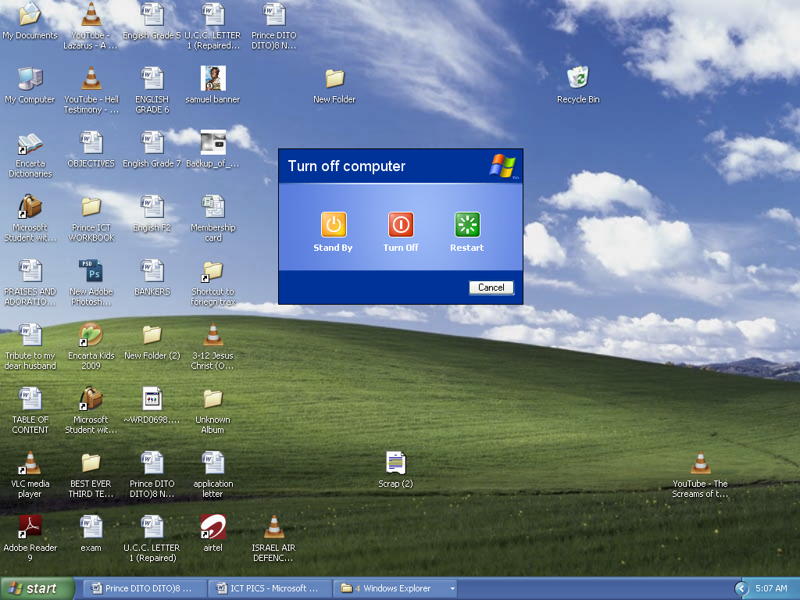



**A B C**

(b) Identify the parts labeled A, B, C in 1(a)

1. Provide the names and functions of each of the following mouse pointer shapes:
2. 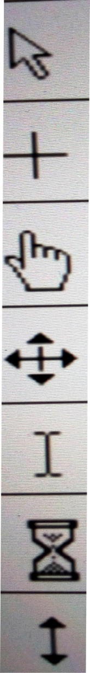 (ii) (iii) (iv) (v)
3. Outline the steps used to rename a folder on the desktop of a computer.
4. (a) Explain the term word processing.

(b) Give the default extension for the following file format: Notepad……

( c) Write the shortcut keyboard keys combination for the following commands as in a word processing environment:

1. Cut (ii) Copy (iii) Paste (iv) Print
2. (a) List two examples of:

(i) input devices; (ii) output devices; (iii) storage devices;

(iv) devices which serve both input and output purposes.

1. Outline two differences between storage media and storage devices.
2. (a) Explain the following terms:
3. Internet; (ii) Search engine

(b)What does the following Top Level Domains (TDLs) represent in a website address?

(i) .com (ii) .edu. (iii) .net (iv) .mil. (v) .org

1. (a) What is copyright?
2. State two reasons for copyright protection.

(c ) Give three devices that can produce output on paper.

(d) State one difference between softcopy output and

hardcopy output.

**ANSWERS – 2016**

1.(a) Turn off computer dialog box

(b) A–Stand By button B–Turn off button C–Restart button.

(c ) (i) Normal Select or Default or Left pointer.

- It is used for object selection and activation.

(ii) Right arrow or Right pointer.

- Enables users to select a row of text or a row of cells in a

Document.

(ii) Hour Glass or Wait Cursor or Busy

- Informs users that the operating system or program is

occupied with another task.

(iv) Text select or I-Beam or Insertion point.

- Enables users to select or indicate appoint of editing text in

an open document.

(v) Link Select or Hand pointer.

- Enables users to select shortcuts or links.

(d) 1. Click the folder to be renamed.

2. Right-click on the folder for a menu to pop up.

3. Click on the rename option.

4. Type the new name.

5. Press the enter key on the keyboard.

1. (a) Word processing refers to the creation, input, editing and production of documents and text by means of a computer system.

(b) Notepad - **.txt**

(c ) (i) Cut – Ctrl + X (ii) Copy – Ctrl + C

(iii) Paste – Ctrl + V (iv) Print – Ctrl + P

1. (a) (i) keyboard, Scanner, Mouse, Joystick etc.
2. Monitor, Printer, Plotter, Speaker, etc.
3. Hard disk, Compact disc, Floppy disk, Memory stick.
4. Modem, Headset, Fax, Touch screen, Multiplexer,

Network Interface Card.

(b)

|  |  |
| --- | --- |
| Storage Media | Storage Device |
| 1. Used to store data | 1. Records data on the medium |
| 2.Often external to the computer | 2.Usaully an integrated part of the computer |
| 3. They are reckoned in terms of capacity | 3. They are reckoned in terms of speed |

1. (a) (i) Internet refers to a computer network consisting of a world wide network of computer networks that use the TCP/IP network protocols to facilitate data transmission and exchange.

(ii) Search engine is a computer program that finds information on the internet by looking for the key words which users have typed.

(b) (i) Commercial (ii) Education (iii) Government

(iv) Network (v) Military (vi) Organization

1. (a) Copyright is the exclusive legal right that prohibits copying of intellectual property without the permission of the copyright holder.
2. – Prevents people from taking credits for other peoples work.

- Prevents people from profiting from other people work.

- Motivates people to produce their own original works.

(c ) Printer, Plotter, Facsimile (Fax), Photocopier, etc.

(d)

|  |  |
| --- | --- |
| Softcopy | Hardcopy |
| 1. Output can be enlarged | 1. Output is fixed in size |
| 2. Output is on-screen on the computer | 2. Output is on paper |

OBJECTIVE ANSWERS

|  |  |
| --- | --- |
| 2016 | |
| 1. D | 21.A |
| 2. C | 22.B |
| 3. B | 23.D |
| 4. B | 24.C |
| 5. A | 25.C |
| 6. A | 26.A |
| 7. C | 27.D |
| 8. D | 28.D |
| 9. A | 29.A |
| 10.A | 30.C |
| 11.D | 31.D |
| 12.D | 32.A |
| 13.C | 33.D |
| 14.D | 34.D |
| 15.B | 35.A |
| 16.B | 36.C |
| 17.A | 37.B |
| 18.A | 38.C |
| 19.D | 39.B |
| 20.B | 40.B |