**Bece Past Questions & Answers -2016 (Science)**

**JUNE 2016  
INTEGRATED SCIENCE 1  
OBJECTIVE TEST  
45 minutes**

1. An example of a third class lever is  
A. wheelbarrow  
B. sugar tongs  
C. pair of scissors  
D. crowbar

2. The release of a mature egg from an ovary into the fallopian tube in humans is called  
A. copulation  
B. ejaculation  
C. menstruation  
D. ovulation

3. The blood vessel that carries oxygenated blood from the lungs to the heart is known as  
A. pulmonary artery  
B. pulmonary vein  
C. vena cava  
D. aorta

4. An example of a plant micro-nutrient is  
A. calcium  
B. copper  
C. magnesium  
D. potassium

5. What is the colour of the neutral wire in a three-pin plug?  
A. Blue  
B. Brown  
C. Green  
D. Yellow

6. In the pin-hole camera, the image formed is always  
A. erect and bright  
B. erect and blurred  
C. inverted and real  
D. inverted and virtual

7. The part of the flower that develops into a fruit is the  
A. ovary  
B. ovule  
C. stamen  
D. style

8. The number of elements in the compound Ca(OH)2 is  
A. 2  
B. 3  
C. 4  
D. 5

9. The reason why alum is added to water during treatment is to  
A. kill germs  
B. give taste to water  
C. make water colourless  
D. make suspended particles settle

10. Which of the following animal parasites could be controlled by hand picking?  
A. Liver fluke  
B. Tapeworm  
C. Tick  
D. Roundworm

11. A stick which is partially immersed in water appeared to be bent due to  
A. absorption  
B. reflection  
C. refraction  
D. transmission

12. One difference between metals and non-metals is that metals  
A. have low density  
B. are not malleable  
C. have luster  
D. have low melting points.

13. The cultivation of different crops on different plots of a farmland in a definite cycle is called  
A. land rotation  
B. shifting cultivation  
C. crop rotation  
D. mixed cropping

14. Iodine deficiency in humans could result in a disorder known as  
A. diabetes  
B. goiter  
C. kwashiorkor  
D. scurvy

15. A substance is termed combustible if it  
A. easily catches fire  
B. dissolves common salt  
C. sublimes at room temperature  
D. boils at 100°C.

16. Micro-organisms that cause diseases are collectively called  
A. bacteria  
B. infections  
C. pathogens  
D. viruses

17. Which type of energy is lost when sweat evaporates from the human body?  
A. Sound energy  
B. Mechanical energy  
C. Chemical energy  
D. Heat energy

18. Which of the following gases is involved in the rusting of iron?  
A. Hydrogen  
B. Oxygen  
C. Nitrogen  
D. Carbon dioxide

19. The feeling of soil between fingers is used to determine the  
A. texture of the soil  
B. drainage of the soil  
C. capillarity of the soil  
D. water holding capacity of the soil.

20. Sodium hydroxide is an example of a base because it  
A. has sour taste  
B. has a pH less than 7  
C. turns wet blue litmus paper red  
D. turns wet red litmus paper blue

21. Which of the following plants has its leaves modified for storing food?  
A. Ginger  
B. Onion  
C. Pineapple  
D. Tomato

22. Gases enter and leave the leaf of a plant through the  
A. mesophyll cells  
B. stomata  
C. pith  
D. palisade cells

23. Which of the following vegetable crops is cultivated for its leaves?  
A. Carrrot  
B. Lettuce  
C. Okro  
D. Pepper

24. An example of a body that does not produce its own light is the  
A. moon  
B. sun  
C. star  
D. fire fly

25. Which of the following devices converts electrical energy into sound energy?  
A. Electric heater  
B. Electric fan  
C. Washing machine  
D. Loudspeaker

26. Transplanting of young seedlings is usually done in the evening because  
A. darkness promotes rapid growth  
B. seedlings require less nutrients  
C. pest attack is minimal  
D. transpiration is minimal

27. A mixture of sugar and water could be separated by  
A. decantation  
B. evaporation  
C. filtration  
D. sublimation

28. Which of the following processes results in the formation of new substances?  
A. Cooling water to form ice  
B. Adding saliva to cooked yam  
C. Dissolving sugar in water  
D. Mixing iron dust and sand

29. Photosynthesis is important to living organisms because it produces  
A. glucose and oxygen  
B. glucose and carbon dioxide  
C. oxygen and carbon dioxide  
D. water and carbon dioxide

30. Global warming is caused by the  
A. circulation of oxygen in the atmosphere  
B. excessive release of carbon dioxide into the atmosphere  
C. release of hydrogen into the atmosphere  
D. circulation of nitrogen in the atmosphere

31. The warning and safety signs on chemical containers are usually represented by a symbol placed within a  
A. circle  
B. rectangle  
C. square  
D. triangle

32. In which of the following structures in a living cell is cellulose found?  
A. Chloroplast  
B. Mitochondrion  
C. Cell membrane  
D. Cell wall

33. Elements that could easily lose electrons to form cations are  
A. metals  
B. non-metals  
C. semi-metals  
D. noble gases

34. The conversion of agricultural produce from its original form to other desirable forms is termed  
A. preservation  
B. processing  
C. recycling  
D. storage

35. The function of the hair in the nose of humans is to  
A. make breathing easier  
B. keep nose moist  
C. filter dust from the air breathed in  
D. keep the nose warm

36. A metal that is used as a thermometric liquid is  
A. aluminium  
B. copper  
C. mercury  
D. silver

37. The joule is the S.I unit for  
A. energy  
B. force  
C. power  
D. pressure

38. Which of the following gases supports combustion?  
A. Hydrogen  
B. Oxygen  
C. Carbon dioxide  
D. Carbon monoxide

39. The form of energy which flows from one point to another due to temperature differences is known as  
A. mechanical energy  
B. heat energy  
C. solar energy  
D. nuclear energy

40. Which of the following resources does not produce energy?  
A. Coal  
B. Sand  
C. Water  
D. Wind

# Objective Answers

1. B. sugar tongs

2. D. ovulation  
3. B. pulmonary vein  
4. B. copper  
5. A. Blue  
6. C. inverted and real  
7. A. ovary  
8. B. 3  
9. D. make suspended particles settle  
10. C. Tick  
11. C. refraction  
12. C. have luster  
13. C. crop rotation  
14. B. goiter  
15. A. easily catches fire  
16. C. pathogens  
17. D. Heat energy  
18. B. Oxygen  
19. A. texture of the soil  
20. D. turns wet red litmus paper blue  
21. B. Onion  
22. B. stomata  
23. B. Lettuce  
24. A. moon  
25. D. Loudspeaker  
26. D. transpiration is minimal  
27. B. evaporation  
28. B. Adding saliva to cooked yam  
29. A. glucose and oxygen  
30. B. excessive release of carbon dioxide into the atmosphere  
31. D. triangle  
32. D. Cell wall  
33. A. metals  
34. B. processing  
35. C. filter dust from the air breathed in  
36. C. mercury  
37. A. energy  
38. B. Oxygen  
39. B. heat energy  
40. B. Sand

**Bece Past Questions & Answers -2016 (Science) Paper 2**

This paper is in two parts: I and II. Answer Question 1 in part I and any other four questions in part II

PART I  
[40 marks]

Answer all of Question 1

1. (a) The funnels in the diagram below contain equal amounts of different types of soils labelled K, L and M. Equal volumes of water were poured onto each soil at the same time and allowed to drain for 20 minutes.

Study the diagram and answer the questions that follow  
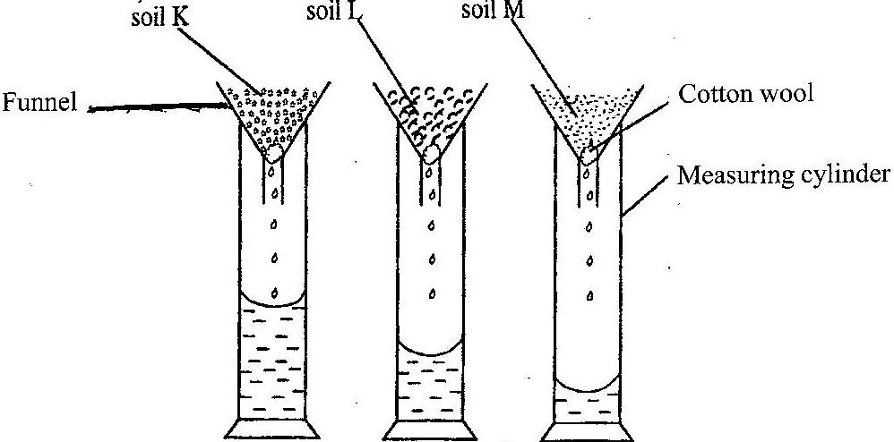

(i) What is the aim of the experiment? [2 marks] (ii) Which soil has the highest rate of drainage? [1 mark] (iii) Which soil has the highest water retention capacity? [1 mark] (iv) Which soil is most likely to lose water and dry faster after rainfall? [1 mark] (v) Which soil is most likely to be waterlogged after rainfall? [1 mark] (vi) Which of the soil types would be suitable for maize cultivation? [1 mark]

(b) The diagram below illustrates hazard symbols labelled I, II, III and IV.  
*Study the diagram carefully and answer the questions that follow.*

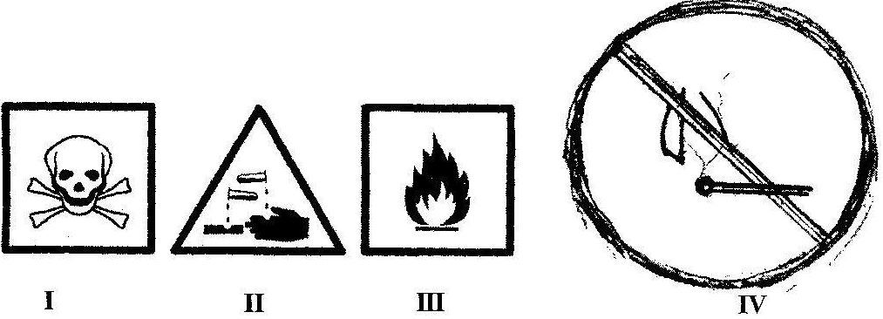

(i) What does each of the symbols labelled I, II, III and IV represent?  
(ii) Name one substance each that is associated with:  
(α) I;  
(β) II;  
(γ) III. [3 marks]

(iii) Name a place where the hazard symbol labelled IV is often displayed [1 mark] (iv) Which of the symbol(s) is / are found on chemical containers? [3 marks]

(c)The diagrams below are illustrations of devices used to do work easily  
*Study the diagrams and answer the questions that follow*

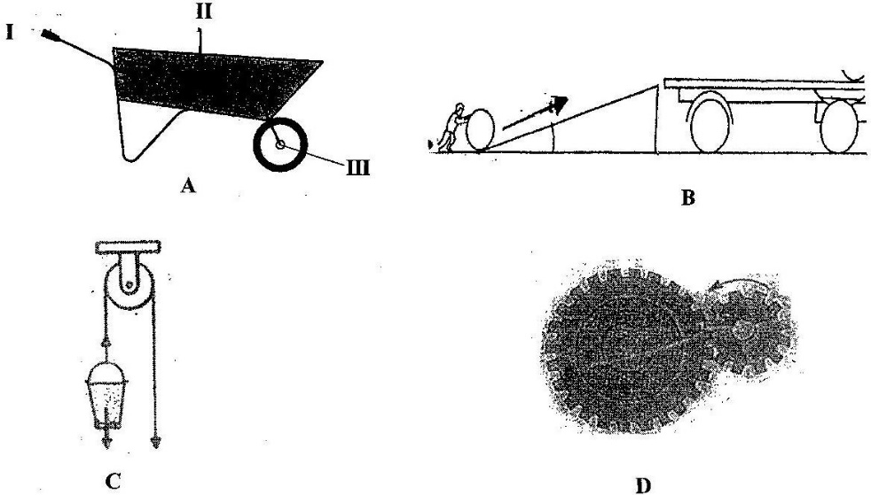

(i) Give a general name for the devices. [1 mark] (ii) Identify each of the devices labelled A, B, C and D. [4 marks] (iii) Name the parts labelled I, II and III of device A when it is considered as a lever.  
[3 marks] (iv) What does the arrow represent in the device labelled B? [1 mark] (v) Name the type of work done with each of the devices labelled:

(α) C;  
(β) D; [2 marks]

(d) The diagram below illustrates the digestive system in humans.

*Study the diagram carefully and answer the questions that follow*

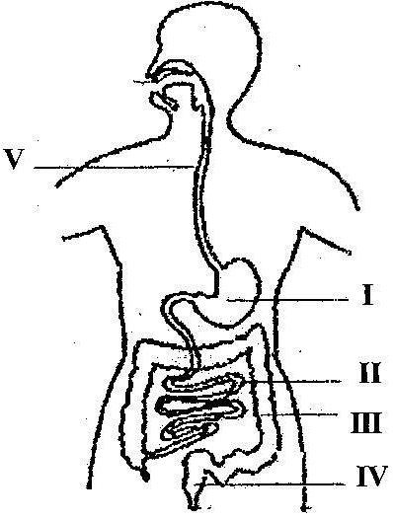

(i) Name each of the parts labelled I, II, III, IV and V [5 marks] (ii) Name the part(s) of the digestive system where  
(α) digestion of food substances occur  
(β) digested food is absorbed into the bloodstream [3 marks] (iii) Name the end-products of the digestion that is absorbed into the bloodstream  
[3 marks]

2. (a) Name four weather measuring instruments. [4 marks]

(b) Name the stages in the life cycle of a mosquito. [4 marks]

(c) (i) List two properties of water  
(ii) Explain why it is advisable to wash clothes with soft water [4 marks]

(d) State three ways in which soil profile is important. [3 marks]

3. (a) List three modes of heat transfer. [3 marks]

(b) (i) What is a deficiency disease?  
(ii) Name three deficiency diseases in humans. [5 marks]

(c) State two ways in which each of the following factors cause depletion of soil resources:  
(i) burning  
(ii) leaching [4 marks]

(d) List three processes that can change matter from one state to another. [3 marks]

4. (a) (i) What is a satellite?  
(ii) Give three uses of artificial satellites. [5 marks]

(b) State the composition of each of the following alloys:  
(i) brass  
(ii) steel  
(iv) bronze [3 marks]

(c) Name three cultural practices used in vegetable production. [3 marks]

(d) List four parts of the respiratory system in humans. [4 marks]

5. (a) (i) What is a force?  
(ii) State two ways in which forces could affect a body [4 marks]

(b) (i) What is a chemical change?  
(ii) State three differences between chemical change and physical change.  
[5 marks] (c) Name three physical properties of soil. [3 marks]

(d) Mention three diseases of the circulatory system in humans. [3 marks]

6. (a) Write the systematic name for each of the following compounds:  
(i) H2O  
(ii) MgO  
(iii) CaO  
(iv) CaCl2 [4 marks]

(b) Name the instrument used in measuring the following:  
(i) length of a rope  
(ii) mass of a stone  
(iii) temperature of a liquid  
(iv) volume of a liquid [4 marks]

(c) List three factors that influence vegetable crop production. [3 marks]

(d) Name four stages in the life cycle of a flowering plant. [4 marks]

# Paper 2 Answers

(a) (i) The aim of the experiment [2 marks] To determine the drainage ability / water-holding capacity of the soils

(ii) Soil with the highest rate of drainage [1 mark] Soil K

(iii) Soil with the highest water retention capacity [1 mark] Soil M

(iv) The soil most likely to lose water and dry faster after rainfall [1 mark] Soil K

(v) The soil most likely to be waterlogged after rainfall [1 mark] Soil M

(vi) Which of the soil types would be suitable for maize cultivation? [1 mark] Soil L

(b) (i) What each of the symbols labelled I, II, III and IV represent  
I – Danger  
II – Corrosive  
III – Highly inflammable / highly flammable  
IV – No naked flame

(ii) One substance each that is associated with:  
(α) I; DDT, Hydrogen cyanide, Salicylic acid  
(β) II; Concentrated Inorganic acids, such as HCl, H2SO4, HNO3,  
Concentrated inorganic bases, such as NaOH, KOH, Ca(OH)2  
Household bleach  
(γ) III. Petrol, Kerosene, LPG, Perfume, Insecticides, Alcohol [3 marks]

(iii) A place where the hazard symbol labelled IV is often displayed [1 mark] Gas Filling stations, Storage places of combustible substances

(iv) Symbol(s) found on chemical containers [3 marks] I, II and III

(c) (i) General name for the devices. [1 mark] Simple machines

(ii) Identification of each of the devices labelled A, B, C and D. [4 marks] A – Wheel barrow  
B – Inclined plane  
C – Pulley  
D – Gear

(iii) The parts labelled I, II and III of device A when it is considered as a lever.  
[3 marks] I – Effort  
II – Load  
III – Pivot

(iv) What the arrow represents in the device labelled B [1 mark] Direction of effort / effort distance

(v) The type of work done with each of the devices labelled:

(α) C; Lifting objects

(β) D; moving a vehicle or parts of an engine efficiently  
[2 marks]

(d) (i) Names of the parts labelled I, II, III, IV and V [5 marks] I – Stomach  
II – Small intestines  
III – Large intestines  
IV – Rectum  
V – Oesophagus / gullet

(ii) The part(s) of the digestive system where  
(α) digestion of food substances occur  
I and II  
(β) digested food is absorbed into the bloodstream [3 marks] II

(iii) The end-products of the digestion that is absorbed into the bloodstream  
[3 marks] Amino acids, glucose, fatty acids and glycerol

2. (a) Four weather measuring instruments. [4 marks] Barometer, rain gauge, anemometer, wind vane, hygrometer, sun dial / lightmeter

(b) The stages in the life cycle of a mosquito. [4 marks] Egg stage, larva stage, pupa stage and adult stage

(c) (i) Two properties of water  
• Colourless  
• Odourless  
• Tasteless  
• Boils at 100°C  
• Freezes at 0°C

(ii) Why it is advisable to wash clothes with soft water [4 marks] It lathers better with soap, since it does not contain dissolved salts such as calcium carbonate, magnesium hydroxide and calcium sulphate.  
There is no production of scum, therefore it makes washing easier and faster.

(d) Three ways in which soil profile is important. [3 marks] • to determine the type of crop to grow  
• to determine the most suitable farming system to use  
• to determine the type / amount of fertilizer needed  
• to determine the cultural practices to use  
• to determine the type of tools / equipment to use  
• to determine the cost of production

3. (a) Three modes of heat transfer. [3 marks] Conduction, convection and radiation

(b) (i) What a deficiency disease is  
A disease that results from the lack or shortage of certain nutrients in the body of an organism

(ii) Three deficiency diseases in humans. [5 marks] Kwashiorkor, goiter, rickets, anaemia, scurvy, night blindness

(c) Two ways in which each of the following factors cause depletion of soil resources:  
(i) burning  
♣ kills soil micro organism, such as nitrogen-fixing bacteria  
♣ makes the land bare, which results in soil erosion  
♣ causes faster evaporation of soil water  
♣ destroys soil nutrients

(ii) leaching [4 marks] ♣ washes away water-soluble plant nutrients, especially nitrates and sulphur.  
♣ leads to soil acidity  
♣ affects the texture of the topsoil.

(d) Three processes that can change matter from one state to another. [3 marks] ♣ Freezing  
♣ Condensation  
♣ Sublimation  
♣ Melting  
♣ Evaporation  
♣ Deposition

4. (a) (i) What a satellite is.  
A body that moves around / orbits a planet

(ii) Three uses of artificial satellites. [5 marks] ♣ weather forecasting  
♣ communication  
♣ scientific exploration  
♣ Navigation – using GPS, etc.  
♣ television/ radio broadcast  
♣ military purposes

(b) The composition of each of the following alloys:  
(i) brass  
copper and zinc

(ii) steel  
iron and carbon

(iii) bronze [3 marks] copper and tin

(c) Three cultural practices used in vegetable production. [3 marks] ♣ Weeding  
♣ Pruning  
♣ Mulching  
♣ Watering  
♣ Thinning out  
♣ Staking

(d) Four parts of the respiratory system in humans. [4 marks] Nostril, bronchus, bronchioles, alveoli, trachea, pharynx, blood capillaries

5. (a) (i) What a force is  
A push or pull on an object

(ii) Two ways in which forces could affect a body [4 marks] A force can:  
♣ cause a stationery body to move  
♣ cause a moving body to stop  
♣ increase the speed of a moving body (acceleration)  
♣ decrease the speed of a moving body (deceleration)  
♣ change the shape of a body

(b) (i) What a chemical change is  
A change in which a new substance is formed and is irreversible, eg, the neutralization reaction between HCl and NaOH

(ii) Three differences between chemical change and physical change.

|  |  |
| --- | --- |
| **CHEMICAL CHANGE** | **PHYSICAL CHANGE** |
| A new substance is formed | No new substance is formed |
| It is irreversible (not reversible) | It is usually reversible |
| Heat energy is given off or absorbed | No heat energy given off or absorbed |
| Chemical bonds are broken and new ones form | Chemical bonds are not broken and no new ones are formed |

[5 marks]

(c)        T**hree** physical properties of soil.                                                                    [3 marks]

* Soil Texture,
* Soil Structure,
* Water-holding capacity/ permeability / porosity
* Soil colour
* Bulk density
* Soil temperature
* Soil Consistency / Soil strength

(d)       T**hree** diseases of the circulatory system in humans.                                      [3 marks]

* Anaemia
* Haemophilia
* Coronary artery disease
* Arteriosclerosis
* Leukemia
* stroke
* hypertension
* heart failure
* heart attack
* Aortic dissection
* Cardiomyopathy, etc

6. (a) The systematic name for each of the following compounds:  
(i) H2O – Dihydrogen monoxide or hydrogen oxide  
(ii) MgO – Magnesium oxide  
(iii) CaO – Calcium oxide  
(iv) CaCl2 – Calcium chloride [4 marks]

(b) The instrument used in measuring the following:  
(i) length of a rope –  
Metre rule or tape measure  
(ii) mass of a stone –  
Beam balance, triple beam balance,  
(iii) temperature of a liquid-  
Mercury-in-glass thermometer, alcohol thermometer  
(iv) volume of a liquid –  
Measuring/graduated cylinder, beaker, pipette, volumetric flask, measuring cup/jug  
[4 marks]

(c)        T**hree** factors that influence vegetable crop production.                                            [3 marks]

* Site selection
* Quality of crop variety /planting material
* Nature of soil
* Climate / weather conditions
* Cultural practices
* Harvesting
* Storage
* Marketing

(d)        F**our** stages in the life cycle of a flowering plant.                                          [4 marks]

* Germination
* Seedling
* Mature plant
* Flowering
* Pollination
* Fertilization
* Formation of seeds and fruits
* Dispersal of seeds and fruits