BASIC 7
WEEKLY LESSON PLAN – WEEK 2
Learning Indicator(s) | B7.3.3.1
Performance Indicator | B7.3.3.1.1 Discuss the key principles of information security  (confidentiality, integrity and availability)  B7.3.3.1.2 Explore the legal issues regarding intellectual property  rights (e.g. Copyright, Patent, Trademark, Piracy, Copyright  Infringement)
Week Ending | 23-09-2022
FORM | B.S.7
Subject | Computing
Reference | Teacher Resource Pack, Learners Resource Pack, Curriculum.
Teaching / Learning Resources | Personal Computer, Word Chart, Copyrighted Products.
CORE COMPETENCIES | Core Competencies:  CI, CC, CL, CI 6.1, CC 7.4
DAYS | PHASE 1 : STARTER | PHASE 2: MAIN | PHASE 3: REFECTION
MONDAY  19-09-2022 | Review Learners knowledge on the previous lesson. | - Discuss with Learners 5 examples of Information Security.  - Learners in small groups discuss Information Security activities.  - Research scenarios involving information security  Examples of Information Security;  - pass cards or codes for access to buildings  - user ids and passwords for network logi  - finger print  - retinal scanners  Information Security Activities;  - Inspection  - Modification  - Recording  - disruption or destruction.  The goal is to ensure the safety and privacy of critical data such as customer account details, financial data or intellectual property.  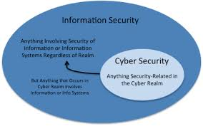 | Core Competencies;  - Ability to ascertain when  information is needed and be able to  identify, locate, evaluate and effectively  use it to solve a problem.  - Anticipate different responses  from the participants and plan for them.
THURSDAY  22-09-2022 | Through questions and answers, introduce the lesson. | - Discuss with Learners the concepts of copyright (e.g. freeware, shareware, cripple ware).  - Assist Learners to differentiate between Copyright and Copyright Infringement.  - Learners in small groups discuss 5 consequences associated with breaking Copyright laws.  Copyright;  Copyright refers to the legal right of the owner of intellectual property. In simpler terms, copyright is the right to copy. This means that the original creators of products and anyone they give authorization to are the only ones with the exclusive right to reproduce the work.  Difference between Shareware and Cripple ware;  cripple ware is a program whose functionality is severely limited beyond that of shareware, often in the interest of its author having the cripple ware user make a purchase of the uncrippled program while shareware is (computing) a type of software that is distributed.  Difference between Freeware and Shareware;  Freeware software is provided to its users free of cost. Shareware software is provided to its users free for a limited period of time after which software needs to be paid. The source code of the software is not available to its user.  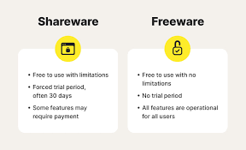 | - Ability to ascertain when  information is needed and be able to  identify, locate, evaluate and effectively  use it to solve a problem.  - Anticipate different responses  from the participants and plan for them.

