BASIC 7
WEEKLY LESSON PLAN – WEEK 2
Learning Indicator(s) | B7.5.1.1
Performance Indicator | B7.5.1.1.2: Identify the types of lines used in graphic  Communication  B7.5.1.1.3: Make sketches of lines, curves, objects, and write the  Letterings
Week Ending | 23-09-2022
FORM | B.S.7
Subject | Career technology
Reference | Curriculum, Teachers Resource Pack, Learners Resource Pack.
Teaching / Learning Resources | Drawing Paper, Pencil, Eraser, chalk, etc.
DAYS | PHASE 1 : STARTER | PHASE 2: MAIN | PHASE 3: REFECTION
MONDAY  19-09-2022 | Learners brainstorm to explain the meaning of Line and identify the types of Line. | - Discuss with Learners the types of Lines used in Graphic Communication.  - Learners in small groups are to discuss the features and uses of lines.  - Learners individually practice using Lines in drawing objects.  What is called line?  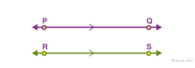  A line is a one-dimensional figure, which has length but no width. A line is made of a set of points which is extended in opposite directions infinitely. It is determined by two points in a two-dimensional plane. The two points which lie on the same line are said to be collinear points.  Features of a Line;  - short or long  - thin or thick  - straight or curved  - direct or meandering  - zigzag or serpentine  - distinct or blurred.  USES OF LINES  - It is used to indicate a part.  - It is used show direction.  - It is used as a symbol.  - It is used as a plan.  - It is used to make a sketch.  - It is used to mark out.  - It is used to cut out a part.  - It is used as measurement | Core Competencies;  - Ability to select alternatives that  adequately meet selected criteria.  - Exhibit strong memory, intuitive  thinking and respond appropriately.  - Reflect on work and explore  thinking behind thoughts and processes.
THURSDAY  22-09-2022 | Individual Learners practice drawing lines, curves and objects. | - Learners brainstorm to identify lower- and upper-case letters.  - Discuss with Learners the principles of lettering.  - Assist Learners to Set out drawing paper and prepare title block indicating name, school,  class, date and drawing number.  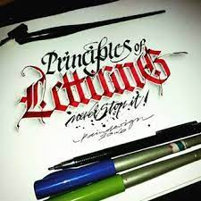  Principles of Lettering;  - Font Choice. Your choice of font will be the first thing you need to consider – and probably the most time consuming!  - Size.  - Letter Spacing & Line Height.  - Alignment & Proximity.  - Readability. | Core Competencies;  - Ability to select alternatives that  adequately meet selected criteria.  - Exhibit strong memory, intuitive  thinking and respond appropriately.  - Reflect on work and explore  thinking behind thoughts and processes.

