BASIC 7
WEEKLY LESSON PLAN – WEEK 6
Learning Indicator(s) | B7 6.1.1
Performance Indicator | B7 6.1.1.1: Explain the meaning of work and entrepreneurship
Week Ending | 21-10-2022
FORM | B.S.7
Subject | Religious and Moral Education
Reference | Curriculum, Teachers Resource Pack, Learners Resource Pack.
Teaching / Learning Resources | Textbook, Word Chart, Pictures showing types of Work.
DAYS | PHASE 1 : STARTER | PHASE 2: MAIN | PHASE 3: REFECTION
TUESDAY  18-10-2022 | Learners are to be assisted to explain the meaning of Work with examples. | - Discuss the difference between the concept ‘Work’ and ‘Entrepreneurship’  - Assist Learners to explain Social Security with regards to retiring from work.  - Learners in small groups to discuss the types of work and present to the class.  Work;  Work refers to an activity in which one exerts strength or faculties to do or perform something: : activity that a person engages in regularly to earn a livelihood. people looking for work. : a specific task, duty, function, or assignment often being a part or phase of some larger activity.  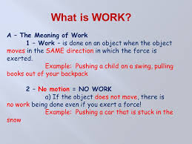  Entrepreneurship is the creation or extraction of economic value. With this definition, entrepreneurship is viewed as change, generally entailing risk beyond what is normally encountered in starting a business, which may include other values than simply economic ones. | Core Competencies;  Demonstrate a thorough understanding  of generalised concepts and facts specific to  task or situation.
THURSDAY  20-10--2022 | Ask individual learners about the kind of work they will do in future. | - Discuss the types of work with the Leaners.  - Learners brainstorm to give examples each of the types of Work.  - Assist learners to mention the kind of works they do at school and at home.  Types of Work  • Domestic – washing, sweeping, cooking, etc.  • Community – clean-up exercises, building of schools, clinics, etc.  • School (academic and non-academic) – studying, sweeping, games,  work of school prefects, etc.  • Work for livelihood/Occupational – teaching, farming,  carpentry, nursing, policing, etc.  • Religious work — the work of priests/priestesses, imams,  church administrators, evangelist.  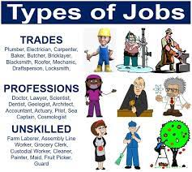 | Core Competencies;  - Analyse and make distinct judgement  about viewpoints expressed in an argument.  - Understanding of influences of  globalisation on traditions, languages and  cultures.

