WEEK ENDING………28/10/2022……………………………………
SUBJECT…RELIGIOUS AND MORAL EDUCATION.
REFERENCE…SYLLABUS(CRDD,2007), RME FOR JHS ……
FORM……………..BASIC 8……………WEEK………7…………..

DAY/DURATION | TOPIC/SUB-TOPIC/ASPECT | OBJECTIVES/R.P. K | TEACHER-LEARNER ACTIVITIES | T/L MATERIALS | CORE POINTS | EVALUATION AND REMARKS
TUESDAY  25-10-2022  1:20PM – 2:40PM  80min | Topic;  Rites of passage (Death rites)  Sub-Topic;  Death Rites Among the Christian Religion | Objective;  By the end of the lesson the Pupil will be able to;  Identify death rites among the Christian Religion.  RPK  Most of the Pupils are Christians and have seen how Christians perform death rite. | Introduction  Review Pupils knowledge on the previous lesson.  Activities  - Pupils brainstorm to explain why Christians perform death rite.  - Discuss ways of performing death rite in the Christian religion.  - Assist Pupils to role play on how Christians perform death rite  Closure  Through questions and answers, conclude the lesson | - Pictures showing how death rite is performed.  - Word Chart  - Textbook.  - Video player | Christian death rites  - laying in state  - wake-keeping  - burial service  - burial with body in coffin  - memorial /thanksgiving service  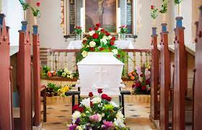 | Exercise  - Describe the death rite among the Christians.  - According to Christians what are the importance of performing death rites?
THURSDAY  27-10-2022  8:05AM – 9:15AM  70min | Topic;  Rites of passage (Death rites)  Sub-Topic;  Death Rite Among Islamic Religion | Objective;  By the end of the lesson the Pupil will be able to;  Explain how death rite is performed in the Islamic religion.  RPK  Pupils have witnessed Islamic death rite in their community. | Introduction  Show video of how Islamic death rite is performed.  Activities  - Discuss with the Pupils how Islamic death is performed.  - Assist Pupils to explain each rite performed during the Islamic death rite.  Closure  Pupils in small groups to discuss the reasons why Muslims perform death rite. |  | Islamic death rites;  Muslims are always buried, never cremated. It is a religious requirement that the body be ritually washed and draped before burial, which should be as soon as possible after death.  - laying in state  - Janazah prayer  - burial without coffin  - 40th day funeral celebration for some  Muslim sects.  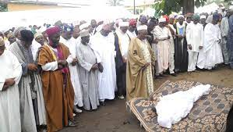 | REMARKS

