Welcome!

Please scroll down to read introductory information

WordPub
BECE
BASIC DESIGN AND TECHNOLOGY
(Pre-Technical Skills)

Past Questions & Answers

2017

Junior High School
Years 1, 2 & 3

Compiled by:


© 2018 Word Publishers. All rights reserved

Unauthorized distribution and/or reproduction of this document prohibited.

CONTACT

Email:
info@wordpub.org

Telephone:
(+233) 030 295 1486,
(+233) 020 893 0787,
(+233) 057 860 0052,
(+233) 024 850 6613.

Postal Address:
Word Publishers,
P.O. Box NT 583,
Newtown – Accra,
Ghana.

Location:
7 Tunemete Street,
Dzorwulu-Accra,
Ghana.

Website:
bece.wordpub.org

ACKNOWLEDGEMENTS

- The West African Examination Council - for the BECE Pre-Technical Skills past questions used in this document.

- Ernest Ato Bentil and Maxwell Mensah – for your invaluable contribution to this work.

- Ruth, Baaba and Fiifi Arthur – for your relentless support

- Teachers, parents and educational institutions – for your continuous patronage and tireless efforts at ensuring quality education for the 21st century child

- Junior High School students – you are the ultimate reason for this work.

DEDICATION
To the Lord Jesus Christ, our Saviour and soon-coming King

June 2017

BASIC DESIGN AND TECHNOLOGY 1

(Pre-Technical Skills 1)

Objective Test

40 minutes

- A common method of cooking ripe plantain for sale is
  - boiling.
  - roasting.
  - grilling.
  - baking.

- To shorten the cooking time for meat,
  - slice along the grain.
  - cut into small pieces.
  - slice into thin pieces.
  - cut across the grain.

- In taking body measurement, a firm tape measure is needed to
  - save time.
  - avoid wasting fabric.
  - obtain accuracy.
  - make sewing easy.

- Which of the following principles of design is similar to proportion?
  - Balance
  - Perspective
  - Rhythm
  - Scale

- A preliminary design is meant to
  - improve creativity.
  - increase production.
  - make sketches.
  - produce ideas.

Use the sketch in Figure 1 to answer Questions 6 and 7

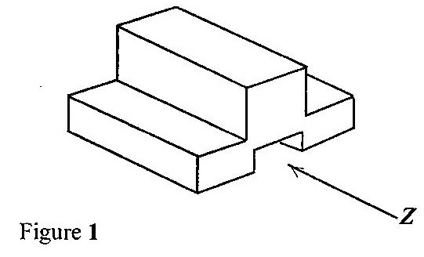

- Which of the following represents the front view in the direction of arrow Z?

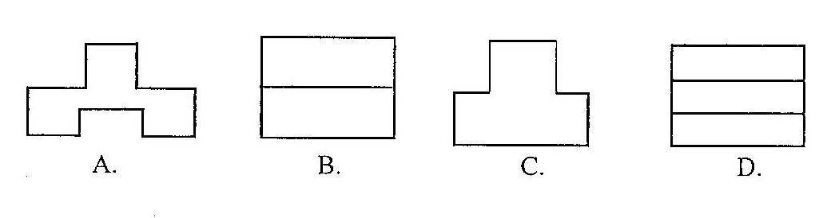

- Which of the following represents the left end elevation?

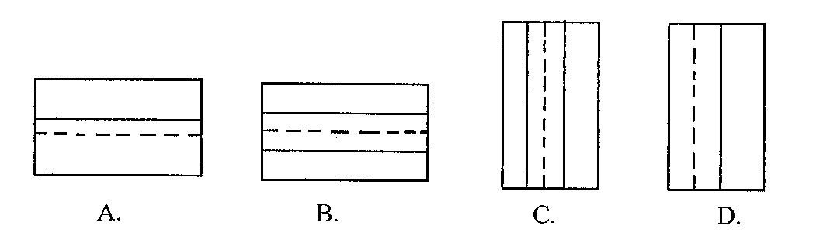

- A single unit of a design is known as
  - motif.
  - pattern.
  - plan.
  - print.

- Angles are measured by using a
  - compass.
  - protractor.
  - rule.
  - set square.

- In designing, the analysis question, what is the purpose of the unit? falls under
  - construction.
  - ergonomics.
  - function.
  - material.

- To repair an electrical fault, a safety precaution to observe is to
  - disconnect live wires.
  - remove fuse.
  - remove cover of socket.
  - switch off main supply.

- Which of the following is not a cause of weakness in furniture?
  - Loose joint
  - Insufficient polish
  - Overloading
  - Removal of nail

- The tee-square is used for drawing
  - arcs.
  - circles.
  - horizontal lines.
  - vertical lines.

- Identify the type of lettering used for emphasis.
  - Freestyle
  - Gothic
  - Italics
  - Romans

- Strips cut on the true cross of fabric are usually used for curved edges because they
  - stretch easily.
  - do not fray.
  - are easily prepared.
  - are colourful.

- The body of a box-iron is made from
  - aluminium.
  - cast iron.
  - copper.
  - wrought iron.

- Polyvinyl acetate is a type of
  - abrasive.
  - adhesive.
  - aggregate.
  - finish.

- The type of aggregate that passes through a 5 mm wire mesh is
  - clay.
  - laterite.
  - sand.
  - stone.

- Which of the following tools is suitable for pairing on wood?
  - Cross-cut saw
  - Firmer chisel
  - Mortise chisel
  - Rip saw

Use the sketch in Figure 2 to answer questions 20 and 21.

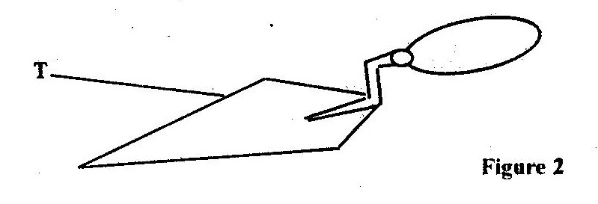

- The tool is used for
  - cutting bricks.
  - mixing mortar.
  - picking and spreading mortar.
  - setting out a wall.

- The part labelled T is
  - blade.
  - ferrule.
  - handle.
  - shank.

- Personal safety is observed on site in order to
  - reduce the risk of damaging tools
  - prevent damage to workpiece.
  - care and maintain tools.
  - prevent accidents to workers.

Use the sketch in Figure 3 to answer questions 23 and 24
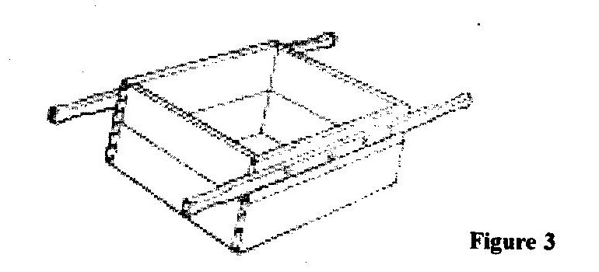

- The sketch shown is
  - gauge box.
  - head pan.
  - mould box.
  - pallet.

- The tool is used for
  - holding blocks.
  - moulding blocks.
  - fetching water.
  - batching materials.

Use the sketch in Figure 4 to answer questions 25 and 26

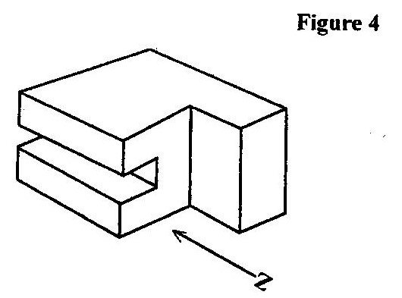

- Which of the following represents the front view in the direction of arrow Z?
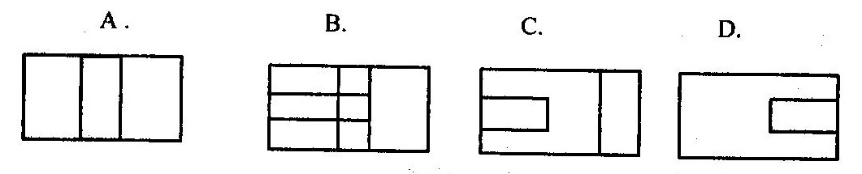

- Which of the following represents the left end elevation?
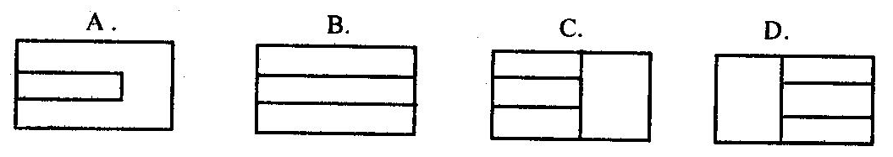

Use the sketch in Figure 5 to answer questions 27 and 28

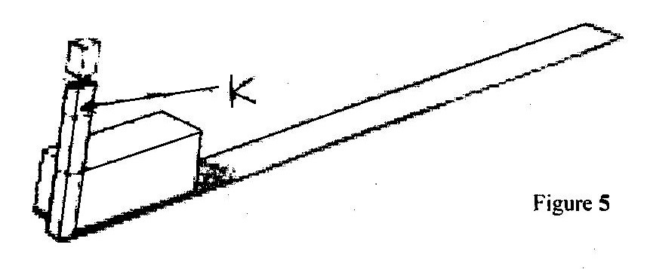

- The sketch shows the process of
  - plumbing a wall.
  - levelling a wall.
  - spreading mortar for a wall.
  - checking height of a wall.

- The tool labelled K is the
  - builder’s square.
  - gauge rod.
  - spirit level.
  - straight edge.

- In an electrical circuit, the fuse is connected to the
  - earth wire.
  - live wire.
  - negative wire.
  - neutral wire.

- Which of the following components helps to open and close a circuit?
  - Cell
  - Fuse
  - Plug
  - Switch.

June 2017

BASIC DESIGN AND TECHNOLOGY 1

(Pre-Technical Skills 1)

Objective Test
ANSWERS

- C. grilling
- D. cut across the grain
- C. obtain accuracy
- D. Scale
- D. produce ideas
- A. 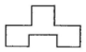
- A 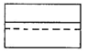
- A. motif
- B. protractor
- C. function
- D. switch off main supply
- B. Insufficient polish
- C. horizontal lines
- C. Italics
- A. stretch easily
- B. cast iron
- B. adhesive
- C. sand
- C. Mortise chisel
- C. picking and spreading mortar
- A. blade
- D. prevent accidents to workers
- A. gauge box
- D. batching materials
- C. 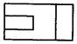
- C. 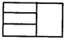
- A. plumbing a wall
- C. spirit level
- B. live wire
- D. Switch

June 2017

BASIC DESIGN AND TECHNOLOGY 2

(Pre-Technical Skills 2)

Essay

1 hour 15 minutes

SECTION A
(CORE SKILLS)
[20 marks]
Answer question 1 [COMPULSORY]

- (a) What are temporary stitches? [2 marks]

(b) State four reasons for setting a table for family meals. [4 marks]

(c) A unit for hanging school uniforms is to be designed and made in the school workshop.

(i) State two places where the unit would be placed in the workshop. [3 marks]

(ii) State two specifications of the unit based on construction; [2 marks]

(iii) Name one specific material to be used for making the unit. [2 marks]

(d) (i) List five important pieces of information printed onto a package. [5 marks]

(ii) Name two other methods for making a print. [2 marks]

SECTION B
[50 marks]
Answer two questions only from this section
All questions carry equal marks

- (a) (i) Make a freehand pictorial sketch of the hand file with a handle used for filing metals.

(ii) Label any two parts of the hand file sketched in question 2 (a)(i).

(iii) State one use of the hand file.

(b) Copy and complete the table below:

OPERATION | TWO TOOLS REQUIRED FOR EACH OPERATION
- Moulding of bricks
- Marking out on metal plate
- Soldering sheet metals
- Cutting a piece of wood into two

Figure 1 shows the front view and plan of a square pyramid.

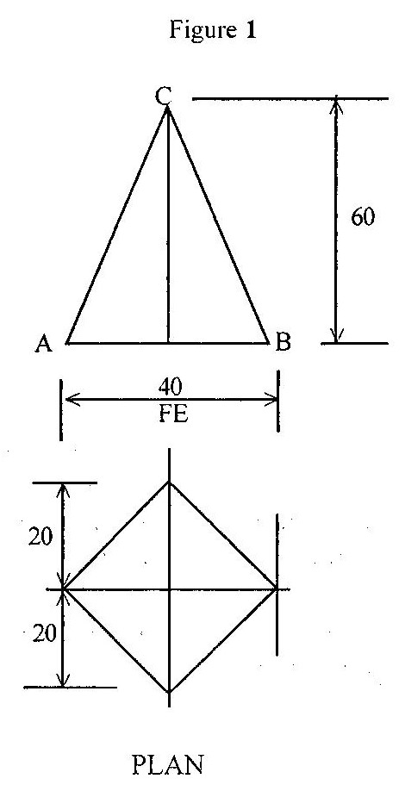

(c) Draw full size the following views:
(i) front view;
(ii) plan.
[25 marks]

- (a) (i) Make a freehand pictorial sketch of the claw hammer.

(ii) Label any two parts of the claw hammer sketched in question 3(a)(i)

(iii) State one use of the claw hammer.

(b) Copy and complete the table below:

PRODUCT | ONE SPECIFIC MATERIAL FOR MAKING THE PRODUCT
- Body of sewing machine
- Water hose
- Gauge box
- Traditional oven
- Drawing board

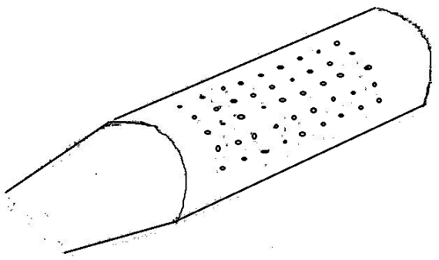
Figure 2

(c) Figure 2 shows the pictorial sketch of a cassava grater made from sheet metal.
Re-arrange the following procedure for making the grater in the correct order:

- cut out the shape with snips;
- draw patterns on paper;
- punch holes on the sheet metal;
- solder closed edges;
- fold workpiece.

(d) (i) Explain the term batching in blockwork.

(ii) Name one tool used for mixing mortar.
[25 marks]

- (a) (i) Make a freehand pictorial sketch of a ball-pein hammer.

(ii) Label any two parts of the ball-pein hammer sketched in question 4(a)(i).

(iii) State one use of the ball-pein hammer.

(b) Copy and complete the table below

MATERIAL | ONE USE | ONE PROPERTY
- Mahogany
- Nylon
- Clay

(c) (i) List two tools used for reviting metal pieces.

(ii) State two safety precautions to be observed when building a wall.

(iii) List two types of chisels used in wood work.
[25 marks]

END OF ESSAY TEST

June 2017

BASIC DESIGN AND TECHNOLOGY 2

(Pre-Technical Skills 2)

Objective Test
ANSWERS

- (a) What are temporary stitches? [2 marks]

These are stitches used to hold parts of articles together and removed when permanent stitches are made.

(b) State four reasons for setting a table for family meals. [4 marks]

(State any four of the following)

- To stimulate / whet appetite
- To have all items needed within reach
- To make eating more pleasant
- To create a welcoming environment
- It brings out the skills of the caterer
- Young ones are taught how to set table

(c) A unit for hanging school uniforms is to be designed and made in the school workshop.
[7 marks]

(i) State two places where the unit would be placed in the workshop.

(State any two of the following)
- In the wardrobe
- On the wall
- Partition bar
- Behind the door
- On the window frame

(ii) State two specifications of the unit based on construction;

(State any two of the following)
- Must be strong
- Should take more uniforms at a time
- Corrosive resistant
- Use all types of joints
- Screwed
- Must be portable

(iii) Name one specific material to be used for making the unit.

(Mention any one of the following)
- Odum
- Sapele
- Wawa
- Raffia palm
- Cane
- PVC (acrylic)
- mild steel
- Aluminium

(d) (i) List five important pieces of information printed onto a package. [5 marks]

(Mention any five of the following)

- The name of the product
- Manufacturing date
- Expiry date
- Bar code
- The ingredients used
- Picture of content
- Country of origin
- Usefulness of product
- Net weight / volume of the product

(ii) Name two other methods for making a print. [2 marks]

- Direct printing from existing surfaces, e.g. leaf, tree bark, coin
- Indirect printing, e.g., block, screen, stencil, roller, relief and frontage

SECTION B
[50 marks]
Answer two questions only from this section
All questions carry equal marks

- (a) (i) Make a freehand pictorial sketch of the hand file with a handle used for filing metals.

(ii) Label any two parts of the hand file sketched in question 2 (a)(i).

(State any two of the following)
- Tang
- Blade
- Body
- Edge
- Teeth / cuts
- Handle
- Ferrule

(iii) State one use of the hand file.

(State any one of the following)
- Used to file shoulders of metal
- Used to file corners of metal

(b) Copy and complete the table below:

OPERATION | TWO TOOLS REQUIRED FOR EACH OPERATION
- Moulding of bricks | Mould box  Tamping Rod  Shovel, Spade  Wheel barrow / Head pan  Gauge box
- Marking out on metal plate | Scriber  Steel Rule / Rule / Ruler  Try square  Dot Punch  Chalk  Oddleg Calipers  A pair of compasses / wing compasses  Pair of Dividers  Tape measure  Pencil
- Soldering sheet metals | Soldering Bit / Stove / Soldering iron/ Soldering hammer  Brush, File  Tin snips / snips / shears
- Cutting a piece of wood into two | Cross cut saw  Rip saw  Tenon saw  Dovetail saw  Hand saw (all specific woodwork saws)

Figure 1 shows the front view and plan of a square pyramid.

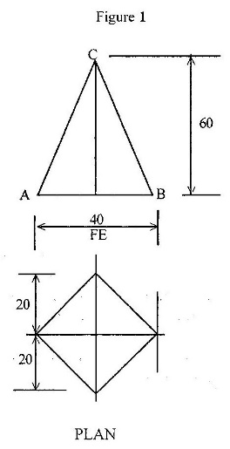

(c) Draw full size the following views:
(i) front view;

(ii) plan.
[25 marks]

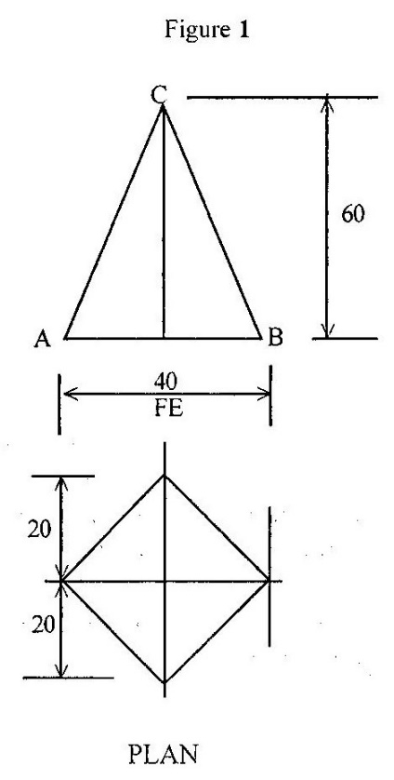

- (a) (i) Make a freehand pictorial sketch of the claw hammer.
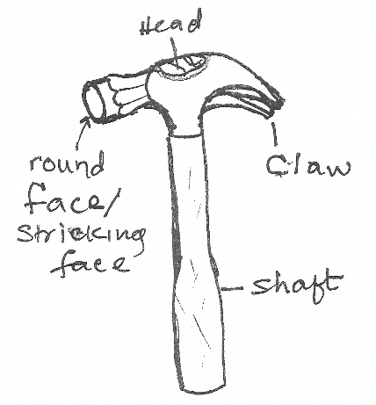

(ii) Label any two parts of the claw hammer sketched in question 3(a)(i)

(State any one of the following)
- Claw
- Head
- Shaft
- Striking face

(iii) State one use of the claw hammer. [2 marks]

(State any one of the following)
- For removing nails
- For driving in nails

(b) Copy and complete the table below: [5 marks]

PRODUCT | ONE SPECIFIC MATERIAL FOR MAKING THE PRODUCT
- Body of sewing machine | Cast Iron
- Water hose | PVC rubber
- Gauge box | Wawa (or any specific wood/metal)
- Traditional oven | Clay laterite
- Drawing board | Acrylic wawa, plywood sapele  (or any specific wood mentioned)

Figure 2

(c) Figure 2 shows the pictorial sketch of a cassava grater made from sheet metal.
Re-arrange the following procedure for making the grater in the correct order: [2 marks]

- Draw patterns on paper;
- Cut out the shape with snips;
- Punch holes on the sheet metal;
- Fold workpiece into shape.
- Solder closed edges;
Note: Steps 2 and 3 are interchangeable

(d) (i) Explain the term batching in blockwork. [3 marks]

Measuring of aggregates

(ii) Name one tool used for mixing mortar. [1 mark]

Spade / shovel

- (a) (i) Make a freehand pictorial sketch of a ball-pein hammer. [6 marks]

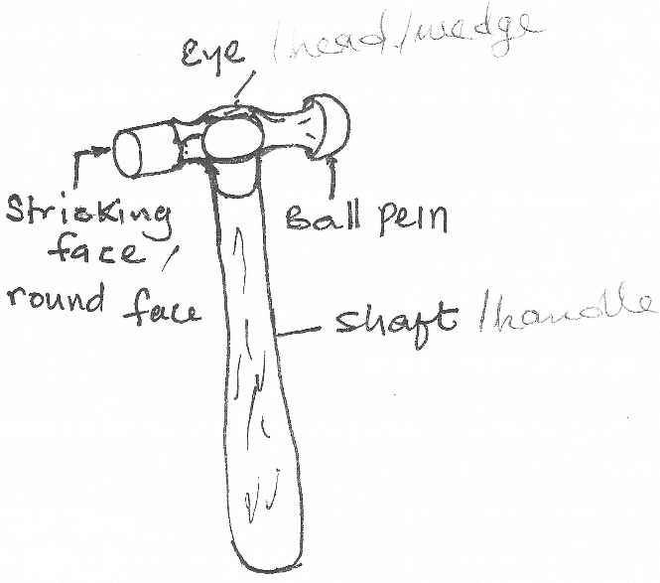

(ii) Label any two parts of the ball-pein hammer sketched in question 4(a)(i).
[2 marks]
(State any two of the following)
- handle / shaft
- striking face
- eye / wedge / head
- ball pein
- head

(iii) State one use of the ball-pein hammer. [2 marks]

(State any one of the following)

- Used for riveting / shaping
- Used for driving nails / pins

(b) Copy and complete the table below [7 marks]

MATERIAL | ONE USE  (State any one of the following) | ONE PROPERTY  (State any one of the following)
- Mahogany | Panelling, Plywood, furniture | Hard, durable, mixed grain / Interlock grain, brownish / brownish red / red in colour
- Nylon | Clothing, carpets, comb, brushes, gears, plug | Hard, resistance to wear
- Clay | Ceramic wares, bricks, tiles, oven, water cooler, pots, mugs, bowls, earthen ware | Sticky when wet, hard when dry, dense, can hold water, prone to cracks

(c) (i) List two tools used for riveting metal pieces. [2 marks]

(State any two of the following)
- ball-pein hammer
- vice
- dolly
- rivet set

(ii) State two safety precautions to be observed when building a wall. [4 marks]

(State any two of the following)
- Wearing of helmet
- Wearing safety boot
- Wearing of overall / overcoat

(iii) List two types of chisels used in wood work. [2 marks]

(State any two of the following)
- Firmer chisel
- Mortise chisel
- Bevel edge chisel

