Welcome!

**Please scroll down to read introductory information**

**WordPub**

**BECE**

**Mathematics**

**Past Questions & Answers**

**2017**

**Junior High School**

**Years 1, 2 & 3**

**Compiled by:**



**© 2018 Word Publishers. All rights reserved**

**Unauthorized distribution and/or reproduction of this document prohibited.**

**CONTACT**

**Email:**

**info@wordpub.org**

**Telephone:**

**(+233) 030 295 1486,**

**(+233) 020 893 0787,**

**(+233) 057 860 0052,**

**(+233) 024 850 6613.**

**Postal Address:**

**Word Publishers,**

**P.O. Box NT 583,**

**Newtown – Accra,**

**Ghana.**

**Location:**

**7 Tunemete Street,**

**Dzorwulu-Accra,**

**Ghana.**

**Website:**

[**bece.wordpub.org**](https://bece.wordpub.org/)

**ACKNOWLEDGEMENTS**

* The **West African Examination Council** - for the BECE Mathematics past questions used in this document.
* **Ernest Ato Bentil** and **Abdulai Zakaria**– for your invaluable contribution to this work.
* **Mr Eric Arthur** – for your expert counsel and assistance.
* **Ruth, Baaba** and **Fiifi Arthur** – for your relentless support
* **Teachers, parents and educational institutions** – for your continuous patronage and tireless efforts at ensuring quality education for the 21st century child
* Junior High School **students** – you are the ultimate reason for this work.

**DEDICATION**

To the Lord **Jesus Christ**, our Saviour and soon-coming King

## JUNE 2017

## MATHEMATICS 1

## Objective Test

## 1 Hour

1. If Q = {1, 3, 5, 7, 9, 10, 11, 13, 15} and T = {1, 2, 3, 5, 6, 7, 10, 11, 12}, find Q ∪ T
   1. {1, 2, 3, 5, 7, 10, 11}
   2. {1, 3, 5, 7, 9, 11, 13, 15}
   3. {1, 2, 3, 4, 5, 6, 7, 8, 9, 10, 11, 12, 13}
   4. {1, 2, 3, 5, 6, 7, 9, 10, 11, 12, 13, 15}
2. If 21 : 2*x* = 7 : 12, find the value of *x*.
   1. 10
   2. 12
   3. 15
   4. 18

1. Given that , find the value of *p*.
   1. 4
   2. 3
   3. 2
   4. 1
2. Simplify
3. If A = {2, 6, 8} and B = {4, 6, 8, 10}, which of the following statements is true?
   1. A ⊂ B
   2. A ∩ B = {2, 6, 8}
   3. A ∪ B = {2, 4, 6, 8, 10}
   4. A ⊃ B
4. Find the product of and
5. The sum of the interior angles of a regular polygon with 10 sides is
   1. 144°
   2. 900°
   3. 1440°
   4. 1800°
6. Solve
7. The ages of the members of a social club are 20 years, 55 years, 60 years and 25 years. Find the mean age of the members of the club.
   1. 20 years
   2. 30 years
   3. 40 years
   4. 50 years
8. Evelyn saved GHc 35.48 every month for 8 months. How much did she save?
   1. GHc 183.60
   2. GHc 280.63
   3. GHc 283.20
   4. GHc 283.84
9. Evaluate:
   1. 0.012
   2. 0.12
   3. 1.2
   4. 12.0
10. A woman deposited an amount of GHc 50,000.00 at a bank for 2 years at a rate of 20% per annum. Find the simple interest.
    1. GHc 1,000.00
    2. GHc 2,000.00
    3. GHc 10,000.00
    4. GHc 20,000.00
11. What is the total cost of *x* shirts at GHc 5.00 **each** and *y* shirts at GHc 1.50 **each**?
    1. 5*x* + 1.5*y*
    2. 5*y* + 1.5*x*
    3. 5(*x* + 1.5*y*)
    4. 1.5(5*x* + *y*)
12. At a meeting attended by 23 people, the females were 7 more than the males. How many males were there?
    1. 8
    2. 15
    3. 16
    4. 30

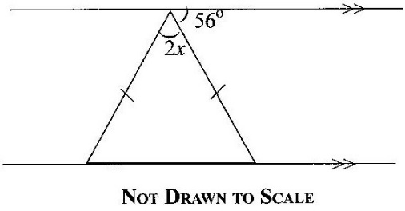

1. Find the value of x in the diagram.
   1. 28°
   2. 30°
   3. 34°
   4. 60°
2. How many lines of symmetry does a rhombus have?
   1. 2
   2. 3
   3. 4
   4. 5
3. In 1995, 215 boys and 185 girls were admitted into a Senior Secondary School. Find, correct to the nearest whole number, the percentage of girls admitted.
   1. 46%
   2. 47%
   3. 53%
   4. 54%
4. Simplify:
5. Solve 25x + 450 ≤ 3000
   1. x ≥ 102
   2. x ≤ 102
   3. x ≥ 138
   4. x ≤ 138
6. Given that a = and b = , find a + b.
7. Mr. Agyekum has 11 of the GHc 20.00 notes, 15 of the GHc 10.00 notes and 6 of the GHc 5.00 notes. How much does Mr. Agyekum have altogether?
   1. 280.00
   2. 320.00
   3. 360.00
   4. 400.00

1. A man travelled a distance of 1.5 km in 30 minutes. What distance can he cover in 50 minutes, travelling at the same speed?
   1. 2.2 km
   2. 2.5 km
   3. 2.8 km
   4. 3.2 km



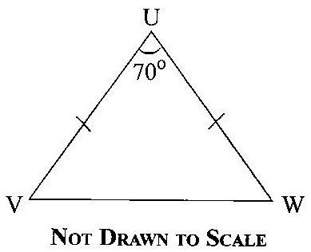

In the diagram, UVW is an isosceles triangle, |UV| = |UW| and angle VUW = 70°. Find angle UVW

* 1. 70°
  2. 60°
  3. 55°
  4. 35°

1. Arrange the following in descending order:
2. The point D(4, 3) is reflected in the y-axis. Find the coordinates of its image.
   1. (–4, –3)
   2. (–3, 4)
   3. (–4, 3)
   4. (3, –4)
3. Simplify:
4. Divide 64.5 by 0.015, leaving the answer in standard form.
5. The point Q(–2, 3) is rotated anticlockwise about the origin through an angle of 90°. Find the coordinates of its image.
   1. (–3, –2)
   2. (–3, 2)
   3. (3, –2)
   4. (3, 2)
6. Elias bought five books. Their mean price was GHc 3.25. The total cost for four of the books was GHc 11.75. What was the cost of the fifth book?
   1. GHc 3.50
   2. GHc 4.00
   3. GHc 4.20
   4. GHc 4.50

Tins of milk **each** of volume 77 cm3 and weight 170 g were packed into an empty carton of volume 1540 cm3 and weight 500 g.

*Use this information to answer Questions* 30 *and* 31

1. How many tins of milk can be packed to fill the carton?
   1. 2
   2. 3
   3. 20
   4. 22
2. What is the weight of the carton when packed with the tins of milk?
   1. 2.06 kg
   2. 2.94 kg
   3. 3.90 kg
   4. 8.50 kg
3. A piece of cloth is 8.4 m long. If 30 cm is needed to sew a napkin, how many napkins can be sewn from this piece of cloth?
   1. 20
   2. 25
   3. 28
   4. 30
4. Express as a decimal fraction.
   1. 0.3200
   2. 0.3125
   3. 0.3676
   4. 0.3222
5. A match box contains 40 sticks. If 15 of them are spoil, find the probability that a stick chosen at random is **not** spoilt?

The number of pupils who attended hospital from eight classes on a particular day are: 1, 5, 3, 1, 7, 5, 1, 1.

*Use the information to answer Questions* 35 *to* 37.

1. Find the median number.
   1. 1
   2. 2
   3. 3
   4. 4
2. What is the modal number?
   1. 1
   2. 4
   3. 5
   4. 7

1. Calculate the mean.
   1. 2
   2. 3
   3. 4
   4. 5
2. The distance from the centre of a circle to any point on it is called
   1. Circumference
   2. Diameter
   3. Radius
   4. Sector
3. Express 1352 as a product of prime factors.
   1. 23 × 133
   2. 23 × 132
   3. 22 × 133
   4. 22 × 132
4. Which of the following statements about sets is **true**?
   1. Every set is a subset of the null set.
   2. The universal set is the subset of the null set
   3. The intersection of two sets is always a null set
   4. The universal set is the union of all its subsets.

## JUNE 2017

## MATHEMATICS 1

## Objective Test

SOLUTIONS

1. D. {1, 2, 3, 5, 6, 7, 9, 10, 11, 12, 13, 15}
2. D. 18
3. A. 4
4. C.
5. C. A ∪ B = {2, 4, 6, 8, 10}
6. B.
7. C. 1440°
8. B.
9. C. 40 years
10. D. GHc 283.84
11. B. 0.12
12. D. GHc 20,000.00
13. A. 5*x* + 1.5*y*
14. A. 8
15. C. 34°
16. A. 2
17. A. 46%
18. D.
19. B. x ≤ 102
20. A.
21. D. GHc 400.00
22. B. 2.5 km
23. C. 55°
24. A.
25. C. (–4, 3)
26. A.
27. B.
28. A. (–3, –2)
29. D. GHc 4.50
30. C. 20
31. C. 3.90 kg
32. C. 28
33. B. 0.3125
34. C.
35. B. 2
36. A. 1
37. B. 3
38. C. Radius
39. B. 23 × 132
40. D. The universal set is the union of all its subsets

**JUNE 2017**

**MATHEMATICS 2**

**PAPER 2**

**ESSAY 1 HOUR**

*Answer* **four** *questions* **only***.*

**All** *questions carry* **equal** *marks.*

*All working* **must** *be clearly shown.*

*Marks will* **not** *be awarded for correct answers without corresponding working*

1. (a) In a class of 30 girls, 17 play football, 12 play hockey and 4 play both games.
   * 1. Draw a Venn diagram to illustrate the given information
     2. How many girls play:

(α) one or two of the games;

(β) none of the two games?

(b)

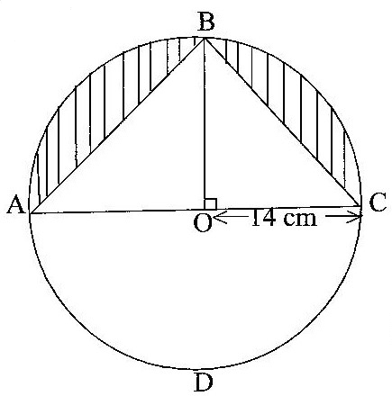

**NOT DRAWN TO SCALE**

In the diagram, ABCD is a circle of radius 14 cm and centre O. Line BO is perpendicular to line AC. Calculate, the total area of the shaded portions.

[Take π = ]

1. (a) Two consecutive odd numbers are such that seven times the smaller, subtracted from nine times the bigger, gives 144. Find the two numbers.

(b) A paint manufacturing company has a machine which fills 24 tins with paint in 5 minutes.

(i) How many tins will the machine fill in

(α) 1 minute, correct to the nearest whole number?

(β) 1 hour?

(ii) How many hours will it take to fill 1440 tins?

(c) Given that and, find the value of s.

1. (a) Using a ruler and pair of compasses only, construct:

(i) a triangle ABC, with |BC| = 9cm, |AC| = 8 and |AB| = 6 cm;

(ii) the perpendicular bisector of line BC;

(iii) the bisector of angle ACB

(b) Label the point of intersection of the two bisectors as Y.

(c) Draw a line to join B and Y.

(d) Measure

(i) |BY|;

(ii) |YC|;

(iii) the base angles of triangle BYC.

(e) What type of triangle is BYC?

1. (a) The table below shows the ages of students admitted in a hospital.

|  |  |  |  |  |  |  |
| --- | --- | --- | --- | --- | --- | --- |
| Age (years) | 10 | 11 | 12 | 13 | 14 | 15 |
| Number of Students | 5 | 1 | 7 | 10 | 3 | 4 |

Use the information to answer the following questions:

(i) What is the modal age?

(ii) Calculate, correct to two decimal places, the mean age of the students.

(b) Rice is sold at GHc 56.00 per bag of 50 kg. A trader bought some bags of rice and paid GHc 1,344.00.

(i) How many bags of rice did the trader buy?

(ii) If the trader retailed the bags of rice at GHc 1.40 per kg, how much profit was made on 1 kg of rice?

1. (a) Using a scale of 2 cm to 1 unit on both axes, draw on a graph sheet two perpendicular axes Ox and Oy for and

(i) Plot, indicating the coordinates of all points A(2, 3) and B(–3, 4). Draw a straight line passing through the points A and B.

(ii) Plot on the same graph sheet, indicating the coordinates of the points C(4, 2) and D(–2, –3). Draw a straight line passing through the points to meet line AB

(b) Using the graphs in 5(a),

(i) find the values of y when x = –2;

(ii) measure the angle between the lines AB and CD.

1. (a) If m = , n = and m + n = , find the:

(i) values of x and y

(ii) components of m

(b) (i) Solve the inequality:

(ii) Illustrate the answer in b(i) on a number line.

(c)

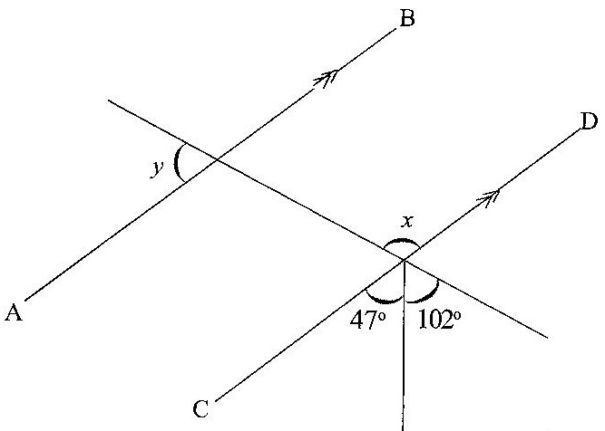

**NOT DRAWN TO SCALE**

In the diagram, AB is parallel to CD. Find the value of:

(i) x

(ii) y

**JUNE 2017**

**MATHEMATICS 2**

**ESSAY**

**SOLUTIONS**

1. **(a) In a class of 30 girls, 17 play football, 12 play hockey and 4 play both games.**
   * 1. **Draw a Venn diagram to illustrate the given information**

Let

U = Total number in class

F = Number of girls who play football

H = Number of girls who play hockey

n = Number of girls who play none of the two games

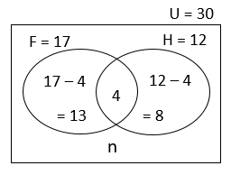

* + 1. **How many girls play:**

**(α) one or two of the games;**

= 13 + 4 + 8

= 25

**(β) none of the two games?**

= 30 – 25

= 5

**(b)**

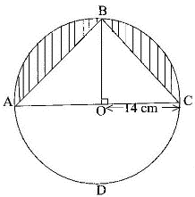

**Total area of shaded portion**

Alternatively, you may first find the area of the entire circle and divide by 2 to get area of semicircle

= Area of semi-circle – Area of the triangle ABC

Area of semi-circle =

=

=

= 308 cm2

Area of triangle ABC =

=

=

=

= 196 cm2

Therefore, Area of shaded portion = 308 – 196

= 112 cm2

1. **(a) Two consecutive odd numbers are such that seven times the smaller, subtracted from nine times the bigger, gives 144. Find the two numbers.**

Let the first (smaller) odd number = n

Then the next (bigger) odd number = n + 2

Seven times the smaller = 7n

Nine times the bigger = 9 (n + 2)

Hence ⇒

⇒

⇒

⇒

⇒

⇒

Therefore the smaller odd number is 63

And the bigger odd number = 63 +2 = 65

**(b) A paint manufacturing company has a machine which fills 24 tins with paint in 5 minutes.**

**(i) How many tins will the machine fill in**

**(α) 1 minute, correct to the nearest whole number?**

If 5 minutes → 24 tins,

then 1 minute → = ≈ 5 tins

Hence, 1 minute → 5 tins (to the nearest whole number)

**(β) 1 hour?**

If 1 minute →

then 1 hour (60 minutes) →

= 24 × 12

= 288 tins

**(ii) How many hours will it take to fill 1440 tins?**

If 288 tins → 1 hour

then 1440 tins →

= 5 hours

**(c) Given that and, find the value of s.**

⇒

⇒

⇒

⇒

⇒

1. **(a) Using a ruler and pair of compasses only, construct:**

**(i) a triangle ABC, with |BC| = 9cm, |AC| = 8 and |AB| = 6 cm;**

**(ii) the perpendicular bisector of line BC;**

**(iii) the bisector of angle ACB**

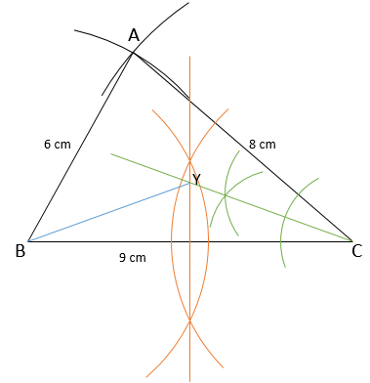

**(b) Label the point of intersection of the two bisectors as Y.**

See diagram (point Y within triangle ABC)

**(c) Draw a line to join B and Y.**

See diagram (blue line from B to Y)

**(d) Measure**

**(i) |BY|;**

= 4.8 cm [± 0.1 cm]

**(ii) |YC|;**

= 4.8 cm [± 0.1 cm]

**(iii) the base angles of triangle BYC.**

= 20.5° [or 20° or 21°]

**(e) What type of triangle is BYC?**

= Isosceles triangle

1. **(a) The table below shows the ages of students admitted in a hospital.**

|  |  |  |  |  |  |  |
| --- | --- | --- | --- | --- | --- | --- |
| **Age (years)** | **10** | **11** | **12** | **13** | **14** | **15** |
| **Number of Students** | **5** | **1** | **7** | **10** | **3** | **4** |

**Use the information to answer the following questions:**

**(i) What is the modal age?**

= 13 years (the age with the highest no. of students)

**(ii) Calculate, correct to two decimal places, the mean age of the students.**

Mean age =

=

=

=

= 12.57 years.

**(a) (ii) ALTERNATIVE APPROACH (using the table)**

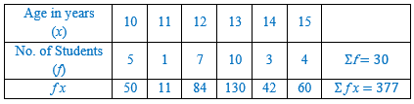

Mean age =

=

=

= 12.57 years

**(b) Rice is sold at GHc 56.00 per bag of 50 kg. A trader bought some bags of rice and paid GHc 1,344.00.**

**(i) How many bags of rice did the trader buy?**

No. of bags bought =

= 24 bags

**(ii) If the trader retailed the bags of rice at GHc 1.40 per kg, how much profit was made on 1 kg of rice?**

Profit = Selling Price – Cost Price

Cost Price of 1 kg = = GHc 1.12

Selling Price of 1 kg = GHc 1.40

Therefore Profit made on 1 kg = 1.40 – 1.12

= GHc 0.28

**(b) (ii) ALTERNATIVE APPROACH (using the totals)**

Total amount of rice = 24 × 50 kg

= 1200 kg

Total Retailed (selling) price = GHc 1.40 × 1200

= GHc 1680

Total cost price (given) = GHc 1344

Profit on total amount = Total SP – Total CP

= 1680 – 1344

= GHc 336

Profit on each kg (1 kg) =

= GHc 0.28

1. **(a) Using a scale of 2 cm to 1 unit on both axes, draw on a graph sheet two perpendicular axes Ox and Oy for and**

**(i) Plot, indicating the coordinates of all points A(2, 3) and B(–3, 4). Draw a straight line passing through the points A and B.**

**(ii) Plot on the same graph sheet, indicating the coordinates of the points C(4, 2) and D(–2, –3). Draw a straight line passing through the points to meet line AB**

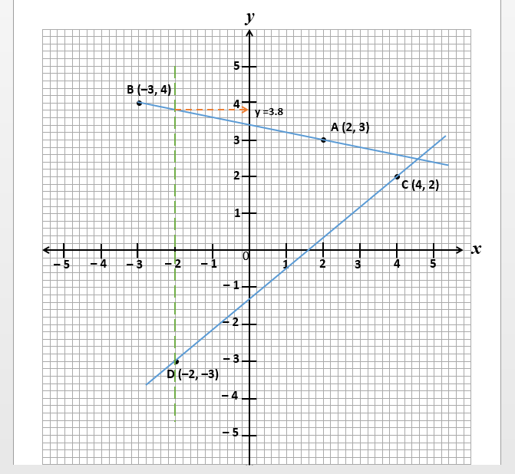

**(b) Using the graphs in 5(a),**

**(i) find the values of y when x = –2;**

Values of y = –3 and 3.8 [± 0.1]

**(ii) measure the angle between the lines AB and CD.**

Acute angle between lines = 51° [± 0.1]

OR

Obtuse angle between lines = 129° [± 0.1]

1. **(a) If m = , n = and m + n = , find the:**

**(i) values of *x* and *y***

Since **m** + **n** =

Then from the horizontal (x) component,

⇒

⇒

⇒

⇒

and from the vertical (y) component,

⇒

⇒

⇒

⇒

⇒

⇒

**(ii) components of m**

**m** =

=

Substituting x = 1 and y = 2

=

Simplifying

=

**(b) (i) Solve the inequality:**

Multiplying through by 4 (to clear fractions) and simplifying

⇒

Expanding

⇒

⇒

Simplifying and regrouping

⇒

Simplifying

⇒

⇒

**(ii) Illustrate the answer in b(i) on a number line.**

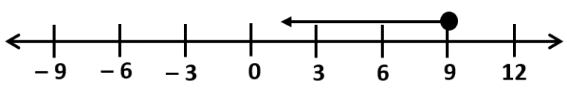

**(c)**

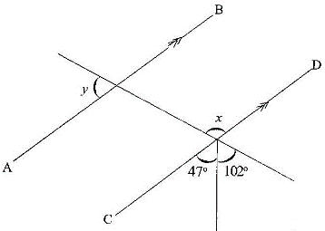

**In the diagram, AB is parallel to CD. Find the value of:**

**(i) *x***

Angle *x* and (47° + 102°) form vertically opposite angles

Hence,

⇒

**(ii) y**

*x* is congruent to the angles adjacent to y (alternate or corresponding)

Hence

⇒

⇒