**ICT 2017**

**OBJECTIVE TEST QUESTIONS**

1. A group of instructions that directs a computer is called
2. Logic B. Memory

C. Program D. Storage

1. Devices that extend their services to enhance the function of the computer is called
2. Hardware B. Software

C. Peripherals D. Firmware

1. The physical material on which a computer keeps data, instructions, and information is called
2. Primary storage
3. Secondary storage
4. Tertiary storage
5. Cache storage
6. When a computer is on, it is normally termed
7. Information B.Programming

C. Running D. Working

1. Working with more than one application at the same time is known as
2. Double tasking
3. Multitasking
4. Running
5. Launching
6. The duplication of an original document is referred to as
7. Backup B. Back down

C. Production D. Copying

1. The steps data go through to become information are
2. Information steps.
3. Information technology
4. Information processing cycle
5. information
6. Which of the following is a keyboard layout format?
7. QWERTY B.QWRETY

C.QWRTEY D.QWREYT

1. Which of the following programs has features like gridbook?
2. Microsoft Paint
3. Spreadsheet
4. Open Source Writer
5. Microsoft Word
6. System software is a platform which runs

A. Source codes

B. Application software

C. Operating system

D. Utilities

1. The memory that stores permanent instructions is referred to as

A. Random access memory.

B. Read only memory

C. Write once read many memory

D. Virtual memory

1. The interaction between the input and the output devices is controlled by the
2. BIOS B.LINUX

C.CPU D. RAM

1. Which of the following is **not** storage device?
2. Pen drive B. Touch pad

C. Hard disk D. Floppy disk

1. To boot a computer system, the user needs
2. Word processing software.
3. Printer attached.
4. Virus checking program.
5. Operating system.
6. The following are features on the GUI **except**
7. Command line. B .Icon.

C. Menu driven. D. Window

1. When files are cleared from the computer, it is known as
2. Restoring B .Editing

C. Deleting D. Removing.

1. Viewing television for long periods can damage an individual’s
2. Nose B. Eye

C. Feet D. Mouth

1. The following are good posture positions when using the computer **except**
2. Back straight
3. Eyes on monitor
4. Elbows on the table.
5. Feet on the floor
6. The ethical issue that relates to the responsibility of those who collect data to ensure that the data is correct is
7. Accuracy B. Privacy

C. Access D. Ethics

1. The legal right to control the production and selling of a book, play, film, or software is called
2. Production right B.Copyright

C. Trader right D. Patent

1. A word document created with a word processing program will have the extension
2. .doc.
3. .txt.
4. .ppt.
5. .xls.
6. A collection of linked documents or pages stored on millions of computers and distributed across the world is called
7. Internet
8. Hyperlink
9. World Wide Web
10. Browser
11. The set of rules that enables different types of computers and networks on the internet to communicate with one another is the
12. Internet rules
13. Protocols
14. Network rules
15. Communication rules.
16. The fastest form of sending information is through the
17. Ghana Post B. EMS

C. E-mail D. DHL.

1. After work, your mother decided to bring a copy of the data home to work on. Which of the following storage devices would you advise her to use?

I. RAM

II. Floppy disk

III. Pen drive

IV. Hard disk

1. I and II only
2. II, III and IV only
3. II and III only
4. I, II, III and IV
5. The process of moving different portions of a document on the screen into view is called
6. Downward B. Upward
7. Moving D. Scrolling
8. Which of the following is **not** reason for using ICT in education?
9. ICT tools increase learner motivation and engagement
10. ICT tools facilitate the acquisition of basic skills in Maths, English, Science etc.
11. ICT tools enhance teaching through the use of presentation software
12. ICT tools force students to learn at other’s pace.
13. Which of the following computer keyboard keys are used issuing commands?
14. Alphanumeric
15. Numeric
16. Standard
17. Function
18. Which of the following mouse buttons when clicked, provides a menu which a user can choose from?
19. Left button B. Right button

C. Scroll ball D. Scroll button

1. Making changes to an existing document is referred to as
2. Creating B. Modifying

C. Adjusting D. Editing

1. A symbol on the screen that indicates where the next character typed will appear is
2. Text mark
3. Indicator
4. Pointing stick
5. Insertion point
6. Which of the following steps can be used to change font type of a document?
7. Format/select/font/font type
8. Font/select/format/font type/OK
9. Select/format/font type/Ok
10. Format/font/highlight/ok/font type
11. The standard Toolbar contains button that
12. Control page margins and tabs.
13. Perform the most common tasks.
14. Help users navigate through the document
15. Close and resize windows
16. In using MS Word, one can decide to see exactly how the pages of the current document will appear when printed. Which of the following best describes this?
17. Printer print B.Print preview

C. Printer view D. Print view

1. The basic information on the internet can be in the form of the following except
2. Text B .Sound

C. Graphic D. Game

1. If you want any information on the internet that contains the keywords “Kofi”, “Annan” and “Ghana”, which of the following would be the most appropriate search text to provide to the search engine.

I. Search for Kofi Annan and Ghana on any website

II. I want any information on Kofi Annan and Ghana

III. Kofi Annan Ghana

1. I only B.II only

C. I and II only

D. III only

1. A student wants to search for information on the internet to have solution to the ICT assignment from school. Which of the following do you recommend for him/her to use?
2. E-mail address
3. Search engine
4. compose
5. inbox
6. A set of cells in the horizontal direction in a spreadsheet application is called
7. active cell B. column

C. row D. sheet

39. In spreadsheets, you can create a relationship between two cells using

A. numbers

B. text

C. formulae

D. rows.

40. The sign used to prompt a spreadsheet that a user is about to apply a formula/function to a cell is

1. = **or +**
2. = **or -**
3. = **or \***
4. = **or**

**ESSAY TYPE QUESTIONS - 2017**

1. (a) Study the worksheet below carefully and use it to answer (i-vi)

|  |  |  |  |  |  |  |  |
| --- | --- | --- | --- | --- | --- | --- | --- |
|  | **A** | **B** | **C** | **D** | **E** | **F** | **G** |
| **1** | **BECE CLASS 3 RESULTS** | | | | | | |
| **2** | **Serial No.** | **NAME** | | **MATHS** | **ENGLISH** | **SCIENCE** | **TOTAL** |
| **3** | **1** | **Mensah** | **Kofi** | **63** | **67** | **45** | **175** |
| **4** | **2** | **Jonfia** | **Esi** | **34** | **78** | **64** | **176** |
| **5** | **3** | **Mends** | **Eddy** | **54** | **82** | **66** | **202** |
| **6** | **4** | **Skews** | **Okra** | **58** | **57** | **65** | **180** |
| **7** | **5** | **Coffie** | **Sans** | **50** | **50** | **54** | **154** |
| **8** | **6** | **Okrah** | **Emma** | **56** | **83** | **67** | **206** |
| **9** | **7** | **TOTAL** | | **315** | **417** | **361** | **1093** |

1. Outline the steps by which the Serial No, (1, 2,…,7) were generated without typing them one by one.
2. What is the cell address in which the name “MATHS” was created?
3. Write down the cell range in which “BECE CLASS 3 RESULT” was type.
4. Write the spreadsheet formula that was used in computing the total value “202” in cell G5.
5. Write the spreadsheet function used in computing the total “417” in cell E9.
6. How many cells are in the cell range C3:E6

(b)Outline the proper way of shutting down a computer after using it.

(c ) Identify the following web browsers:

(i) 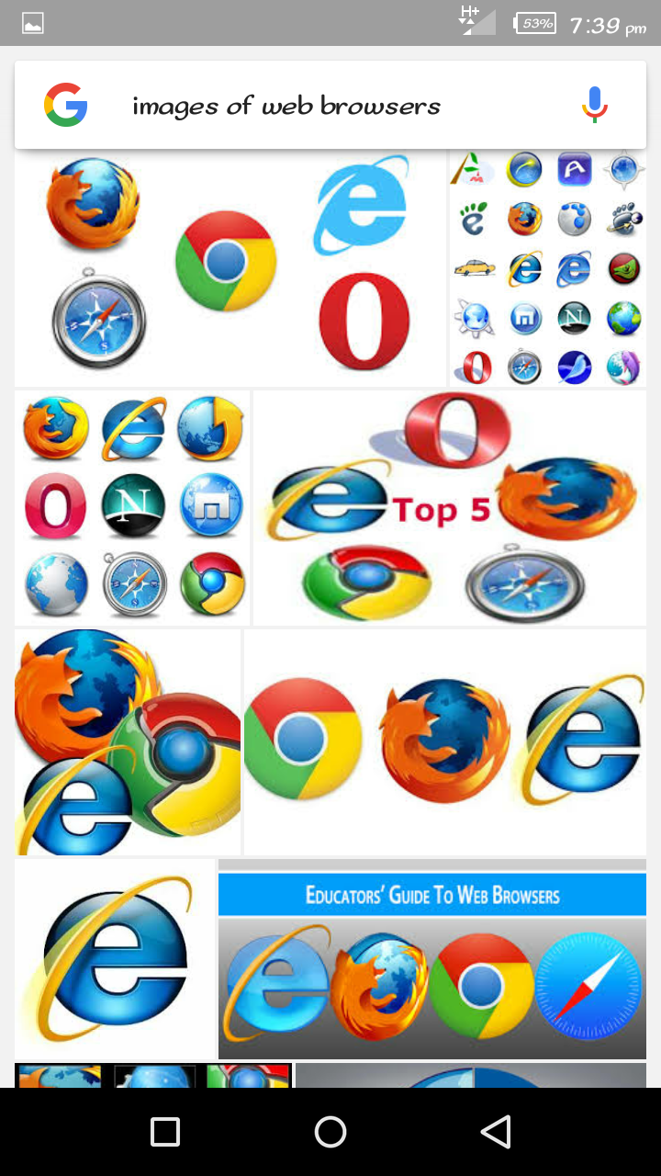 (ii)  (iii)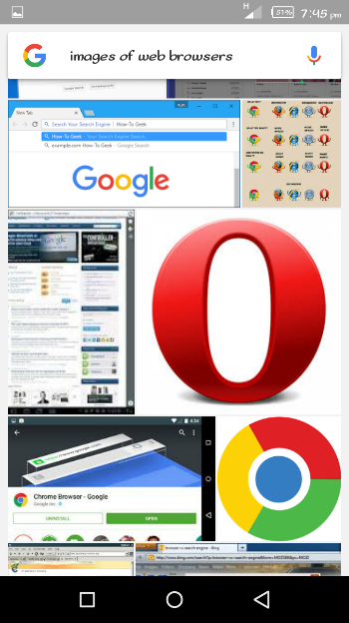

2. (a) State three uses of the shift key on the computer keyboard.

(b) Write down the acronyms below in full:

(i) HDD: (ii) VDU: (iii) BIOS:

3. (a) State two functions

(i) of input device; (ii) performed by an output device;

(b) Match the items in Group 1 to those in Group 2 with a line.

Group 1 Group 2

Speedometer Bank

Electric Stove School

Money Counting Machine Hospital

X-ray Machine Vehicle

Home

1. (a) State three ways through which computer may be damaged.

(b) List three specific areas of learning where ICT tools can be

integrated.

(c ) List three devices that may be used for transmission of messages on the computer.

1. (a) The Operating System makes it easy to store files in places that make a lot of sense. Give the default folder or storage area for the following files:

(i) Text files; (ii) Image files; (iii) Music files;

(b) Write the shortcut keyboard keys combination for the following commands as used in a word processing environment:

(i) Undo; (ii) Find; (iii) Select All;

(c ) List three toolbars available in a word processing application.

**ANSWERS – 2017**

1. (a) (i) 1. Enter 1 in cell A3.

2. Enter 2 in cell A4.

3. Select A3 and A4.

4. Click at the bottom right corner of the selected range.

5. Pull to cell A9 and release the mouse button.

(ii) D2 (iii) A1: G1 (iv) =D5 + E5 + F5

(v) =SUM ( E3 : E8 ) (vi) 12 cells

(b) 1. Close all programs.

2. Click on the start button.

3. Click on the Turn off computer button.

4. Click on the Turn off button.

5. Turn off the monitor.

6. Unplug the main power supply or source.

(c ) (i) Internet Explorer (ii) Mozilla Firefox (iii) Opera Mini.

1. (a) The sift key is used to:

- type capital letters (upper case letters) when the caps lock is off.

- type small letters (lower case letters) when the caps lock is on.

- in combination with the directional keys to select series of text.

- select/type the upper characters on some keys.

(b) (i) HDD: Hard Disk Drive

(ii) VDU: Visual Display Unit or Video Display Unit

(iii) BIOS: Basic Input/Output System

1. (a) (i) – Presenting the computer with data/information.

- Giving the computer commands and instructions.

- Changes human language to the computer language.

(ii) – Provides processed/stored data to user.

- Indicates what the computer needs from user

- Changes the processed data from computer language to

human language.

(b) Group 1 Group 2

Speedometer Bank

Electric Stove School

Money Counting Machine Hospital

X-ray Machine Vehicle

Home

1. (a) – Exposure to dusty environment.

- Exposure to excessive heat.

- Lack of proper maintenance.

- Accessing a disk or network that has been infected with a virus.

- Erratic power fluctuations.

- Exposure to high humidity environment.

- Attempting to correct a problem on your computer without

having full knowledge of the actual problem/cause.

(b) – Mathematics - Science - English Language - French

- Research - Governance - Education - Health

(c ) – Computer - Modem - Telephone line/Radio Network

- Router - Telephone/Mobile phone

1. (a) (i) My Document (ii) My Pictures (iii) My Music

(b) (ii) Undo – Ctrl + Z (ii) Find – Ctrl + F (iii) Select all- Ctrl+A

(c ) – Standard Toolbar - Formatting Toolbar - Drawing Toolbar

- Picture - WordArt -Forms - Frames - Ribbon

**ANSWERS TO OBJECTIVE TEST**

|  |  |
| --- | --- |
| **2017** | |
| 1. C | 21.B |
| 2. A | 22.C |
| 3. B | 23.B |
| 4. C | 24.C |
| 5. B | 25.C |
| 6. A | 26.D |
| 7. C | 27.D |
| 8. A | 28.D |
| 9. B | 29.B |
| 10.B | 30.D |
| 11.B | 31.D |
| 12.B | 32.C |
| 13.B | 33.B |
| 14.D | 34.B |
| 15.A | 35.D |
| 16.C | 36.B |
| 17.B | 37.B |
| 18.C | 38.C |
| 19.B | 39.C |
| 20.B | 40.A |