Welcome!

**Please scroll down to read introductory information**

**WordPub**

**BECE**

**BASIC DESIGN AND TECHNOLOGY**

**(Home Economics)**

**Past Questions & Answers**

**2017**

**Junior High School**

**Years 1, 2 & 3**

**Compiled by:**



**© 2018 Word Publishers. All rights reserved**

**Unauthorized distribution and/or reproduction of this document prohibited.**

**CONTACT**

**Email:**

**info@wordpub.org**

**Telephone:**

**(+233) 030 295 1486,**

**(+233) 020 893 0787,**

**(+233) 057 860 0052,**

**(+233) 024 850 6613.**

**Postal Address:**

**Word Publishers,**

**P.O. Box NT 583,**

**Newtown – Accra,**

**Ghana.**

**Location:**

**7 Tunemete Street,**

**Dzorwulu-Accra,**

**Ghana.**

**Website:**

[**bece.wordpub.org**](https://bece.wordpub.org/)

**ACKNOWLEDGEMENTS**

* The **West African Examination Council** - for the BECE BDT (Home Economics) past questions used in this document.
* **Ernest Bentil** and **Dorothy Mensah** – for your invaluable contribution to this work.
* **Mr Eric Arthur** – for your expert counsel and assistance
* **Ruth, Baaba and Fiifi Arthur** – for your relentless support
* **Teachers, parents and educational institutions** – for your continuous patronage and tireless efforts at ensuring quality education for the 21st century child
* Junior High School **students** – you are the ultimate reason for this work.

**DEDICATION**

To the Lord **Jesus Christ**, our Saviour and soon-coming King

## June 2017

# BASIC DESIGN AND TECHNOLOGY 1

# (Home Economics 1)

# Objective Test

# 40 minutes

1. A **common** method of cooking ripe plantain for sale is
   1. boiling.
   2. roasting.
   3. grilling.
   4. baking.
2. To shorten the cooking time for meat,
   1. slice along the grain.
   2. cut into small pieces.
   3. slice into thin pieces.
   4. cut across the grain.
3. In taking body measurement, a firm tape measure is needed to
   1. save time.
   2. avoid wasting fabric.
   3. obtain accuracy.
   4. make sewing easy.
4. Which of the following principles of design is similar to proportion?
   1. Balance
   2. Perspective
   3. Rhythm
   4. Scale
5. A preliminary design is meant to
   1. improve creativity.
   2. increase production.
   3. make sketches.
   4. produce ideas.

*Use the sketch in* **Figure 1** *to answer Questions* **6** *and* **7**

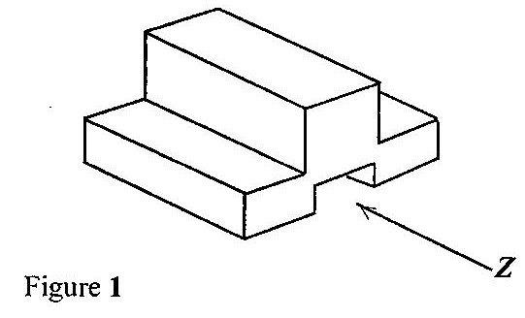

1. Which of the following represents the front view in the direction of arrow Z?

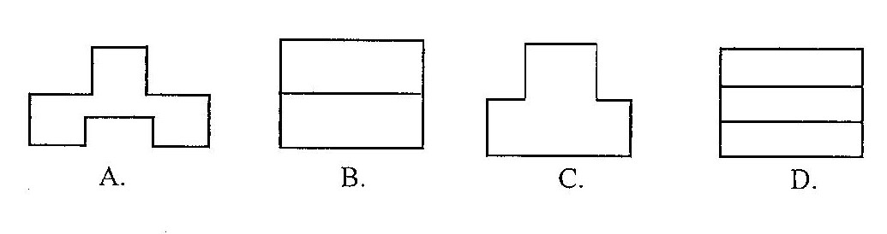

1. Which of the following represents the left end elevation?

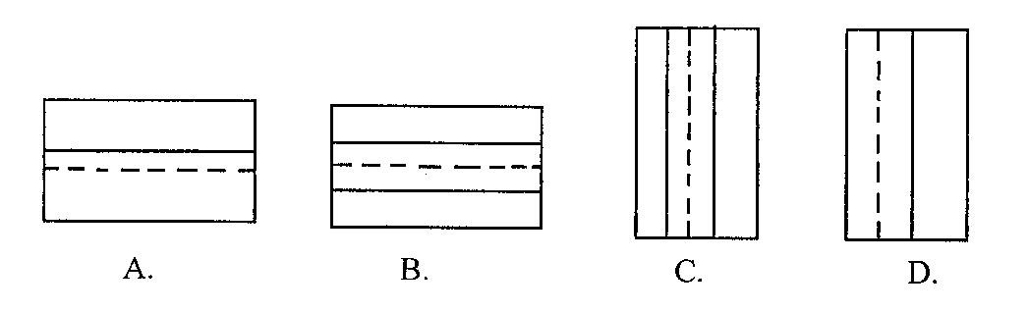

1. A single unit of a design is known as
   1. motif.
   2. pattern.
   3. plan.
   4. print.
2. Angles are measured by using a
   1. compass.
   2. protractor.
   3. rule.
   4. set square.
3. In designing, the analysis question, what is the purpose of the unit? falls under
   1. construction.
   2. ergonomics.
   3. function.
   4. material.
4. To repair an electrical fault, a safety precaution to observe is to
   1. disconnect live wires.
   2. remove fuse.
   3. remove cover of socket.
   4. switch off main supply.
5. Which of the following is **not** a cause of weakness in furniture?
   1. Loose joint
   2. Insufficient polish
   3. Overloading
   4. Removal of nail
6. The tee-square is used for drawing
   1. arcs.
   2. circles.
   3. horizontal lines.
   4. vertical lines.
7. Identify the type of lettering used for emphasis.
   1. Freestyle
   2. Gothic
   3. Italics
   4. Romans
8. Strips cut on the true cross of fabric are usually used for curved edges because they
   1. stretch easily.
   2. do not fray.
   3. are easily prepared.
   4. are colourful.
9. The **best** fastening for the full back opening of a fourteen year old school girl’s uniform is
   1. press studs.
   2. zipper.
   3. velcro.
   4. tapes.
10. When making a shirt sleeve, the two rows of gathering stitches are worked on the
    1. seam allowance of the sleeves.
    2. hem of the sleeves.
    3. side seam of the sleeves.
    4. cap of the sleeves.

1. The **most** suitable pocket found on men’s classic shirt is
   1. bound.
   2. in-seam.
   3. patch.
   4. welt.

1. In attaching a turnover to a shirt, the first process to work on is the
   1. joining and stitching of the side seam.
   2. preparation and fixing of a pocket.
   3. joining and stitching of the shoulder.
   4. preparation and setting in of sleeve.
2. The French seam is the **most** appropriate seam for
   1. children’s wear.
   2. heavy weight fabrics.
   3. light weight fabrics.
   4. undergarment.
3. A repair work done by weaving thread into weakened portion of article is termed
   1. renovating.
   2. darning.
   3. remodeling.
   4. patching.
4. An advantage of freehand cutting is that
   1. it is good for mass production.
   2. it is good for beginners.
   3. it conserves time and energy.
   4. there is no need for pattern drafting.
5. The **most** important factor to consider when buying canned food is the
   1. weight.
   2. label on product.
   3. colour.
   4. expiry date.
6. In order to retain the nutrients in leafy vegetables,
   1. cut one hour before cooking.
   2. cut when ready to cook.
   3. cut when the water is boiling.
   4. cut few minutes before cooking.
7. In table setting, a cover refers to the space
   1. beside the person’s seat.
   2. left of the person’s seat.
   3. in front of the person’s seat.
   4. right of the person’s seat.
8. The basic ingredients for preparation of batter are
   1. flour, egg and milk.
   2. flour, egg and oil.
   3. flour, egg and yeast.
   4. flour, egg and baking powder.
9. Food is preserved **mainly** to
   1. maintain its shape.
   2. make it last longer.
   3. make it palatable.
   4. protect micro organism.
10. A suitable flour used to prepare bread is
    1. soft flour.
    2. self raising flour.
    3. composite flour.
    4. strong flour.
11. Which of the following dishes is garnished with lemon and parsley?
    1. Grilled mackerel
    2. Grilled chicken
    3. Roast lamb
    4. Beef loaf
12. Which of the following is a white fish?
    1. Mackerel
    2. Cod
    3. Herring
    4. Tilapia

## June 2017

# BASIC DESIGN AND TECHNOLOGY 1

# (Home Economics 1)

# Objective Test

# ANSWERS

1. C. grilling
2. D. cut across the grain
3. C. obtain accuracy
4. D. Scale
5. D. produce ideas
6. A.
7. A
8. A. motif
9. B. protractor
10. C. function
11. D. switch off main supply
12. B. Insufficient polish
13. C. horizontal lines
14. C. Italics
15. A. stretch easily
16. B. zipper
17. D. cap of the sleeves
18. C. patch
19. C. joining and stitching of the shoulder
20. C. light weight fabrics.
21. B. darning
22. D. there is no need for pattern drafting
23. D. expiry date
24. B. cut when ready to cook
25. C. in front of the person’s seat
26. A. flour, egg and milk
27. B. make it last longer
28. D. strong flour
29. B. Grilled chicken
30. B. Grilled chicken

## June 2017

# BASIC DESIGN AND TECHNOLOGY 2

# (Home Economics 2)

# Essay

# 1 hour 15 minutes

**SECTION A**

**(CORE SKILLS)**

**[20 marks]**

**Answer question 1 [COMPULSORY]**

1. (a) What are *temporary stitches*?

……………………………………………………………………………………………………

……………………………………………………………………………………………………

……………………………………………………………………………………………………

……………………………………………………………………………………………………

[2 marks]

(b) State **four** reasons for setting a table for family meals.

……………………………………………………………………………………………………

……………………………………………………………………………………………………

……………………………………………………………………………………………………

……………………………………………………………………………………………………

[4 marks]

(c) A unit for hanging school uniforms is to be designed and made in the school workshop.

(i) State **two** places where the unit would be placed in the workshop.

……………………………………………………………………………………………

……………………………………………………………………………………………

(ii) State **two** specifications of the unit based on construction;

……………………………………………………………………………………………

……………………………………………………………………………………………

……………………………………………………………………………………………

……………………………………………………………………………………………

(iii) Name **one** specific material to be used for making the unit.

……………………………………………………………………………………………

……………………………………………………………………………………………

[7 marks]

(d) (i) List **five** important pieces of information printed onto a package.

……………………………………………………………………………………………

……………………………………………………………………………………………

……………………………………………………………………………………………

……………………………………………………………………………………………

……………………………………………………………………………………………

……………………………………………………………………………………………

[5 marks]

(ii) Name **two** other methods for making a print.

……………………………………………………………………………………………

……………………………………………………………………………………………

……………………………………………………………………………………………

……………………………………………………………………………………………

[2 marks]

**SECTION B**

**[50 marks]**

*Answer* **two** *questions* **only** *from this section*

**All** *questions carry equal marks*

1. (a) Identify **two** types of permanent stitches.

……………………………………………………………………………………………

……………………………………………………………………………………………

……………………………………………………………………………………………

……………………………………………………………………………………………

[2 marks]

(b) State **five** general rules for making stitches.

……………………………………………………………………………………………

……………………………………………………………………………………………

……………………………………………………………………………………………

……………………………………………………………………………………………

……………………………………………………………………………………………

……………………………………………………………………………………………

[10 marks]

(c) State **one** use **each** of the following tools and equipment for sewing:

1. tracing wheel;

……………………………………………………………………………………………

1. pressing iron;

……………………………………………………………………………………………

1. full length mirror;

……………………………………………………………………………………………

1. seam ripper;

……………………………………………………………………………………………

1. stiletto.

……………………………………………………………………………………………

[10 marks]

(d) Complete the definition of a patch with the appropriate words listed below.

**weak, space, material, repair, hole.**

A patch is a small piece of ……………………….. that is used to cover a ………………….. or to strengthen a ……………………. area.

[3 marks]

1. (a) State **one** function **each** of the following nutrients:

(i) protein: ………………………………………………………………………………………………………………………………………………………………………………………………

(ii) carbohydrates;

……………………………………………………………………………………………

……………………………………………………………………………………………

(iii) vitamins.

……………………………………………………………………………………………

……………………………………………………………………………………………

[3 marks]

(b) List **three** protein sources **each** of the following:

(i) animal;

……………………………………………………………………………………………

……………………………………………………………………………………………

(ii) vegetable

……………………………………………………………………………………………

……………………………………………………………………………………………

[3 marks]

(c) (i) Ama has to prepare chicken stew for the mother’s birthday.

List **six** ingredients she will need for the stew.

……………………………………………………………………………………………

……………………………………………………………………………………………

……………………………………………………………………………………………

……………………………………………………………………………………………

……………………………………………………………………………………………

……………………………………………………………………………………………

……………………………………………………………………………………………

[3 marks]

(ii) State **three** accompaniment that can be served with the stew.

……………………………………………………………………………………………

……………………………………………………………………………………………

……………………………………………………………………………………………

……………………………………………………………………………………………

[3 marks]

(iii) What are the basic ingredients used in pastry making?

……………………………………………………………………………………………

……………………………………………………………………………………………

……………………………………………………………………………………………

……………………………………………………………………………………………

[3 marks]

(d) State **four** causes of food spoilage.

……………………………………………………………………………………………

……………………………………………………………………………………………

……………………………………………………………………………………………

……………………………………………………………………………………………

……………………………………………………………………………………………

[4 marks]

(e) Explain the term *Essential Amino Acids* by filling in the blank spaces with appropriate words below.

**body, protein, foods, produced, cannot, compounds, eat**.

They are the chemical ………………………..of protein which are found in the ………………………….. we ………………………… and ……………………………….. be ……………………………. by the ………………………………………….

[6 marks]

1. (a) State **four** signs of Kwashiorkor.

……………………………………………………………………………………………

……………………………………………………………………………………………

……………………………………………………………………………………………

……………………………………………………………………………………………

……………………………………………………………………………………………

[8 marks]

(b) Outline **three** functions of water in the body.

……………………………………………………………………………………………

……………………………………………………………………………………………

……………………………………………………………………………………………

……………………………………………………………………………………………

……………………………………………………………………………………………

[6 marks]

(c) (i) State **one** reason why dietary fibre is important in a diet.

……………………………………………………………………………………………

……………………………………………………………………………………………

……………………………………………………………………………………………

[2 marks]

(ii) List the **four** fat soluble vitamins.

……………………………………………………………………………………………

……………………………………………………………………………………………

……………………………………………………………………………………………

……………………………………………………………………………………………

……………………………………………………………………………………………

[4 marks]

(d) Explain **two** reasons for preserving foods.

……………………………………………………………………………………………

……………………………………………………………………………………………

……………………………………………………………………………………………

……………………………………………………………………………………………

……………………………………………………………………………………………

[4 marks]

(e) State the **major** function of iodine in the body.

……………………………………………………………………………………………

……………………………………………………………………………………………

……………………………………………………………………………………………

……………………………………………………………………………………………

[1 marks]

***END OF ESSAY TEST***

**June 2017**

**BASIC DESIGN AND TECHNOLOGY 2**

**(Home Economics 2)**

**Essay**

**ANSWERS**

1. **(a) What are *temporary stitches*? [2 marks]**

These are stitches used to hold parts of articles together and removed when permanent stitches are made.

**(b) State four reasons for setting a table for family meals. [4 marks]**

(Mention any **four** of the following)

* To stimulate / whet appetite
* To have all items needed within reach
* To make eating more pleasant
* To create a welcoming environment
* It brings out the skills of the caterer
* Young ones are taught how to set table

**(c) A unit for hanging school uniforms is to be designed and made in the school workshop.**

**[7 marks]**

**(i) State two places where the unit would be placed in the workshop.**

(Mention any **two** of the following)

* In the wardrobe
* On the wall
* Partition bar
* Behind the door
* On the window frame
* Rod
* Pipe
* Hanger

**(ii) State two specifications of the unit based on construction;**

(Mention any **two** of the following)

* Must be strong
* Should take more uniforms at a time
* Corrosive resistant
* Screwed
* Portable
* Joints

**(iii) Name one specific material to be used for making the unit.**

(Mention any **one** of the following)

* Odum
* Sapele
* Wawa
* Raffia palm
* Cane
* PVC (acrylic)

**(d) (i) List five important pieces of information printed onto a package. [5 marks]**

(Mention any **five** of the following)

* The name of the product
* Manufacturing date
* Expiry date
* Bar code
* The ingredients used
* Picture of content
* Country of origin
* Usefulness of product
* Net weight / volume of the product

**(ii) Name two other methods for making a print. [2 marks]**

* Direct printing from existing surfaces, e.g. leaf, tree bark, coin
* Indirect printing, e.g., block, screen, stencil, roller, relief and frontage

**SECTION B**

**[50 marks]**

*Answer* **two** *questions* **only** *from this section*

**All** *questions carry equal marks*

1. **(a) Identify two uses of permanent stitches. [2 marks]**

(Mention any two of the following)

* For joining /holding fabric
* For neatening
* For decorating

**(b) State five general rules for making stitches. [10 marks]**

(Mention any **five** of the following)

* Choose the correct stitch for the work to be carried out.
* Use the correct size of needle and right types of thread for the material fabric
* Fasten on and off securely/start with a double stitch and end with a double stitch
* Wear a thimble on the middle finger of the hand which is used for sewing
* Work one stitch at a time
* Do not use a knot for fastening on stitches
* Length of thread for hand sewing is from the tip of your middle finger to the elbow / the thread for sewing should not be long
* Use the colour of thread to match the colour of fabric.

**(c) State one use each of the following tools and equipment for sewing: [10 marks]**

1. **tracing wheel;**

It is used with dressmaker’s carbon paper for transferring pattern lines and marking unto fabrics

1. **pressing iron;**

(Mention any one of the following)

* It is used to press articles to remove creases
* It is used to press seam open.
* It is used to iron seam / garment / article

1. **full length mirror;**

It is used for fitting garment and appreciating the style of the garment.

1. **seam ripper;**

(Mention any one of the following)

* It is used to remove stitches
* For making a slit for buttonholes
* For cutting button holes

1. **stiletto.**

Used for piercing holes and eyelets

**(d) Complete the definition of a patch with the appropriate words listed below.**

**[weak, space, material, repair, hole] [3 marks]**

A patch is a small piece of material that is used to cover a hole or to strengthen a weak area.

1. **(a) State one function each of the following nutrients: [3 marks]**

**(i) protein:**

(Mention any one of the following)

* For body-building
* For repair of worn-out tissues
* For maintenance of the body

**(ii) carbohydrates;**

Provides heat and energy

**(iii) vitamins.**

(Mention any one of the following)

* For regulating body processes
* For protection against diseases

**(b) List three protein sources each of the following: [3 marks]**

**(i) animal;**

(Mention any three of the following)

* Meat (beef, mutton, veal, pork, poulty, etc),
* fish,
* snails,
* milk,
* cheese,
* egg,
* wagashi

**(ii) vegetable**

(Mention any three of the following)

* soyabeans,
* cowpeas,
* tofu,
* neri,
* melon seeds,
* agushie,
* groundnuts,
* soya milk,
* dawadawa

**(c) (i) Ama has to prepare chicken stew for the mother’s birthday.**

**List six ingredients she will need for the stew. [3 marks]**

(Mention any **six** of the following)

* + - * Chicken
      * Onion
      * Tomatoes
      * Salt
      * Cooking oil
      * Stock cube
      * Pepper
      * Ginger
      * Garlic

**(ii) State three accompaniment that can be served with the stew. [3 marks]**

(Mention any **three** of the following)

* + - * All rice dishes – boiled, vegetable, curried, saffron, fried, coconut
      * Banku
      * Boiled yam / fried yam / yam chips/ yam balls /
      * Boiled Potato / potato chips
      * Kenkey / fomfom
      * Eba
      * Abolo
      * Yakeyake
      * Akyeke

**(iii) What are the basic ingredients used in pastry making? [3 marks]**

* Flour
* Fat – butter, margarine
* Water

**(d) State four causes of food spoilage. [4 marks]**

(Mention any **four** of the following)

* Enzyme action / natural decay within the food
* Contamination by micro organisms, e.g., yeast
* Insects / rodents attack
* Improper handling of food / handling food with dirty hands
* Oxidation

**(e) Explain the term *Essential Amino Acids* by filling in the blank spaces with appropriate words below.**

**body, protein, foods, produced, cannot, compounds, eat. [6 marks]**

They are the chemical **compounds** of protein which are found in the **foods** we **eat** and **cannot** be **produced** by the **body**

1. **(a) State four signs of Kwashiorkor. [8 marks]**

(Mention any **four** of the following)

* The child’s skin become wrinkled
* The hair looks silky, reddish brown and scanty / loss of hair
* Growth is retarded / stunted growth
* The child has a protruding shiny belly, flabby buttocks
* The child is easily infected
* The child becomes restless
* The child develops oedema / edema (swollen feet, moon-like face)
* The child loses interest in his/her surroundings
* The child loses weight

**(b) Outline three functions of water in the body. [6 marks]**

(Mention any **three** of the following)

* It is required for all body fluids, e.g. saliva, mucus, blood, sweat, urine, digestive juices
* It is required as part of many metabolic reactions / body processes
* Some nutrients dissolve in water for proper absorption
* It helps regulate body temperature
* It helps with easy bowel movement / prevents constipation / It helps with egestion
* It lubricates joints and membranes
* It quenches thirst
* It prevents dehydration.

**(c) (i) State one reason why dietary fibre is important in a diet. [2 marks]**

(Mention any **three** of the following)

* + - It increases the bulk of food
    - It helps in the movement of the digestive tract / it aids digestion
    - It helps with easy bowel movement / prevents constipation / It helps with egestion

**(ii) List the four fat soluble vitamins. [4 marks]**

* Vitamin A
* Vitamin D
* Vitamin E
* Vitamin K

**(d) Explain two reasons for preserving foods. [4 marks]**

(State and briefly explain any **two** of the following)

* To prevent waste
* To make food available throughout the year.
* To save money
* To bring variety in meals
* For easy transportation
* For easy storage
* To prolong the life span of the food
* To prevent micro-organisms from contaminating the food / to prevent spoilage
* To take care of emergencies

**(e) State the major function of iodine in the body. [1 mark]**

* For the proper functioning of the thyroid gland
* For the prevention of goitre