**2018 Basic Design And Technology (Pre Technical Skills ) – Paper Two**

**SECTION A**

1. (a) State one advantage of baked foods.

(b) State two disadvantages of freehand cutting.

(c) (i) List two stages of the design process.  
(ii) List two methods of recording information for solving a design problem.  
(iii) Name a suitable pencil for sketching a possible solution in a design work.  
(iv) List two methods of sketching a final solution in pictorial drawing

(d) (i) Define a poster.  
(ii) Give two reasons why poster is important in advertisement.  
(iii) List two types of poster.  
(iv) State one major difference between the two types of poster

**SECTION B**

2. (a) (i) Make a freehand pictorial sketch of the brick hammer.  
(ii) Label any two parts of the brick hammer sketched in question 2 (a)(i)  
(iii) State one use of the brick hammer

(b) State one reason for each of the following operations:  
(i) oiling metal parts of the firmer chisel  
(ii) wearing goggles when grinding the cold chisel  
(iii) racking back a wall.

(c) State one use of each of the following electronic components:  
(i) resistor  
(ii) inductor  
(iii) diode

3. (a) Figure 1 shows the Orthographic Projection of a block made of metal.  
Use it to answer questions (a)(i) to (a)(iv)

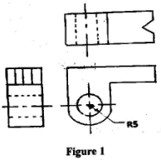  
(i) Copy the views shown in figure 1  
(ii) Label the copied views shown in question (a)(i) with the following:  
(α) front elevation  
(β) plan  
(γ) end elevation  
(iii) State the type of orthographic projection used  
(iv) Name one cutting tool used for producing the 5mm diameter hole.

(b) (i) Make a freehand pictorial sketch of a pick axe.  
(ii) Label any one part of the pick axe sketched in question 3(b)(i)  
(iii) State one use of the pick axe.

4. (a) (i) Make a freehand pictorial sketch of the mould box.  
(ii) State one use of the mould box.  
(iii) State one reason for oiling the inside of the mould box before using it.

(b) State two examples of each of the following materials:  
(i) non-ferrous alloys;  
(ii) aggregate  
(iii) abrasives

(c) Figure 2 shows the sketch of a piece of timber for making a joint. Copy and complete the processes involved in preparing the workpiece in the table below

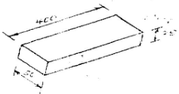

|  |  |
| --- | --- |
| OPERATION | ONE TOOL USED FOR CARRYING OUT OPERATION |
| (i)          Measure the given length and width |  |
| (ii)        cut off the rough piece; |  |
| (iii)      Plane the face side and face edge |  |
| (iv)      Test for flatness and squareness |  |
| (v)        Mark face side and face edge |  |
| (vi)      Plane off waste |  |
| (vii)     Square one end and mark the required length; |  |
| (viii)   cut off the waste |  |

**Paper Two – Answers**

1. (a) State one advantage of baked foods.  
(i) Baked foods look attractive  
(ii) Baked foods are appetizing  
(iii) They last longer as compared to boiled foods  
(iv) They do not need much attention when cooking  
(v) Shape of the food is maintained.

(b) State two disadvantages of freehand cutting.  
(i) It is not easy for beginners because they cannot cut accurately and precisely  
(ii) Mistakes made cannot be easily corrected  
(iii) It can result in waste of fabric  
(iv) It is difficult to estimate or determine the exact quantity of fabric needed  
(v) It is sometimes difficult to match motifs and lines  
(vi) It leads to change in style  
(vii) It requires special skill

(c) (i) List two stages of the design process.  
♣ Problem identification / Situation  
♣ Brief  
♣ Analysis  
♣ Investigation  
♣ Specification  
♣ Making  
♣ Possible solution  
♣ Final solution  
♣ Development of chosen solution  
♣ Working drawing  
♣ Testing  
♣ Evaluation

(ii) List two methods of recording information for solving a design problem.  
♣ Note-taking  
♣ Tape recording  
♣ Taking pictures / photographs  
♣ Making sketches / drawing  
♣ Graphs  
♣ Modelling  
♣ Video recording  
♣ Charts

(iii) Name a suitable pencil for sketching a possible solution in a design work.  
♣ HB pencil  
♣ H pencil  
♣ 2B pencil

(iv) List two methods of sketching a final solution in pictorial drawing  
♣ Oblique  
♣ Isometric  
♣ Perspective

(d) (i) Define a poster  
A written or printed message on a fairly large sheet of paper used to announce events and advertise goods and services  
OR  
It is a notice or advertisement that informs the public

(ii) Give two reasons why poster is important in advertisement.  
♣ It provides information to the public  
♣ It educates the public  
♣ It announces important events to the public  
♣ It promotes sales / patronage.

(iii) List two types of poster  
♣ Pictorial  
♣ Fully text / non-pictorial / texture poster / unwritten poster

(iv) State one major difference between the two types of poster  
Pictorial combines drawing or photographs with text, while fully text has no illustration at all

2. (a) (i) Make a freehand pictorial sketch of the brick hammer.

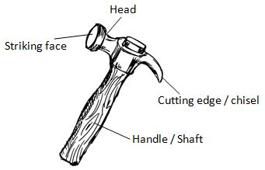

(ii) Label any two parts of the brick hammer sketched in question 2 (a)(i)  
Head, handle

(iii) State one use of the brick hammer  
♣ Brick hammer is used for cutting bricks / blocks into required sizes;  
♣ Tapping blocks / bricks into position

(b) State one reason for each of the following operations:  
(i) oiling metal parts of the firmer chisel  
♣ To prevent rusting  
♣ To last longer

(ii) wearing goggles when grinding the cold chisel  
To prevent flying metals or chips from entering the eye

(iii) racking back a wall.  
♣ For future continuation of the wall  
♣ Temporary termination of a wall

(c) State one use of each of the following electronic components:  
(i) resistor  
♣ It resists / opposes the flow of the current  
♣ It is used in heating coil /  
♣ It is used in incandescent lamp /  
♣ It is used in dryer /  
♣ It is used in wireless set

(ii) inductor  
♣ It creates a magnetic field / oscillators  
♣ It is used in motor coils /  
♣ It is used in ceiling fan /  
♣ It is used in compact fluorescent lamp /  
♣ It is used in choke or ballast

(iii) diode  
♣ It allows current to flow in one direction only;  
♣ It is used in converting a.c to d.c  
♣ It is used in compact fluorescent lamp  
♣ It is used in wireless set

3. (a) Figure 1 shows the Orthographic Projection of a block made of metal.  
Use it to answer questions (a)(i) to (a)(iv)

(i) Copy the views shown in figure 1  
(ii) Label the copied views shown in question (a)(i) with the following:  
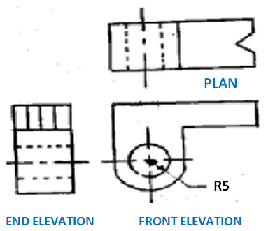

(α) front elevation  
(β) plan  
(γ) end elevation

(iii) State the type of orthographic projection used  
Third angle projection

(iv) Name one cutting tool used for producing the 5mm diameter hole.  
♣ Drill bit  
♣ Twist drill bit  
♣ Hand drill

(b) (i) Make a freehand pictorial sketch of a pick axe.

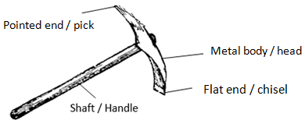

(ii) Label any one part of the pick axe sketched in question 3(b)(i)  
♣ Metal body  
♣ Pointed end  
♣ Flat end  
♣ Handle

(iii) State one use of the pick axe.  
♣ For digging  
♣ For trenching

4. (a) (i) Make a freehand pictorial sketch of the mould box.

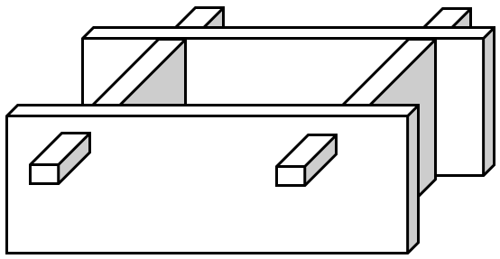  
(ii) State one use of the mould box.  
Used for making / moulding blocks or bricks

(iii) State one reason for oiling the inside of the mould box before using it.  
♣ To prevent the mortar from sticking to the mould box  
♣ To allow for the easy removal of the mould box after moulding the block / brick

(b) State two examples of each of the following materials:  
(i) non-ferrous alloys;  
♣ brass  
♣ bronze  
♣ soft solder

(ii) aggregates  
♣ stone  
♣ sand  
♣ gravel  
♣ chippings

(iii) abrasives  
♣ Emery cloth  
♣ sand / glass paper  
♣ oxide paper / wet and dry

(c) Figure 2 shows the sketch of a piece of timber for making a joint. Copy and complete the processes involved in preparing the workpiece in the table below

|  |  |
| --- | --- |
| **OPERATION** | **ONE TOOL USED FOR CARRYING OUT OPERATION** |
| (i)          measure the given length and width | §   Tape measure /  §   Ruler |
| (ii)        cut off the rough piece; | §   Cross-cut saw  §   Tenon saw  §   Dovetail saw |
| (iii)      Plane the face side and face edge | §   Smoothing plane  §   Jack  §   Roughing plane |
| (iv)      Test for flatness and squareness | §   Try square |
| (v)        Mark face side and face edge | §   Pencil |
| (vi)      Plane off waste | §   Smoothing plane  §   Jack plane  §   Roughing plane |
| (vii)     Square one end and mark the required length; | §   Try square  §   Tape measure  §   Roughing plane  §   Ruler  §   Pencil  §   Smoothing plane  §   Jack plane |
| (viii)   cut off the waste | §   Cross-cut saw  §   Tenon saw  §   Dovetail saw |

**2018 Basic Design And Technology (Pre Technical Skills ) – Paper One**

1. Short dashes are used for

A. cutting planes  
B. hidden outlines  
C. dimensioning  
D. visible outlines

2. Which of the following wires carries electric current to an electric iron?

A. Earth  
B. Live  
C. Negative  
D. Neutral

3. Which of the following is not a stage in the design process?

A. Making  
B. Situation  
C. Specification  
D. Questionnaire

4. Missing nails in household furniture occur in

A. concrete benches  
B. metal tables  
C. plastic cabinets  
D. wooden chairs

Figure 1 shows a sketch of wooden block. Use it to answer questions 5 and 6.

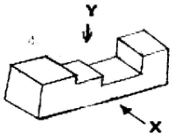

5. The view indicated by arrow X is

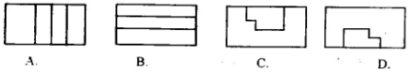

6. The view indicated by the arrow Y is

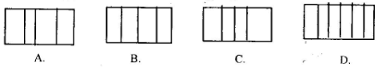

7. The main function of carbohydrate in the body is for

A. growth  
B. energy  
C. repair  
D. maintenance

8. Portion control equipment include

A. sauce boat  
B. oval plate  
C. casserole  
D. ladle

9. The process of making another article out of an existing one is termed

A. patching  
B. remodelling  
C. renovation  
D. darning

10. The best seam for children’s dress is

A. French seam  
B. open seam  
C. overlaid seam  
D. welt seam

11. Select the element of design from the following options.

A. Colour  
B. Motif  
C. Repeat  
D. Rhythm

12. Shading in tones is best done with

A. 2B pencil  
B. 2H pencil  
C. HB pencil  
D. HH pencil

13. Preliminary sketches help the artist to

A. increase his drawings  
B. gather required materials  
C. get the required form  
D. make the product last longer

14. Select a neutral colour from the options below;

A. blue  
B. orange  
C. red  
D. white

15. Which colour is directly opposite red on the six-point colour wheel?

A. Orange  
B. Violet  
C. Green  
D. Black

Figure 2 shows the sketch of a rectangular aluminium sheet labelled M, N, O, P.  
Use it to answer Questions 16 and 17

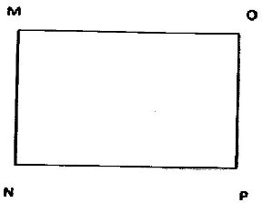

16. Which of the following products is obtained when the sides MN is soldered to OP?

A. Chalk box  
B. Match box  
C. Milk tin  
D. Watering can

17. Which of the following tools is used to produce heat to join the sides?

A. Folding bar  
B. Snips  
C. Soldering iron  
D. Torch

18. The surface development of a cylinder is

A. an arc  
B. a circle  
C. a rectangle  
D. a square

19. The first procedure involved in making a wooden joint is to

A. glasspaper workpiece  
B. hold workpiece firmly  
C. mark out workpiece  
D. polish workpiece

20. Which of the following is true about metals?

A. All metals are malleable  
B. All non-ferrous metals are hard  
C. Ferrous metals do not contain iron  
D. Non-ferrous metals do not contain iron

21. The bristles of a tooth brush is made from

A. acrylic  
B. Bakelite  
C. nylon  
D. PVC

22. The fine aggregate in mortar is

A. cement  
B. sand  
C. stone  
D. water

23. A mixture of cement, sand, stones and water forms

A. blocks  
B. bricks  
C. concrete  
D. mortar

24. Which of the following is a safe use of tools?

A. Clean spilt oil on the floor  
B. Keep the workshop tidy  
C. Wear protective clothing  
D. Work with firm head hammer

The sketch in Figure 3 shows parts of a wooden joint.  
Use it to answer questions 25 and 26.

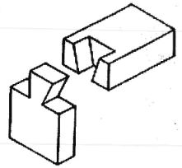

25. The parts when assembled will give a

A. dovetail joint  
B. butt joint  
C. lap joint  
D. mortise and tenon joint

26. The most suitable tool for cutting the joint is a

A. crosscut saw  
B. dovetail saw  
C. pad saw  
D. rip saw

27. The first thing to do when an electrical socket is faulty is to

A. check if wires are loose  
B. put off switch of the socket  
C. switch off the mains  
D. remove cover of socket

28. The hammer used for removing nails in wood is

A. ball pein hammer  
B. bossing hammer  
C. cross pein hammer  
D. claw hammer

Use the sketch shown in figure 4 to answer questions 29 and 30

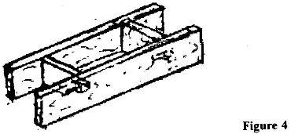  
29. The tool shown is a

A. builder’s square  
B. gauge box  
C. mould box  
D. tamping rod

30. The tool is used for

A. carrying blocks  
B. moulding blocks  
C. measuring aggregates  
D. tamping mortar

**Paper One – Answers**

1. B. hidden outlines

2. B. Live

3. D. Questionnaire

4. D. wooden chairs

5. C.

6. A.

7. B. energy

8. D. ladle

9. B. remodelling

10. A. French seam

11. A. Colour

12. A. 2B pencil

13. C. get the required form

14. D. white

15. C. Green

16. C. Milk tin

17. C. Soldering iron

18. B. a circle

19. C. mark out workpiece

20. D. Non-ferrous metals do not contain iron

21. C. nylon

22. B. sand

23. C. concrete

24. D. Work with firm head hammer

25. A. dovetail joint

26. B. dovetail saw

27. C. switch off the mains

28. D. claw hammer

29. C. mould box

30. B. moulding blocks