**BASIC 7 – CREATIVE ARTS AND DESIGN**

**SECTION A – OBJECTIVES**

|  |  |  |  |  |  |
| --- | --- | --- | --- | --- | --- |
| 1. B | 6. A | 11. B | 16. B | 21. C | 26. C |
| 2. C | 7. C | 12. B | 17. C | 22. D | 27. D |
| 3. D | 8. C | 13. C | 18. B | 23. B | 28. B |
| 4. D | 9. A | 14. D | 19. A | 24. B | 29. B |
| 5. A | 10. C | 15. B | 20. A | 25. B | 30. C |

**Award 1 mark for each correct answer. Overall Score for Section A = 30 marks**

**SECTION B**

**Part 1 – Compulsory**

**QUESTION 1.**

a) 1. Zig-zag line 2. Straight line 3. Curved line 4. Wavy line

5. Spiral line **5 marks**

b) i) *Learner expected to shade mango using dots (stippling); use cross-hatching technique for the orange and hatching for the cup. Learner is also expected to label or identify the highlight, dark tone and cast shadow in his/her shading. (****Award 1mark for the shading and 2marks for the labelling****)* ***9 marks***

ii) 1. Graphite pencil 2. Charcoal pencil 3. Carbon pencil. **3 marks**

c) Shading is the process of adding value to create form, space, and light in a drawing with lines or blocks of colour. **3 marks**

**Total Score = 20 marks**

**Part 2**

**QUESTION 1:**

a) i) Primary colours are basic colours from which other colours are developed. Examples include Red, Yellow and Blue.

ii) Secondary colours are colours obtained from a mixture of two primary colours in equal proportion. Examples include Orange, Violet and Green.

(**Award** **3 marks for definition and 2 marks for two examples each) 10 marks**

b) Design is an activity that converts ideas into blueprints that show the look and function of an object before it is made. **3 marks**

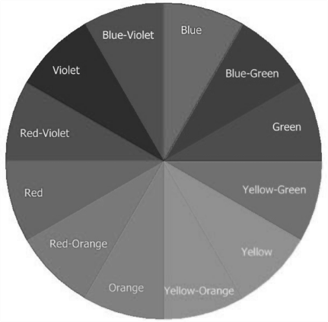

c) The 12-point colour wheel

**12 marks**

**Total Score = 25 marks**

**QUESTION 2:**

a) Pitch is used to describe how high or low a musical note sound. **3 marks**

b) Stave is the foundation on which musical notes and clefs rest. **3marks**

c) i) Semi breve/Whole note **2marks**

ii) Minim/Half beat **2marks**

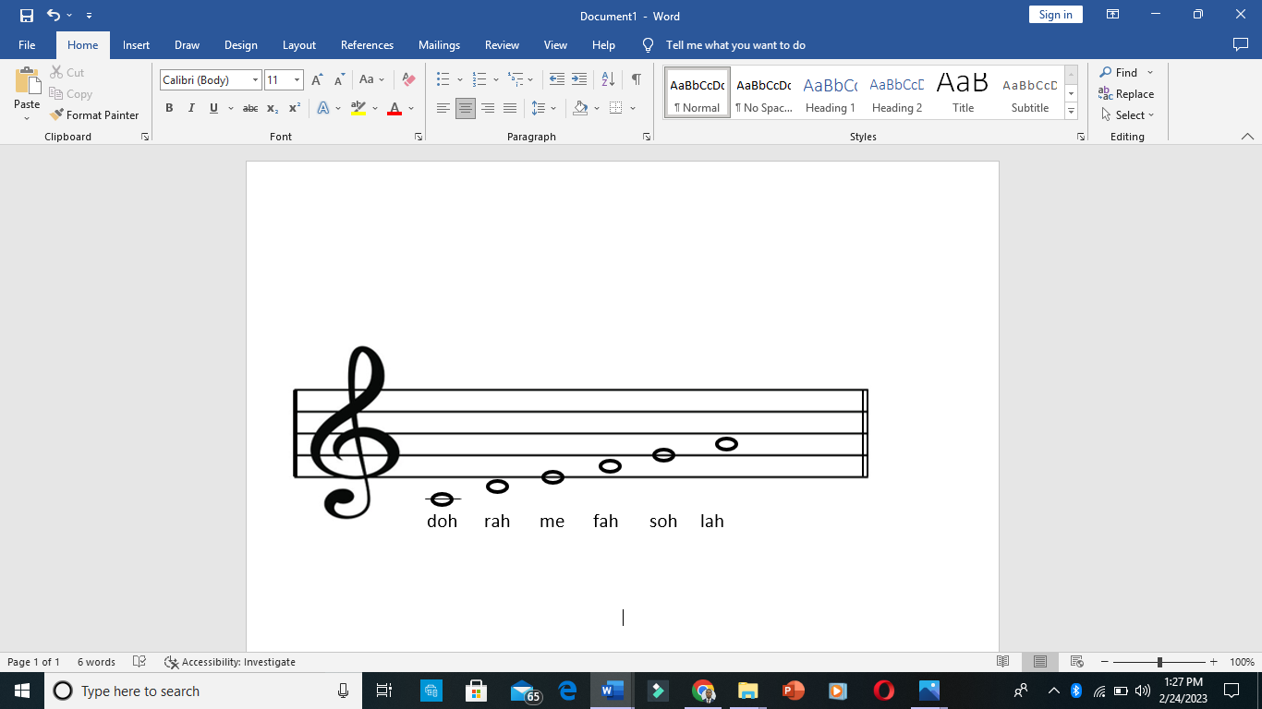iii) Crochet/Quarter beat **2marks**

d)

(*Award two marks for rightly locating the notes on the stave)* **12 marks**

e) Treble clef **1 mark**

**Total Score = 25 marks**

**QUESTION 3:**

a) Still-life drawing is the drawing of non-living or inanimate objects, arranged in a specific way to create meaning or visual effect. **3 marks**

b) Pencil, chalk, charcoal, pen, drawing board, pins, etc. **3 × 1mark = 3 marks**

c) i) Proportion refers to the size of the parts of an object in relation to other parts of the same object. **3marks**

ii) Variety refers to the use of different visual elements in a design to achieve visual effects.

**3 marks**

iii) Emphasis is a principle used by designers to attract the attention of viewers to specific design elements. **3 marks**

d) Flower pot, bowl, mug, statue, tray, etc. **4 × 1mark = 4 marks**

e) 1. Cleaning paint brushes after use.

2. Store tools properly in bags or boxes after use

3. Regularly repair or replace damaged tools

4. Keep tools away from moisture or water. Etc. **3 × 2marks = 6 marks**

**Total Score = 25 marks**

**Overall Score for section B = 70 marks**

**BASIC 8 – CREATIVE ARTS AND DESIGN**

**SECTION A – OBJECTIVES**

|  |  |  |  |  |  |
| --- | --- | --- | --- | --- | --- |
| 1. C | 6. D | 11. C | 16. C | 21. C | 26. B |
| 2. B | 7. C | 12. B | 17. D | 22. A | 27. A |
| 3. C | 8. C | 13. C | 18. D | 23. C | 28. C |
| 4. C | 9. B | 14. A | 19. A | 24. A | 29. B |
| 5. C | 10. C | 15. B | 20. D | 25. A | 30. A |

**Award 1 mark for each correct answer. Overall Score for Section A = 30 marks**

**SECTION B**

**Part 1 – Compulsory**

**QUESTION 1.**

a) **A** – Plain (**2marks**) **B** – Twill (**2marks**) **C** – Satin (**2marks**)

b) **A** – Plain Weave: Plain weave is the most basic type of fabric weave pattern in which the weft thread runs through the warp thread in an ‘over and under’ sequence. **3 marks**

**B** – Twill Weave: Twill weave creates a pattern of diagonal lines, or ribs, by passing the weft yarn under and over several warp yarns in an alternating pattern. **3 marks**

**C** – Satin Weave: This is weaved with three or more wefts over one warp or one weft over three or more warp threads. **3 marks**

c) Raffia, Cane, Straw, Grasses, Bamboo, etc. **3 × 1mark = 3 marks**

d) Mat, Basket, Bags, Fabric, Furniture, etc. **2 × 1mark = 2 marks**

**Total Score = 20 marks**

**Part 2**

**QUESTION 1:**

a) Weft refers to the horizontal threads that are interlaced through the warp in a woven fabric whiles Warp refers to the longitudinal or lengthwise yarns that are held stationary on the frame or loom. **6marks**

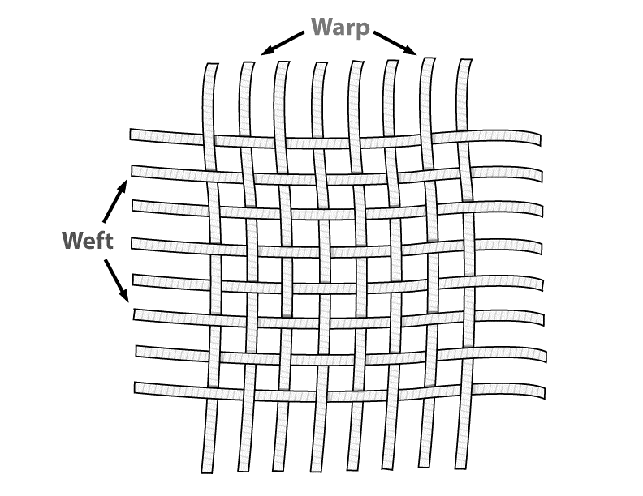

b)

**6marks**

c) 1. Defining or identifying the problem.

2. Brief

3. Conducting Research

4. Ideating the possible solution.

5. Invent **10marks**

d) Line, shape, texture, colour, dot **3 × 1mark = 3 marks**

**QUESTION 2:**

a) i) Creativity refers to the generation of new ideas or the act of inventing something original. **3marks**

ii) Innovation is the successful implementation of creative ideas into viable solutions. **3marks**

b)

|  |  |
| --- | --- |
| **Creativity** | **Innovation** |
| It involves coming up with new ideas | It involves implementation of ideas |
| Imaginative process | Productive process |
| No risk involved | Involves risk |
| Cannot be measured | Can be measured |
| Does not require money. | Requires money |

**10marks**

c) Relief, Etching, Stencil, block printing, etc. **3 × 2marks = 6 marks**

d) Oil paint, Acrylic, poster colour, ink, water colour, etc. **3 × 1mark = 3 marks**

**Total Score = 25 marks**

**QUESTION 3:**

a) Materials are things needed to create artworks, example paper, colour, wood, etc. whiles tools are devices used to carry out work, example chisel, brush, etc. **6 marks**

b) Materials: Pencil, paper, colour, felt pen, etc. **3 × 1mark = 3 marks**

Tools: Pencil, chalk, charcoal, pen, drawing board, pins, brush, etc. **3 × 1mark = 3 marks**

c) 1) Keeping the tools in their cases or containers after use.

2. Washing brushes used in painting.

3. Regularly repair or replace damaged tools .

4. Keep tools away from moisture or water. Etc **3 × 2marks = 6 marks**

d) *Learner expected to create a frottage pattern by the use of pencil and coin only.* ***5marks***

e) Stone, sand paper, etc. **2 × 1mark = 2 marks**

**Total Score = 25 marks**

**Overall Score for section B = 70 marks**