MARKING SCHEME
BASIC 7 – COMPUTING
SECTION A – OBJECTIVES
1. D | 6. C | 11. C | 16. A | 21. B | 26. A | 31. C | 36. A
2. B | 7. D | 12. D | 17. C | 22. A | 27. B | 32. C | 37. B
3. A | 8. A | 13. C | 18. B | 23. B | 28. D | 33. B | 38. C
4. D | 9. C | 14. D | 19. C | 24. C | 29. C | 34. C | 39. B
5. D | 10. D | 15. A | 20. B | 25. A | 30. A | 35. D | 40. D
Award 1 mark for each correct answer. Overall Total = 40marks

PART 2
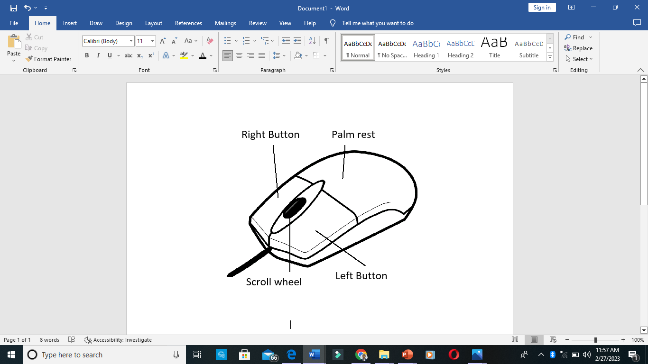
SECTION A – COMPULSORY
1. a)

Award 3marks for the drawing and 4marks for correct labelling of the parts. 7 marks

b) Selecting, clicking, double-clicking, pointing, dragging, etc. 3 $×$ 2marks = 6 marks
c) Mechanical mouse, optical mouse, wireless mouse, laser mouse, trackball mouse, etc. 2 $×$ 2marks = 4 marks
d) Arrow/navigational/directional keys 3 marks
e) Joystick, trackball, Pointing stick, etc. 2 $×$ 2marks = 4 marks
Total Score for Question 1 = 24 marks

SECTION B
2. a) Mouse, keyboard, scanner, joystick, etc. 4 $×$ 1mark = 4 marks
b) Projector, monitor, printer, plotter, etc. 4 $×$ 1mark = 4 marks
c) i) File extensions: .docx, .pdf, .jpg, .png, etc. 2 $×$ 1mark = 2 marks
ii) Word Processing Software: Microsoft Word, WordStar, WordPad, Word Perfect, etc. 2 $×$ 1mark = 2 marks
Total for Question 2 = 12 marks

3. a) i) DVD – Digital Versatile Disk 2 marks
ii) HDD – Hard Disk Drive 2 marks
b) 1. It makes finding files easier and faster.
2. It cleans up the desktop space.
3. For backup in case of loss of original files. 2 $×$ 2marks = 4 marks
c) 1. Right-click a blank spot on the desktop.
2. Select New from the pop-up menu.
3. Move the mouse pointer to folder and click on it.
4. Type the desired folder name and press enter on the keyboard. 4 marks
Total Score for Question 3 = 12 marks
4. a)
First Generation Computers | Third Generation Computers
1. Uses Vacuum tube technology | Uses integrated circuits
2. Not portable | Portable
3. Large size | Smaller in size
4. Consumed a lot of electricity | Consumed lesser electricity
3 $×$ 2marks = 6 marks
b) 1. They occupy less space.
2. They emit less radiation.
3. They consumed less electricity. Etc. 3 $×$ 2marks = 6 marks
Total Score for Question 4 = 12 marks

5. a) Desktop represents the first environment seen when the computer is first turned on. 3 marks
b) Wallpaper, Taskbar, Icons, Cortana, etc. 3 $×$ 1marks = 3 marks
c)
Action | Keyboard Shortcut
Bolden texts | Ctrl + B
Print a document | Ctrl + P
Save a document | Ctrl + S
6 marks
Total for Question 5 = 12 marks

Overall Score for Section B (3 $×$ 12marks) = 36 marks
MARKING SCHEME
BASIC 8 – COMPUTING
SECTION A – OBJECTIVES
1. C | 6. B | 11. B | 16. A | 21. A | 26. C | 31. C | 36. D
2. C | 7. A | 12. C | 17. D | 22. B | 27. B | 32. D | 37. C
3. D | 8. C | 13. C | 18. C | 23. B | 28. B | 33. A | 38. D
4. B | 9. A | 14. C | 19. C | 24. A | 29. B | 34. B | 39. C
5. C | 10. D | 15. B | 20. D | 25. D | 30. B | 35. C | 40. A
Award 1 mark for each correct answer. Overall Total = 40marks

PART 2
SECTION A – COMPULSORY
1. a) Microsoft Word 2 marks
b) A – font size B – change case C – font colour D – bullets
E – align right F – line and paragraph spacing G – borders 7 marks
c) H – Clipboard I – Font J – Paragraph 3 marks

d) Home tab 2 marks
e) File, Insert, Layout, Design, etc. 2 $×$ 1mark = 2 marks
f) i) C is font colour. It is used to change the colour of the text. 2marks
ii) E is align right. It is used to align text at the right margin of the page. 2marks
g) Sentence case/lowercase/uppercase/toggle case/capitalize each word. 2 $×$ 2marks = 4 marks
Total Score for Question 1 = 24 marks

SECTION B
2. a) 1. Toxic metals from damaged computer parts may pollute water bodies.
2. Polluted air from toxic chemicals from damaged computer parts being burnt.
3. E-waste is not biodegradable and can accumulate in the soil. 3 $×$ 2marks = 6 marks
b) 1. Recycling used computer components.
2. Safely disposing damaged computer components.
3. Using energy efficient gadgets. 3 $×$ 2mark = 6 marks

Total for Question 2 = 12 marks

3. a)
Generation | Period | Main technology used
Example:  First Generation | 1946 – 1959 | Vacuum tubes
Second Generation | 1959 – 1965 | Transistors
Fourth Generation | 1971 - 1980 | Very Large Scale Integrated  Circuits (VLSI)

6 marks
b) 1. The concept of internet was introduced in the fourth generation.
2. It does not require AC
3. Computers of fourth generation became easily available. Etc. 2 $×$ 2marks = 4 marks
c) Java script, C, C++, DBASE, etc. 2 $×$ 1mark = 2 marks
Total Score for Question 3 = 12 marks
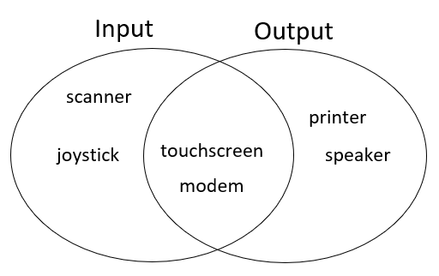
4. a)

6marks

b) 1. CD-ROM = 700MB 2. DVD-ROM = 4.7GB 3. BD = 128GB etc. 6marks
Total Score for Question 4 = 12 marks

5. a) i) Visual/eye problem arising from very bright screen. 2marks
ii) Hearing problem arising from loud volumes. 2marks
iii) Wrist pains from prolonged usage. 2marks
b) Programs tab, start button, quick launch area, notification area 3 $×$ 1mark = 3 marks
c) a counter is a device which stores and sometimes displays the number of times a particular event or process occurs often in relationship to a clock. 3marks
Total for Question 5 = 12 marks

Overall Score for Section B (3 $×$ 12marks) = 36 marks

MARKING SCHEME
JHS 3 – ICT – TERM 1
PART 1 – OBJECTIVES
1. C | 6. A | 11. D | 16. C | 21. D | 26. C | 31. B | 36. B
2. B | 7. B | 12. C | 17. B | 22. A | 27. B | 32. B | 37. D
3. A | 8. C | 13. A | 18. D | 23. B | 28. A | 33. D | 38. C
4. D | 9. B | 14. A | 19. C | 24. D | 29. C | 34. A | 39. B
5. B | 10. A | 15. C | 20. C | 25. C | 30. A | 35. A | 40. A
Award 1 mark for each correct answer. Overall Score for Part 1 = 40 marks

PART 2
SECTION A – COMPULSORY
QUESTION 1:
a) i) Microsoft Excel, Google sheets, Lotus 1-2-3, Quattro Pro, Numbers, etc. 3 $×$ 2marks = 6marks
ii) I – Row II – Column III – Active cell IV – Cell 8 marks
b) i) = B6*C6 ii) =D7/B7 iii) =D9/B9 6marks
c) C10 2 marks
d) =SUM(D5:D9) 2marks
Total Score for Question 1 = 24 marks

SECTION B
2 a) i. The internet is expensive to use.
ii. Unexpected download of computer virus.
iii. Watching of pornographic materials.
iv. Sending of spam messages. 3 $×$ 2marks = 6 marks
b) i) A web page is a hypertext document on the World Wide Web. 3marks
ii) Web browser is a program used to access the pages of a website on the internet. 3marks
Total Score for Question 2 = 12 marks

3. a) i) Open your web browser
ii) Type in the address of your email service provider in the address bar and press the enter key.
iii) On the sign in page, enter your user name and password and click on sign to access your account.
iv) Click on inbox to access the message. Award 6marks for correct steps.

b) 1. WhatsApp 2. Telegram 3. Facebook Messenger
4. Online Education Portals 5. YouTube, etc. 3 $×$ 2marks = 6 marks

Total Score for Question 3 = 12 marks
4. a) i) Application software can be defined as a set of instructions designed to perform specific functions for end users. 3marks
ii) System software is a set of instructions designed to control the allocation and usage of the computer’s hardware resources. 3marks
b) i) Opera, Encarta, MS Word, Chrome, Skype, etc. 3 $×$ 1mark = 3 marks
ii) Windows XP, LINUX, Mac OS, Windows Vista, etc. 3 $×$ 1mark = 3 marks
Total Score for Question 4 = 12 marks
5. a) i) Compose is an email feature used to create and send new messages. 3marks
ii) Spam refers to unsolicited internet mail in the form of chain commands promoting the sale of products. 3marks
b) Google, Yahoo, Mail.com, Zoho, Aol.com, etc. 2 $×$ 1mark = 2 marks

c) 1. Email is a very fast way of sending and receiving information.
2. It is not expensive.
3. It is time saving. Etc. 2 $×$ 2marks = 4 marks
Total Score for Question 5 = 12 marks

Overall Score for Part 2 = 60 marks

