**MARKING SCHEME**

**BASIC 7 – COMPUTING**

**SECTION A – OBJECTIVES**

|  |  |  |  |  |  |  |  |
| --- | --- | --- | --- | --- | --- | --- | --- |
| 1. D | 6. C | 11. C | 16. A | 21. B | 26. A | 31. C | 36. A |
| 2. B | 7. D | 12. D | 17. C | 22. A | 27. B | 32. C | 37. B |
| 3. A | 8. A | 13. C | 18. B | 23. B | 28. D | 33. B | 38. C |
| 4. D | 9. C | 14. D | 19. C | 24. C | 29. C | 34. C | 39. B |
| 5. D | 10. D | 15. A | 20. B | 25. A | 30. A | 35. D | 40. D |

**Award 1 mark for each correct answer. Overall Total = 40marks**

**PART 2**

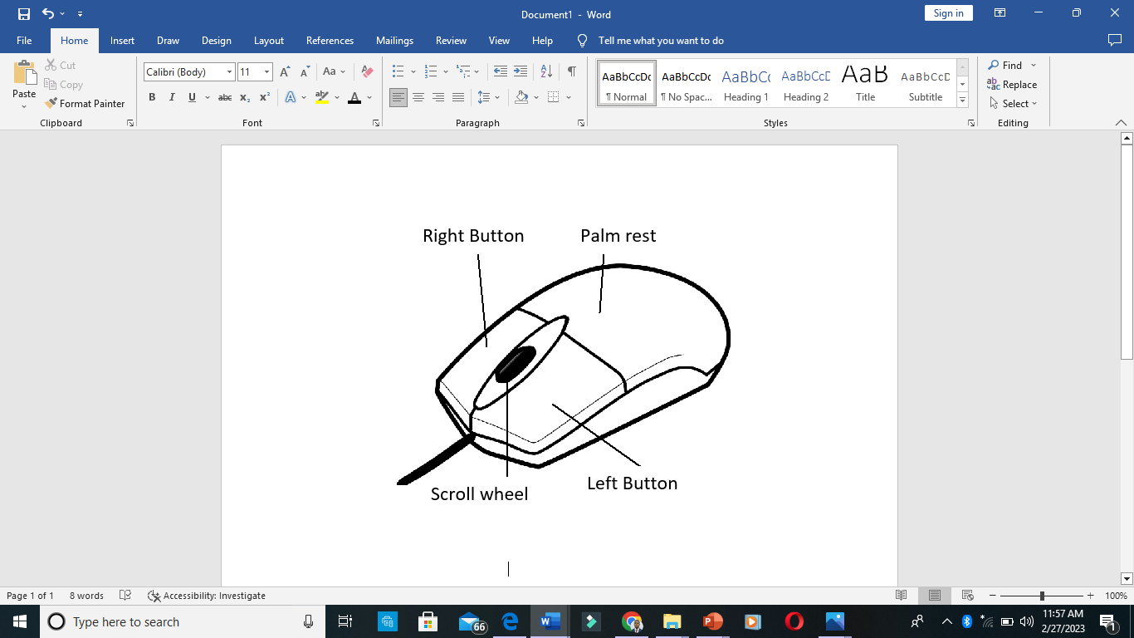**SECTION A – COMPULSORY**

1. a)

*Award 3marks for the drawing and 4marks for correct labelling of the parts.* **7 marks**

b) Selecting, clicking, double-clicking, pointing, dragging, etc. **3 2marks = 6 marks**

c) Mechanical mouse, optical mouse, wireless mouse, laser mouse, trackball mouse, etc. **2 2marks = 4 marks**

d) Arrow/navigational/directional keys **3 marks**

e) Joystick, trackball, Pointing stick, etc. **2 2marks = 4 marks**

***Total Score for Question 1 = 24 marks***

**SECTION B**

2. a) Mouse, keyboard, scanner, joystick, etc. **4 1mark = 4 marks**

b) Projector, monitor, printer, plotter, etc. **4 1mark = 4 marks**

c) i) File extensions: .docx, .pdf, .jpg, .png, etc. **2 1mark = 2 marks**

ii) Word Processing Software: Microsoft Word, WordStar, WordPad, Word Perfect, etc. **2 1mark = 2 marks**

***Total for Question 2 = 12 marks***

3. a) i) **DVD** – Digital Versatile Disk **2 marks**

ii) **HDD** – Hard Disk Drive **2 marks**

b)1. It makes finding files easier and faster.

2. It cleans up the desktop space.

3. For backup in case of loss of original files. **2 2marks = 4 marks**

c) 1. Right-click a blank spot on the desktop.

2. Select ***New*** from the pop-up menu.

3. Move the mouse pointer to folder and click on it.

4. Type the desired folder name and press enter on the keyboard. **4 marks**

*Total Score for Question 3 = 12 marks*

4. a)

|  |  |
| --- | --- |
| **First Generation Computers** | **Third Generation Computers** |
| 1. Uses Vacuum tube technology | Uses integrated circuits |
| 2. Not portable | Portable |
| 3. Large size | Smaller in size |
| 4. Consumed a lot of electricity | Consumed lesser electricity |

**3 2marks = 6 marks**

b) 1. They occupy less space.

2. They emit less radiation.

3. They consumed less electricity. Etc. **3 2marks = 6 marks**

***Total Score for Question 4 = 12 marks***

5. a) Desktop represents the first environment seen when the computer is first turned on. **3 marks**

b) Wallpaper, Taskbar, Icons, Cortana, etc. **3 1marks = 3 marks**

c)

|  |  |
| --- | --- |
| **Action** | **Keyboard Shortcut** |
| ***Bolden texts*** | Ctrl + B |
| Print a document | ***Ctrl + P*** |
| Save a document | ***Ctrl + S*** |

**6 marks**

*Total for Question 5 = 12 marks*

**Overall Score for Section B (3 12marks) = 36 marks**

**MARKING SCHEME**

**BASIC 8 – COMPUTING**

**SECTION A – OBJECTIVES**

|  |  |  |  |  |  |  |  |
| --- | --- | --- | --- | --- | --- | --- | --- |
| 1. C | 6. B | 11. B | 16. A | 21. A | 26. C | 31. C | 36. D |
| 2. C | 7. A | 12. C | 17. D | 22. B | 27. B | 32. D | 37. C |
| 3. D | 8. C | 13. C | 18. C | 23. B | 28. B | 33. A | 38. D |
| 4. B | 9. A | 14. C | 19. C | 24. A | 29. B | 34. B | 39. C |
| 5. C | 10. D | 15. B | 20. D | 25. D | 30. B | 35. C | 40. A |

**Award 1 mark for each correct answer. Overall Total = 40marks**

**PART 2**

**SECTION A – COMPULSORY**

1. a) Microsoft Word **2 marks**

b) **A** – font size **B** – change case **C** – font colour **D** – bullets

**E** – align right **F** – line and paragraph spacing **G** – borders **7 marks**

c) **H** – Clipboard **I** – Font **J** – Paragraph **3 marks**

d) Home tab **2 marks**

e) File, Insert, Layout, Design, etc. **2 1mark = 2 marks**

f) i) **C** is font colour. It is used to change the colour of the text. **2marks**

ii) **E** is align right. It is used to align text at the right margin of the page. **2marks**

g) Sentence case/lowercase/uppercase/toggle case/capitalize each word. **2 2marks = 4 marks**

***Total Score for Question 1 = 24 marks***

**SECTION B**

2. a) 1. Toxic metals from damaged computer parts may pollute water bodies.

2. Polluted air from toxic chemicals from damaged computer parts being burnt.

3. E-waste is not biodegradable and can accumulate in the soil. **3 2marks = 6 marks**

b) 1. Recycling used computer components.

2. Safely disposing damaged computer components.

3. Using energy efficient gadgets. **3 2mark = 6 marks**

***Total for Question 2 = 12 marks***

3. a)

|  |  |  |
| --- | --- | --- |
| **Generation** | **Period** | **Main technology used** |
| Example:  First Generation | *1946 – 1959* | *Vacuum tubes* |
| Second Generation | *1959 – 1965* | *Transistors* |
| Fourth Generation | *1971 - 1980* | *Very Large Scale Integrated*  *Circuits (VLSI)* |

**6 marks**

b) 1. The concept of internet was introduced in the fourth generation.

2. It does not require AC

3. Computers of fourth generation became easily available. Etc. **2 2marks = 4 marks**

c) Java script, C, C++, DBASE, etc. **2 1mark = 2 marks**

**Total Score for Question 3 = 12 marks**

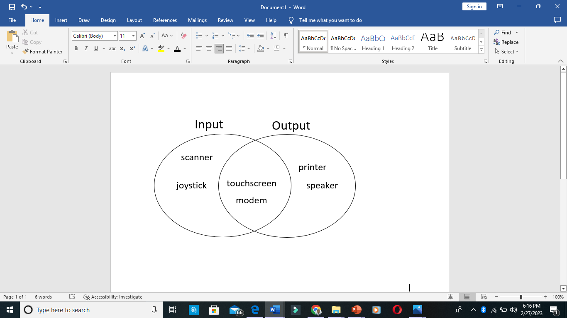

4. a)

**6marks**

b) 1. CD-ROM = 700MB 2. DVD-ROM = 4.7GB 3. BD = 128GB etc. **6marks**

**Total Score for Question 4 = 12 marks**

5. a) i) Visual/eye problem arising from very bright screen. **2marks**

ii) Hearing problem arising from loud volumes. **2marks**

iii) Wrist pains from prolonged usage. **2marks**

b) Programs tab, start button, quick launch area, notification area **3 1mark = 3 marks**

c)a counter is a device which stores and sometimes displays the number of times a particular event or process occurs often in relationship to a clock. **3marks**

**Total for Question 5 = 12 marks**

**Overall Score for Section B (3 12marks) = 36 marks**

**MARKING SCHEME**

**JHS 3 – ICT – TERM 1**

**PART 1 – OBJECTIVES**

|  |  |  |  |  |  |  |  |
| --- | --- | --- | --- | --- | --- | --- | --- |
| 1. C | 6. A | 11. D | 16. C | 21. D | 26. C | 31. B | 36. B |
| 2. B | 7. B | 12. C | 17. B | 22. A | 27. B | 32. B | 37. D |
| 3. A | 8. C | 13. A | 18. D | 23. B | 28. A | 33. D | 38. C |
| 4. D | 9. B | 14. A | 19. C | 24. D | 29. C | 34. A | 39. B |
| 5. B | 10. A | 15. C | 20. C | 25. C | 30. A | 35. A | 40. A |

**Award 1 mark for each correct answer. Overall Score for Part 1 = 40 marks**

**PART 2**

**SECTION A – COMPULSORY**

**QUESTION 1:**

a) i) Microsoft Excel, Google sheets, Lotus 1-2-3, Quattro Pro, Numbers, etc. **3 2marks = 6marks**

ii) I – Row **II** – Column **III** – Active cell **IV** – Cell  **8 marks**

b) i) = B6*C6 ii) =D7/B7 iii) =D9/B9 **6marks**

c) C10 **2 marks**

d) =SUM(D5:D9) **2marks**

**Total Score for Question 1 = 24 marks**

**SECTION B**

2 a) i. The internet is expensive to use.

ii. Unexpected download of computer virus.

iii. Watching of pornographic materials.

iv. Sending of spam messages. **3 2marks = 6 marks**

b) i) A web page is a hypertext document on the World Wide Web. **3marks**

ii) Web browser is a program used to access the pages of a website on the internet. **3marks**

**Total Score for Question 2 = 12 marks**

3. a) i) Open your web browser

ii) Type in the address of your email service provider in the address bar and press the enter key.

iii) On the sign in page, enter your user name and password and click on sign to access your account.

iv) Click on inbox to access the message. **Award 6marks for correct steps.**

b) 1. WhatsApp 2. Telegram 3. Facebook Messenger

4. Online Education Portals 5. YouTube, etc. **3 2marks = 6 marks**

**Total Score for Question 3 = 12 marks**

4. a) i) Application software can be defined as a set of instructions designed to perform specific functions for end users. **3marks**

ii) System software is a set of instructions designed to control the allocation and usage of the computer’s hardware resources. **3marks**

b) i) Opera, Encarta, MS Word, Chrome, Skype, etc. **3 1mark = 3 marks**

ii) Windows XP, LINUX, Mac OS, Windows Vista, etc. **3 1mark = 3 marks**

**Total Score for Question 4 = 12 marks**

5. a) i) Compose is an email feature used to create and send new messages. **3marks**

ii) Spam refers to unsolicited internet mail in the form of chain commands promoting the sale of products. **3marks**

b) Google, Yahoo, Mail.com, Zoho, Aol.com, etc. **2 1mark = 2 marks**

c) 1. Email is a very fast way of sending and receiving information.

2. It is not expensive.

3. It is time saving. Etc. **2 2marks = 4 marks**

**Total Score for Question 5 = 12 marks**

**Overall Score for Part 2 = 60 marks**