END OF FIRST TERM MARKING SCHEME

SUBJECT: FRENCH LANGUAGE

**JHS: THREE**

**60 MARKS**

|  |  |  |  |  |  |  |  |
| --- | --- | --- | --- | --- | --- | --- | --- |
| 1. D | 6. C | 11. D | 16. B | 21. D | 26. D | 31. B | 36. B |
| 2. B | 7. C | 12. B | 17. D | 22. C | 27. C | 32. A | 37. C |
| 3. A | 8. A | 13. C | 18. A | 23. B | 28. A | 33. A | 38. A |
| 4. A | 9. B | 14. A | 19. D | 24. B | 29. C | 34. B | 39. D |
| 5. B | 10. B | 15. C | 20. B | 25. A | 30. B | 35. C | 40. B |

**Composition**

**SECTION B**

**PREAMBLE**

There is only one section in this part. Two questions are set and candidates are to answer only one. However, if a candidate answers the two questions please mark both and choose the better of the two.

A. Content 20 marks

B. Grammar 10 marks

C. Clarity 05 marks

D. Overall expressiveness 05 marks

Total 40 marks

**INDICATION OF MARKS**

Each grammar mistake is underlined and a stroke put in the left hand margin. Each stroke represents ½ marks: therefore a candidate who makes 20 mistakes will lose all the 20 marks allocated to grammar. A consequential repeated error is ringed. Positive markings for content are shown in the right hand margin while negative markings (grammar mistakes) are shown in the left hand margin.

All fractions are retained until the grand total mark, when the ½ is approximately to one full mark. The total is written in the bottom right hand corner of the paper and ringed after all the fractions; deductions have been taken care of. This is then transferred to the front page of the answer sheet.

**DEVIATION**

A candidate who deviates completely from the subject matter should be awarded a maximum mark of 2. Where there is a partial deviation in the essay, please circle the deviated portion. This should not be counted as part of the essay.

**MEANINGLESSNESS ESSAY**: is an essay that does not make sense. Eg. Compilation of wards either French or English words or both. Such an essay attract zero.

**DETAILS**

1. **Content**

This refers to a correct or appropriate response to an item or question. The candidate scores the full mark, if he or she responds correctly in a full or complete sentence. However, a correct answer in an incomplete sentence attracts ½ of the full mark for the item.

2. **Grammar**

Grammar mistakes include: wrong tense, omitted words, wrong article, preposition, gender, number, person, adverb, pronoun, expression and any other wrong form of grammar. Omission of accents should not be penalized except in the past participle form. Misapplication of capital letters is not penalized. Deduct 1 mark for consistent use of wrong tense (if this occurs 7 or more times).

**NOTE:**  Consequential errors are not penalized e.g. c’est un montre blanc. Blanc is a consequential error because3 the candidate used blanc to agree with ‘un’, that’s why, we should not penalized him/her for the use of the blanc, instead of blanche. We should penalized him for the use of ‘un’ before ‘montre’, any answer written in English does not attract a mark for content. It must be circled and not counted among written words of the essay. Eg. Esther boit water, un goat est près de Esther.

**SUPERFLUTY**

A superfluous word that grammatical mistake where it touches on a point of grammar and it is penalized Eg. Sami se lève très tôt en le matin. The ‘en’ is a superfluous word and it is penalized.

**N. B.** A candidate loses ½ marks for every grammatical mistake made.

3. **Overall expressiveness (OE)**

This is the examiner’s assessment of the whole composition taking into account presentation, range of vocabulary choice of words, grammatical/idiomatic expressions etc.

4. **Clarity**

Has the examiner clearly understood what the candidate has written? If yes then it is clear. Candidate who writes in English scores zero.

Paper 2 composition

1. (a) Le nom de mon village est………./ Mon village s’appelle ………/ ……….. est le nom de mon village 2 marks

(b) Mon village est à Ashanti Region/…..se trouve à Volta Region 2 marks

(c) Le nom du festival est Homowo/L’évènement est Hogbetsotso etc. 2 marks

(d) Il est célébré en mai, en août, ………./ Le festival c’est le 10 septembre, ………. 2 marks

(e) La cérémonie se passe à la place publique/Le lieu où se passe la cérémonie est le centre du village etc.

2 marks

(f) Les villageois balaient le village/Avant la fête, les villageois nettoient le village etc. 2 marks

(g) Ils portent des habits rouges/blancs etc.

Les villageois portent des boubous. 2 marks

(h) Les personnalités presentes sont les chefs, les invités etc. 2 marks

(i) Les villageois boivent Dry Gin, Coca Cola, Alomo etc. 1 mark

(j) Je trouve la fête très excellente/bonne etc. 2 marks

2. Picture description.

A. (i) Naomi mange/ Naomi est en train de manger kenkey 1 mark

(ii) Une poule/un coq est près de Naomi 2 marks

B. (i) Naomi va puiser de l’eau. 2 marks

(ii) Elle laisse son plat sur le sol/par terre 2 marks

C. (i) Maintenant Naomi boit de l’eau. 1 mark

(ii) Derrière Naomi, la poule prend son poisson/sa viande 2 marks

D. (i) L’oi seau vole/La poule s’enfuit 2 marks

(ii) L’oiseau vole car il prend le poisson de Naomi/ Naomi le poursuit 2 marks

E. (i) La pauvre Naomi va à l’école. 1 mark

(ii) Elle tient un sac à la main 1 mark

F. (i) Elle est assise sur une chaise/un banc. 2 marks

(ii) Elle lit un livre /Elle apprend. 2 marks

END OF FIRST TERM MARKING SCHEME

SUBJECT: FRENCH LANGUAGE

**JHS: TWO**

**60 MARKS**

|  |  |  |  |  |  |  |  |
| --- | --- | --- | --- | --- | --- | --- | --- |
| 1. C | 6. C | 11. C | 16. D | 21. D | 26. D | 31. B | 36. D |
| 2. B | 7. C | 12. C | 17. D | 22. C | 27. A | 32. B | 37. A |
| 3. A | 8. D | 13. A | 18. B | 23. B | 28. C | 33. D | 38. C |
| 4. A | 9. C | 14. A | 19. C | 24. D | 29. B | 34. C | 39. B |
| 5. D | 10. D | 15. C | 20. A | 25. C | 30. C | 35. D | 40. B |

**Composition**

**SECTION B**

**PREAMBLE**

There is only one section in this part. Two questions are set and candidates are to answer only one. However, if a candidate answers the two questions please mark both and choose the better of the two.

A. Content 20 marks

B. Grammar 10 marks

C. Clarity 05 marks

D. Overall expressiveness 05 marks

Total 40 marks

**INDICATION OF MARKS**

Each grammar mistake is underlined and a stroke put in the left hand margin. Each stroke represents ½ marks: therefore a candidate who makes 20 mistakes will lose all the 20 marks allocated to grammar. A consequential repeated error is ringed. Positive markings for content are shown in the right hand margin while negative markings (grammar mistakes) are shown in the left hand margin.

All fractions are retained until the grand total mark, when the ½ is approximately to one full mark. The total is written in the bottom right hand corner of the paper and ringed after all the fractions; deductions have been taken care of. This is then transferred to the front page of the answer sheet.

**DEVIATION**

A candidate who deviates completely from the subject matter should be awarded a maximum mark of 2. Where there is a partial deviation in the essay, please circle the deviated portion. This should not be counted as part of the essay.

**MEANINGLESSNESS ESSAY**: is an essay that does not make sense. Eg. Compilation of wards either French or English words or both. Such an essay attract zero.

**DETAILS**

1. **Content**

This refers to a correct or appropriate response to an item or question. The candidate scores the full mark, if he or she responds correctly in a full or complete sentence. However, a correct answer in an incomplete sentence attracts ½ of the full mark for the item.

2. **Grammar**

Grammar mistakes include: wrong tense, omitted words, wrong article, preposition, gender, number, person, adverb, pronoun, expression and any other wrong form of grammar. Omission of accents should not be penalized except in the past participle form. Misapplication of capital letters is not penalized. Deduct 1 mark for consistent use of wrong tense (if this occurs 7 or more times).

**NOTE:**  Consequential errors are not penalized e.g. c’est un montre blanc. Blanc is a consequential error because3 the candidate used blanc to agree with ‘un’, that’s why, we should not penalized him/her for the use of the blanc, instead of blanche. We should penalized him for the use of ‘un’ before ‘montre’, any answer written in English does not attract a mark for content. It must be circled and not counted among written words of the essay. Eg. Esther boit water, un goat est près de Esther.

**SUPERFLUTY**

A superfluous word that grammatical mistake where it touches on a point of grammar and it is penalized Eg. Sami se lève très tôt en le matin. The ‘en’ is a superfluous word and it is penalized.

**N. B.** A candidate loses ½ marks for every grammatical mistake made.

3. **Overall expressiveness (OE)**

This is the examiner’s assessment of the whole composition taking into account presentation, range of vocabulary choice of words, grammatical/idiomatic expressions etc.

4. **Clarity**

Has the examiner clearly understood what the candidate has written? If yes then it is clear. Candidate who writes in English scores zero.

Paper 2 Composition.

1. Mon Meilleur professeur

(a) Mon professeur/ enseignant s’appelle monsieur Kojo/ madame Eva.

Son nom est madame Joyce etc. 2 marks

(b) Son âge est 30 ans/Il –Elle a 24 ans 2 marks

(c) Elle/Il vient de Kpone/d’Asasewa etc

Son village est………./sa ville s’appelle ……………. 2 marks

(d) Il – Elle habite à Oyibi/sa residence est à Taifa. 2 marks

(e) Le nom de son école est Alpha International /School Son école s’appelle…… 2 marks

(f) La taille de mon professeur est 1.66 mètres/Mon enseignante mesure 1.60 mètres/sa taille est grande

2 marks

(g) Le teint de mon professeur est noir/Il – Elle a un teint clair/Monsieur Kofi est clair. 2 marks

(h) Son repas favori est banku avec la sauce du gombo/ Madame Eva aime manger du riz etc. 2 marks

(i) Son jeu préféré est ampe./ Mon professeur aime jouer au football etc. 2 marks

(j) J’adore madame Eva car elle est gentille. / J’aime mon professeur parcequ’il / elle est bon(ne). 2 marks

2. Ma famille

(a) Le nom de ma est Dumasi/Ma famille’appelle Quaye. Etc. 2 marks

(b) Nous venons de Teshie / Notre ville s’appelle Madina. Etc. 2 marks

(c) Nous habitons à Kasoa / Ma famille vit à Adenta . 2 marks

(d) Nous sommes cinq dans la famille etc. 2 marks

(e) Mon père est monsieur Yao. Il est docteur etc. 2 marks

(f) Ma mère s’appelle madame Vida. Elle est infirmière . 2 marks

(g) Nous parlons Twi et anglais etc. 2 marks

(h) Hous sommes chrétiens/musumans; Nous allons à la l’église, à mosquée 2 marks

(i) Notre plat favori est fufu avec la sauce d’arachide et de la viande etc. 2 marks

(j) J’aime ma famille parce que nous sommes bons. 2 marks

END OF FIRST TERM MARKING SCHEME

SUBJECT: FRENCH LANGUAGE

**JHS: ONE**

**60 MARKS**

|  |  |  |  |  |  |  |  |
| --- | --- | --- | --- | --- | --- | --- | --- |
| 1. B | 6. A | 11. C | 16. B | 21. A | 26. A | 31. B | 36. A |
| 2. C | 7. C | 12. D | 17. B | 22. D | 27. B | 32. C | 37. B |
| 3. A | 8. D | 13. A | 18. B | 23. D | 28. C | 33. C | 38. D |
| 4. D | 9. B | 14. A | 19. A | 24. C | 29. D | 34. D | 39. A |
| 5. B | 10. B | 15. D | 20. D | 25. B | 30. A | 35. B | 40. C |

**Composition**

**SECTION B**

**PREAMBLE**

There is only one section in this part. Two questions are set and candidates are to answer only one. However, if a candidate answers the two questions please mark both and choose the better of the two.

A. Content 20 marks

B. Grammar 10 marks

C. Clarity 05 marks

D. Overall expressiveness 05 marks

Total 40 marks

**INDICATION OF MARKS**

Each grammar mistake is underlined and a stroke put in the left hand margin. Each stroke represents ½ marks: therefore a candidate who makes 20 mistakes will lose all the 20 marks allocated to grammar. A consequential repeated error is ringed. Positive markings for content are shown in the right hand margin while negative markings (grammar mistakes) are shown in the left hand margin.

All fractions are retained until the grand total mark, when the ½ is approximately to one full mark. The total is written in the bottom right hand corner of the paper and ringed after all the fractions; deductions have been taken care of. This is then transferred to the front page of the answer sheet.

**DEVIATION**

A candidate who deviates completely from the subject matter should be awarded a maximum mark of 2. Where there is a partial deviation in the essay, please circle the deviated portion. This should not be counted as part of the essay.

**MEANINGLESSNESS ESSAY**: is an essay that does not make sense. Eg. Compilation of wards either French or English words or both. Such an essay attract zero.

**DETAILS**

1. **Content**

This refers to a correct or appropriate response to an item or question. The candidate scores the full mark, if he or she responds correctly in a full or complete sentence. However, a correct answer in an incomplete sentence attracts ½ of the full mark for the item.

2. **Grammar**

Grammar mistakes include: wrong tense, omitted words, wrong article, preposition, gender, number, person, adverb, pronoun, expression and any other wrong form of grammar. Omission of accents should not be penalized except in the past participle form. Misapplication of capital letters is not penalized. Deduct 1 mark for consistent use of wrong tense (if this occurs 7 or more times).

**NOTE:**  Consequential errors are not penalized e.g. c’est un montre blanc. Blanc is a consequential error because3 the candidate used blanc to agree with ‘un’, that’s why, we should not penalized him/her for the use of the blanc, instead of blanche. We should penalized him for the use of ‘un’ before ‘montre’, any answer written in English does not attract a mark for content. It must be circled and not counted among written words of the essay. Eg. Esther boit water, un goat est près de Esther.

**SUPERFLUTY**

A superfluous word that grammatical mistake where it touches on a point of grammar and it is penalized Eg. Sami se lève très tôt en le matin. The ‘en’ is a superfluous word and it is penalized.

**N. B.** A candidate loses ½ marks for every grammatical mistake made.

3. **Overall expressiveness (OE)**

This is the examiner’s assessment of the whole composition taking into account presentation, range of vocabulary choice of words, grammatical/idiomatic expressions etc.

4. **Clarity**

Has the examiner clearly understood what the candidate has written? If yes then it is clear. Candidate who writes in English scores zero.

Paper 2

Composition

1. Mon école.

(a) Mon école est ………../Mon école s’appelle …………Le nom de mon école est …… 2 marks

(b) Le lieu de l’école est Malam Junction /Mon école se trouve à ……… / Mon école est à ……. 2 marks

(c) Il y a deux bâtiments dans mon école. 2 marks

(d) La couleur de mon école est bleue / blanche/ ect. Mon école est …………… 2 marks

(e) Ma directrice s’appelle madame Esther

Le nom de mon directeur est monsieur Martin. 2 marks

(f) Il y a 300 élèves dans mon école. Etc 2 marks

(g) Les cours commencent à 8 heures du matin. Etc. 2 marks

(h) Nous apprenons twi, l’anglais, BDT. etc. 2 marks

(i) Mon professeur dé classe est madame Ama. 1 mark

Elle enseigne ICT. etc. 1 mark

(j) J’aime mon école car les professeurs sont gentils etc 2 marks

2. Mon ami/Mon amie.

(a) Mon Meilleur ami est Kwesi./Ma meilleure amie s’appelle Senam. etc. 2 marks

(b) Il/Elle a 12 ans / son âge est 10 ans 2 marks

(c) Il/vient de Kpedze/sa ville est Oguaa. 2 marks

(d) Il/Elle habite à Accra etc. 2 marks

(e) Le nom de son école est St. Martins Academy etc. 1 mark

Sa classe est class 6. Etc. 1mark

(f) Sa taille est 1.50 métres / sa taille est courte etc. 1 mark

Son teint est clair etc. 1 mark

(g) Son père s’appelle monsieur John 1 mark

Sa profession est cultivateur 1 marks

(h) Le nom de sa mère est Dede etc 1 mark

La mère de Kwesi est marchaude etc. 1 mark

(i) Son repas préféré est le riz au gras etc. 1 mark

Son jeu préféré est le basket ball etc. 1 mark

(j) J’aime Senam car elle est intelligente. 2 marks

END OF FIRST TERM MARKING SCHEME

SUBJECT: FRENCH LANGUAGE

**CLASS: 6**

**4 marks each**

|  |  |
| --- | --- |
| 1. B | 6. A |
| 2. A | 7. C |
| 3. C | 8. A |
| 4. B | 9. B |
| 5. B | 10. B |

**B.** 11. Il/Elle s’appelle …………../Son nom est ………..etc.

12. Il/Elle vient de Takoradi etc.

13. Il/Elle habite à Achimota etc.

14. Le nom de son école est ………/Son école s’appelle……….

15. Sa date de naissance est lundi 2 octobre 2010 etc.

16. Sa class est Primary 4 etc

17. Sa nationalité est ghanéenne/togolaise etc.

18. Il/Elle est élève / étudiante etc.

**C**. 19. A 20. B 21. A 22. C 23. B

24. 9h 30

25. 12 heures/midi [4 marks each]

FIRST TERM MARKING SCHEME

SUBJECT: FRENCH LANGUAGE

**CLASS: 5**

4 Marks Each

|  |  |
| --- | --- |
| 1. B | 6. C |
| 2. C | 7. B |
| 3. A | 8. B |
| 4. A | 9. A |
| 5. B | 10. C |

B. 11. Il s’appelle monsieur …………../Mon père s’appelle ……..

12. Il a …..36……. ans/ Papa a 32 ans.etc

13. Mon père est professeur / docteur / policier etc

14. Mon père habite à East Legon etc

15. Mon père est grand et gros. Etc.

**C and D**

16. B 17. A 18. C 19. A 20. B

21. le doigt 22. le fer à repasser 23. le ventilateur

24. les yeux (l’oeil) 25. la dent

[4 marks each]

END OF FIRST TERM MARKING SCHEME

SUBJECT: FRENCH LANGUAGE

**CLASS: 4**

A. 1. Yaw et Kwesi 4. habite à Accra

2. 8 ans 5. Habite à Acbimota

3. 9 ans

B. 6. Je m’appelle ……………/ Mon nom est ………

7. J’ai …………..ans/Mon âge est …………..ans

8. Mon école s’appelle …………/ Le nom de mon école est

9. J’habite à …………..

10 Je suis ghanéen/ghanéenne etc.

11. Je suis né/née samedi, 4 mai 2008 etc.

12. Je suis élève

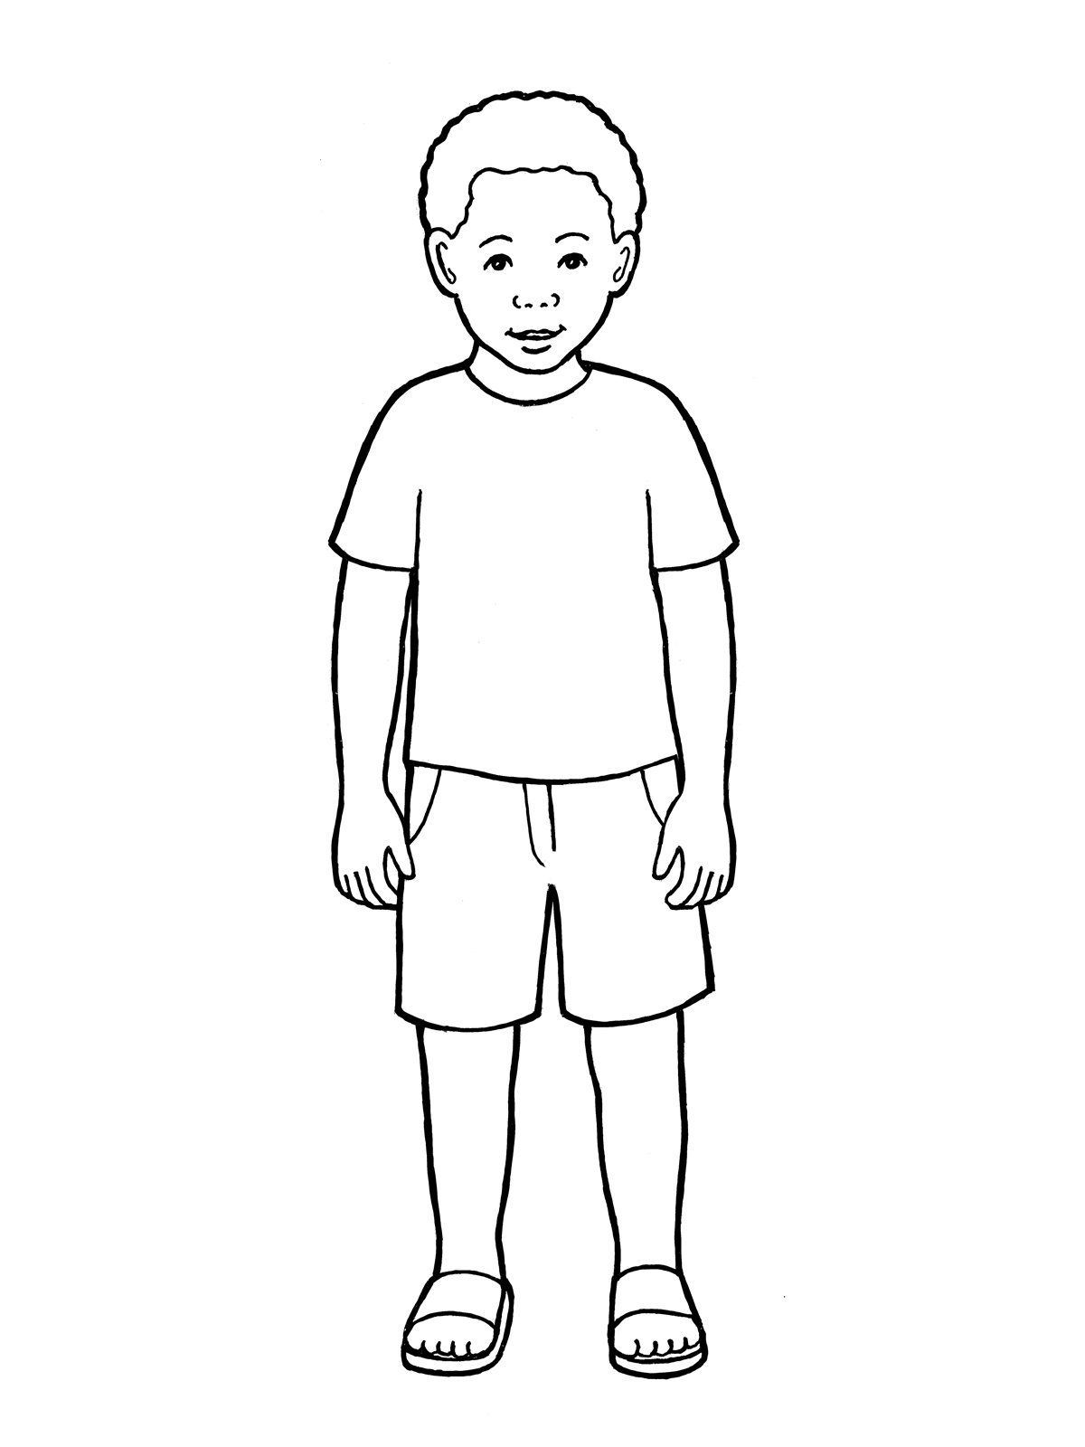

l’ceil(les yeux) l’oreille

la bouche

la main

le pied

D. 18. On entend avec l’o eille

19. On marche avec le pied/on joue au football avec le pied

20. On voit avec les yeux

On mange avec la bouche/on mange avec la main.

21. 20 = vingt

22. 30 = trente

23. 40 = quarante

24. 16 = seize

25. 3 = trois [4 marks each]