FIRST TERM MARKING SCHEME
SUBJECT: MATHEMATICS
CLASS: JHS 1
SECTION A [40 marks]
1. A | 6. B | 11. D | 16. D | 21. C | 26. D | 31. B | 36. B
2. C | 7. B | 12. C | 17. D | 22. D | 27. B | 32. A | 37. B
3. A | 8. D | 13. C | 18. B | 23. C | 28. D | 33. A | 38. B
4. D | 9. C | 14. A | 19. A | 24. C | 29. D | 34. B | 39. A
5. A | 10. B | 15. B | 20. A | 25. D | 30. C | 35. D | 40. D

SECTION B
1. (a) (i) 1,841,943,780 = One billion, eight hundred and forty-one million, nine hundred and forty-three thousand, seven hundred and eighty. M1 A1
(ii) 2,011,987 = Two million and eleven thousand, nine hundred and eighty seven. M1 A1
(b)
78.460783 | Round up | Round off | Round down
Nearest hundredths | 78.47 M1 A1 | 78.46 M1 A1 | 78.46 M1 A1
Nearest thousand | 78.461 M1 A1 | 78.460 | 78.460 M1 A1

(c) 327.6 + 54.13
327.60 = 300 + 20 + 7 + 6 + 5 M1 (d) 45.75m ÷ 5
54.13 = 50 + 4 + 10 100 M1 9.15
1 + 3 5 45.75
10 100 45 M1 B1
381.73 = 300 + 70 + 11 + $\frac{7}{10} +\frac{3}{100}$ A1 7
5
(d) 345 x 27 = 3 4 5 25
0  6 | 0  8 | 1  2  0
2  9  1 | 2  8 | 3  7  5
25

Each child recceives 9.15m of linen
A1 B1
3 1 5
M1 B1
. 3. (a) (i) 0.098, 0.983 and 0.123
. . 345 x 27 = 9315 A1

2. (a) 2 10 15 20
2 5 15 10
5 5 15 5 M1 B1
3 1 3 7
1 1 1
.
. . L. C. M. 2 x 2 z 5 x 3 M1 = 60 A1

(b) (i) 45 = 5 x 3 x 3 M1
= 5 x 3² A1 B1

(ii) 72 = 2 x 2 x 2 x 3 x 3 M1
= 2³ x 3² A1 B1
98, 985, 123
1000 1000 1000
98 985 123 M1
. 1000
. . From the least to the greatest is
0.098, 0.123 and 0.985 A1
(ii) $\frac{5}{6}, \frac{3}{4} , \frac{7}{8}, \frac{1}{4},$

= $\frac{20 18 21 6}{24}$ M1
.
. .From the least to the greatest is
$\frac{1}{4}, \frac{3}{4}, \frac{5}{6}, \frac{7}{8},$ A1 B1

(c) (i) 746.9781 = 746.98 M1 A1
(ii) 0.004834 = 0.0048 M1 A1
(iii) 94164km = 9416km M1 A1

(b) (i) 0.2% of 15000
0.2 x 15000 M1
100
= 30 A 1 ½

(ii) 28% of 40
28 x 40 M1
100
= 5 $\frac{56}{5}$ 11.2 A1 ½

(c) 40 x GH¢450 M1
100
= GH¢180.00 M1
.
. . The customer will pay GH¢450 – GH¢180
M1
= GH¢270.00 A1 B1

(d) 48 = 2⁴ x 3 M1
60 = 2² x 3 x 5 M1
.
. . H. F. C = 2² x 3 = 4 x 3 M1
M1
= 12 A 1

4. (a) (i) 2 ÷ $\left(\frac{15}{64} ÷\frac{6}{7}\right)$
₅ ₁
2 ÷ $\left(\frac{15}{63} x\frac{7}{6}\right)$ M1
⁹ ²
2 ÷ $\frac{5}{18}$ M1
2 x $\frac{18}{5}$ = $\frac{36}{5}$ = $7\frac{1}{5}$ A1

(ii) $7\frac{2}{3}- 4\frac{5}{6}+ 2\frac{3}{8}$
= $\frac{23}{3}- 296 + \frac{19}{8}$ M1
= $\frac{184-116+57 }{24}$ M1
₁₁₉
= $\frac{357}{24}$ = $\frac{119}{8}$ = $14\frac{7}{8}$ A1
⁸

(iii) $5\frac{7}{15}- 2\frac{2}{3}+ 1\frac{5}{12}$
= $\frac{82}{15} - \frac{8}{3}+ \frac{17}{12}$ M1
= $\frac{328-160+85}{60}$ M1 B1
= $\frac{253}{60}$ A1

(b) (i) 6³ = 6 x 6 x 6 M1
= 216 A

(ii) 34 = 3 x 3 x 3 x 3 M1
= 81 A1

(iii) 1 1
2⁵ = 2 x 2 x 2 x 2 x 2 M1
= $\frac{1}{32}$ A

(c) (i) 84.4099500 = 84.410 M1 A1

(ii) 0.002587 = 0.0026 M1 A1

FIRST TERM MARKING SCHEME
SUBJECT: MATHEMATICS
CLASS: JHS 2
SECTION A [40 marks]
1. A | 6. A | 11. C | 16. D | 21. D | 26. A | 31. D | 36. B
2. A | 7. B | 12. D | 17. A | 22. C | 27. A | 32. D | 37. A
3. C | 8. C | 13. A | 18. D | 23. B | 28. B | 33. B | 38. B
4. B | 9. D | 14. C | 19. B | 24. D | 29. A | 34. A | 39. D
5. C | 10. D | 15. A | 20. A | 25. D | 30. C | 35. D | 40. B
SECTION B
1. (a) (i) 2408,321 = Two million, four hundred and eight thousand, three hundred and twenty-one. B1 A2
(ii) 10,5674,451 = Ten million, five hundred and sixty seven thousand, four hundred and fifty-one. B1 A2

(b) (i) 1800,000, 1,800,500. 1,801,000
1,801,500, 1802,000, 1,802,500 B1 A2
(ii) 700,000, 700,500, 701,000, 701,500, 702,000, 702,500. B1 A2

(c) 42 = 2 x 3 x 7 M1
36 = 2² x 3² M1
.
. . H. C. F. = 2 x 3 = 6 A1

2. (i) Let U = 80
n(R) = 60
n(M) = 50
n(R∩M) = x
U=80
n(R) = 60 n(M) = 50 B1

60-x x 50-x
B1 B1 B1

(ii) 60 – x + x + 50 – x = 80 M1
110 - x = 80 M1
110 – 80 = x M1
30 = x
x = 30 A1

(b) 193.60 – 37.85
193.60 = 100 + 90 + 3 + $\frac{6}{10}+\frac{0}{100}$ M1
-37.85 = -(30 + 7) + 7 + $\frac{8}{100}$ M1
= 100 + 90 + 3 + $\frac{60}{100}$ - 30 – 7 – $\frac{85}{100}$
= 100 + 90 – 30 + 3 – 7 + $\frac{60}{100}-\frac{85}{100}$ M1
= 100 + 53 + 2 + $\frac{160}{100}-\frac{85}{100}$
155.75 = 155 + $\frac{75}{100}$ A1

(c) 2700 = 2 x 2 x 3 x 3 x 3 x 5 x 5 M1
= 2² x 3³ x 5² A1 B1
3. (a) Cost of 8 notebooks =
8 x GH¢12 = GH¢96.00 M1
Cost of 12 pens =
12 x GH¢5 = GH¢60.00 M
Total cost GH¢156.00

(b) (i) $\frac{1}{27}$ = 3^{x}
27⁻¹ = 3x
3⁻³ = 3^{x} M1
-3 = x
x = -3 A1
(ii) 2^{2x} = 16
2^{2x} = 24 M
$\frac{2x}{2}$ = $\frac{4}{2}$ M1
x = 2 A1

(c) (i) $\frac{3}{4}÷\frac{5}{8}+ \left(\frac{4}{5}-\frac{1}{2}\right)$
$\frac{3}{4}÷\frac{5}{8}+ \left(\frac{8-5}{10}\right)$ M1
= $\frac{3}{4} ÷ \frac{5}{8}+\frac{3}{10}$
= $\frac{3}{4} x \frac{8}{5}+ \frac{3}{10}$ M1
= $\frac{6}{5}+ \frac{3}{10}$
= $\frac{12+3}{10}$
= $\frac{13}{10} or 1\frac{3}{10}$ A1

(ii) $\left(\frac{3}{4}+ \frac{5}{8}\right) x\frac{4}{11}- \frac{1}{2}$
= $\frac{6+5}{8}$ x $\frac{4}{11} =- \frac{1}{2}$ M1
= $\frac{11}{8} x \frac{4}{11}- \frac{1}{2}$ M1
= $\frac{1}{2}-\frac{1}{2}$
= 0 A1

4. (a) (i) y = $\frac{2x}{5}$ + 10

x (years) | 0 | 10 | 20 | 30 | 50
y (diameter in inches) | 10 | 14 | 18 | 22 | 30
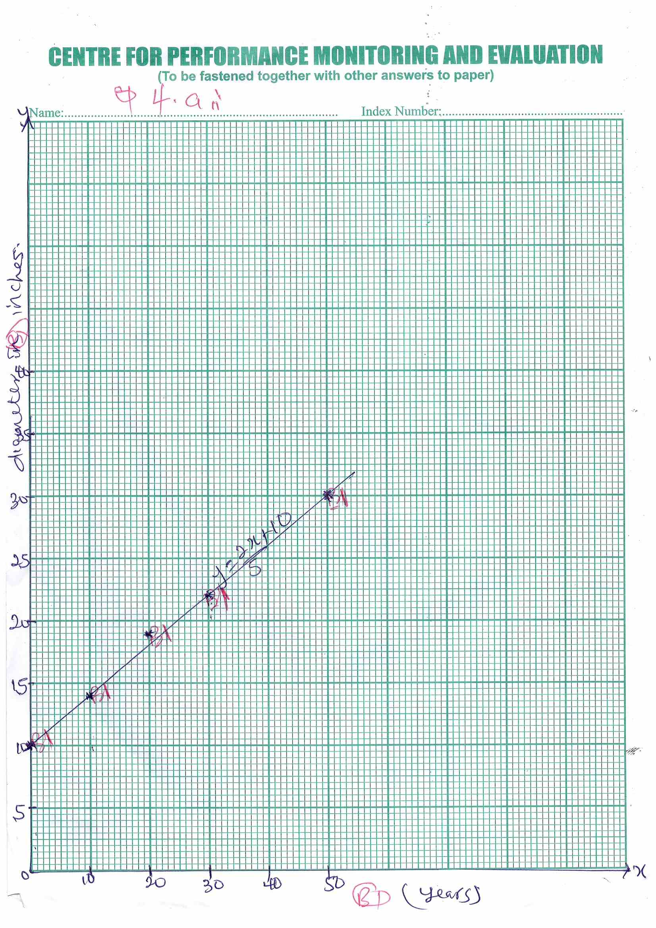
B 1

(c)

30 inches A3

5. (a) (i) $\frac{3a+5b}{4} + \frac{a+b}{8}$
= $\frac{2\left(3a+5b\right) + a+b}{8}$
= $\frac{6a+10b+a+b}{8}$
= $\frac{6a+a+10b+b}{8}$
= $\frac{7a + 11b}{8}$

(ii) $\frac{2x}{6}$ + $\frac{2x - 3y}{3} - \frac{x+y}{2}$
= $\frac{2x+2\left(2x-3y\right)}{6} –(x+y)$
= $\frac{2x+4x-6y-3x-3y}{6}$
= $\frac{2x+4x-3x-6y-3y}{6}$
= $\frac{3x-9y}{6}$

(b) (i) 3(x + 4) – 2(x - 5)
= 3x + 12 – 2x + 10
= 3x – 2x + 12 + 10
= x + 22

(ii) 2(6 – 5x) – 3(2 + 2x) – 4(3x - 1)
12 – 10x – 6 – 6x – 12x + 4
-10x – 6x – 12x + 12 – 6 + 4
-28x + 10

(c) Let y represent total number of students.
Total ratio = 12 + 25
= 37
$\frac{12}{37}$ x y = 120

$\frac{12y}{12}$ = $\frac{37 x 120}{+2}$
y = 370

(i) Number of girls = $\frac{25}{37}$ x 370
= 250

(ii) Total number of boys and girls
= 120 + 250
= 370

FIRST TERM MARKING SCHEME
SUBJECT: MATHEMATICS
CLASS: JHS 3
SECTION A [40 marks]
1. A | 6. D | 11. A | 16. C | 21. D | 26. C | 31. B | 36. B
2. B | 7. D | 12. C | 17. C | 22. C | 27. B | 32. A | 37. A
3. D | 8. C | 13. C | 18. C | 23. C | 28. C | 33. A | 38. D
4. D | 9. D | 14. D | 19. C | 24. D | 29. C | 34. A | 39. C
5. B | 10. A | 15. C | 20. A | 25. B | 30. B | 35. B | 40. D

SECTION B

1. (a) (i) Let U = 60
n(S) = x
n(M) = x + 15
n(S∩M) = 12
U=60
n(M) = x + 15 n(S) = x
B1
x+15- x x-12 B1
B1 12
B1
9

(ii) (x + 15) – 12 + 12 + x – 12 + 9 = 60 M1
2x + 12 = 60 M1
2x = 60 - 12
$\frac{2x}{2} = \frac{48}{2}$ M1
x = 24
Hence, number of students who like science is 24 A1

(ii) Number of students who like exactly one subject
= (x + 15) - -12 + x – 12 M1
But x = 24
= (24 + 15) – 12 + 24 – 12 M1
= 39 A1

(b) $\frac{2x-1}{4}- \frac{x-2}{3 }$
$\frac{3\left(2x-1\right) - 4(x-2)}{12}$ M1
= $\frac{6x-3-4x+8}{12}$ M1
= $\frac{6x-4x-3+8}{12}$ M1
= $\frac{2x+5}{12}$ A1

2. (a) (i) Area of Land = 90m x 60m M1
= 5400m² M1

(ii) Corn = $\frac{2}{5}$ x 5400m M1
= 2160m²

Remainders = 5400m² – 2160m² M1
= 3240m² M1

Tomatoes = $\frac{3}{4}$ x 3240m² M1
= 2430m²
Hence, fraction of land used to cultivate tomatoes
= $\frac{2430}{5400}$ = $\frac{9}{20}$ A1

(iii) Area of land left uncultivated
= 5400m² – (2160m² + 2430m²) M1
= 5400m² – 4590m² M1
= 810m² A1

(b) Let x represent the number
$\frac{5x}{6}$ = 10 + $\frac{1x}{3}$ M1

L. C. M = 6
6 x $\frac{5x}{6}$ = 6 x 10 + 6 x $\frac{1x}{3}$
5x = 60 + 2x
5x – 2x = 60 M1
$\frac{3x}{3}=\frac{60}{3}$ x = 20
The number is 20 A1

3. (a)
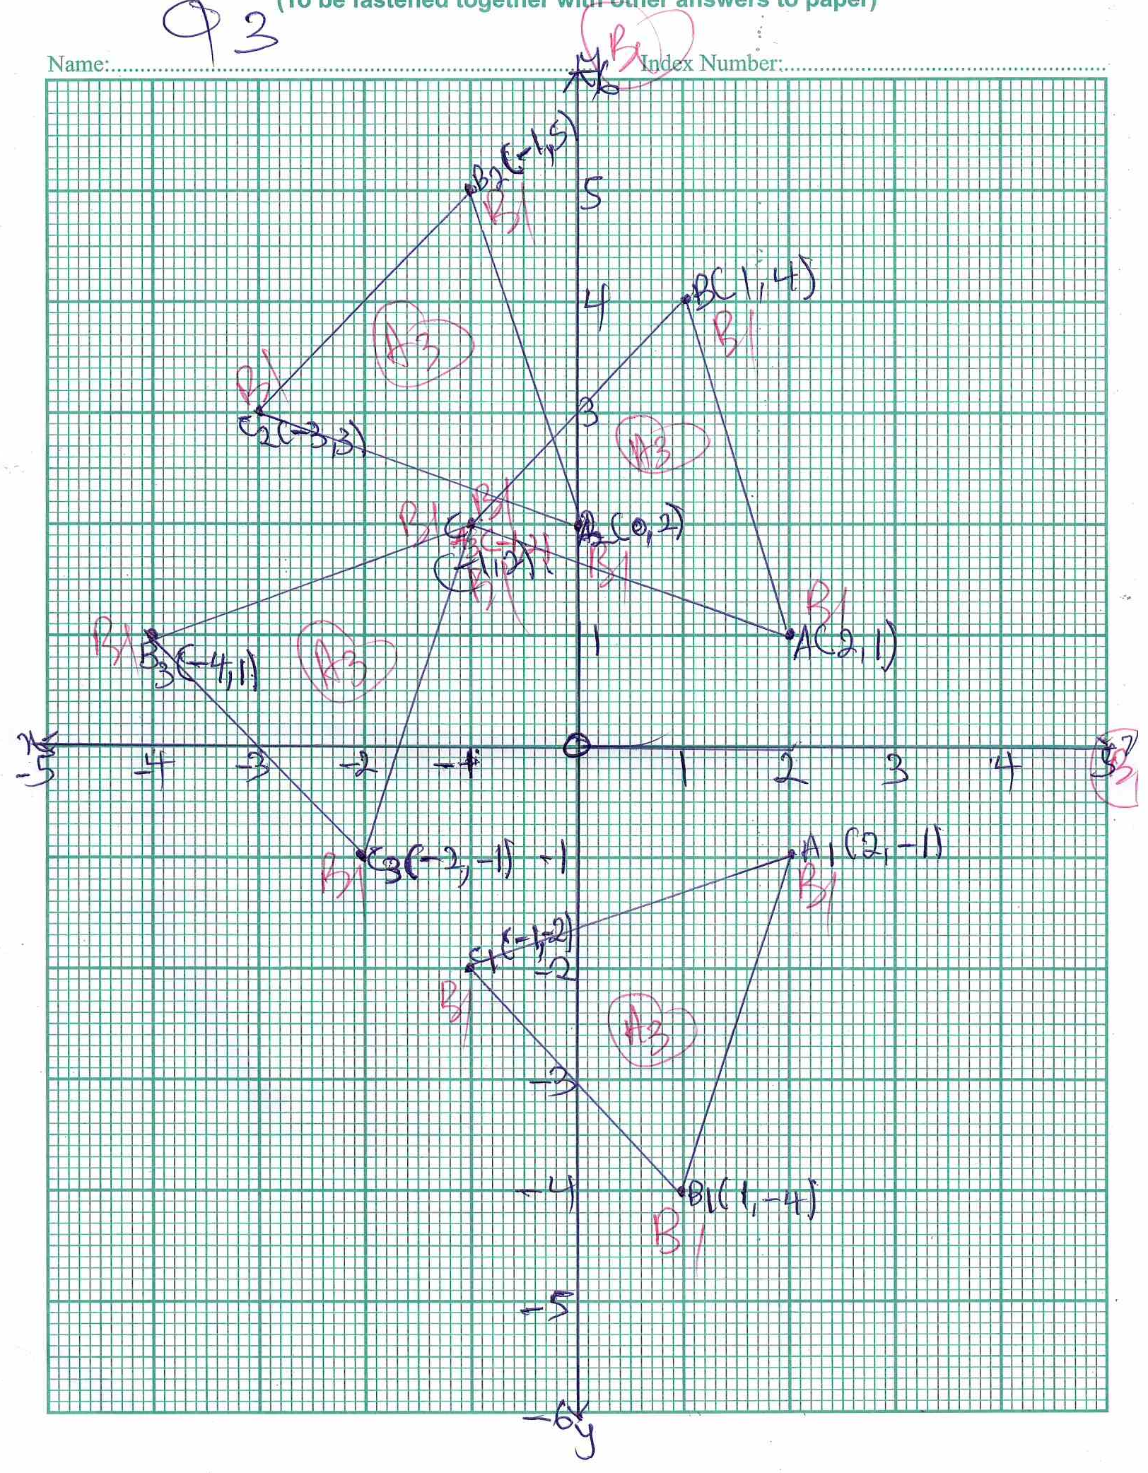

(c) The single transformation that maps ∆A1, B1, C1 and ∆A3, B3 C3 is reflection in the line y – x A1

4. (a) (i) Number of sample space
n(S) = 11 B1
.
. . P(taking out a vowel) = $\frac{4}{11}$ A1

(ii) P(taking out (M)) = $\frac{2}{11}$ A1

(b) (i) Total ratio = 5 + 2 M1
= 7
Three boys = $\frac{5}{7}$ x GH¢189 M1

GH¢135.00 A1
Four girls = $\frac{2}{7}$ x GH¢189 M1
= GH¢54.00 A1

(ii) Amount received by each girl =
GH¢54
4 M1
GH¢13.50 A1

(c) $\frac{4x+5}{5} + \frac{x+3}{4}$ = -1
20 $\left(\frac{4x+5}{5}\right)+ 20 \left(\frac{x+3}{4}\right)$ = 20x – 1 M1
4(4x + 5) + 5(x + 3) = -20
16x + 20 + 5x + 15 = -20 M1
16x + 5x + 35 = -20
21x = -20 – 35 M1
$\frac{21x}{21}= -\frac{55}{21}$ M1
.
. . x = $-\frac{55}{21} or x= -2\frac{12}{21}$ A1
5. (a)

Marks | Freq | Fx
2 | 2 | 4
3 | 4 | 12
4 | 6 | 24
5 | 4 | 20
6 | 1 | 6
7 | 5 | 35
8 | 3 | 24

B 6 fort completion of table.
Note: Three errors in the table consider the table to be zero.
∑f = 25 B ½
∑fx = 125 B ½

(i) Mean mark = $\frac{∑fx}{∑f}$ = $\frac{125}{25}$ M1
= 5 A1

(ii) Modal Mark = 4 A1

(b) Percentage of students who passed
= 1 + $\frac{5+3}{25}$ x 100%
= $\frac{9}{25}$ x 100% M1
= 36% A1

(c) P(a student obtained more than 5 marks)
= $\frac{1+5+3}{25}$ M1
= $\frac{9}{25}$ A1

6. (a) (i) Perimeter of sector
= 2r + $\frac{ϴ}{360}$ x 2πr
= 2(14cm) + $\frac{72}{360}$ x 2 x $\frac{22}{7}$ x 14cm M1 B1
= 28cm + $\frac{88}{5}$ M1
= 45.6cm A1

(ii) Area of minor sector AOB
= $\frac{ϴ}{360}$x πr²
$\frac{72}{360}$ x $\frac{22}{7}$ x 14cm x 14cm M1 B1
= $\frac{616}{5}$cm² M1
= 123.2cm²

(b) (i) Value of computer after one year
= $\frac{75}{100}$ x GH¢65000 M1 B1
GH¢48,750.00 A1 B1

(ii) Profit = GH¢55.000 – GH¢48,750 M1
= GH¢6,250.00 A1 B1

