FIRST TERM MARKING SCHEME

SUBJECT: MATHEMATICS

CLASS: JHS 1

SECTION A [40 marks]

|  |  |  |  |  |  |  |  |
| --- | --- | --- | --- | --- | --- | --- | --- |
| 1. A | 6. B | 11. D | 16. D | 21. C | 26. D | 31. B | 36. B |
| 2. C | 7. B | 12. C | 17. D | 22. D | 27. B | 32. A | 37. B |
| 3. A | 8. D | 13. C | 18. B | 23. C | 28. D | 33. A | 38. B |
| 4. D | 9. C | 14. A | 19. A | 24. C | 29. D | 34. B | 39. A |
| 5. A | 10. B | 15. B | 20. A | 25. D | 30. C | 35. D | 40. D |

SECTION B

1. (a) (i) 1,841,943,780 = One billion, eight hundred and forty-one million, nine hundred and forty-three thousand, seven hundred and eighty. M1 A1

(ii) 2,011,987 = Two million and eleven thousand, nine hundred and eighty seven. M1 A1

(b)

|  |  |  |  |
| --- | --- | --- | --- |
| 78.460783 | Round up | Round off | Round down |
| Nearest hundredths | 78.47 M1 A1 | 78.46 M1 A1 | 78.46 M1 A1 |
| Nearest thousand | 78.461 M1 A1 | 78.460 | 78.460 M1 A1 |

(c) 327.6 + 54.13

327.60 = 300 + 20 + 7 + 6 + 5 M1 (d) 45.75m ÷ 5

54.13 = 50 + 4 + 10 100 M1 9.15

1 + 3 5 45.75

10 100 45 M1 B1

381.73 = 300 + 70 + 11 + A1 7

5

(d) 345 x 27 = 3 4 5 25

|  |  |  |
| --- | --- | --- |
| 0  6 | 0  8 | 1  2  0 |
| 2  9  1 | 2  8 | 3  7  5 |

25

Each child recceives 9.15m of linen

A1 B1  
 3 1 5

M1 B1

. 3. (a) (i) 0.098, 0.983 and 0.123

. . 345 x 27 = 9315 A1

2. (a) 2 10 15 20

2 5 15 10

5 5 15 5 M1 B1

3 1 3 7

1 1 1

.

. . L. C. M. 2 x 2 z 5 x 3 M1 = 60 A1

(b) (i) 45 = 5 x 3 x 3 M1

= 5 x 32 A1 B1

(ii) 72 = 2 x 2 x 2 x 3 x 3 M1

= 23 x 32 A1 B1

98, 985, 123

1000 1000 1000

98 985 123 M1

. 1000

. . From the least to the greatest is

0.098, 0.123 and 0.985 A1

(ii)

= M1

.

. .From the least to the greatest is

A1 B1

(c) (i) 746.9781 = 746.98 M1 A1

(ii) 0.004834 = 0.0048 M1 A1

(iii) 94164km = 9416km M1 A1

(b) (i) 0.2% of 15000

0.2 x 150~~00~~ M1

1~~00~~

= 30 A 1 ½

(ii) 28% of 40

28 x 4~~0~~ M1

10~~0~~

= 5 11.2 A1 ½

(c) 4~~0~~ x GH¢450 M1

100

= GH¢180.00 M1

.

. . The customer will pay GH¢450 – GH¢180

M1

= GH¢270.00 A1 B1

(d) 48 = 24 x 3 M1

60 = 22 x 3 x 5 M1

.

. . H. F. C = 22 x 3 = 4 x 3 M1

M1

= 12 A 1

4. (a) (i) 2 ÷

5 1

2 ÷ M1

9 2

2 ÷ M1

2 x = = A1

(ii)

= M1

= M1

119

= = = A1

8

(iii)

= M1

= M1 B1

= A1

(b) (i) 63 = 6 x 6 x 6 M1

= 216 A

(ii) 34 = 3 x 3 x 3 x 3 M1

= 81 A1

(iii) 1 1

25 = 2 x 2 x 2 x 2 x 2 M1

= A

(c) (i) 84.4099500 = 84.410 M1 A1

(ii) 0.002587 = 0.0026 M1 A1

FIRST TERM MARKING SCHEME

SUBJECT: MATHEMATICS

CLASS: JHS 2

SECTION A [40 marks]

|  |  |  |  |  |  |  |  |
| --- | --- | --- | --- | --- | --- | --- | --- |
| 1. A | 6. A | 11. C | 16. D | 21. D | 26. A | 31. D | 36. B |
| 2. A | 7. B | 12. D | 17. A | 22. C | 27. A | 32. D | 37. A |
| 3. C | 8. C | 13. A | 18. D | 23. B | 28. B | 33. B | 38. B |
| 4. B | 9. D | 14. C | 19. B | 24. D | 29. A | 34. A | 39. D |
| 5. C | 10. D | 15. A | 20. A | 25. D | 30. C | 35. D | 40. B |

SECTION B

1. (a) (i) 2408,321 = Two million, four hundred and eight thousand, three hundred and twenty-one. B1 A2

(ii) 10,5674,451 = Ten million, five hundred and sixty seven thousand, four hundred and fifty-one. B1 A2

(b) (i) 1800,000, 1,800,500. 1,801,000

1,801,500, 1802,000, 1,802,500 B1 A2

(ii) 700,000, 700,500, 701,000, 701,500, 702,000, 702,500. B1 A2

(c) 42 = 2 x 3 x 7 M1

36 = 22 x 32 M1

.

. . H. C. F. = 2 x 3 = 6 A1

2. (i) Let U = 80

n(R) = 60

n(M) = 50

n(R∩M) = x

U=80

n(R) = 60 n(M) = 50 B1

60-x x 50-x

B1 B1 B1

(ii) 60 – x + x + 50 – x = 80 M1

110 - x = 80 M1

110 – 80 = x M1

30 = x

x = 30 A1

(b) 193.60 – 37.85

193.60 = 100 + 90 + 3 + M1

-37.85 = -(30 + 7) + 7 + M1

= 100 + 90 + 3 + - 30 – 7 –

= 100 + 90 – 30 + 3 – 7 + M1

= 100 + 53 + 2 +

155.75 = 155 + A1

(c) 2700 = 2 x 2 x 3 x 3 x 3 x 5 x 5 M1

= 22 x 33 x 52 A1 B1

3. (a) Cost of 8 notebooks =

8 x GH¢12 = GH¢96.00 M1

Cost of 12 pens =

12 x GH¢5 = GH¢60.00 M

Total cost GH¢156.00

(b) (i) = 3x

27-1 = 3x

3-3 = 3x M1

-3 = x

x = -3 A1

(ii) 22x = 16

22x = 24 M

= M1

x = 2 A1

(c) (i)

M1

=

= M1

=

=

= A1

(ii)

= x M1

= M1

=

= 0 A1

4. (a) (i) y = + 10

|  |  |  |  |  |  |
| --- | --- | --- | --- | --- | --- |
| x (years) | 0 | 10 | 20 | 30 | 50 |
| y (diameter in inches) | 10 | 14 | 18 | 22 | 30 |

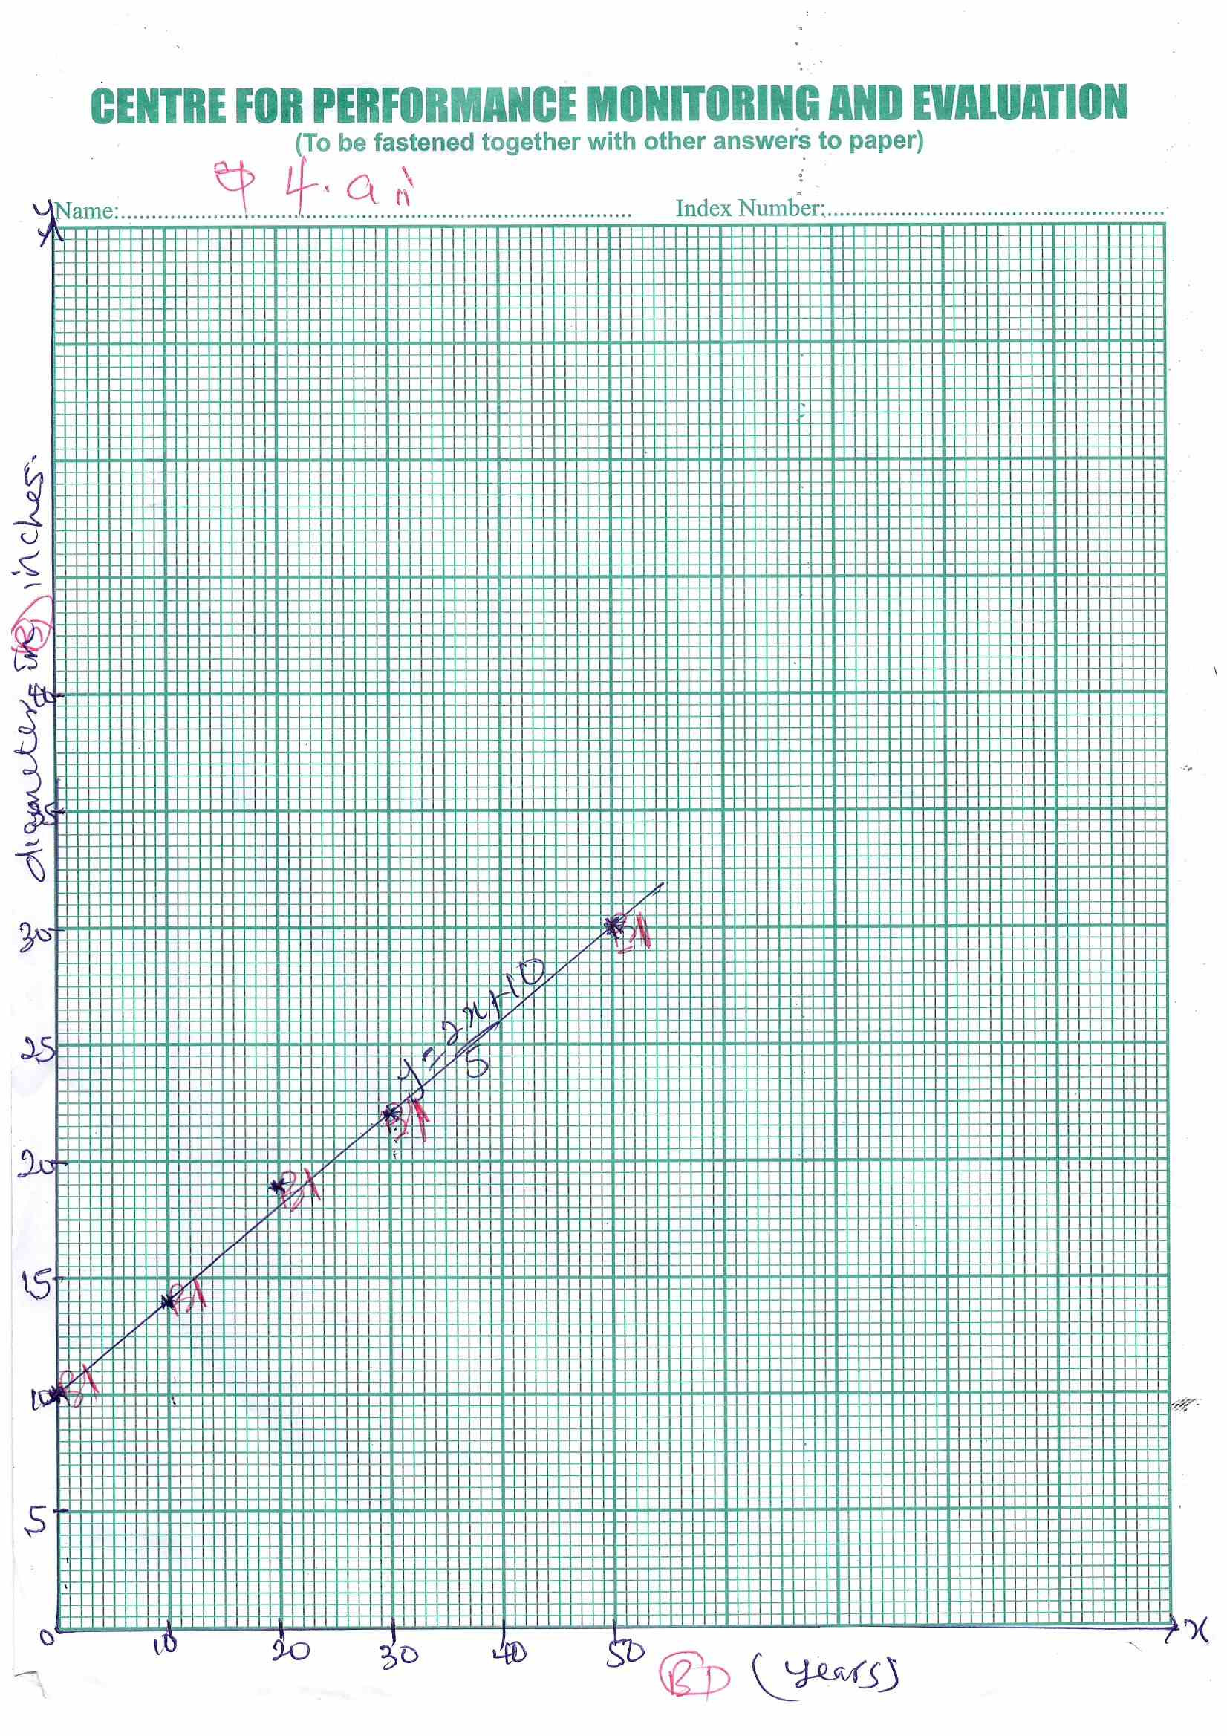 B 1

(c)

30 inches A3

5. (a) (i)

=

=

=

=

(ii) +

=

=

=

=

(b) (i) 3(x + 4) – 2(x - 5)

= 3x + 12 – 2x + 10

= 3x – 2x + 12 + 10

= x + 22

(ii) 2(6 – 5x) – 3(2 + 2x) – 4(3x - 1)

12 – 10x – 6 – 6x – 12x + 4

-10x – 6x – 12x + 12 – 6 + 4

-28x + 10

(c) Let y represent total number of students.

Total ratio = 12 + 25

= 37

x y = 120

=

y = 370

(i) Number of girls = x 370

= 250

(ii) Total number of boys and girls

= 120 + 250

= 370

FIRST TERM MARKING SCHEME

SUBJECT: MATHEMATICS

CLASS: JHS 3

SECTION A [40 marks]

|  |  |  |  |  |  |  |  |
| --- | --- | --- | --- | --- | --- | --- | --- |
| 1. A | 6. D | 11. A | 16. C | 21. D | 26. C | 31. B | 36. B |
| 2. B | 7. D | 12. C | 17. C | 22. C | 27. B | 32. A | 37. A |
| 3. D | 8. C | 13. C | 18. C | 23. C | 28. C | 33. A | 38. D |
| 4. D | 9. D | 14. D | 19. C | 24. D | 29. C | 34. A | 39. C |
| 5. B | 10. A | 15. C | 20. A | 25. B | 30. B | 35. B | 40. D |

SECTION B

1. (a) (i) Let U = 60

n(S) = x

n(M) = x + 15

n(S∩M) = 12

U=60

n(M) = x + 15 n(S) = x

B1

x+15- x x-12 B1

B1 12

B1

9

(ii) (x + 15) – 12 + 12 + x – 12 + 9 = 60 M1

2x + 12 = 60 M1

2x = 60 - 12

M1

x = 24

Hence, number of students who like science is 24 A1

(ii) Number of students who like exactly one subject

= (x + 15) - -12 + x – 12 M1

But x = 24

= (24 + 15) – 12 + 24 – 12 M1

= 39 A1

(b)

M1

= M1

= M1

= A1

2. (a) (i) Area of Land = 90m x 60m M1

= 5400m2 M1

(ii) Corn = x 5400m M1

= 2160m2

Remainders = 5400m2 – 2160m2 M1

= 3240m2 M1

Tomatoes = x 3240m2 M1

= 2430m2

Hence, fraction of land used to cultivate tomatoes

= = A1

(iii) Area of land left uncultivated

= 5400m2 – (2160m2 + 2430m2) M1

= 5400m2 – 4590m2 M1

= 810m2 A1

(b) Let x represent the number

= 10 + M1

L. C. M = 6

6 x = 6 x 10 + 6 x

5x = 60 + 2x

5x – 2x = 60 M1

x = 20

The number is 20 A1

3. (a)

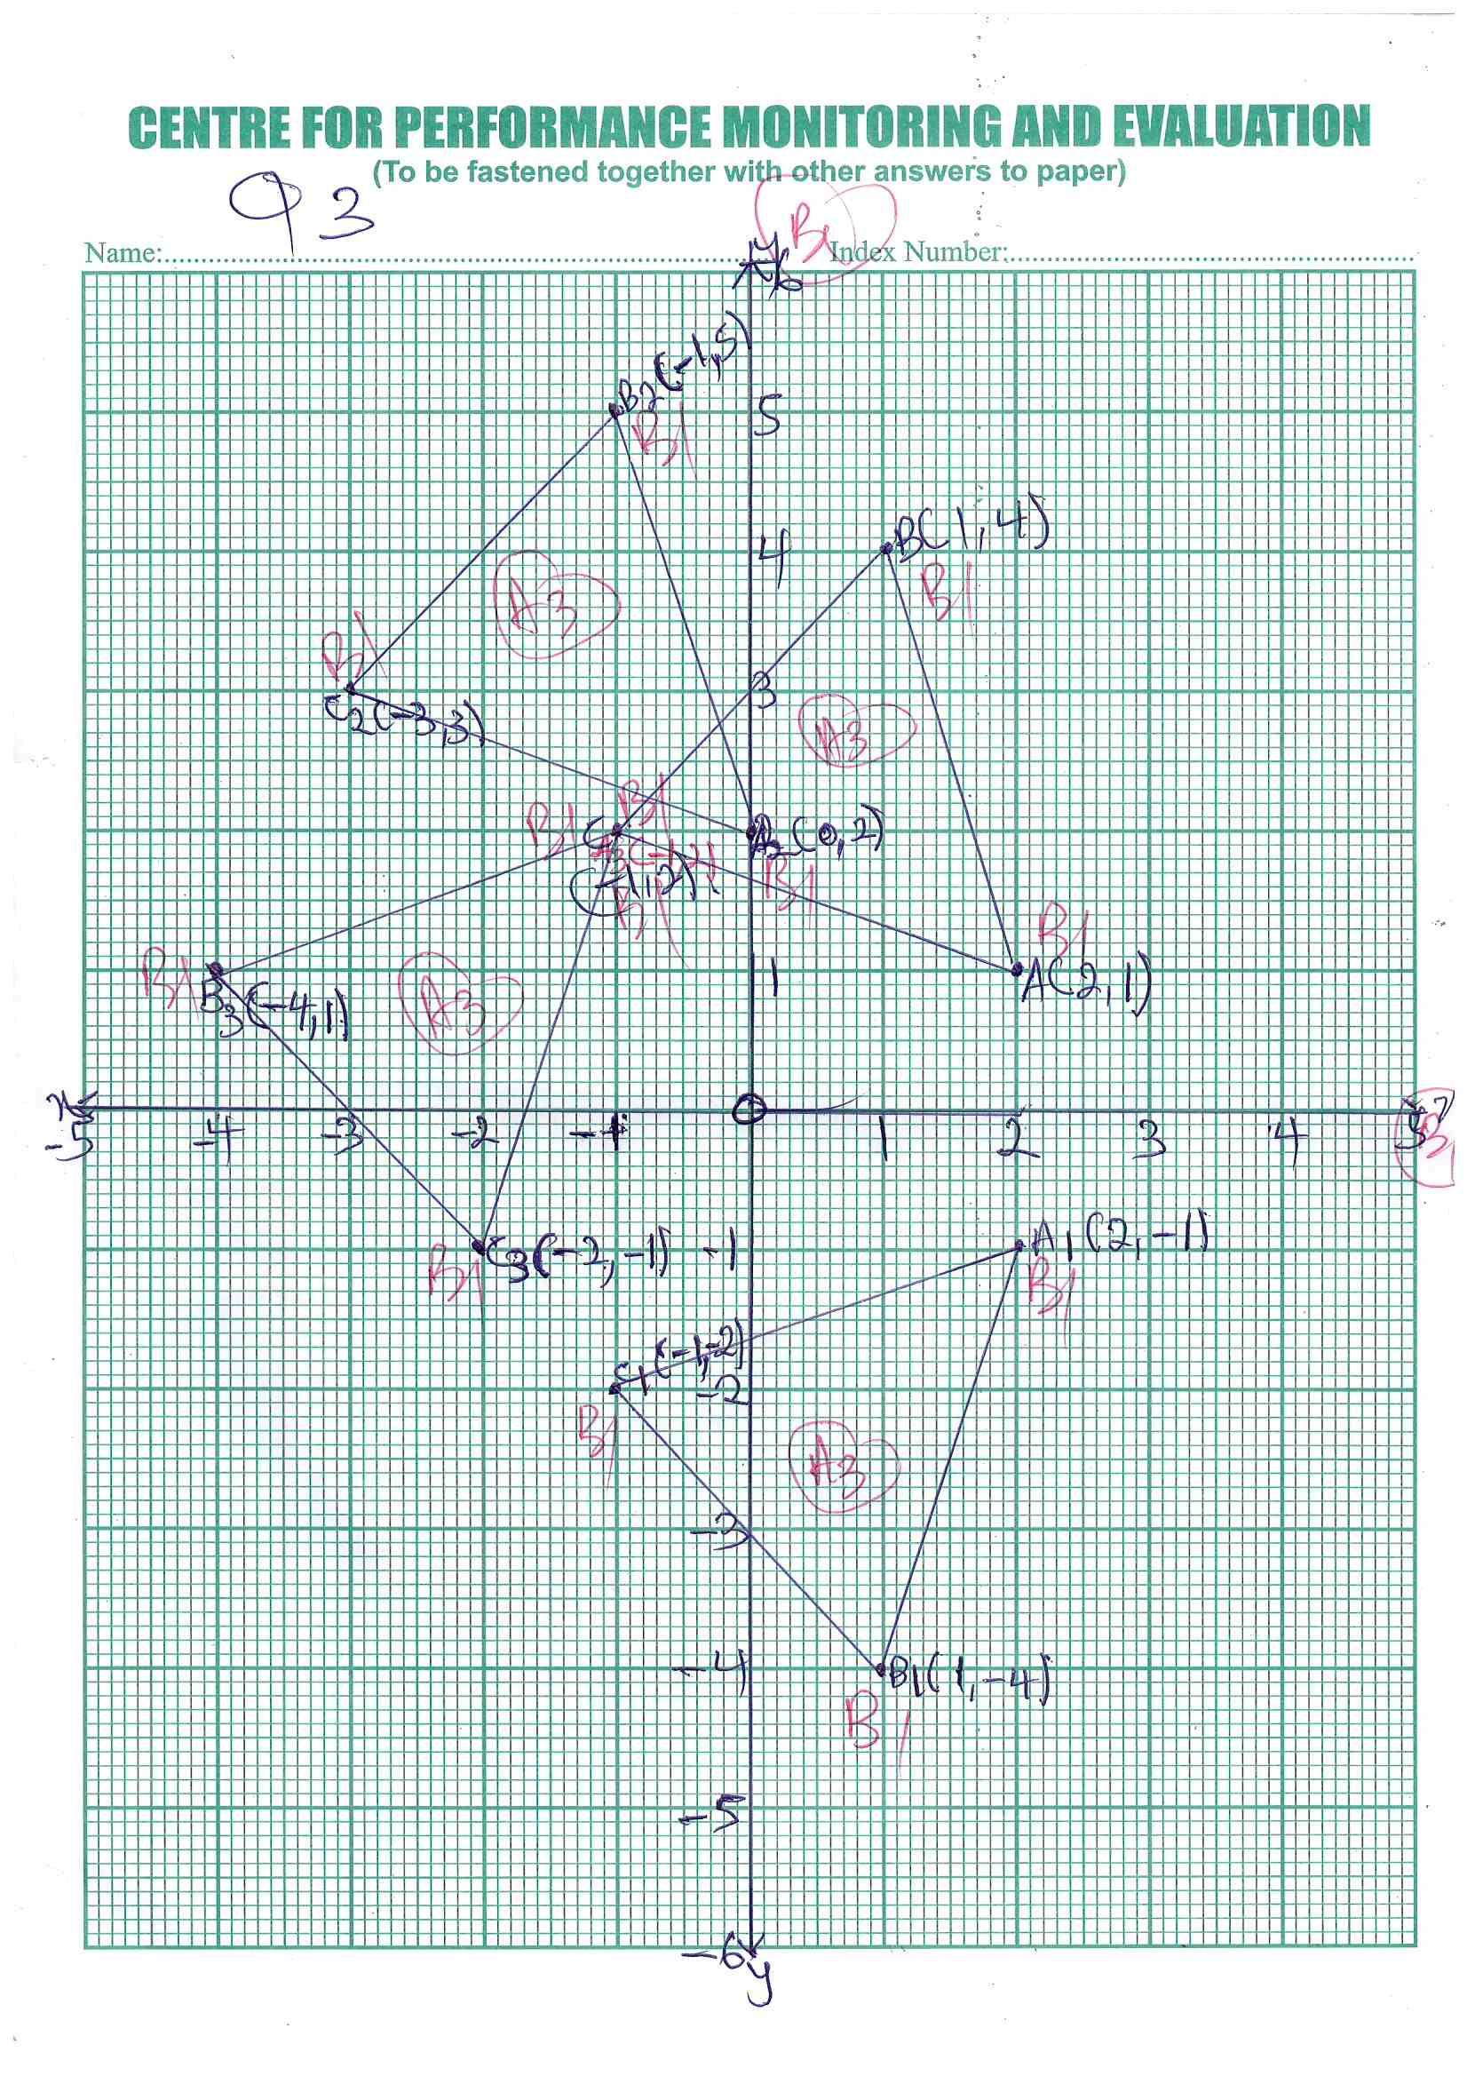

(c) The single transformation that maps ∆A1, B1, C1 and ∆A3, B3 C3 is reflection in the line y – x A1

4. (a) (i) Number of sample space

n(S) = 11 B1

.

. . P(taking out a vowel) = A1

(ii) P(taking out (M)) = A1

(b) (i) Total ratio = 5 + 2 M1

= 7

Three boys = x GH¢189 M1

GH¢135.00 A1

Four girls = x GH¢189 M1

= GH¢54.00 A1

(ii) Amount received by each girl =

GH¢54

4 M1

GH¢13.50 A1

(c) = -1

20 = 20x – 1 M1

4(4x + 5) + 5(x + 3) = -20

16x + 20 + 5x + 15 = -20 M1

16x + 5x + 35 = -20

21x = -20 – 35 M1

M1

.

. . x = A1

5. (a)

|  |  |  |
| --- | --- | --- |
| Marks | Freq | Fx |
| 2 | 2 | 4 |
| 3 | 4 | 12 |
| 4 | 6 | 24 |
| 5 | 4 | 20 |
| 6 | 1 | 6 |
| 7 | 5 | 35 |
| 8 | 3 | 24 |

B 6 fort completion of table.

Note: Three errors in the table consider the table to be zero.

∑f = 25 B ½

∑fx = 125 B ½

(i) Mean mark = = M1

= 5 A1

(ii) Modal Mark = 4 A1

(b) Percentage of students who passed

= 1 + x 100%

= x 100% M1

= 36% A1

(c) P(a student obtained more than 5 marks)

= M1

= A1

6. (a) (i) Perimeter of sector

= 2r + x 2πr

= 2(14cm) + x 2 x x 14cm M1 B1

= 28cm + M1

= 45.6cm A1

(ii) Area of minor sector AOB

= x πr2

x x 14cm x 14cm M1 B1

= cm2 M1

= 123.2cm2

(b) (i) Value of computer after one year

= x GH¢65000 M1 B1

GH¢48,750.00 A1 B1

(ii) Profit = GH¢55.000 – GH¢48,750 M1

= GH¢6,250.00 A1 B1