EaD Comprehensive Lesson Plans
or  0248043888
https://www.TeachersAvenue.net
https://TrendingGhana.net
https://www.mcgregorinriis.com
NAME OF TEACHER: ………………………………………………… WEEK ENDING…05-05-2023………………
NUMBER ON ROLL: ………………………………………………… SUBJECT… GHANAIAN LANGUAGE
DURATION: ………………………………………………………….... REFERENCE…SYLLABUS(CRDD,2007), FOR JHS …… GHA. LANG.
FORM……………..BASIC 9…………… WEEK………5…………..
DAY/DURATION | TOPIC/SUB-TOPIC/ASPECT | OBJECTIVES/R.P. K | TEACHER-LEARNER ACTIVITIES | T/L MATERIALS | CORE POINTS | SKILLS ACQUISITION
MONDAY  01-05-2023 | Aspect; Reading & Literature  Topic; Reading Comprehension  Sub-Topic; Literary Effects of texts. | By the end of the lesson the Pupil will be able to;  show the literary effect  a text has on the reader.  RPK  Pupils can identify literary devices in passages. | Introduction;  Through questions and answers, review Pupils knowledge on the previous lesson.  Activities  - Assist Pupils to identify the literary effects of texts on the reader.  - Discuss with Pupils on the meanings of literary effects identified.  Closure  In small groups,  Pupils discuss to identify and write their  views on texts. | Word Chart, Sentence Cards, letter cards | Literary effects on Readers;  - Literary devices are powerful tools that must not be overlooked in storytelling.  - They can add emphasis to phrases, evoke moods and emotions, and provide insight into an author’s words by making the storytelling clear and vivid. By using these literary devices you will definitely make the most of your storytelling  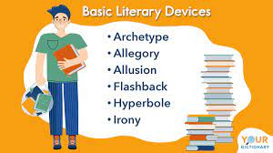 | - Identification  - Reading  - Brainstorming  - Listening skills.
TUESDAY  02-05-2023 | Aspect; Writing Composition  Topic; Narrative  Sub-Topic; Features of Stories. | Objective  By the end of the lesson the Pupil will be able to;  Identify the various features of a story  including the use of language and  punctuations.  RPK  Pupils have been telling stories | Introduction;  Tell the class a short story.  Activities  - Pupils brainstorm to answer questions on the story told.  - Assist Pupils to identify the features of a story.  - Discuss with Pupils on the importance of telling stories  Closure  Through questions and answers, conclude the lesson. |  | Features of a story;  - Theme  - Plot  - Characters  - Setting  - Conflict  - point-of-view  - tone  - style.  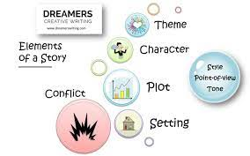 | - Identification  - Explanatory  - Brainstorming  - Discussion
Name of Teacher: School: District:

