McGregorINRI & TEACHERS AVENUE EXAMINATIONS PORTAL
(https://mcgregorinriis.com OR https://teachersavenue.net)
END OF SECOND TERM EXAMINATIONS
CREATIVE ARTS AND DESIGN (CAD) – BASIC 7 (JHS 1)
NAME: ………………………………………………………………………………………………
SCHOOL: …………………………………………………………………………………………..
CLASS: ……………………………………………………………………………………………..
DATE: ……………………………………………………………………........................................

INSTRUCTIONS
- Do not open this booklet until you are told to do so.
- In the spaces provided above, you are to write your Name, School, Class and Date of Examination.
- This paper consists of Sections A and B: Answer both questions on your Question Booklet.
- Choose and circle the correct answer from the options lettered A to D.

FOR EXAMINERS ONLY
Question Number | Marks
TOTAL


WHATSAPP US ONLY: https://wa.me/+233540422666 || https://wa.me/+233246714421 https://wa.me/+233243910155 ||
CALLS ONLY: 0244402425

PART II (ESSAY)
COMPULSORY ASPECT – 20 MARKS
- a) Draw these types of lines correctly in the spaces provided below.
(i) straight line.

(ii) zigzag line.

(iii) circle chain line.
(iv) Parallel line.
b) Shade each object according to the technique specified for it.
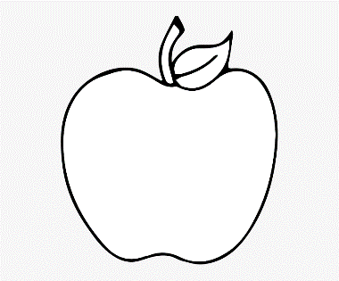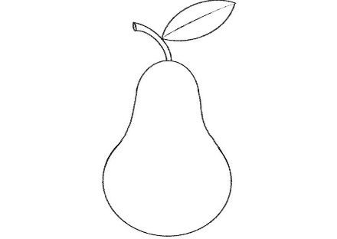
STIPPLING HATCHING CROSS HACTCHING

c) List some two (2) examples of drawing materials.

ANSWER ONLY TWO QUESTIONS FROM THIS SECTION
- a) What is observational drawing? 3 marks
b) State some three (3) examples of visual artworks. 9 marks
c) There are three (3) types of visual artworks. Name them. 8 marks

- a) What is a portfolio? 4 marks
b) State three (3) things drama can demonstrate. 6 marks
c) Dance movement takes place on three levels. Name them. 6 marks
d) List some four (4) principles of design. 4 marks

- a) What is a design process? 4 marks
b) Name any four (4) types of artefacts. 8 marks
c) Identify any two (2) tools used for creating still life drawing. 4 marks
d) In music, what is meant by pitch. 4 marks
PART I (OBJECTIVE TEST)
ANSWER ALL QUESTIONS FROM THIS SECTION

- Mensah is in the process of imagining and planning the creation of objects, systems and buildings. This is termed as……………………
- Plan
- Illustrate
- Design
- Creating

- 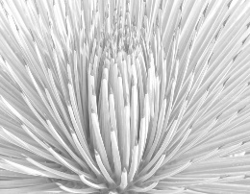 This is a/an……….design
- Artificial
- Natural
- Creative
- Idealistic

- Which of the following is an element of design?
- Value
- Cost
- Durability
- Tensile strength

- 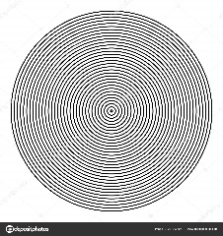 This design is a…..
- Dotted line
- Circle
- Circular motion
- Circle line pattern

- Pick the odd one out.
- Patten
- Line
- Dot
- Value

- In principles of design, one of the following is very key…………
- Line
- Feature
- Balance
- Texture

- 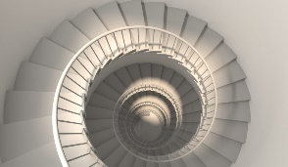 The design here is a……………………
- Staircase
- Snail Shell
- Cowrie
- Oyster shell

- Design has many techniques, one of them is……………………..
- Sculpture
- Emphasis
- Movement
- Elongation

- Kwame wants to make basket, which kind of shape will the base of the basket assume?
- Rectangle
- Circle
- Oval
- Polygon

- Which of these statements is true?
- Outline design bridges the gap between Concept and Detailed Design.
- Outline design is of more value than others.
- Concept design is superior to Outline design.
- None of the above is true.

- Hatching is design means………..
- Parallel lines at right angle
- Long, parallel line on an angle
- Scribbling
- Dotting of lines

- The match box is designed based on which concept?
- Cuboid
- Cube
- Cone
- Rectangle
- Digital tools are vital for drawing. One of them is………………..
- Television
- Radio
- Computer
- Interface
- A heart shape can be used to draw a fun shape like………..
- Fish
- Cloud
- Leaf
- Apple
- Objects made by human beings are termed?
- Articles
- Artefacts
- Mummies
- Pyramids
- Among these is a challenge of design
- Balance of Design and Function
- Having adequate resources
- Having great design ideas
- None of the above is true.

- The tool that helps a designer to break down large projects into smaller and easier to handle stages is known as……………………..
- Design Idea
- Design Stage
- Design Process
- Design Capital
- Artefact type among these is…….
- Moving artefact
- Stagnant doll
- Locomotive pottery
- Ancient pottery
- Charcoal is one of the tools for……
- Still-life drawing
- Dead-life drawing
- Moving-life drawing
- Pencil drawing

- The art or technique of representing an object or outlining a figure, plan or sketch by means of lines is known as………………………
- Sketching
- Drawing
- Scribbling
- Printing
- In still-life drawing, one of the following is a technique
- Shaping
- Sharpening
- Direct printing
- Embroidery

- 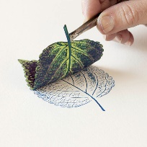 This picture depicts….
- Direct printing
- Indirect printing
- Shading
- Scribbling
- What is the scale degree name for 2?
- Tonic
- Supertonic
- Mediant
- Subdominant
- The name is “subdominant” what is the degree coefficient?
- 1
- 2
- 3
- 4
- Among these, one is a major.
- Y
- W
- A
- Z
- 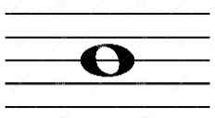 This picture represents a/an…………..
- Half note
- Whole note
- Eighth note
- Zero note
- The art of moving rhythmically to music, typically following a set of sequence steps is termed?
- Dancer
- Dance
- Acting
- Performing
- Kpanlogo is a popular dance for the..
- Ga
- Akans
- Gonja
- Ewes

- 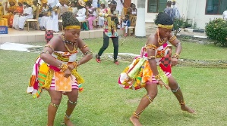 The dance here depicts……………………….
- Adowa
- Kpanlogo
- Borborbor
- Agbadza
- Which people dance Agbadza?
- Anlos
- Ewes
- Ada
- Mamprusi
- Dance movements take place on three levels, one of them is?
- Strong
- Fast
- Slower
- High
- 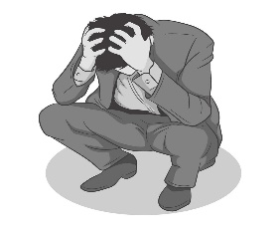The posture of this man is that of?
- Happiness
- Anger
- Sadness
- Loneliness

- ………..refers to the process of creating a three-dimensional form of a two-dimensional work of art such as sculpture of a man, clothing design or something else.
- 3D art
- 2D art
- 1D art
- 4D art

- 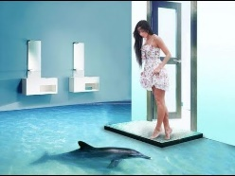 This is a……artwork of a room.
- 2D
- 4D
- 3D
- 5D

- A compilation of academic and professional materials that exemplifies your beliefs, skills, qualifications, education, training etc is termed a/an……………………
- Portfolio
- Philosophy
- Analysis
- Thesis

RESPOND TRUE OR FALSE
- Sikyi is a recreational music and dance of the youth of Ashanti.
True/False

- A Painter is also an artist.
True/False

- Hosting dance auditions is NOT a way of producing a dance show.
True/False

- Drama can help people acquire history and tradition.

- Advertisement is NOT a visual artwork.
True/False

