**McGregorINRI & TEACHERS AVENUE EXAMINATIONS PORTAL**

**(**[**https://mcgregorinriis.com**](https://mcgregorinriis.com) **OR** [**https://teachersavenue.net**](https://teachersavenue.net)**)**

**END OF SECOND TERM EXAMINATIONS**

**CREATIVE ARTS AND DESIGN (CAD) – BASIC 7 (JHS 1)**

|  |
| --- |
| **NAME:** ………………………………………………………………………………………………  **SCHOOL:** …………………………………………………………………………………………..  **CLASS:** ……………………………………………………………………………………………..  **DATE:** ……………………………………………………………………........................................ |

**INSTRUCTIONS**

* ***Do not open this booklet until you are told to do so.***
* ***In the spaces provided above, you are to write your Name, School, Class and Date of Examination.***
* ***This paper consists of Sections A and B: Answer both questions on your Question Booklet.***
* ***Choose and circle the correct answer from the options lettered A to D.***

|  |  |
| --- | --- |
| **FOR EXAMINERS ONLY** | |
| **Question Number** | **Marks** |
|  |  |
|  |  |
|  |  |
|  |  |
| **TOTAL** |  |



**WHATSAPP US ONLY:** [**https://wa.me/+233540422666**](https://wa.me/+233540422666) **||** [**https://wa.me/+233246714421**](https://wa.me/+233246714421)[**https://wa.me/+233243910155**](https://wa.me/+233243910155) **||**

**CALLS ONLY: 0244402425**

**PART II (ESSAY)**

**COMPULSORY ASPECT – 20 MARKS**

1. a) Draw these types of lines correctly in the spaces provided below.

|  |
| --- |
|  |

(i) ***straight line.***

|  |
| --- |
|  |

(ii) ***zigzag line.***

|  |
| --- |
|  |

(iii) ***circle chain line.***

|  |
| --- |
|  |

(iv) ***Parallel line.***

b) Shade each object according to the technique specified for it.

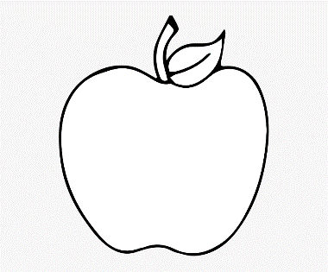 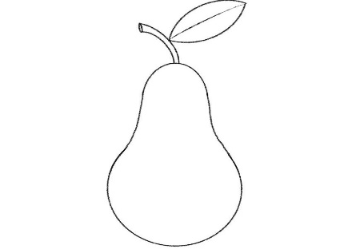

STIPPLING HATCHING CROSS HACTCHING

c) List some two (2) examples of drawing materials.

**ANSWER ONLY TWO QUESTIONS FROM THIS SECTION**

1. a) What is ***observational drawing?*** 3 marks

b) State some three (3) examples of ***visual artworks.*** 9 marks

c) There are three (3) types of ***visual artworks.*** Name them. 8 marks

1. a) What is a ***portfolio?*** 4 marks

b) State three (3) things ***drama*** can demonstrate. 6 marks

c) Dance movement takes place on three levels. Name them. 6 marks

d) List some four (4) ***principles of design.*** 4 marks

1. a) What is a ***design process***? 4 marks

b) Name any four (4) types of ***artefacts.*** 8 marks

c) Identify any two (2) tools used for ***creating still life drawing.*** 4 marks

d) In music, what is meant by ***pitch.*** 4 marks

**PART I (OBJECTIVE TEST)**

**ANSWER ALL QUESTIONS FROM THIS SECTION**

1. Mensah is in the process of imagining and planning the creation of objects, systems and buildings. This is termed as……………………
2. Plan
3. Illustrate
4. Design
5. Creating
6. 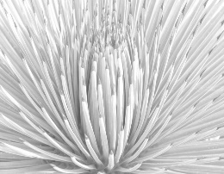 This is a/an……….design
7. Artificial
8. Natural
9. Creative
10. Idealistic
11. Which of the following is an element of design?
12. Value
13. Cost
14. Durability
15. Tensile strength
16. 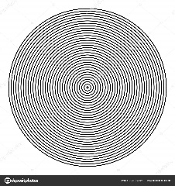 This design is a…..
17. Dotted line
18. Circle
19. Circular motion
20. Circle line pattern
21. Pick the odd one out.
22. Patten
23. Line
24. Dot
25. Value
26. In principles of design, one of the following is very key…………
27. Line
28. Feature
29. Balance
30. Texture
31. 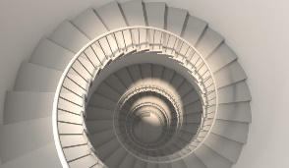 The design here is a……………………
32. Staircase
33. Snail Shell
34. Cowrie
35. Oyster shell
36. Design has many techniques, one of them is……………………..
37. Sculpture
38. Emphasis
39. Movement
40. Elongation
41. Kwame wants to make basket, which kind of shape will the base of the basket assume?
42. Rectangle
43. Circle
44. Oval
45. Polygon
46. Which of these statements is true?
47. Outline design bridges the gap between Concept and Detailed Design.
48. Outline design is of more value than others.
49. Concept design is superior to Outline design.
50. None of the above is true.
51. Hatching is design means………..
52. Parallel lines at right angle
53. Long, parallel line on an angle
54. Scribbling
55. Dotting of lines
56. The match box is designed based on which concept?
57. Cuboid
58. Cube
59. Cone
60. Rectangle
61. Digital tools are vital for drawing. One of them is………………..
62. Television
63. Radio
64. Computer
65. Interface
66. A heart shape can be used to draw a fun shape like………..
67. Fish
68. Cloud
69. Leaf
70. Apple
71. Objects made by human beings are termed?
72. Articles
73. Artefacts
74. Mummies
75. Pyramids
76. Among these is a challenge of design
77. Balance of Design and Function
78. Having adequate resources
79. Having great design ideas
80. None of the above is true.
81. The tool that helps a designer to break down large projects into smaller and easier to handle stages is known as……………………..
82. Design Idea
83. Design Stage
84. Design Process
85. Design Capital
86. Artefact type among these is…….
87. Moving artefact
88. Stagnant doll
89. Locomotive pottery
90. Ancient pottery
91. Charcoal is one of the tools for……
92. Still-life drawing
93. Dead-life drawing
94. Moving-life drawing
95. Pencil drawing
96. The art or technique of representing an object or outlining a figure, plan or sketch by means of lines is known as………………………
97. Sketching
98. Drawing
99. Scribbling
100. Printing
101. In still-life drawing, one of the following is a technique
102. Shaping
103. Sharpening
104. Direct printing
105. Embroidery
106. 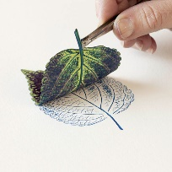 This picture depicts….
107. Direct printing
108. Indirect printing
109. Shading
110. Scribbling
111. What is the scale degree name for 2?
112. Tonic
113. Supertonic
114. Mediant
115. Subdominant
116. The name is “subdominant” what is the degree coefficient?
117. 1
118. 2
119. 3
120. 4
121. Among these, one is a major.
122. Y
123. W
124. A
125. Z
126. 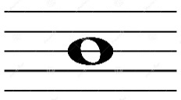 This picture represents a/an…………..
127. Half note
128. Whole note
129. Eighth note
130. Zero note
131. The art of moving rhythmically to music, typically following a set of sequence steps is termed?
132. Dancer
133. Dance
134. Acting
135. Performing
136. ***Kpanlogo*** is a popular dance for the..
137. Ga
138. Akans
139. Gonja
140. Ewes
141. 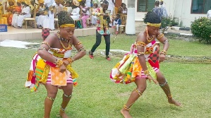 The dance here depicts……………………….
142. Adowa
143. Kpanlogo
144. Borborbor
145. Agbadza
146. Which people dance Agbadza?
147. Anlos
148. Ewes
149. Ada
150. Mamprusi
151. Dance movements take place on three levels, one of them is?
152. Strong
153. Fast
154. Slower
155. High
156. 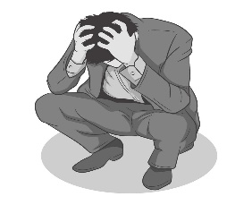The posture of this man is that of?
157. Happiness
158. Anger
159. Sadness
160. Loneliness
161. ………..refers to the process of creating a three-dimensional form of a two-dimensional work of art such as sculpture of a man, clothing design or something else.
162. 3D art
163. 2D art
164. 1D art
165. 4D art
166. 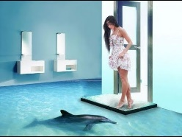 This is a……artwork of a room.
167. 2D
168. 4D
169. 3D
170. 5D
171. A compilation of academic and professional materials that exemplifies your beliefs, skills, qualifications, education, training etc is termed a/an……………………
172. Portfolio
173. Philosophy
174. Analysis
175. Thesis

**RESPOND TRUE OR FALSE**

1. ***Sikyi*** is a recreational music and dance of the youth of Ashanti.

True/False

1. A ***Painter*** is also an artist.

True/False

1. Hosting dance auditions is NOT a way of producing a dance show.

True/False

1. Drama can help people acquire history and tradition.
2. Advertisement is NOT a visual artwork.

True/False