McGregorINRI & TEACHERS AVENUE EXAMINATIONS PORTAL
[https://mcgregorinriis.com OR https://teachersavenue.net]
END OF SECOND TERM EXAMINATIONS
CAREER TECHNOLOGY – BASIC 7 (JHS 1) TIME: 1:30 MINUTES
NAME: ………………………………………………………………………………………………
SCHOOL: …………………………………………………………………………………………..
CLASS: ……………………………………………………………………………………………..
DATE: ……………………………………………………………………........................................

INSTRUCTIONS
- Do not open this booklet until you are told to do so.
- In the spaces provided above, you are to write your Name, School, Class and Date of Examination.
- This paper consists of Sections A and B: Answer both questions on your Question Booklet.
- Choose and circle the correct answer from the options lettered A to D.

FOR EXAMINERS ONLY
Question Number | Marks
TOTAL


WHATSAPP US ONLY: https://wa.me/+233540422666 || https://wa.me/+233246714421
https://wa.me/+233243910155 || CALLS ONLY: 0244402425

PAPER 2 (ESSAY)
ANSWER QUESTION ONE (1) AND ANY OTHER TWO IN ADDITION
COMPULSORY ASPECT = 30 MARKS
- Study the tool below and answer the questions that followed.
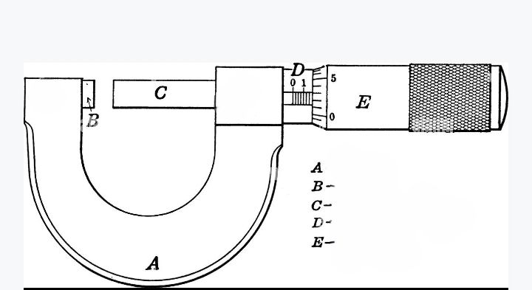

- The tool above is called?
- Which kind of tool is the object?
- What is the use of the tool above?
- Identify the parts labeled A, B, C, D, E

ANSWER ONLY TWO QUESTIONS FROM THIS SECTION
- a) What are measuring tools? 2 marks
b) State five (5) examples of measuring tools and state a function each. 5 marks
c) List some four (4) ways by which cutting and shaping tools can be cared for. 4 marks
d) Write down the four (4) classifications of plant food source. 4 marks

- a) What is food hygiene? 2 marks
b) Identify any three (3) effects of poor environmental health. 3 marks
c) State any four (4) benefits of storing and preserving foods. 4 marks
d) Outline any three (3) causes of accidents at workshops. 6 marks

- a) How do you understand the term “desilting?” 2 marks
b) Provide any four (4) sure ways of improving environmental health. 4 marks
c) Identify any four (4) properties of resistant materials. 4 marks
d) State any five (5) features of a line. 5 marks

PAPER 1 – OBJECTIVE TEST
Answer ALL QUESTIONS from this section
From the alternatives A to D, choose the one that suits the questions

- Rest and sleep enable humans to stay……………….
- Hyperactive
- Hypoactive
- Healthy
- Dull

- One sure way of proper food storage is…………….
- Drying/dehydrating
- Throwing it away
- Ironing
- Greasing

- Which of the following can quickly damage the ear?
- Listening to music
- Using sticks to clean the ear
- Corking the ear while working with loud machines
- Using medicated ear drops

- A negative effect of accidents at the workshop is?
- Loss of productivity of the victims
- Increased productivity
- Supervised productivity
- Minimum occurrence of injuries

- One of this can cause trips and falls at the work place..
- Lack of necessary equipment
- Adequate lighting systems
- Oil and water spillage on the floor
- Being extremely careful

- Among the following, one can endanger environmental health……..

- Increasing sanitation activities
- Increasing healthcare activities
- Immunization against malaria
- Increasing heatwaves and exposure to chemicals

- Due to increase in air pollution, the world is now slightly abandoning fossil fuels cars to……………………
- Diesel powered engines
- Petrol powered engines
- LPG powered engines
- Electric engine cars

- A severe effect of poor environmental health is….
- Outbreak of diseases
- Availability of clean air
- Availability of clean water
- Increased good health

- The art of removing potential health hazards from the environment prior to population exposure is termed as……………………………………..
- Intermediary prevention
- Secondary prevention
- Primary prevention
- Tertiary prevention

- Among these below is a way of improving environmental health
- Encourage recycling
- Discourage good sanitation
- Encourage more screen times
- Non-use of eco-friendly materials

- It is important to prevent and manage environmental health in order to…………..
- Reduce population
- Increase population
- Neutralize population
- Reduce risks for diseases

- How many types of compliant materials are available?
- 1
- 2
- 3
- 4
- Nylon as a example of compliant material is….
- Card
- Cotton
- Corrugated card
- Fabric/Textile
- Fibers are mostly obtained from………and………..
- Birds and plants
- Fish and bats
- Plants and animals
- Insects and birds

- Materials that are not pliable or flexible and cannot be easily compressed with bare hands are called?
- Resistant materials
- Compliant materials
- Non-compliant materials
- Aggressive materials

- Elasticity is the property of which material?
- Compliant
- Aggressive
- Non-compliant
- Resistant

- In classifying plastics, PVC stands for?
- Pure Vital Plastic
- Polythene Chloride
- Polyvinyl Chloride
- Polypropylene

- Which of these is true about smart materials?
- Smart materials are resistant to heat
- Smart materials are water resistant
- Smart materials change their properties in response to heat, light etc
- Smart materials do not melt

- Soya bean is a plant source of food commodity which contains……………………………………………
- First Class protein
- Second Class protein
- Third Class protein
- Fourth Class protein

- Ginger, pepper and garlic are……………………..
- Fruits
- Vegetables
- Spices
- Ingredients

- Among these is a smart and modern material.
- Leather
- Paper
- Card
- Conductive polymers

- A popular Ghanaian dish among the following is?
- Banku with grilled-tilapia
- Amala
- Pizza
- Hotdog

- ………………..is any nutrient-rich material or substance consumed or absorbed by humans, animals, plants or organisms in order to sustain life and growth.
- Diet
- Nutrition
- Food
- Substance abuse

- Which of the following food source is known to be rich in proteins?
- Plant source
- Animal source
- Bird source
- Fish source

- 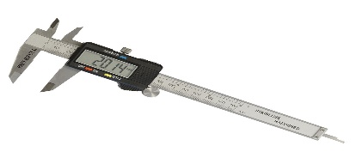 This picture is a…
- Digital caliper
- Speedometer
- Thermometer
- Micrometer

- 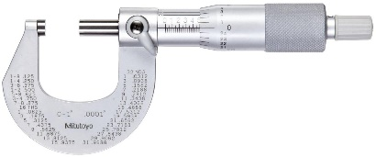 This picture is called?
- Speedometer
- Micrometer
- Caliper
- Rain gauge

- 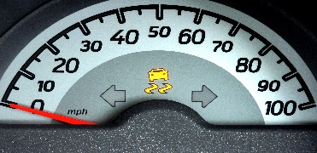 The measuring tool above is called?
- Micrometer
- Thermostat
- Meter
- Speedometer

- Marking out tools can be cared for by?
- Leave the work area in a safe, clean and tidy condition
- Watering
- Printing
- Surfacing

- The function of the drill is?
- Planning and crapping of materials
- Digging of trenches in metals
- For drilling operations on milling machine
- Cutting and marking out of objects

- A shaping tool among the following is a?
- Milling cutter
- Bench grinder
- Boring bar
- Reamer

- One difference between joining and assembling is that?
- Joining is easier than assembling
- Assembling is easy to do than joining
- Assembling includes other processes like measuring, checking and positioning of components
- None of the above

- Adhesive bonds are…………………………………
- Shaping tools
- Cutting tools
- Marking out tools
- Joining and assembling tools

- Locate a joining and assembling technique among the following…………………
- Sewing and crocheting
- Scrapping and smoothing
- Sharpening and joining
- None of the above

- Cutting board is a……………tool/essential.
- Kitchen
- Laboratory
- Cutting
- Living room

- A bigger spoon used in the kitchen can be called?
- Knife
- Scrapper
- Ladle
- Ladder

RESPOND TRUE OR FALSE
- Colander can be located in the kitchen.
True/False

- Oil paints can be diluted using petrol/kerosene
True/False

- Edge finishing can be used to neaten the edge of paper.
True/False

- Dye cannot change the colour clothes.
True/False

- Cookies are traditional Ghanaian foods.
True/False

