**McGregorINRI & TEACHERS AVENUE EXAMINATIONS PORTAL**

**[**[**https://mcgregorinriis.com**](https://mcgregorinriis.com) **OR** [**https://teachersavenue.net**](https://teachersavenue.net)**]**

**END OF SECOND TERM EXAMINATIONS**

**CAREER TECHNOLOGY – BASIC 7 (JHS 1) TIME: 1:30 MINUTES**

|  |
| --- |
| **NAME:** ………………………………………………………………………………………………  **SCHOOL:** …………………………………………………………………………………………..  **CLASS:** ……………………………………………………………………………………………..  **DATE:** ……………………………………………………………………........................................ |

**INSTRUCTIONS**

* ***Do not open this booklet until you are told to do so.***
* ***In the spaces provided above, you are to write your Name, School, Class and Date of Examination.***
* ***This paper consists of Sections A and B: Answer both questions on your Question Booklet.***
* ***Choose and circle the correct answer from the options lettered A to D.***

|  |  |
| --- | --- |
| **FOR EXAMINERS ONLY** | |
| **Question Number** | **Marks** |
|  |  |
|  |  |
|  |  |
|  |  |
| **TOTAL** |  |



**WHATSAPP US ONLY:** [**https://wa.me/+233540422666**](https://wa.me/+233540422666) **||** [**https://wa.me/+233246714421**](https://wa.me/+233246714421)

[**https://wa.me/+233243910155**](https://wa.me/+233243910155) **|| CALLS ONLY: 0244402425**

**PAPER 2 (ESSAY)**

***ANSWER QUESTION ONE (1) AND ANY OTHER TWO IN ADDITION***

**COMPULSORY ASPECT = 30 MARKS**

1. Study the tool below and answer the questions that followed.

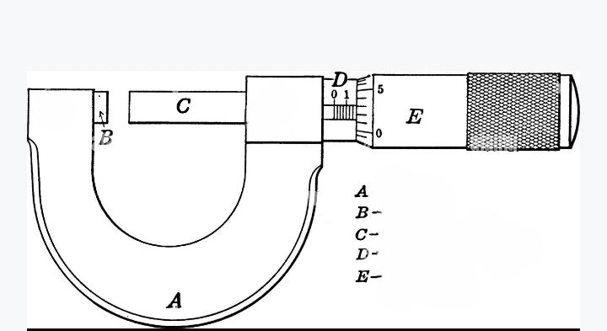

1. The tool above is called?
2. Which kind of tool is the object?
3. What is the use of the tool above?
4. Identify the parts labeled A, B, C, D, E

**ANSWER ONLY TWO QUESTIONS FROM THIS SECTION**

1. a) What are measuring tools? 2 marks

b) State five (5) examples of measuring tools and state a function each. 5 marks

c) List some four (4) ways by which cutting and shaping tools can be cared for. 4 marks

d) Write down the four (4) classifications of plant food source. 4 marks

1. a) What is food hygiene? 2 marks

b) Identify any three (3) effects of poor environmental health. 3 marks

c) State any four (4) benefits of storing and preserving foods. 4 marks

d) Outline any three (3) causes of accidents at workshops. 6 marks

1. a) How do you understand the term “desilting?” 2 marks

b) Provide any four (4) sure ways of improving environmental health. 4 marks

c) Identify any four (4) properties of resistant materials. 4 marks

d) State any five (5) features of a line. 5 marks

**PAPER 1 – OBJECTIVE TEST**

**Answer *ALL QUESTIONS* from this section**

***From the alternatives A to D, choose the one that suits the questions***

1. Rest and sleep enable humans to stay……………….
2. Hyperactive
3. Hypoactive
4. Healthy
5. Dull
6. One sure way of proper food storage is…………….
7. Drying/dehydrating
8. Throwing it away
9. Ironing
10. Greasing
11. Which of the following can quickly damage the ear?
12. Listening to music
13. Using sticks to clean the ear
14. Corking the ear while working with loud machines
15. Using medicated ear drops
16. A negative effect of accidents at the workshop is?
17. Loss of productivity of the victims
18. Increased productivity
19. Supervised productivity
20. Minimum occurrence of injuries
21. One of this can cause trips and falls at the work place..
22. Lack of necessary equipment
23. Adequate lighting systems
24. Oil and water spillage on the floor
25. Being extremely careful
26. Among the following, one can endanger environmental health……..
27. Increasing sanitation activities
28. Increasing healthcare activities
29. Immunization against malaria
30. Increasing heatwaves and exposure to chemicals
31. Due to increase in air pollution, the world is now slightly abandoning fossil fuels cars to……………………
32. Diesel powered engines
33. Petrol powered engines
34. LPG powered engines
35. Electric engine cars
36. A severe effect of poor environmental health is….
37. Outbreak of diseases
38. Availability of clean air
39. Availability of clean water
40. Increased good health
41. The art of removing potential health hazards from the environment prior to population exposure is termed as……………………………………..
42. Intermediary prevention
43. Secondary prevention
44. Primary prevention
45. Tertiary prevention
46. Among these below is a way of improving environmental health
47. Encourage recycling
48. Discourage good sanitation
49. Encourage more screen times
50. Non-use of eco-friendly materials
51. It is important to prevent and manage environmental health in order to…………..
52. Reduce population
53. Increase population
54. Neutralize population
55. Reduce risks for diseases
56. How many types of compliant materials are available?
57. 1
58. 2
59. 3
60. 4
61. Nylon as a example of compliant material is….
62. Card
63. Cotton
64. Corrugated card
65. Fabric/Textile
66. Fibers are mostly obtained from………and………..
67. Birds and plants
68. Fish and bats
69. Plants and animals
70. Insects and birds
71. Materials that are not pliable or flexible and cannot be easily compressed with bare hands are called?
72. Resistant materials
73. Compliant materials
74. Non-compliant materials
75. Aggressive materials
76. Elasticity is the property of which material?
77. Compliant
78. Aggressive
79. Non-compliant
80. Resistant
81. In classifying plastics, PVC stands for?
82. Pure Vital Plastic
83. Polythene Chloride
84. Polyvinyl Chloride
85. Polypropylene
86. Which of these is true about smart materials?
87. Smart materials are resistant to heat
88. Smart materials are water resistant
89. Smart materials change their properties in response to heat, light etc
90. Smart materials do not melt
91. Soya bean is a plant source of food commodity which contains……………………………………………
92. First Class protein
93. Second Class protein
94. Third Class protein
95. Fourth Class protein
96. Ginger, pepper and garlic are……………………..
97. Fruits
98. Vegetables
99. Spices
100. Ingredients
101. Among these is a smart and modern material.
102. Leather
103. Paper
104. Card
105. Conductive polymers
106. A popular Ghanaian dish among the following is?
107. Banku with grilled-tilapia
108. Amala
109. Pizza
110. Hotdog
111. ………………..is any nutrient-rich material or substance consumed or absorbed by humans, animals, plants or organisms in order to sustain life and growth.
112. Diet
113. Nutrition
114. Food
115. Substance abuse
116. Which of the following food source is known to be rich in proteins?
117. Plant source
118. Animal source
119. Bird source
120. Fish source
121. 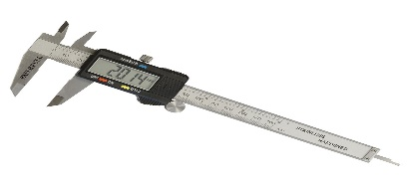 This picture is a…
122. Digital caliper
123. Speedometer
124. Thermometer
125. Micrometer
126. 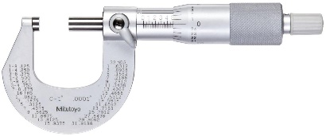 This picture is called?
127. Speedometer
128. Micrometer
129. Caliper
130. Rain gauge
131. 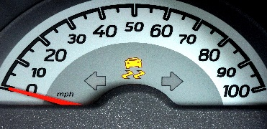 The measuring tool above is called?
132. Micrometer
133. Thermostat
134. Meter
135. Speedometer
136. Marking out tools can be cared for by?
137. Leave the work area in a safe, clean and tidy condition
138. Watering
139. Printing
140. Surfacing
141. The function of the drill is?
142. Planning and crapping of materials
143. Digging of trenches in metals
144. For drilling operations on milling machine
145. Cutting and marking out of objects
146. A shaping tool among the following is a?
147. Milling cutter
148. Bench grinder
149. Boring bar
150. Reamer
151. One difference between joining and assembling is that?
152. Joining is easier than assembling
153. Assembling is easy to do than joining
154. Assembling includes other processes like measuring, checking and positioning of components
155. None of the above
156. Adhesive bonds are…………………………………
157. Shaping tools
158. Cutting tools
159. Marking out tools
160. Joining and assembling tools
161. Locate a joining and assembling technique among the following…………………
162. Sewing and crocheting
163. Scrapping and smoothing
164. Sharpening and joining
165. None of the above
166. Cutting board is a……………tool/essential.
167. Kitchen
168. Laboratory
169. Cutting
170. Living room
171. A bigger spoon used in the kitchen can be called?
172. Knife
173. Scrapper
174. Ladle
175. Ladder

**RESPOND TRUE OR FALSE**

1. Colander can be located in the kitchen.

True/False

1. Oil paints can be diluted using petrol/kerosene

True/False

1. Edge finishing can be used to neaten the edge of paper.

True/False

1. Dye cannot change the colour clothes.

True/False

1. Cookies are traditional Ghanaian foods.

True/False