McGregorINRI & TEACHERS AVENUE EXAMINATIONS PORTAL
[https://mcgregorinriis.com OR https://teachersavenue.net]
END OF SECOND TERM EXAMINATIONS
INTEGRATED SCIENCE – BASIC 8 (JHS 2)
NAME: ………………………………………………………………………………………………
SCHOOL: …………………………………………………………………………………………..
CLASS: ……………………………………………………………………………………………..
DATE: ……………………………………………………………………........................................

INSTRUCTIONS
- Do not open this booklet until you are told to do so.
- In the spaces provided above, you are to write your Name, School, Class and Date of Examination.
- This paper consists of Sections A and B: Answer both questions on your Question Booklet.
- Choose and circle the correct answer from the options lettered A to D.

FOR EXAMINERS ONLY
Question Number | Marks
TOTAL


WHATSAPP US ONLY: https://wa.me/+233540422666 || https://wa.me/+233246714421
https://wa.me/+233243910155 || CALLS ONLY: 0244402425
PAPER II (ESSAY)
PRACTICALS – 40 MARKS
ANWER ALL QUESTIONS FROM THIS SECTION

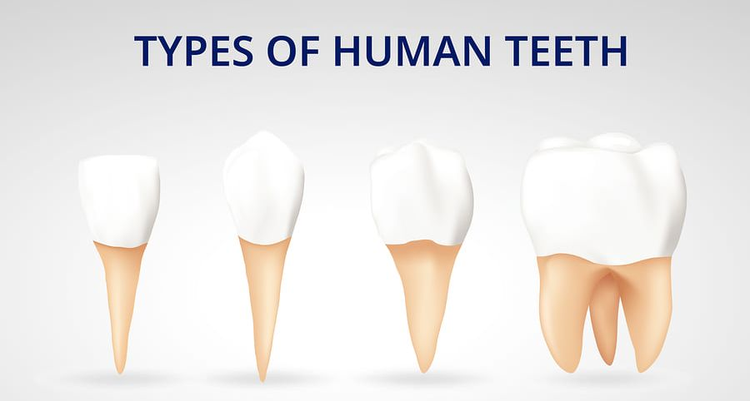

A B C D
a. i. These are the types of teeth in humans. Identify the tooth labeled A, B, C, D
ii. What are the shapes of the teeth labeled A and B?
iii. State the function of A and D in relation to diet. [10 MARKS]

b. The diagrams below show some contents in containers. Use them to answer the questions that followed.
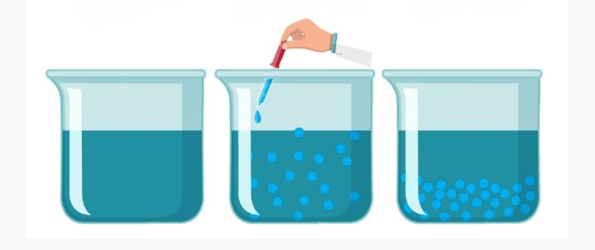
A B C

i. Name the diagrams labeled A, B, and C.
ii. Give some two (2) common examples of the diagram B in real life.
iii. How different is the content in diagram A to diagram B? [10 MARKS]

c. This is an electric circuit below, use it to answer the questions that followed.
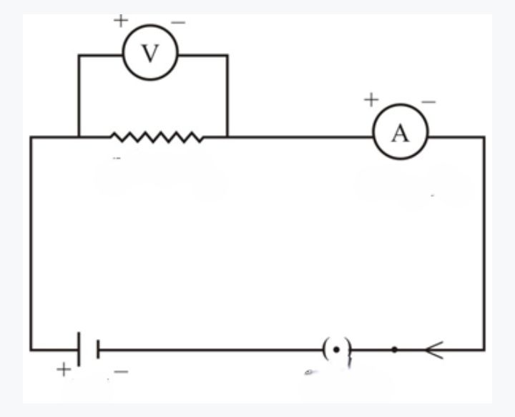
A B C D E F G
- Name the parts labeled A, B, C, D, E, F, G, H
- Disclose the kind of connection of this electric circuit
- What is the function of the parts labeled C and E.

d. The diagram below shows types of nursery seedbeds of a farmer. Use the diagram to answer the questions that followed.
A B

- Identify the name of the seedbeds named A and B.
- What two (2) advantages does seedbed A have over B?
- Identify any two types of crops nursed on both seedbed A and B [10 MARKS]

SELECTIVE ASPECT – 60 MARKS
ANSWER ANY THREE QUESTIONS FROM THIS SECTION
- a. Briefly outline the steps involved in separating a mixture of sand and water using the filtration method. [5 marks]
b. Outline some three (3) measures to control the spread of malaria. [6 marks]
c. Describe briefly how electricity is produced from dam water. [5 marks]
d. Write down some two advantages of nursery beds in crop production. [4 marks]

- a. Briefly talk about the following terms in relation to mixtures.
- Solvent ii. Solute iii. Solution [6 marks]
b. i. What is dentition in humans? [2 marks] ii. Outline three (3) steps to adopt in fighting gum diseases. [3 marks]

c. i. What is meant by renewable energy source? [2 marks]
ii. State three (3) environmental and economic benefits of renewable energy sources in the current trend of the world. [3 marks]
d. i. What is transplanting in crop production? [2 marks]
ii. Identify two plants that can be transplanted from a nursery bed. [2 marks]

- a. i. What is meant by electronic configuration? [3 marks]
ii. Draw the electronic configuration of Potassium (19). [4 marks]

b. i. What are communicable diseases? [2 marks]
ii. Provide three (3) effective steps involved in preventing communicable diseases worldwide. [3 marks]

c. Copy and complete the table below:

QUANTITY | SYMBOL | UNIT OF MEASUREMENT | UNIT ABBREVIATION
Current | I |  | A
 |  | Volt | V
Resistance | R |  | Ω
[4 marks]
d. Give a brief description about Sunken Nursery Beds. [4 marks]

- a. i. What is a heterogeneous mixture? [2 marks]
ii. Explain the following:
- Protons 2. Neutrons 3. Electrons [3 marks]
b. i. Distinguish between heat and temperature. [4 marks]
ii. Briefly explain the following terms:
- Voltage 2. Current 3. Resistance [3 marks]
c. i. What is waste management? [2 marks]
ii. Outline any two (2) waste management strategies. [2 marks]
d. Identify four (4) crops that do not need to be nursed before planting. [4 marks
PAPER I (OBJECTIVE TEST) – 40 MARKS
ANSWER ALL QUESTIONS FROM THIS SECTION

- Comparing solids to liquids, a notable difference is……………
- Liquids flow while solids do not
- Solids flow while liquids do not
- Both solids and liquids flow
- Both liquids and solids do not flow.

- A mixture of sand and water can be separated by?
- Magnetization
- Distillation
- Sedimentation and decantation
- Ionization

- A mixture is said to be heterogeneous when……………..
- It has a uniform composition
- It has many colours
- It has so many layers
- It has no uniform composition

- Sandiley made a heterogeneous mixture in which the solid particles are spread throughout the liquid without dissolving in it. The mixture is said to be a………………………
- Suspension
- Colloid
- Solution
- Solvent-solute

- Daily application of filtration involves?
- Automotive filters usage
- Hair dryer usage
- Fermentation
- Distilling alcohol

- Composition of atoms are…….
- Protons, Atoms and electrons
- Neutrons, Atoms and protons
- Protons, neutrons and electrons
- Ions, molecules and protons
- An atom has 26 electrons and its atomic weight is 56. The number of neutrons in the nucleus of the atom will be…………………………..
- 26
- 30
- 36
- 56

- Number of electrons in the outermost shell of the element of atomic number 15 is……………………
- 1
- 3
- 5
- 7

- In the life cycle of a mosquito, ELPA stands for?
- Egg, Ladle, Pupae, Adult
- Egg, Larva Pupa, Adult
- Egg, Larvae, Pupae, Anther
- Egg, Larva, Pupa, Appendix

- 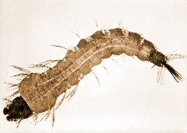 The organism in this picture is………………………..
- Larva
- Pupa
- Pupae
- Algae

- Attractive agents of mosquitoes are...
- Running water
- Stagnant water
- Spoilt food
- Saliva

- An effective way to limit the spread of malaria will be?
- Vector control
- Sleeping early
- Kill mosquitoes manually
- Wearing coloured clothes to bed

- The hardest bodily tissue covering the surface of the dental clown is called?
- Dentin
- Gum
- Cementum
- Enamel

- Canines are strong and are used to….
- Cut food items
- Chew food items
- Rip and tear food.
- Grinding food substances

- Tooth decay can be caused by one of the following except……………
- Bacteria in the mouth
- Frequent snacking
- Using medicated mouthwash
- Sipping sugary drinks

- A sticky film that coats the teeth and contains bacteria is known as………
- Tooth decay
- Tooth plaque
- Tooth rot
- Gum decay

- The most recognizable planet with a system of icy rings is known as……
- Uranus
- Saturn
- Jupiter
- Earth

- Why do we call Mercury, Venus, Earth and Mars as inner planets?
- Because they orbit close to the sun.
- They lie in the inner section of the solar system.
- They have strong gases that attracts the sunlight.
- Because, they can orbit very fast.
- The hottest planet and one of the brightest objects in the solar system that spins in opposition direction to most planets is known as……………………………………….
- Venus
- Mercury
- Mars
- The sun

- Some energy sources are termed as renewable. Example of such is…..
- Fuel
- Charcoal
- LPG
- Solar energy

- Ghana’s biggest energy source is the
- Hydroelectricity
- Geothermal energy
- Wind mill
- Solar energy

- Renewal energies are vital in the current trend of the world because…
- Reduces dependence on imported fuels
- It can be renewed easily
- Works better than non-renewable energy
- Can not cause fire outbreaks

- A similarity between renewable and non-renewable energy is……………
- They save cost
- They cost money to generate and produce
- Does not need solar power
- Both are hydroelectric

- A negative effect of green-house activities on earth is that……………
- It makes the earth much warmer than the atmosphere should be
- It makes the atmosphere too greenish
- Helps organisms to grow rapidly
- The gases cannot flow in engines
- Which of the following is a green-house gas?
- Oxygen
- Nitrogen
- Hydrofluorocarbons
- Argon

- The world is so much concerned about global warming because?
- Cannot make people grow
- Can cause rise in sea levels, droughts and floods.
- Can make fuel prices hike
- It makes cooking gas to become very limited

- Nuclear energy can be classified as...
- Natural energy source
- Artificial energy source
- Limited energy source
- Emitter of carbon dioxide

- The pressure of the water outlets from the dam causes the turbines to rotate, thereby producing…………
- Water energy
- Biomass
- Hydroelectric power
- Fossil fuels

- The S.I Unit for heat is the……….
- Kilogram
- Fahrenheit
- Degrees Celsius
- Joule

- All the following are sources of heat except……………………………….
- Chemical energy
- Atomic energy
- Light
- Earth
- There are……..types of heat transfer.
- 1
- 2
- 3
- 4
- Cell phones use….….to enable communication between two devices
- Convection
- Radiation/Radio waves
- Telephone poles
- Refraction strategy

-  This picture shows………………………..
- Transmission lines
- Power Station
- Solar Power Hub
- Railway line

- The unit of measurement for resistance is………………………
- Ampere
- Volt
- Voltmeter
- Ohm

- Batteries are known to producing….
- Direct current
- Alternating current
- Semiconductor current
- Terminal current

- The function of the capacitor in an electric circuit it………………….
- Permanently stores electrical energy through distributing charged particles on plates to create a potential difference
- Temporarily stores electrical energy through distributing charged particles on plates to create a potential difference
- It breaks the electrical circuit in terms of fire outbreaks
- It is the electrical device that opens or closes the circuit

- In waste management, the 5R’s stand for?
- Rerun, Reduce, Redo, Repurpose, Recycle
- Remove, Refute, Reuse, Repurpose, Recycle
- Refuse, Reduce, Reuse, Repurpose, Recycle
- Rename, Rerun, Reduce, Recycle

-  In waste management, this logo represents…..
- Refuse
- Recycle
- Reduce
- Repurpose

- A disease that is a contagious type of ailment spread from one individual to another through blood and bodily fluids is said to be
- Communicable
- Communal
- Zoonotic
- Botanic

- Viral infections can be effectively controlled by……………………….
- Herbal medicines
- Chloroquine usage
- Vaccines
- Squatting on hot water

