**McGregorINRI & TEACHERS AVENUE EXAMINATIONS PORTAL**

**[**[**https://mcgregorinriis.com**](https://mcgregorinriis.com) **OR** [**https://teachersavenue.net**](https://teachersavenue.net)**]**

**END OF SECOND TERM EXAMINATIONS**

**INTEGRATED SCIENCE – BASIC 8 (JHS 2)**

|  |
| --- |
| **NAME:** ………………………………………………………………………………………………  **SCHOOL:** …………………………………………………………………………………………..  **CLASS:** ……………………………………………………………………………………………..  **DATE:** ……………………………………………………………………........................................ |

**INSTRUCTIONS**

* ***Do not open this booklet until you are told to do so.***
* ***In the spaces provided above, you are to write your Name, School, Class and Date of Examination.***
* ***This paper consists of Sections A and B: Answer both questions on your Question Booklet.***
* ***Choose and circle the correct answer from the options lettered A to D.***

|  |  |
| --- | --- |
| **FOR EXAMINERS ONLY** | |
| **Question Number** | **Marks** |
|  |  |
|  |  |
|  |  |
|  |  |
| **TOTAL** |  |



**WHATSAPP US ONLY:** [**https://wa.me/+233540422666**](https://wa.me/+233540422666) **||** [**https://wa.me/+233246714421**](https://wa.me/+233246714421)

[**https://wa.me/+233243910155**](https://wa.me/+233243910155) **|| CALLS ONLY: 0244402425**

**PAPER II (ESSAY)**

**PRACTICALS – 40 MARKS**

**ANWER ALL QUESTIONS FROM THIS SECTION**

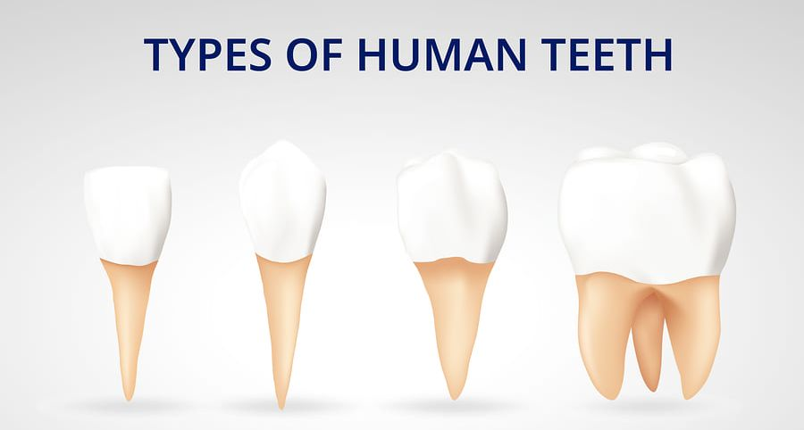

A B C D

a. i. These are the types of teeth in humans. Identify the tooth labeled A, B, C, D

ii. What are the shapes of the teeth labeled A and B?

iii. State the function of A and D in relation to diet. [10 MARKS]

b. The diagrams below show some contents in containers. Use them to answer the questions that followed.

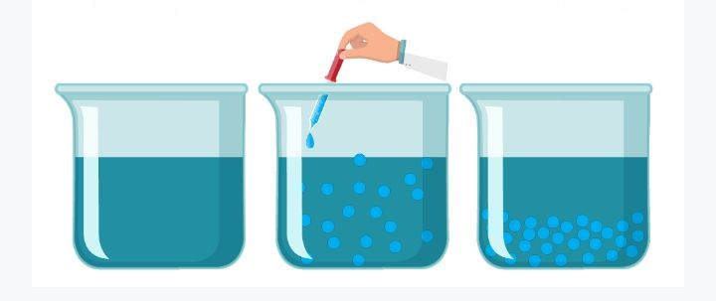

**A B C**

i. Name the diagrams labeled **A, B,** and **C.**

ii. Give some two (2) common examples of the **diagram B** in real life.

iii. How different is the content in **diagram A to diagram B?** [10 MARKS]

c. This is an electric circuit below, use it to answer the questions that followed.

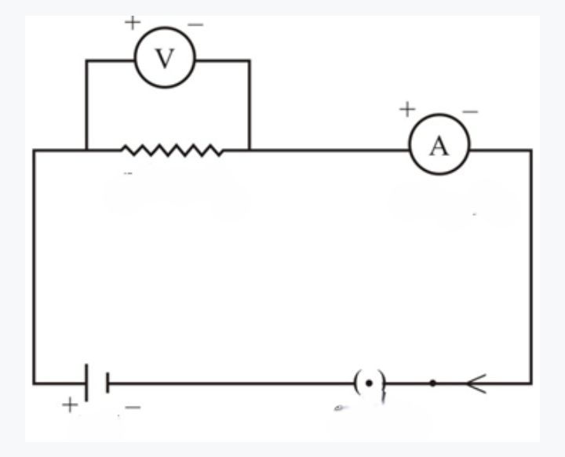

A B C D E F G

1. Name the parts labeled **A, B, C, D, E, F, G, H**
2. Disclose the kind of connection of this electric circuit
3. What is the function of the parts labeled C and E.

d. The diagram below shows types of nursery seedbeds of a farmer. Use the diagram to answer the questions that followed.

**A B**



1. Identify the name of the seedbeds named **A and B.**
2. What two (2) advantages does seedbed A have over B?
3. Identify any two types of crops nursed on both seedbed A and B [10 MARKS]

**SELECTIVE ASPECT – 60 MARKS**

**ANSWER ANY THREE QUESTIONS FROM THIS SECTION**

1. a. Briefly outline the steps involved in separating a mixture of ***sand and water using the filtration method.*** [5 marks]

b. Outline some three (3) measures to control the ***spread of malaria***. [6 marks]

c. Describe briefly how electricity is produced from ***dam water.*** [5 marks]

d. Write down some two advantages of ***nursery beds in crop production.*** [4 marks]

1. a. Briefly talk about the following terms in relation to mixtures.
2. ***Solvent ii. Solute iii. Solution*** [6 marks]

b. i. What is dentition in humans? [2 marks] ii. Outline three (3) steps to adopt in ***fighting gum diseases.***  [3 marks]

c. i. What is meant by ***renewable energy source?*** [2 marks]

ii. State three (3) environmental and economic ***benefits of renewable energy*** sources in the current trend of the world. [3 marks]

d. i. What is ***transplanting*** in crop production? [2 marks]

ii. Identify two plants that can be ***transplanted from a nursery bed.*** [2 marks]

1. a. i. What is meant by ***electronic configuration?*** [3 marks]

ii. Draw the electronic ***configuration of Potassium (19).*** [4 marks]

b. i. What are ***communicable diseases?***  [2 marks]

ii. Provide three (3) effective steps involved in ***preventing communicable diseases*** worldwide. [3 marks]

c. Copy and complete the table below:

|  |  |  |  |
| --- | --- | --- | --- |
| **QUANTITY** | **SYMBOL** | **UNIT OF MEASUREMENT** | **UNIT ABBREVIATION** |
| Current | I |  | A |
|  |  | Volt | V |
| Resistance | R |  | Ω |

[4 marks]

d. Give a brief description about Sunken ***Nursery Beds.*** [4 marks]

1. a. i. What is a ***heterogeneous mixture?***  [2 marks]

ii. Explain the following:

1. ***Protons 2. Neutrons 3. Electrons*** [3 marks]

b. i. Distinguish between ***heat and temperature.***  [4 marks]

ii. Briefly explain the following terms:

1. ***Voltage 2. Current 3. Resistance*** [3 marks]

c. i. What is ***waste management?*** [2 marks]

ii. Outline any two (2) waste ***management strategies.*** [2 marks]

d. Identify four (4) ***crops that do not need to be nursed*** before planting. [4 marks

**PAPER I (OBJECTIVE TEST) – 40 MARKS**

**ANSWER ALL QUESTIONS FROM THIS SECTION**

1. Comparing solids to liquids, a notable difference is……………
2. Liquids flow while solids do not
3. Solids flow while liquids do not
4. Both solids and liquids flow
5. Both liquids and solids do not flow.
6. A mixture of sand and water can be separated by?
7. Magnetization
8. Distillation
9. Sedimentation and decantation
10. Ionization
11. A mixture is said to be heterogeneous when……………..
12. It has a uniform composition
13. It has many colours
14. It has so many layers
15. It has no uniform composition
16. Sandiley made a heterogeneous mixture in which the solid particles are spread throughout the liquid without dissolving in it. The mixture is said to be a………………………
17. Suspension
18. Colloid
19. Solution
20. Solvent-solute
21. Daily application of filtration involves?
22. Automotive filters usage
23. Hair dryer usage
24. Fermentation
25. Distilling alcohol
26. Composition of atoms are…….
27. Protons, Atoms and electrons
28. Neutrons, Atoms and protons
29. Protons, neutrons and electrons
30. Ions, molecules and protons
31. An atom has 26 electrons and its atomic weight is 56. The number of neutrons in the nucleus of the atom will be…………………………..
32. 26
33. 30
34. 36
35. 56
36. Number of electrons in the outermost shell of the element of atomic number 15 is……………………
37. 1
38. 3
39. 5
40. 7
41. In the life cycle of a mosquito, ELPA stands for?
42. Egg, Ladle, Pupae, Adult
43. Egg, Larva Pupa, Adult
44. Egg, Larvae, Pupae, Anther
45. Egg, Larva, Pupa, Appendix
46. 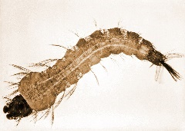 The organism in this picture is………………………..
47. Larva
48. Pupa
49. Pupae
50. Algae
51. Attractive agents of mosquitoes are...
52. Running water
53. Stagnant water
54. Spoilt food
55. Saliva
56. An effective way to limit the spread of malaria will be?
57. Vector control
58. Sleeping early
59. Kill mosquitoes manually
60. Wearing coloured clothes to bed
61. The hardest bodily tissue covering the surface of the dental clown is called?
62. Dentin
63. Gum
64. Cementum
65. Enamel
66. Canines are strong and are used to….
67. Cut food items
68. Chew food items
69. Rip and tear food.
70. Grinding food substances
71. Tooth decay can be caused by one of the following except……………
72. Bacteria in the mouth
73. Frequent snacking
74. Using medicated mouthwash
75. Sipping sugary drinks
76. A sticky film that coats the teeth and contains bacteria is known as………
77. Tooth decay
78. Tooth plaque
79. Tooth rot
80. Gum decay
81. The most recognizable planet with a system of icy rings is known as……
82. Uranus
83. Saturn
84. Jupiter
85. Earth
86. Why do we call Mercury, Venus, Earth and Mars as inner planets?
87. Because they orbit close to the sun.
88. They lie in the inner section of the solar system.
89. They have strong gases that attracts the sunlight.
90. Because, they can orbit very fast.
91. The hottest planet and one of the brightest objects in the solar system that spins in opposition direction to most planets is known as……………………………………….
92. Venus
93. Mercury
94. Mars
95. The sun
96. Some energy sources are termed as renewable. Example of such is…..
97. Fuel
98. Charcoal
99. LPG
100. Solar energy
101. Ghana’s biggest energy source is the
102. Hydroelectricity
103. Geothermal energy
104. Wind mill
105. Solar energy
106. Renewal energies are vital in the current trend of the world because…
107. Reduces dependence on imported fuels
108. It can be renewed easily
109. Works better than non-renewable energy
110. Can not cause fire outbreaks
111. A similarity between renewable and non-renewable energy is……………
112. They save cost
113. They cost money to generate and produce
114. Does not need solar power
115. Both are hydroelectric
116. A negative effect of green-house activities on earth is that……………
117. It makes the earth much warmer than the atmosphere should be
118. It makes the atmosphere too greenish
119. Helps organisms to grow rapidly
120. The gases cannot flow in engines
121. Which of the following is a green-house gas?
122. Oxygen
123. Nitrogen
124. Hydrofluorocarbons
125. Argon
126. The world is so much concerned about global warming because?
127. Cannot make people grow
128. Can cause rise in sea levels, droughts and floods.
129. Can make fuel prices hike
130. It makes cooking gas to become very limited
131. Nuclear energy can be classified as...
132. Natural energy source
133. Artificial energy source
134. Limited energy source
135. Emitter of carbon dioxide
136. The pressure of the water outlets from the dam causes the turbines to rotate, thereby producing…………
137. Water energy
138. Biomass
139. Hydroelectric power
140. Fossil fuels
141. The S.I Unit for heat is the……….
142. Kilogram
143. Fahrenheit
144. Degrees Celsius
145. Joule
146. All the following are sources of heat except……………………………….
147. Chemical energy
148. Atomic energy
149. Light
150. Earth
151. There are……..types of heat transfer.
152. 1
153. 2
154. 3
155. 4
156. Cell phones use….….to enable communication between two devices
157. Convection
158. Radiation/Radio waves
159. Telephone poles
160. Refraction strategy
161. 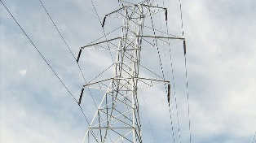 This picture shows………………………..
162. Transmission lines
163. Power Station
164. Solar Power Hub
165. Railway line
166. The unit of measurement for resistance is………………………
167. Ampere
168. Volt
169. Voltmeter
170. Ohm
171. Batteries are known to producing….
172. Direct current
173. Alternating current
174. Semiconductor current
175. Terminal current
176. The function of the capacitor in an electric circuit it………………….
177. Permanently stores electrical energy through distributing charged particles on plates to create a potential difference
178. Temporarily stores electrical energy through distributing charged particles on plates to create a potential difference
179. It breaks the electrical circuit in terms of fire outbreaks
180. It is the electrical device that opens or closes the circuit
181. In waste management, the 5R’s stand for?
182. Rerun, Reduce, Redo, Repurpose, Recycle
183. Remove, Refute, Reuse, Repurpose, Recycle
184. Refuse, Reduce, Reuse, Repurpose, Recycle
185. Rename, Rerun, Reduce, Recycle
186.  In waste management, this logo represents…..
187. Refuse
188. Recycle
189. Reduce
190. Repurpose
191. A disease that is a contagious type of ailment spread from one individual to another through blood and bodily fluids is said to be
192. Communicable
193. Communal
194. Zoonotic
195. Botanic
196. Viral infections can be effectively controlled by……………………….
197. Herbal medicines
198. Chloroquine usage
199. Vaccines
200. Squatting on hot water