BASIC 9
WEEKLY LESSON PLAN – WEEK 7
Strand: | Physical Activity Education |  |  | Sub-Strand: |  |  |  |  | Traditional/Global Rhythmic Gymnastics, Game and Dance
Content Standard: | B9.2.1.1 Demonstrate understanding of performing a variety of traditional games and adaptations for inclusivity and cultural identity.
Indicator (s) | B9.2.1.1.1: Create and classify a variety of  traditional games and adaptation according to  levels of intensity (low, moderate and vigorous  Intensity). |  |  |  |  |  | Performance Indicator: Learners can play traditional games.
Week Ending | 17-11-2023
Class | B.S.9 |  | Class Size: |  |  |  |  | Duration:
Subject | Physical Education
Reference | Physical Education Curriculum, Teachers Resource Pack, Learners Resource Pack.
Teaching / Learning Resources | Poster, Pictures, Video, wordchart. |  |  |  |  | Core Competencies: |  |  |  | - Critical thinking  - Problem Solving
DAYS/DATE | PHASE 1 : STARTER | PHASE 2: MAIN |  |  |  |  |  |  |  |  |  | PHASE 3: REFLECTION
MONDAY | Discuss with the Learners about the meanings of keywords and terminologies in the lesson.  Terminologies;  - Intensity  - Vigorous  - Moderate  - Obesity  - Variety  - Aerobic  - fitness | - Discuss with the Learners about the meaning of a “Traditional Game”.  - Assist Learners to describe 5 characteristics of traditional games.  - Learners brainstorm to identify examples of traditional games.  - Show Learners pictures and video displaying examples of traditional games.  - Engage Learners in playing traditional games.  The traditional games are those playful manifestations or games that are generally transmitted from generation to generation; These are sometimes characteristic of a geographic region, other times they are rather universal. For instance: hopscotch, jump rope, hide and seek.  The name of traditional games or popular games, Although for some these are not equivalent categories: the former generally refer to childhood games, which, as is well known, in addition to representing a recreational space for children, contribute to their psychomotor and socio-affective development.  Characteristics of traditional games  In general, traditional games they don’t use too special objects (a ball or a handkerchief is usually sufficient), and they are based on a series of relatively simple, easy-to-understand rules.  The body with its senses is almost always the main element of the traditional game, sometimes accompanied by the word. Traditional games are often oriented to the skill development, among them the correct perception or development of the body scheme, the tonic and postural control; the temporal-spatial location and fine and gross motor skills.  Do not forget that before television and video games existed, children and adults they played in the squares and in the streets with the few elements that were within reach. These spontaneous games were a very valuable and enriching experience, which many today long for.  Social tradition  Traditional games form an important part of the identity of the peoples and as cultural and social phenomenon it is certainly more than interesting.  Traditional games usually undergo some changes, but almost always maintain their essence and their link with the way of being, incorporating the popular mentality and expressing it through the orality fundamentally.  Some researchers on the subject postulate the influence of magical or religious content in the origin of games, since in ancient times the game was the gift or ability of magicians and shamans.  Then the religion and rationalism they were partly displacing magical thinking, relegating it first to the world of women and then to that of children.  In all parts of the world there are traditional games, and by the way, it is striking that a large part of these games are repeated in different parts, although with their own brands of each place and culture.  Examples of traditional games  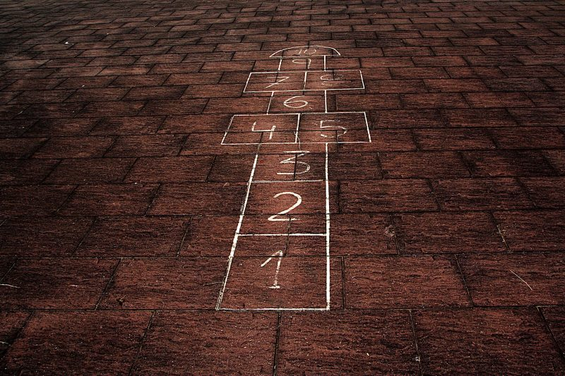 |  |  |  |  |  |  |  |  |  | Learners brainstorm to explain 5 importance of playing traditional games.  Exercise;  Explain 5 characteristics of traditional games.
  Hopscotch | Arm wrestling
  Queenie | Duck, duck, goose
  Capture the flag | Rotten egg
  Jumping Jacks | Down by the banks
  Jumping rope | High-fives
  Elastic | The cat and the mouse
  Hide and seek | Leapfrog
  Rock, paper, scissors | Kick the can
  Policemen and thieves | Truth or dare
  Blind man’s buff | Dancing with the broom
THURSDAY | Review Learners knowledge on the importance of playing traditional games. | - Assist Learners in small groups to adapt and perform traditional games for inclusivity and cultural identity.  - Learners brainstorm to differentiate between High, moderate and low intensity levels.  - Discuss with the Learners about the benefits of each intensity level.  Low Intensity  Low intensity is calculated as working at about 30 to 50 percent of your MHR. Multiply your MHR by .30 and then .50 to determine your heart rate range, Walker says.  Sticking with the example above, if you're 40 years old with an estimated MHR of about 180 beats per minute, multiply 180 by .30 (=54) and then .50 (=90). The result? A hypothetical, healthy 40-year-old's heart rate should remain roughly between 54 and 90 beats per minute when engaging in low-intensity exercise. Low-exertion aerobic activity can often involve moving repetitively at a slower, steadier pace: casual walking (where you can still hold a conversation), light yoga, biking at low-resistance, or leisurely swimming laps. You're moving, but you're not huffing and puffing.  Moderate Intensity  With moderate-intensity aerobic movement, your heart will work a bit harder—though not at max capacity—at roughly 50 to 70 percent of your MHR. Common activities include brisk walking or hiking, aerobic dancing, doubles tennis, cycling (slower than 10 miles per hour, according to the American Heart Association), and even vigorous yard- or housework.  High Intensity  Finally, high intensity means you're training at 75 to 100 percent of your MHR (the average 40-year-old's heart should be pumping at 135 to 180 beats per minute). This vigorous type of movement often involves short, quick-burst exercises where you're fast off the mark, Walker says. You should be working hard, breathing rapidly and heavily, getting sweaty, and unable to sustain a conversation. You might, for instance, be jumping rope, running the stairs, doing a HIIT (high-intensity interval training) workout, playing singles tennis, running, or cycling 10 miles per hour or faster.  The Best At-Home Workout Videos—How to Find the Right One for You  Benefits of Each Exercise Intensity Level  Each exercise intensity affects the body differently. While they all have benefits, how much you do of each one will largely depend on your current fitness level and goals.  Low Intensity  Beginners should start with low intensity, which is beneficial not only for fitness novices, but also seasoned athletes. Think of low-intensity exercise as building the groundwork for more intense exercise.  "Low-intensity exercise reduces the risk of injury while preparing your body for more intense activities," Walker says, adding that it primarily burns fat cells as a fuel resource. It also builds your stamina, which you'll need as you progress in your fitness program since it activates the aerobic system. It's also crucial for sports-specific athletes. "If you're training for any sport that requires a lot of movement for longer spells, you'll need to train aerobically to handle this required level of fitness."  Moderate Intensity  When you shift into moderate-intensity exercise, your body begins using fat, carbohydrates, and sugar as fuel sources. "Burning calories from all of these sources help achieve quicker weight loss results," Walker says. More moderate-level activity is needed to achieve more health benefits (the higher the intensity, the less time is needed to reap those exercise rewards).  High Intensity  As soon as you move into high-intensity exercise, though, you're exercising to your full potential. Not only does this stimulate the best response in your body for fat loss and muscle gains, it also boosts your metabolism for hours after your workout. "By training at maximum capacity, you increase potential for muscle growth and weight loss by breaking down more muscle fibers," says Walker, adding that it's a fantastic way to maintain lean muscle mass and improve body composition. |  |  |  |  |  |  |  |  |  | Through questions and answers, conclude the lesson.  Exercise;  Explain the following;  - High Intensity Level  - Moderate Intensity Level  - Low Intensity Level

Name of Teacher: School: District:

