BASIC 8
WEEKLY LESSON PLAN – WEEK 7
Strand: | Creative Arts |  |  | Sub-Strand: |  |  |  |  | Media and Techniques
Content Standard: | B8/JHS2. 2.1.1. Demonstrate understanding of Visual Arts media and techniques and their application in drawing from direct observation/ memory and imagination, print making and weaving
Indicator (s) | B8/JHS2 2.1.1.4 Experiment with available media and techniques for  weaving to create visual artworks |  |  |  |  |  | Performance Indicator: Learners can apply weaving techniques to create their own artefacts.
Week Ending | 17-11-2023
Class | B.S.8 |  | Class Size: |  |  |  |  | Duration:
Subject | Creative Art and Design
Reference | Creative Art and Design Curriculum, Teachers Resource Pack, Learners Resource Pack, Textbook.
Teaching / Learning Resources | Poster, Pictures, Video, Power Point Presentation |  |  |  |  | Core Competencies: |  |  |  | - Critical Thinking  - Problem Solving  - Communication and Collaboration.
DAY/DATE | PHASE 1 : STARTER | PHASE 2: MAIN |  |  |  |  |  |  |  |  |  | PHASE 3: REFLECTION
MONDAY | Learners brainstorm to explain Weaving . | - Assist Learners to identify media and techniques for weaving.  - Demonstrate using available media and weaving techniques to create woven artefacts.  - Individua Learners practice creating woven artefacts using available media and weaving techniques.  Type of Weaving Technique  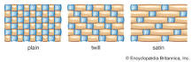  The three basic weaves are plain, twill, and satin. |  |  |  |  |  |  |  |  |  | Through peer-to-peer discussions, Learners discuss ways of creating woven artefacts.
THURSDAY | Learners brainstorm to identify examples of woven artefacts found in their Locality. | - Learners in small groups, assign to each group an example of woven artefacts to create.  - Learners to apply weaving techniques to create their own artefacts.  - Inspect, comment and give feedbacks on Learners Woven artefact.  Woven Artefacts;  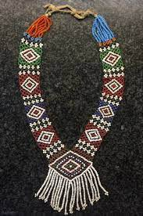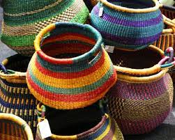  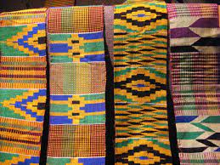 |  |  |  |  |  |  |  |  |  | Through questions and answers, conclude the lesson.  Exercise  Write 10 examples of woven artefacts found in your Locality.

Name of Teacher: School: District:

