BASIC 9
WEEKLY LESSON PLAN – WEEK 9
Strand: | Physical Activity Education |  |  | Sub-Strand: |  |  |  |  | Traditional/Global Rhythmic Gymnastics, Game and Dance
Content Standard: | B9.2.1.2 Demonstrate understanding of performing a variety of traditional dance and adaptations for inclusivity and cultural identity
Indicator (s) | B9.2.1.2.1: Create and classify a variety of traditional dances and adaptation according to levels of intensity. E.g. (low, moderate and vigorous intensity). |  |  |  |  |  | Performance Indicator: Learners can perform examples of traditional dances.
Week Ending | 01-12-2023
Class | B.S.9 |  | Class Size: |  |  |  |  | Duration:
Subject | Physical Education
Reference | Physical Education Curriculum, Teachers Resource Pack, Learners Resource Pack.
Teaching / Learning Resources | Poster, Pictures, Video, Audio Set, Speaker. |  |  |  |  | Core Competencies: |  |  |  | - Critical thinking  - Problem Solving
DAYS/DATE | PHASE 1 : STARTER | PHASE 2: MAIN |  |  |  |  |  |  |  |  |  | PHASE 3: REFLECTION
MONDAY | Discuss the concept of moderate to vigorous exercise intensity with the Learners. | - Assist Learners to explain “Workouts” and identify examples.  - Learners brainstorm to describe what makes dance a workout.  - Learners in small groups to discuss and report to the class on the health benefits of dance.  What Makes Dance a Workout?  The truth is, it doesn’t matter if you stomp it out at a studio hip-hop class or jam to your favorite tunes in your living room: If your heart rate hastens (and you start to sweat), whatever type of dance you’re doing (and wherever you’re doing it), you’re working out.  That said, structured dance workout classes are sometimes created by professionals with fitness expertise to deliver certain exercise benefits.  “The way I program dance cardio is that it’s pretty repetitive, and it’s aerobic, so the intention is to get your heart rate up,” says Megan Roup, a former professional dancer and an ACE-certified personal trainer who founded the The Sculpt Society, a dance cardio workout app. But hitting the dance floor with friends, or busting a move in your living room, can certainly be a workout, too, she adds — even if that’s not your intention.  The Health Benefits of Dance  Dance is chock-full of potential perks for both the body and mind.  Boosted Brainpower  To start with, you need to use both your brain and your body to dance, Roup says — particularly when it comes to learning choreography or dance routines. “Your brain has to be really focused,” she says.  A Stronger, Fitter Heart  And for everyone, because dance is an aerobic exercise, it can boost cardiovascular health.  Improved Bone Density  In addition, dancing is a weight-bearing activity, which the National Osteoporosis Foundation notes can help you maintain or build bone density. |  |  |  |  |  |  |  |  |  | Through questions and answers, conclude the lesson.  Exercise;  - What is a workout?  - State 4 examples.
THURSDAY | Using an audio player and a speaker, play a traditional song for the Learners to dance. | - Learners brainstorm to identify examples of traditional dance.  - Assist Learners to classify traditional dances into low, moderate and high intensity levels.  - Assist Learners to identify traditional dances in their locality.  - Discuss with the Learners on how to adapt traditional dances for inclusivity and cultural identity.  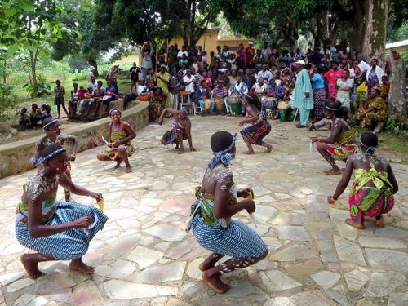  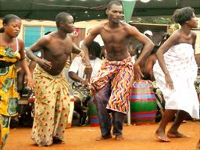  - The Adowa,  - The Agbadza,  - The Borborbor,  - The Bamaya,  - The Kple, Apatampa,  - The Bawa and many others |  |  |  |  |  |  |  |  |  | Learners brainstorm to perform traditional dances for inclusivity and cultural identity.  Exercise;  State 5 examples of traditional dance.

Name of Teacher: School: District:

