BASIC 9
WEEKLY LESSON PLAN – WEEK 3
Strand: | Number |  |  |  | Sub-Strand: |  |  |  |  | Numbers: Ratios and Proportion
Content Standard: | B9.1.4.1 Apply the understanding of ratio, rate and proportions to solve problems that involve rates, ratios, and proportional reasoning and use it to solve real- world mathematical problems
Indicator (s) | B9.1.4.1.3 Use knowledge of rates and proportional reasoning to solve problems involving SSNIT benefits and contributions.  B9.1.4.1.4 Recognise and graph proportional relationships, interpreting the unit rate as the slope of the graph and use these to solve problems. |  |  |  |  |  |  | Performance Indicator: Learners can identify constant of proportionality in tables of vales.
Week Ending | 26-01-2024
Class | B.S.9 |  |  | Class Size: |  |  |  |  | Duration:
Subject | Mathematics
Reference | Mathematics Curriculum, Teachers Resource Pack, Learners Resource Pack, Textbook.
Teaching / Learning Resources | Graph, Poster, Charts, videos. |  |  |  |  |  | Core Competencies: |  |  |  | - Critical Thinking and Problem Solving  Communication and Collaboration.
DAY/DATE | PHASE 1 : STARTER | PHASE 2: MAIN |  |  |  |  |  |  |  |  |  |  | PHASE 3: REFLECTION
MONDAY | Learners brainstorm to explain the full meaning of “SSNIT”. | - Discuss with the Learners about SSNIT benefits and contributions.  - Demonstrate on calculating employee/employer contributions to SSNIT under Act 766.  - Assist Learners to practice solving questions on calculating employee/employer contributions to SSNIT under Act 766.  Three-tier SSNIT Pension scheme;  A: The three-tier contributory scheme, a hybrid of the defined benefit and defined contribution schemes, is made up of the following:  ·Tier 1: A mandatory contributory scheme with monthly contributions of 13.5% (11% towards monthly pensions and 2.5% contribution to NHIS) on the basic salary of all employees. Tier 1 is a defined benefit scheme and contributions are fully tax-exempt and are managed by SSNIT. This scheme will pay monthly benefits to employees upon retirement.  ·Tier 2: A mandatory contributory scheme with monthly contributions of 5% on the basic salary of all employees. Tier 2 is a defined contribution scheme and contributions are fully tax-exempt and are privately managed by National Pensions Regulatory Authority (NPRA) licensed service providers. The scheme will pay out a lump-sum benefit to individuals upon retirement, which is comprised of all contributions made under the scheme plus all returns earned on their contributions. There are two types of Tier 2 schemes: Employer Sponsored Schemes (ESS) and Master Trust Schemes (MTS). If the membership of the scheme is limited to the employees of a specific company, it is deemed to be an Employer Sponsored (ESS). On the other hand, if membership of the scheme is opened to employees of different companies, the scheme is referred to as a Master Trust Scheme (MTS).  ·Tier 3: An optional contributory scheme with monthly contributions of up to 16.5% of the employee’s basic salary on the basic salary of all employees and informal sector workers. Tier 3 is also a defined contribution scheme and is privately managed by NPRA licensed service providers. The contributions for Tier 3 are also tax exempt. If an individual has been in the scheme for 10 years or more, he or she will receive all contributions made under the scheme in addition to all returns earned on their contributions at the time of exit. In the event of an exit prior to the contributor’s tenth anniversary, a marginal tax rate of 15% will be applied to the contributor’s total redemption amount.  Assuming your basic salary is GHC 500, here is a breakdown of how much you can contribute to each of the tiers in the 3 Tier pension scheme. Remember that only Tier 1 is managed by SSNIT:  Tier 1: 13.5% = GHC 67.5  Tier 2: 5% = GHC 25  Tier 3: Up to 16.5% = GHC 82.5  Top of Form  Bottom of Form |  |  |  |  |  |  |  |  |  |  | Learners brainstorm to solve more questions on calculating employee/employer contributions to SSNIT  Exercise;  Write the full meaning of SSNIT?
WEDNESDAY | Using a chart, explain the difference between velocity-time graph and displacement-time graph. |  | - Learners brainstorm to interpret a given travel graph.  - Demonstrate on using tables to check proportional relationships between two quantities.  - Assist Learners to use given tables to check proportional relationships.  Discuss with the Learners about how to decide whether two quantities are in a proportional relationship by testing for equivalent ratios in a table.  Graphs of Proportional Relationships  The coordinate grid shows the graphs of five proportional relationships.  - Approximate, as closely as possible, the constant of proportionality for each line.  - The graph of a proportional relationship with a constant of 1 would lie between two of these lines. Explain why.  - can find one point on the line, how can you determine the constant of proportionality?  - What would a line with a constant of proportionality of 1 look like? What are some examples of ordered pairs that have a ratio of 1? |  |  |  |  |  |  |  |  |  |  | Learners in small groups to discuss on how to decide whether two quantities are in a proportional relationship by graphing on a coordinate plane and observing whether the graph is a straight line through the origin.
FRIDAY | Learners brainstorm to use graphs to check proportional and non-proportional relationship between two quantities. |  | - Demonstrate on finding the constant of proportionality from a table of values, equations and graph.  - Assist Learners to practice finding the constant of proportionality from a table of values, equations and graph.  - Assist Learners to create a table using the points from a graph.  Graphing a Line Using Table of Values  The most fundamental strategy to graph a line is the use of table of values. The goal is to pick any values of x and substitute these values in the given equation to get the corresponding y values. There’s no right or wrong way of picking these values of x. As you develop your skills, you will learn how to select the appropriate values of x depending on how you want to show the graph.  How to Set up a Table of Values  So how does it look? There are two ways to set up the table of values. If the table is presented horizontally, the top row will include all the values of x while the bottom row will contain the corresponding y value for each x. On the other hand, when the table is shown vertically, the left column has the x-values and the right column has the y-values.  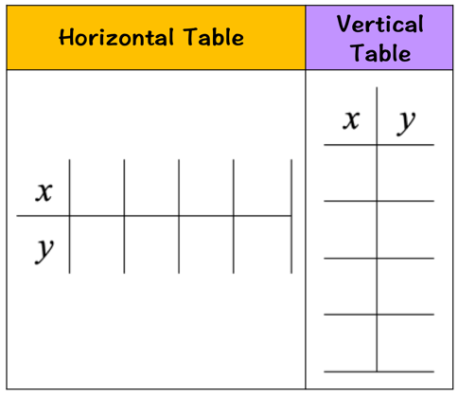  Examples of How to Graph a Line using Table of Values  Let’s take a look at some examples to see how it works.  Example 1: Graph the equation of the line below using table of values.  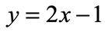  It doesn’t matter which kind of the table of values to use. For this one, we will use the horizontal format. The next step is to pick values of x.  There is no wrong way of selecting the x values. Keep in mind that we need a minimum of two points to graph a line. That means it’s okay to go above the minimum requirements for better accuracy. For me, I always plot three points or more. The reason is that if the line doesn’t pass through the three points, it tells me that I have committed an error in my calculation. This gives me the opportunity to recheck my work.  To decide what x-values to choose, I suggest that you look at the size of our xy-axis. More particularly look at available numbers in the horizontal axis.  Suppose your teacher gives you this xy-axis in your worksheet.  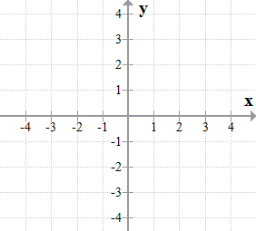  If we want the graph to show within this xy-axis, it makes sense to pick x values that are between –4–4 and +4+4. Always try to include the zero in one of your x values because this will simplify your calculation. So, we chose the following x-coordinates then place them in the table accordingly.  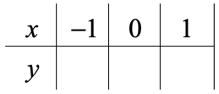  The next obvious step is to figure out the value of y for each x in the table. To do that, we will use the given equation of the line because it is the formula that gives us direct information how to arrive for the value of y when given an x value. We are going to use the formula three times since we have three values of x.  - x=–1  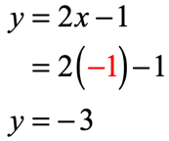  - x=0  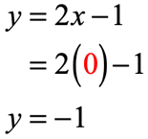  - x=1  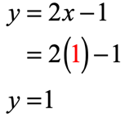  Let’s collect those output values and place them in the row where y values are located.  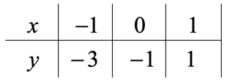  Plot the three points in the xy-axis.  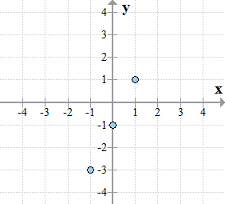  Using a straight edge (ruler), connect the dots to see the graph of the line. That’s it!  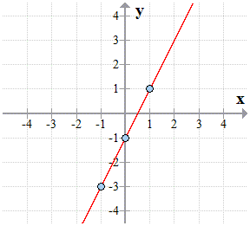 |  |  |  |  |  |  |  |  |  |  | Through questions and answers, conclude the lesson.

Name of Teacher: School: District:

