BASIC 7
WEEKLY LESSON PLAN – WEEK 4
Strand: | Creative Arts (Music) |  |  | Sub-Strand: |  |  |  |  | Media and Techniques
Content Standard: | B7. 2.1.2. Demonstrate understanding and apply scale, note durational values and simple time beat patterns in music.
Indicator (s) | B7 2.1.2.5 Sing in pitch the diatonic major scale when playing the John Curwen’s Hand Sign Game by Lahing or using solfege.  B7 2.1.2.6 Identify durational symbols and move/perform their value in relation to the semibreve.  B7 2.1.2.7 Conduct songs in simple duple, triple and quadruple time. |  |  |  |  |  | Performance Indicator: Learners can perform values of durational symbols in relation to semi breve.
Week Ending | 02-02-2024
Class | B.S.7 |  | Class Size: |  |  |  |  | Duration:
Subject | Creative Arts & Design
Reference | Creative Art Curriculum, Teachers Resource Pack, Learners Resource Pack, Textbook
Teaching / Learning Resources | Audio set, Poster, Sound recorder. |  |  |  |  | Core Competencies: |  |  |  | - Listening skills in Literacy is being enhanced  - Listening skills in Literacy is being enhanced
DAY/DATE | PHASE 1 : STARTER | PHASE 2: MAIN |  |  |  |  |  |  |  |  |  | PHASE 3: REFLECTION
WEDNESDAY | Discuss the meaning of “Scale degree” in music. | - Assist Learners to identify the first five music scale degree.  - Learners brainstorm to sing in pitch one octave ascending and descending from doh and/or any other scale  degree.  - Demonstrate how to match the seven alphabets to the notes in the C major scale in the treble clef by placing them under their locations (i.e., on line or in space).  Scale degree names  Degree Name Semitones  1 Tonic 0  2 Supertonic 2  3 Mediant 3-4  4 Subdominant 5  The key of C Major;  - C  - D  - E  - F  - G  - A  - B |  |  |  |  |  |  |  |  |  | Through questions and answers, conclude the lesson.  Exercise;  - What is Scale degree in music?  - State the first five scale degrees in music.
THURSDAY | Review Learners knowledge on the previous lesson. | - Assist learners to explain “durational symbols”.  - Learners brainstorm to identify examples of durational symbols.  - Assist Learners to internalize the arithmetic or numeral value of note durations against the crochet ( 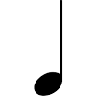) and perform by clapping.  - Using a PowerPoint Presentation, explain the concept of time signature in simple time in music  Example of durational symbols ;  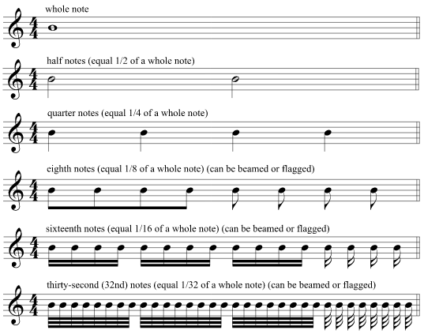  Here are durational symbols for rests.  - To put this information into practice, listen to the durational values double in speed in each measure of the following example.  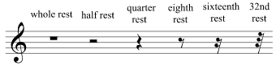  - Two rare durational values are the double whole note (also called a “breve”) and the 64th note, which is twice as fast as a 32nd note.  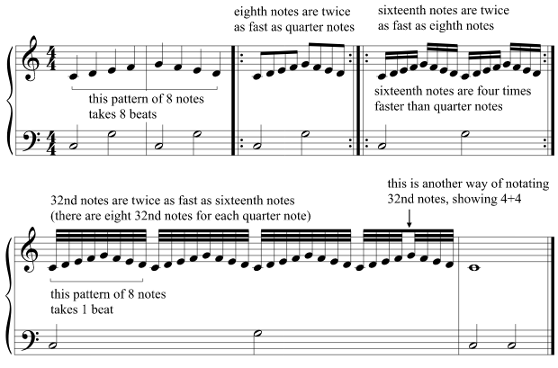 |  |  |  |  |  |  |  |  |  | Through questions and and answers, conclude the lesson.

Name of Teacher: School: District:

