EaD Comprehensive Lesson Plans
or  0248043888
https://www.TeachersAvenue.net
https://TrendingGhana.net
https://www.mcgregorinriis.com
BASIC 9
WEEKLY LESSON PLAN – WEEK 5
Strand: | Algebra |  |  | Sub-Strand: |  |  |  |  | Algebraic Expressions
Content Standard: | B9.2.2.1 Demonstrate an understanding of (i) change of subject (ii) substituting values to evaluate expressions, and (iii) factorize expressions that have simple binomial as a factor.
Indicator (s) | B9.2.2.1.2 Substitute values into given formulae to evaluate it and use it to solve problems.  B9.2.2.1.3 Factorize expressions that have simple binomial. |  |  |  |  |  | Performance Indicator: Learners can factorize simple binomials.
Week Ending | 09-02-2024
Class | B.S.9 |  | Class Size: |  |  |  |  | Duration:
Subject | Mathematics
Reference | Mathematics Curriculum, Teachers Resource Pack, Learners Resource Pack
Teaching / Learning Resources | Poster, Pictures, video, Charts |  |  |  |  | Core Competencies:
DAY/DATE | PHASE 1 : STARTER | PHASE 2: MAIN |  |  |  |  |  |  |  |  | PHASE 3: REFLECTION
MONDAY | Demonstrate on substituting values into equations and solve for a variable. | - Assist Learners to solve examples of substituting values into equations and solving for a variable.  - Learners brainstorm to substitute decimals and negative numbers into equations and solve for a variable.  - Assist Learners to solve word problems involving substituting values into equations and solving for a variable.  How do you factor a binomial?  A binomial is an expression with two terms separated by either addition or subtraction. The goal is to make it all one term — with everything multiplied together. This is accomplished by factoring the two terms. You can use four basic methods to factor a binomial. If none of these methods works, the expression is considered to be prime — meaning it cannot be factored.  The rules or patterns to use when doing the factoring are as follows:  Rule 1: Factoring out the Greatest Common Factor  ab + ac = a(b + c)  Rule 2: Factoring using the pattern for the differences of squares  a² - b² = (a - b)(a + b)  Rule 3: Factoring using the pattern for the difference of cubes  a³ - b³ = (a - b)(a² +ab + b²)  Rule 4: Factoring using the pattern for the sum of cubes  a³ + b³ = (a + b)(a² - ab + b²)  The challenge is in determining which factoring method to use. If you recognize that both terms are perfect squares and they're subtracted, then Rule 2 makes sense. If both terms are perfect cubes, then Rule 3 or 4 will work. If they have one or more factors in common, then use Rule 1. Sometimes, you get to use more than one rule to complete the job.  Examples  Evaluate the following expressions if x=3 and y=− 1  1. 2 x+3=2·3+3=6+3=9  2. y²-2 y+1=(− 1)²-2 (− 1)+1=1+2+1=4  3. xy-y²=3 (− 1)-(− 1)²=− 3-1=− 4  4. x²-y=3²-(− 1)=9+1=10  5. − x²-y²=− 3²-(− 1)²=− 9-(1)=− 9-1=− 10  6. 3 x²+2 xy-12=3 (3)²+2 (3) (− 1)-12=3·9-6-12=27-6-12=9 |  |  |  |  |  |  |  |  | Learners in small groups to discuss and evaluate variable expressions.  Exercise;  - A train traveled for t=5 hours at a constant speed of r=60 miles per hour. Use the formula d=r⋅t to find the total distance (d) the train traveled (in miles).  - A man walked a distance of d=15km (kilometers) in t=3 hours at a constant rate. Use the formula d= t⋅r to find the speed (r) of the man in km per hour.  - A boat traveled a distance of d=140 miles at a constant speed of r=70 miles per hour. Use the formula d=r⋅t to find the number of hours (t) that the trip took.  - A bus traveled for t=3.1 hours at a constant speed of r=62 miles per hour. Use the formula d=r⋅t to find the total distance (d) the bus traveled (in miles). Round your answer to the nearest tenth.  - A truck traveled a distance of d=615km (kilometers) over t=5.9 hours at a constant rate. Use the formula d=r⋅t to find the speed (r) of the truck in km per hour. Round your answer to the nearest tenth
WEDNESDAY | Review Learners knowledge on the previous lesson. | - Learners brainstorm to identify examples of binomials.  - Demonstrate on how to factorize simple binomials.  - Write examples of simple binomials on the chalkboard and assist Learners to factorize.  Bottom of Form  Binomial Theorem  A binomial is a polynomial with two terms  What happens when we multiply a binomial by itself ... many times?  Example: a+b  a+b is a binomial (the two terms are a and b)  Let us multiply a+b by itself using Polynomial Multiplication :  (a+b)(a+b) = a² + 2ab + b²  Now take that result and multiply by a+b again:  (a² + 2ab + b²)(a+b) = a³ + 3a²b + 3ab² + b³  And again:  (a³ + 3a²b + 3ab² + b³)(a+b) = a⁴ + 4a³b + 6a²b² + 4ab³ + b⁴  The calculations get longer and longer as we go, but there is some kind of pattern developing.  That pattern is summed up by the Binomial Theorem:  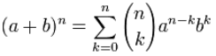  The Binomial Theorem |  |  |  |  |  |  |  |  | Learners brainstorm to solve more examples of factorizing binomials.  Exercise;  Factorize the following;  - 20x2−8x  - 10−5y  - x2−x−6  - 2x2−4x−6  - x2−9
  example of a binomial
FRIDAY | Learners brainstorm to differentiate between binomials and polynomials. | - Assist Learners to factor polynomials with two terms.  - Demonstrate on how to factor polynomials with three terms.  - Learners brainstorm to factor polynomials with three terms.  How to Factor Polynomials with 2 Terms  We will start by learning how to factor polynomials with 2 terms (binomials).  Whenever you are factoring a polynomial with any number of terms, it is always best to start by looking to see if there is a GCF—or greatest common factor—that all of the terms have in common.  For example, consider the example below:  Example #1: Factor 8x + 4  For this example, you should notice that both terms, 8x and 4 are divisible by 4, hence they share a GCF of 4.  Therefore, you can divide out the GCF of 4 from both terms as follows:  - 8x + 4 → 4 (2x + 1)  So, the factors of 8x + 4 are 4 and (2x+1).  What we just did was essentially the reverse of the distributive property, as shown in Figure 03 below.  Figure 03: How to factor a polynomial with 2 terms using the GCF method.  Note that many binomials can be factored using the GCF method, so let’s gain a little more practice with one more example (understanding how to simplify and/or factor a polynomial using the GCF method will come in handy when you start factoring 3 and 4 term polynomials later on).  Example #2: Factor 6x² + 12x  Just like the first example, there is a GCF for both terms. But, in this case, the GCF includes a variable. Why? Because both terms have coefficients that are divisible by 3 and both terms have at least one x variable, so the GCF, in this case, is 3x.  Therefore, you can divide out 3x from both terms as follows:  - 6x² + 12x → 3x(2x + 4)  So, the factors o 6x² + 12x are 3x and (2x+4).  Next, we will look at a special case of factoring a binomial—when the binomial is a difference of two squares (this is sometimes referred to as DOTS).  Whenever you have a binomial of the form a²-b², the factors will be of the form (a+b)(a-b).  Example #3: Factor x² - 49  For example, if you wanted to factor the binomial: x²- 49, you would notice that both x² 49 are squares:  - x² = (x)(x)  - 49=(7)(7)  So, another way to write (x²- 49) is (x²- 7²)  Therefore, you can use the DOTS method for factoring binomials. In this case, a=x and b=7, and…  - (a²-b²) = (a+b)(a-b) → (x²- 7²) = (x-7)(x+7)  You can now conclude that the factors of x²- 49 are (x-7) and (x+7) using the DOTS method.  If you want to learn more about the DOTS method for factoring polynomials that are the difference of two squares,  Otherwise, let’s continue onto the next section where you will learn how to factor polynomials with 3 terms.  How to Factor Polynomials with 3 Terms  Moving on, we will now look at polynomials with 3 terms (these types of polynomials are typically referred to as trinomials).  Learning how to factor polynomials with 3 terms involves a more involved factoring process that we will explore in this section.  The trinomials that we will cover will be of the form ax² + bx + c (where c is a constant). The strategies that we will use will depend on whether or not a (the leading coefficient equals one or not). Therefore, the first two examples in this section will be factoring trinomials when a=1 and the second two examples will be when a≠1.  How to Factor Polynomials with 3 Terms when a=1  Example #1: Factor x² + 6x + 8  For the first example, we have to factor the trinomial: x² + 6x + 8  Figure 06: How to factor polynomials with 3 terms (when a=1)  Again, the leading coefficient, a, is equal to 1 in this example. This is important to note because the following method for factoring a trinomial only works when a=1.  Now we are ready to factor this trinomial in 3 easy steps:  Step One: Identify the values of b and c.  In this example, the values of b and c in the trinomial are: b=6 and c=8  Step Two: Figure out two numbers that both ADD to b and MULTIPLY to c.  The second step often involves some of trial-and-error as you pick numbers and see if they meet both conditions (the two numbers have to add together to make b and multiply together to make c).  - 5 + 1 =6 (the value of b) ✓  - 5 x 1 ≠ 8 (the value of c) ✘  For example, lets say that you chose the numbers 5 and 1. While 5+1=6 is true (satisfying the first condition), 5x1=5 (not 8), therefore, they do not satisfy the second condition. So, 5 and 1 do not work.  But, if you picked the numbers 2 and 4, you can see that:  - 2 + 4 =6 (the value of b) ✓  - 2 x 4 = 8 (the value of c) ✓  Since 2 and 4 satisfy both conditions, you can stop searching and move onto the third step.  Step Three: Use your numbers from step two to write out the factors  In this case, you can conclude that the factors of x² + 6x + 8 are (x+2) and (x+4).  Figure 07: The factors of x² + 6x + 8 are (x+2) and (x+4).  You can verify that these are the correct factors by performing double distribution as follows:  - (x+2)(x+4) = x² + 2x + 4x + 7 = x² + 6x + 8  Notice that you ended up with the trinomial that you started with! Now, lets work through one more example of how to factor polynomials with 3 terms when a=1.  Example #2: Factor x² - 3x - 40  For this next example, we have to factor the trinomial: x² - 3x - 40  Figure 08: How to factor 3rd degree polynomials  Notice that, in this case, the trinomial includes subtraction signs, which will affect how you perform step two below.  Step One: Identify the values of b and c.  For this trinomial, b= -3 and c= -40  Step Two: Figure out two numbers that both ADD to b and MULTIPLY to c.  Again, you have to find two numbers that add to make -3 and that multiply together to make -40.  This part can be tricky when both of the values for b and c are negative (like in this example). You have to recall that a negative number times another negative number will lead to a positive result, so you can’t have two negatives (since you need to find two numbers that multiply together to make -40).  Eventually, after some trial-and-error, you should find that -8 and +5 satisfy both conditions:  - -8 + 5 =-3 (the value of b) ✓  - -8 x 5 = -40 (the value of c) ✓  Step Three: Use your numbers from step two to write out the factors  Finally, you can conclude that the factors of x² - 3x -40 are (x-8) and (x+5).  (You make sure that this answer is correct, you can perform double distribution on (x-8)(x+5) to make sure that the result is equal to the original trinomial).  Figure 09: The factors of x² - 3x -40 are (x-8) and (x+5).  If you want more practice factoring trinomials when a=1, check out our free step-by-step guide on how to factor trinomials to gain some more practice.  Otherwise, you can continue on to learn how to factor polynomials with 3 terms when a≠1.  How to Factor Polynomials with 3 Terms when a≠1  Example #1: Factor 2x² - x - 6  For the first example, we have to factor the trinomial: 2x² - x - 6  Figure 10: How to factor polynomials with 3 terms when a≠1  For starters, notice that you can not pull out a GCF.  So, to solve trinomials of the form ax² + bx + c when a≠1, you can use the AC method as follows:  Step One: Identify the values of a and c and multiply them together  In this case, a=2 and c=-6, so  - a x c = 2 x -6 = -12  Step Two: Factor and replace the middle term  The second step requires you to use the result from step one to factor and replace the middle term.  The middle term is currently -1x and note that:  - -12 = -4 x 3; and  - -4 + 3 = -1  We chose -4 and 3 as factors because the sum of -4 and 3 equals negative 1, so we can rewrite the original trinomial as 2x² - 4x +3x - 6  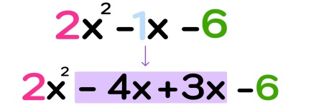  Step Three: Split the new polynomial down the middle and take the GCF of each side  Note that we are now working with a polynomial that actually has four terms: 2x² - 4x + 3x - 6  In this third step, you have to split the polynomial down the middle to essentially create two separate binomials that you can simplify by dividing GCF’s out of as follows:  - First Half: 2x² - 4x = 2x(x-2)  - Second Half: 3x - 6 = 3(x-2)  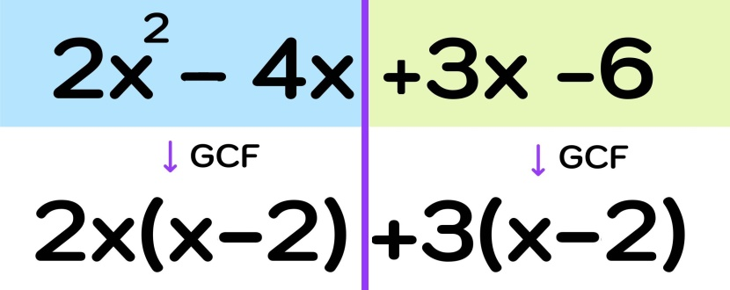  Figure 12: Split the new polynomial down the middle and take the GCF of each side  Step Four: Identify the Factors  Finally, you are ready to identify the factors.  The result from the previous step was 2x(x - 2) + 3(x -2). Hidden within this expression are your two factors, which you can see by looking at Figure 13 below.  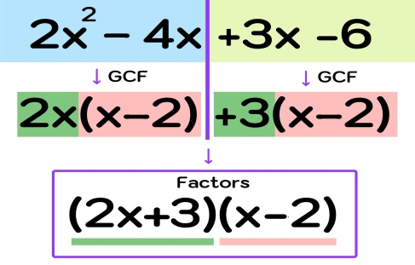  Finally, you can conclude that the factors of 2x² - x - 6 are (2x+3) and (x-2).  Clearly, factoring a trinomial when a≠1 can be a tricky and there are several steps along the way, but, the more that you practice this process, the better you will become at factoring polynomials with 3 terms like the one in this past example. To give you a little more practice, lets work through one more example before we move on to learning how to factor cubic polynomials.  Example #2: Factor 4x² - 15x + 9  Figure 14: Factor the trinomial where a=4, b=-15, and c=9  Step One: Identify the values of a and c and multiply them together  In this example, a=4 and c=9, so  - a x c = 4 x 9 = 36  Step Two: Factor and replace the middle term  For the next step, note that the middle term is -15x, so you will need to find two numbers that multiply to 36 and add to -15:  - 36 = -12 x -3; and  - -12 + -3 = -15  Now, we can rewrite the original trinomial as 4x² -12x -3x +9  Step Three: Split the new polynomial down the middle and take the GCF of each side  For step three, you have to split the polynomial into two separate binomials and divide a GCF out of each one as follows:  - First Half: 4x² -12x = 4x(x-3)  - Second Half: -3x+9 -3(x-3)  Step Four: Identify the Factors  The last step is to identify the factors as shown in Figure 15 below.  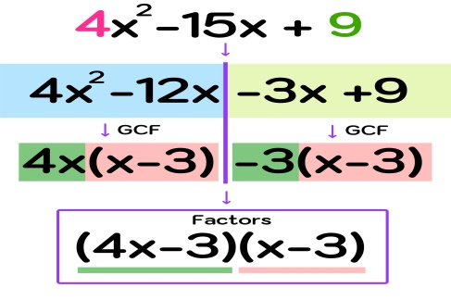  Now, you can conclude that the factors of 4x² - 15x + 9 are (4x-3) and (x-3).  You can again use double distribution on (4x-3)(x-3) to verify that your solution is correct.  If you need more step-by-step help with how to factor polynomials with 3 terms when a does not equal 1,  Otherwise, continue on to the final section where you will learn how to factor polynomials with 4 terms. |  |  |  |  |  |  |  |  | Learners in small groups to discuss and solve polynomials with four terms.  Exercise;  Factor completely.  - x2−9  - x2−100  - y2−36  - y2−144  - x2+4

Name of Teacher: School: District:

