EaD Comprehensive Lesson Plans
or  0248043888
https://www.TeachersAvenue.net
https://TrendingGhana.net
https://www.mcgregorinriis.com
BASIC 8
WEEKLY LESSON PLAN – WEEK 8
Strand: | Creative Arts (Visual Arts) |  |  | Sub-Strand: |  |  |  |  | Creative and Aesthetic Expression
Content Standard: | B8. 2.2.1. Demonstrate the ability to apply the concept of the design process (idea development) to produce and display own creative and expressive art-forms that reflect a range of different times and cultures.
Indicator (s) | B8. 2.2.1.1 Design and produce your own artworks that reflect a range of different times and cultures |  |  |  |  |  | Performance Indicator: Learners can design visual artworks to reflect the history and culture of the peoples of their Community.
Week Ending | 01-03-2024
Class | B.S.8 |  | Class Size: |  |  |  |  | Duration:
Subject | Creative Art and Design
Reference | Creative Arts Curriculum, Teachers Resource Pack, Learners Resource Pack.
Teaching / Learning Resources | Poster, Pictures, Video, Drawing Book, Pencil, colours |  |  |  |  | Core Competencies: |  |  |  | - Communication and Collaboration  - Critical Thinking  Creativity and Innovation
DAY/DATE | PHASE 1 : STARTER | PHASE 2: MAIN |  |  |  |  |  |  |  |  |  | PHASE 3: REFLECTION
TUESDAY | Review Learners knowledge on the previous lesson. | - Assist Learners to identify examples of historic events and the culture of the People of the Community.  - Take Learners out of the classroom to observe natural and man-made things in the school environment.  - Demonstrate to create a visual artwork that reflect on the history, culture, natural and man-made environment.  - Assist Learners to create their own Artworks to reflect on their environment.  Designing Visual Artworks that reflect history, culture, natural and man-made environment;  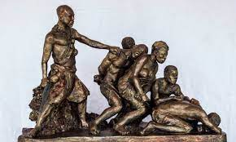  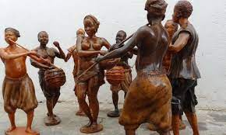  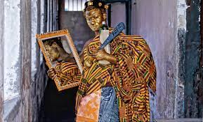 |  |  |  |  |  |  |  |  |  | Group Work;  Learners in small groups are to create visual artworks to reflect the school environment.
WEDNESDAY | Through questions and answers, review Learners knowledge on the previous lesson. | - Learners brainstorm to identify examples of tools and materials for creating artworks that communicate views about topical issues.  - Discuss with Learners the techniques for creating artworks that communicate views about topical issues.  - Assist Learners to apply design process techniques to create their own artworks that communicate views about topical issues.  Materials for creating artworks;  - Water color paint  - show card paint  - Brushes  - Crayons  - Pencils  - Clay  - lettering pens  - weaving materials  - papier mache  - chalk  - paper of different sizes  - soap or wood  - beaver board  - linoleum |  |  |  |  |  |  |  |  |  | Reflect on the use of design process in designing artworks.  Exercise;  - State 5 tools and materials for creating artworks.  - Explain 3 techniques for creating artworks.
  BRANCHES OF CCA | MATERIALS | TOOLS
  Textile | Ink, paper, graphite, tracing paper, wax, dye | Tjanting, sewing machine, rubber glove
  Sculpture | Chalk, wood, stone, wax | Calliper, adze, axe, chisel, file
  Music | Speech, sound, hearing | Musical instruments, hand
  Literature | Ink, graphite(pencil), paper, marker | Pen, quill, computer, printer

Name of Teacher: School: District:

