BASIC 9
WEEKLY LESSON PLAN – WEEK 7
Strand: | Physical Activity Education |  |  | Sub-Strand: |  |  |  |  | Organized Sports Participation
Content Standard: | B9.2.3.2 Demonstrate ability to apply movement principles and strategies in performing limited–contact physical activity (e.g., ball and stick and hand and ball physical activities).
Indicator (s) | B9.2.3.2.2: Apply movement concepts, principles and strategies to perform intermediate level hand and ball physical activity. |  |  |  |  |  | Performance Indicator; Learners can identify examples of hand and ball activities.
Week Ending | 23-02-2024
Class | B.S.9 |  | Class Size: |  |  |  |  | Duration:
Subject | Physical Edu. & Health.
Reference | Physical Edu. & Health Curriculum, Teachers Resource Pack, Learners Resource Pack
Teaching / Learning Resources | Poster, Chart, Pictures and Video.. |  |  |  |  | Core Competencies: |  |  |  | - Communication and collaboration  - Critical Thinking and Problem solving  - Personal Development  - Creativity and Innovation
DAY/DATE | PHASE 1 : STARTER | PHASE 2: MAIN |  |  |  |  |  |  |  |  |  | PHASE 3: REFLECTION
WEDNESDAY | Discuss with the Learners about examples of hand and ball physical activities. | - Show Learners pictures and video displaying how to play examples of hand and ball activities.  - Demonstrate on playing examples of hand and ball physical activities for the Learners to observe.  - Learners brainstorm to apply movement concepts, principles and strategies in learning hand and ball physical activities on (offensive and defensive technique) based on individual adaptation and pacing.  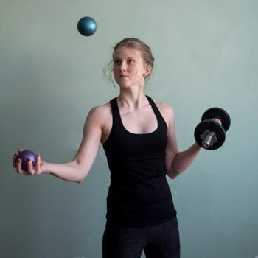  1. Power Grip  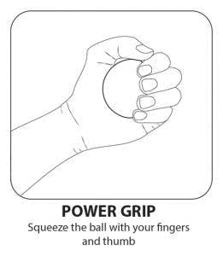  This hand therapy ball exercise will help strengthen your grip so that it is easier to grab objects, pick them up, and release them. Grasping the ball will target the flexor muscles to improve strength for picking objects up. It will also be important to practice releasing the ball, which will target the extensor muscles that allow you to let items go from your hand. This exercise also helps relieve joint pain, stress, and anxiety.  Squeeze the therapy ball with your fingers and thumb, as if making a fist. Squeeze, then release the ball completely, opening your fingers as wide as you can.  2. Pinch  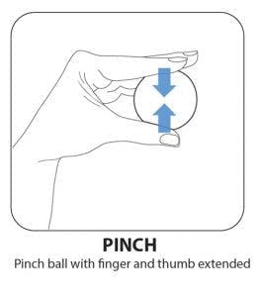  For this exercise, pinch the hand therapy ball with your fingers and thumb extended. And by extended, we mean keep all your fingers straight. This will help strengthen different muscles than the ones targeted by curled fingers.  To make this hand therapy ball exercise more challenging, pinch the ball for a greater amount of time.  3. Thumb Flexion & Extension  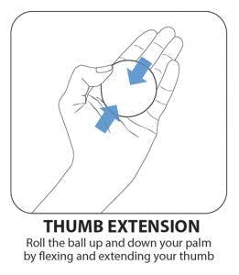  The thumb plays an essential role in various hand functions including pinching and grasping, so it’s essential to strengthen its muscles to improve control.  With your palm flat (as flat as you can), place the therapy ball on your palm and use your thumb to keep it in place.  Then, use your thumb to roll the ball up and down your palm. This movement really isolates your thumb.  4. Table Roll  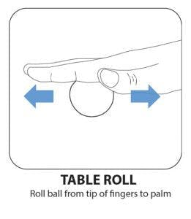  Place the hand therapy ball on a table and place your hand on top of it.  Then, while keeping a flat hand, roll the ball from the base of your palm up to your fingertips.  Placing too much or not enough pressure will make the ball difficult to maneuver. Therefore, this hand therapy ball exercise will help individuals practice adjusting and sustaining a certain amount of pressure on the ball.  5. Finger Flexion  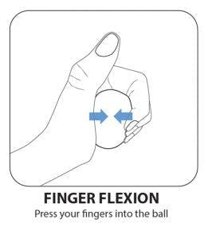  Unlike the Power Grip exercise, you won’t be using your thumb in this hand therapy ball exercise.  Instead, hold the therapy ball in your palm and press into it using all your fingers except your thumb. Press and release.  Notice how much more challenging it is to squeeze the ball without using your thumb. This will help strengthen the muscles that allow you to bend your fingers.  6. Thumb Roll  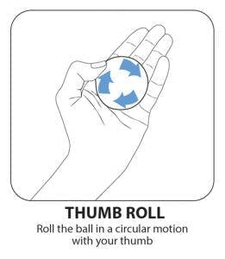  This hand therapy exercise isolates your thumb and encourages you to move it through its entire range of motion. As a result, it will help prevent stiffness and improve control.  Place the therapy ball on your palm. Keep your palm as flat as you can and use your thumb to keep it in place. Then, use your thumb to roll the ball in a circle on your palm.  7. Finger Squeeze  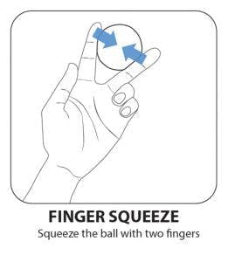  This hand therapy ball exercise will help individuals strengthen their finger adduction muscles. These are the muscles that allow you to bring the fingers together, which play a key role in grasping objects.  Place the therapy ball between two fingers and squeeze your fingers together. Squeeze and release. You can do this between any combinations of fingers, so be sure to exercise all your fingers!  Some fingers will be more difficult than others (like your ring and pinky finger), so be sure not to neglect them.  8. Thumb Opposition  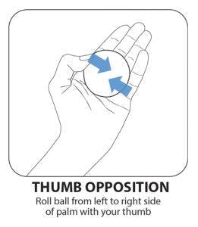  This therapy ball exercise is similar to the Thumb Roll, but you will be rolling the ball side-to-side instead of in circles. |  |  |  |  |  |  |  |  |  | Engage Learners in playing varieties of hand and ball physical activities.  Exercise  State 5 examples of hand and ball physical activities.
FRIDAY | Organize a competition among groups of Learners to play hand and ball physical activities. | - Plan and practice variety of hand and ball physical activities using concepts, principles and strategies on (offensive and defensive skills) for individual adaptation and pacing.  - Learners brainstorm to identify examples of offensive and defensive skills for playing hand and ball physical activities.  - Design a competition with variety of hand and ball physical activities using adapted rules and equipment for inclusion.  Benefits of Hand and Ball Physical Activities;  For Stress Relief: Pressing an anxiety round consistently assists in relaxing your nerves down, easing stress, and also minimizing frustration.  For Arthritis of the Hand: It aids develop muscle mass as well as minimize tension on the arthritic joints in your hands, gradually boosting the pain and also increasing the variety of movement. Soft gel rounds constructed from rubber as well as full of air, foam, or beads vary in resistance levels and sizes. It is normally suggested to start with a larger round that has reduced resistance, allowing the fingertips to curl over its edges.  For Stroke Patients: Frequently pressing a hand treatment round could assist you in keeping your fingers and hands flexible and solid, boosting blood circulation and also reducing rigidity typically experienced after stroke.  For Carpal Tunnel: Pressing a ball on a regular basis could help in enhancing blood circulation and easing the pain and also numbness in your hands, wrists, as well as arms connected with carpal tunnel.  For Protecting against Overuse Injuries like Tennis Elbow: Doing pressing workouts with this medicine ball could help in reinforcing the weak muscular tissues and also boost the adaptability of your wrist as well as lower arm, lessening the chances of muscle mass injury as a result of repetitive arm activity and stopping tennis elbow.  Best Hand Exercise Balls  - Dynaflex Pro Gyro Ball: Regularly working out with it assists in increasing blood circulation with the joints, improving the production of synovial fluid, and raising grasp stamina. It is a reliable training tools for golf enthusiasts, in addition to tennis as well as tennis players.  - Isokinetics Hand Exercise Squeeze Ball: It is a rubber hand exercise round typically utilized by physiotherapists to improve movement and hold toughness in people recuperating from carpal passage, stroke, wrist or hand fracture.  - Thera Band Hand Exercise Ball: It could be made use of for hot/cold physical therapy and also is excellent for arthritis, stroke recuperation, enhancing fingers, and also anxiety reduction. |  |  |  |  |  |  |  |  |  | Through questions and answers, conclude the lesson.

Name of Teacher: School: District:

