BASIC 7
WEEKLY LESSON PLAN – WEEK 1
Strand: | Design |  |  | Sub-Strand: |  |  |  |  | Design in nature and manmade environment
Content Standard: | B7/JHS1 1.1.1Demonstrate understanding of design as a concept in relation to the elements (dots, lines, and shapes) and principles (balance, rhythm, repetition) of design and as a medium for creative expression of design in nature and the manmade environment.
Indicator (s) | B7/JHS1 1.1.1.1 Demonstrate understanding of design as a concept and its importance and role as a medium for creative expression of design in nature and the manmade environment. |  |  |  |  |  | Performance Indicator: :Learners can apply the knowledge of design in designing things.
Week Ending | 13-09-2024
Class | B.S.7 |  | Class Size: |  |  |  |  | Duration:
Subject | Creative Art and Design.
Reference | Creative Arts Curriculum, Teachers Resource Pack, Learners Resource Pack.
Teaching / Learning Resources | Posters and Pictures showing natural and manmade things in the environment, Video, Wordchart. |  |  |  |  | Core Competencies: |  |  |  | - Communication and Collaboration  - Critical Thinking  - Creativity and Innovation.
DAY/DATE | PHASE 1 : STARTER | PHASE 2: MAIN |  |  |  |  |  |  |  |  |  | PHASE 3: REFLECTION
TUESDAY | Assist Learners to explain the meaning of keywords and vocabularies in the lesson. | - Discuss with Learners the meaning of Design.  - Using poster showing design in nature and manmade environment, Assist Learners to identify examples of natural and manmade things in relation to their designs.  - Learners in groups to discuss the importance and roles of design.  - Each group to report on their discussions.  Keywords;  - Design  - Nature  - Manmade  - Environment  - Creative  - Differences  - Similarities  Design; Design is the process of imagining and planning the creation of objects, systems, buildings, vehicles etc.  Design in Nature; This refers to imagining and planning the creation of things created by God.  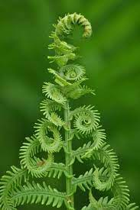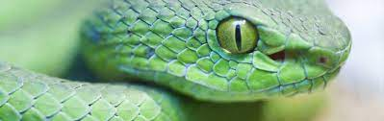  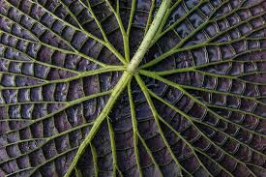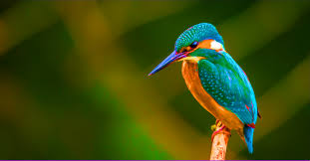  Design in Manmade Environment; It refers to the imagining and planning the creation of objects made by Human.  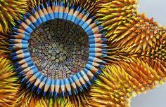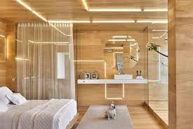  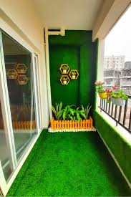 |  |  |  |  |  |  |  |  |  | Reflect on designs in the school environment.
THURSDAY | Show Learners video of designs in nature and manmade environment. | - Learners brainstorm to identify 5 ways design in nature has influenced manmade designs to benefit the Society.  - Learners in small groups to discuss on the similarities and difference between designs in nature and manmade in the school environment.  - Assist Learners to draw examples of design in nature and manmade environment.  Difference between natural design and man made design.  Natural materials are sourced directly from nature -- cotton is picked from cotton plants, corn harvested from corn fields and granite is mined from quarries. Man-made materials, on the other hand, go through rigorous processing to alter the material so that it suits its intended purpose.  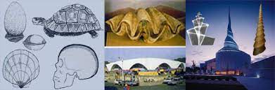 |  |  |  |  |  |  |  |  |  | Inspect, appreciate and comment on Learners designs work.

Name of Teacher: School: District:

